# ISYE 6501 Lecture Transcripts

|  |
| --- |
| About This Document This document was originally created in the summer of 2017 and is maintained collaboratively through the efforts of the students of edX GTx ISYE 6501 using transcripts and screenshots from the video lectures. You are strongly encouraged to improve the formatting, layout, add or adjust images, bold key words, and even condense copy and remove personal asides (sorry, Professor Sokol).  It is expected that sections may be added, removed, or modified -- in which case, again, you should please take the liberty of adjusting this document to match.  Some tips on formatting: the Weeks (e.g., Week 1), Modules (e.g., 1. Introduction), and Sub-Modules (e.g., 1.3 (C): What is Modeling?) are formatted respectively as Heading 1, Heading 2, and Heading 3. These can be adjusted in the format menu, or by pressing Ctrl + 1, Ctrl + 2, and Ctrl + 3, respectively, while the cursor is on the line you wish to change.  Pressing Ctrl + , will toggle subscript text on and off. |

**ISYE 6501 Lecture Transcripts** **0**

About This Document 0

**Week 1** **6**

1. Introduction 6

1.1 (C): Introduction to Analytics Modeling 6

1.2 (C): Introduction to the Course 9

1.3 (C): What is Modeling? 11

2. Classification 12

2.1 (M): Introduction to Classification 12

2.2 (M): Choosing a Classifier 14

2.3 (C): Data Definitions 19

2.4 (M): Support Vector Machines (SVM) 21

2.5 (M): SVM: What the Name Means 25

2.6 (M): Advanced SVM 27

2.7 (C): Scaling and Standardization 30

2.8 (M): K-Nearest Neighbor Classification 33

**Week 2** **35**

3. Validation 35

3.1 (C): Introduction to Validation 35

3.2 (C): Validation and Test Data Sets 37

3.3 (C): Splitting Data 39

3.4 (C): Cross-Validation 41

4. Clustering 43

4.1 (M): Introduction to Clustering 43

Examples of Clustering 43

[IMAGE] 44

[IMAGE] 44

4.2 (C): Distance Norms 45

4.3 (M): K-means Clustering 48

4.4 (M): Practical Details for K-Means 50

4.5 (M): Clustering for Prediction 52

4.6 (M): Supervised vs Unsupervised Learning 54

**Week 3** **55**

5. Basic Data Preparation 55

5.1 (C): Introduction to Data Preparation 55

5.2 (C): Outlier Detection 56

[IMAGE] 56

[IMAGE] 56

[IMAGE] 57

[IMAGE] 57

[IMAGE] 57

5.3 (C): Dealing with Outliers 58

6. Change Detection 60

6.1 (M): Introduction to Change Detection 60

Case Study: Semiconductor Manufacturing Traffic 60

Case Study: Railroad Safety 61

[IMAGE] 61

[IMAGE] 61

6.2 (M): CUSUM for Change Detection 62

[IMAGE] 63

[IMAGE] 63

[IMAGE] 63

[IMAGE] 64

6.3 (M): Change-Detection Homework Follow-up 65

**Week 4** **67**

7. Time Series Models 67

7.1 (M): Introduction to Exponential Smoothing 67

7.2 (M): Trends and Cyclic Effects 71

[FORMULA SCREENCAP] 71

7.3 (M): Exponential Smoothing: What The Name Means 76

[IMAGE] 76

7.4 (M): Forecasting 78

7.5 (M): ARIMA 80

7.6 (M): GARCH 85

[IMAGE] 85

**Week 5** **87**

8. Basic Regression 87

8.1 (M): Introduction to Regression 87

[IMAGE] 87

[IMAGE] 88

8.2 (C): Maximum Likelihood and Information Criteria 90

8.3 (M): Using Regression 93

8.4 (C): Causation vs Correlation 95

8.5 (M): Transformation and Interactions 98

8.6 (M): Regression Output 99

**Week 6** **101**

9. Advanced Data Preparation 101

9.1 (C): Box-Cox Transformation 101

9.2 (C): De-Trending 103

9.3 (C): Introduction to Principal Component Analysis 105

9.4 (C): Using Principal Component Analysis 107

9.5 (C): Eigenvalues and Eigenvectors 109

**Week 7** **109**

10. Advanced Regression 110

10.1 (M): Introduction to CART 110

10.2: (M): Branching 112

10.3: (M): Random Forests 114

10.4: (M): Logistic Regression 116

10.5: (C): Confusion Matrices 119

10.6: (C): Situationally-Driven Comparison 122

10.7: (M): Advanced Topics in Regression 124

**Week 8** **126**

11. Variable Selection 126

11.1: (C): Introduction to Variable Selection 126

11.2: (C): Models for Variable Selection 129

11.3: (C): Choosing a Variable Selection Model 133

12. Design of Experiments 136

12.1 (M): Introduction to Design of Experiments 136

12.2 (M): A/B Testing 138

Case Study: Banner Ad Test 138

12.3 (M): Factorial Designs 140

12.4 (M): Multi-Armed Bandits 143

13. Probability-Based Models 145

13.1 (M): Introduction to Advanced Probability Distributions 145

Case Study: Baseball Ticket Upgrades 145

13.2 (M): Bernoulli, Binomial and Geometric Distributions 147

13.3 (M): Poisson, Exponential and Weibull Distributions 151

Case Study: Atlanta Airport Arrivals 152

13.4 (C): Q-Q Plots 155

13. Probability-Based Models, Continued 158

13.5 (M): Queuing 158

13.6 (M): Simulation Basics 161

13.7 (M): Prescriptive Simulation 164

13.8 (M): Markov Chains 166

14. Missing Data 168

14.1 (C): Introduction to Missing Data 168

14.2 (C): Methods That Do Not Require Imputation 171

Method 1. Throw Away Data 171

Method 2. Use Categorical Variables 171

14.3 (C): Imputation Methods 173

Imputation Method: Use An Average 173

Imputation Method: Use A Predictive Model 173

Imputation Method: Perturbation 174

15. Optimization 176

15.1 (M): Introduction to Optimization 176

15.2 (M): Elements of Optimization Models 178

15.3 (M): Modeling is an Art: Two Examples 180

Case Study: The Army Diet Problem 180

15.4 (M): Modeling With Binary Variables 183

**Week** **9 184**

15.5 (M): Optimization for Statistical Models 186

15.6 (M): Classification of Optimization Models 189

15.7 (M): Stochastic Optimization 192

15.8 (M): Basic Optimization Algorithms 195

16.1 (M): Non-Parametric Methods 197

16.2 (M): Bayesian Modeling 200

16.3 (M): Communities in Graphs 204

16.4 (M): Neural Networks and Deep Learning 207

16.5 (M): Competitive Models 209

16.5a (M): Competitive Models Demo 212

**Week** **10 215**

17.1 A Format For Discussion 216

18.1 Introduction to Power Company Case 217

18.2 Models for Customer Identification 218

18.3 (X): Models for Cost Estimation 220

18.4 (X): Models for Shutoff Selection 222

**Week** **11 222**

19.1 (X): Introduction to Retailer Case 224

19.2 (X): Testing the Hypothesis 226

19.3 (X): Using a New Data Source 228

19.4 (X): Making Recommendations 230

**Week 1****2 232**

20.1 (X): Introduction to Monetization Case 232

20.2 (X): Sample Models 234

20.3 (X): Matching Across Data Sets 236

21.1 (C): Many Analysts, One Dataset 239

[IMAGE] 239

21.2 (C): Course Summary 242

Appendix I: Analytics Software and Functions 244

R 244

Arena 245

Python 245

# Week 1

*Time to get started! This week, you’ll get introduced to the course and its organization, and then we’ll jump right into classification models, including a couple of basic machine learning algorithms. We’ll also cover some cross-cutting concepts about data, scaling, and model validation.*

## 1. Introduction

### 1.1 (C): Introduction to Analytics Modeling

Hi, welcome to Introduction to Analytics Modeling, Georgia Tech's course ISYE6501. I'm Joel Sokol, director of the Master of Science in Analytics degree at Georgia Tech and a professor in Georgia Tech's Stewart School of ISyE.

In my research and consulting, I've used analytics in a lot of different ways to help a lot of different people. I've worked with medical doctors and airline pilots, newspaper recyclers and investors, human resource specialists and lab managers. My analytics solutions have been used by professional sports teams, major manufacturers, and the world's busiest airport, and they've provided insights to the United States military and the largest energy company in the world.

In almost all of that work, a critical key to success has been analytics modeling, selecting and specifying the right analytics model or models to combine into a solution, compiling, building, and/or forecasting the necessary data sets, and then interpreting the model's output to make suggestions that match the organization's needs, priorities, and structure. w

And that's what this course is about. As the name says, it's an introduction to analytics modeling. Analytics can help answer lots of important types of questions. It can answer **descriptive questions**, questions that ask for explanations of what happened, like:

* How much effect did a new system for scanning carry-on luggage have on airport security wait times?
* When did the reliability of a critical component of a piece of manufacturing equipment drop below an acceptable level?
* Which sets of customers are most alike in their buying patterns? And what factors are most important in determining customer similarity?
* Is a new medical treatment better than what's currently being used?

Analytics can also answer **predictive questions**, questions that ask what's going to happen in the future:

* How much worldwide demand will there be for crude oil next year, or five or ten years from now?
* What will Google's stock price be a year from now, and how much uncertainty is there in that estimate?
* How likely is it that a person with certain characteristics will eat in my restaurant chain if I send him a coupon or vote for the political candidate I support or click on a specific banner ad on a website?

And analytics can also answer **prescriptive questions**, questions that ask what action or actions would be best:

* How should traffic lights be timed and synchronized to minimize delays downtown when there's a major sporting event?
* When and where should giant oil tankers make pickups and deliveries all around the world?
* What strategies can an airline use to get passengers to their destinations quickly before, during, and after a big snow storm?

Finally, sometimes analytics is useful for answering even more general questions, like: we just installed technology to track all kinds of detailed information that we never had before so how do we monetize it? How can we use that data to create value for our company? We'll talk about all of these types of questions as we go through the course in both discussions of when analytics can help you answer them and in lessons on how to use analytics models and methods to help find the answers you're looking for.

In addition to viewing lessons from me, you'll have a chance to contribute your own thoughts and ideas too as part of the discussion forums, the team-based homework assignments, and the peer grading process.

As we go through the course, if you get confused or you're not sure you understand what I am saying, please ask. Asking questions is one of the best ways to really learn something, and the discussion forums are a great place both to ask questions and to discuss answers with your fellow learners.[1] So please take advantage of the opportunity.

### 

### 

### 1.2 (C): Introduction to the Course

In the first part of the course, the largest part will be focused on knowledge building: what you need to know, to be successful in analytics from a modeling and methods perspective.

Then, in the second part of the course, we'll focus on experience building. Based on what you learned in the first part of the course, we'll talk through some case studies, especially focusing on integration: both how to integrate data decisions and modeling decisions and also on how to integrate different models with each other to deliver a complete solution or recommendation.

Looking a little deeper within the knowledge building part of the course, there will be two streams of lessons:

###### Capture.PNG

On the left is a stream of models, lots of different mathematical approaches to solving analytic problems. Machine learning, regression, optimization and many others, sprinkled with examples and situations where they're each valuable. And on the the right, is a stream of cross-cutting concepts like, preparing data, measuring the quality of a model's output, including missing data, et cetera -- all concepts that are important for using and understanding many different models.

But there are things that you can then apply, to other models as you learn them. In both streams, the models and the cross-cutting concepts, I'm going to try to walk a tightrope. Because this is an introductory course, I want to give you enough of the mathematical intuition and detail of each model, that you'll understand what's going on and what the benefits and drawbacks of the model are, without getting overly far down into the mathematical theory. And I want to give you a broad set of modeling approaches for your analytics tool box.

### 1.3 (C): What is Modeling?

In the course introduction, we talked about how modeling means taking a real-life situation and expressing the key parts of that situation in terms of math, so we can analyze the math and then turn the mathematical analysis back into a real-life answer or solution or recommendation. The mathematical expression of the real-life situation is called a **model**, and confusingly, there are at least three different ways of using the word model in analytics.

1. If I say that I'm going to use regression to predict the delivery date of packages the company ships out, then regression is referred to as a model.
2. And if I go one level of detail lower and say that I'm going to use regression to predict delivery dates based on a package's size, weight, and distance between where it's being shipped from and where it's being shipped to, then all that detail, the use of regression, and the use of size, weight, and distance is also called a model.
3. And if I go even one more step and use regression to find that the time for a package to be delivered is approximately equal to 37 plus 81 times the sum of its linear dimensions, plus 76 times its weight, plus four times the delivery distance, then that specific equation is also called a model.

It can mean all of these different things, and I'll use it often to mean each of those three in the same lesson.

## 2. Classification

[*Knowledge Check*](https://docs.google.com/document/d/1yuw3-UDAshOEO7obCBcrQhyoLQaJSfegLRhkrjMU-PE/edit#heading=h.l1kqd7gty6z4)

[*Lecture Video*](https://youtu.be/hewlxSVj8g0)

### 2.1 (M): Introduction to Classification

In this lesson, we'll talk about **classification**, including what it means, examples of when it's important and a simple demonstration of how classification works. Then in later lessons, we'll see a basic model for solving classification problems.

Classification in analytics has the same meaning as it does in everyday life: putting things into categories. The simplest examples of classification are when there are two categories, which are often just yes and no:

* A bank might want to differentiate between loan applications who will fully repay their loan and those who won't.
* A security agency might want to differentiate between a regular person and a potential terrorist.
* An automated email filter might need to differentiate between real and spam email.
* A legal document system might be designed to differentiate between documents that are relevant or irrelevant to a certain case.

In my own research, we're working with a CDC on a project to increase the number of organs that can be given to people in need of a transplant and one of the questions we use analytics to answer is is this organ safe to transplant or does it carry a deadly infectious disease. Of course, one answer would be to subject the organ to a laboratory test, but if the donor was recently infected, the test might not come out positive yet, so we need the analytical approach. In each case, we can use classification models to put applicants, people, documents, livers, etc. into one of the categories.

As you can imagine, having more than two categories as well is possible. For example, a political consultant might want to differentiate between supportive voters, opposition voters, and undecided voters, or a paleontologist might want to differentiate between many different species of dinosaurs to determine which one a newfound bone belongs to. Each of these classification questions will require some data in order to get answers.

For example, for loan applicants, a bank might collect data on income, credit history, age, family size, assets, liabilities, and more. Based on those attributes of previous loan recipients and the bank's observation of whether each loan was repaid or not, the bank can then build a model to help classify future applicants.

Let's see how this would look graphically. Suppose the bank is trying to decide whether or not to give loans to applicants using the applicants' credit scores and incomes. So we can plot each past recipient's information on this graph:

[IMAGE]

The horizontal axis will show credit score and the vertical axis will show household income. For example, someone with a credit score of 730 and an income of $76,000 a year would be this data point. If they repaid the entire loan, we'll mark the data point in green. If they defaulted, we'll mark it in red.

Of course, in real life there might be other factors, each of which would be another dimension. Length of time as a customer of this bank might be a third factor, number of dependents might be a fourth, total assets and liabilities would be a fifth and so on. But we'll use this two-dimensional picture to see how classification works. As you can see, we can draw a line like this that separates between the green points above and the red points below. So if we want to use this data to decide whether to offer a loan to a new applicant, we could just see where the new applicant's data point would be relative to the line. An applicant up here would be in the green zone, so we might want to give them the loan. An applicant down here would be in the red zone, so we might not want to give them the loan.

But how do we know that we've drawn the right line? There are lots of lines, infinitely many in fact that would also separate the green points from the red ones. You might be wondering what's the difference between all the lines we choose. After all they all seem to separate between the green and the red points, right? Which one is the best? That's a great question and in a future lesson, we'll see the answer.

### 2.2 (M): Choosing a Classifier

In this lesson, we'll see how to think about trade-offs in classification problems graphically to build your intuition before we get to the underlying mathematical models. Then in a later lesson, we'll see the models for solving classification problems.

Continuing with the bank example from the previous lesson, consider just these two lines, called **separators** or **classifiers**. For lots of applicants, like the two black points, both classifiers make the same decisions. But how about this applicant?

###### Capture.PNG

The lower classifier would suggest that we give this applicant a loan while the higher classifier would suggest that we deny the loan application. Which one should we use? In general, we'd like to choose the line that's farther from making mistakes. Suppose we use this line to separate:

###### Capture.PNG

It gets pretty close to a red point and pretty close to a green point, which means it almost makes a couple of mistakes in classification. If the line or the points were a little different, the line might misclassify them. That's important because the input data might be inexact. What if this person got a small raise, and their income was a bit higher than the record showed? We don't want small uncertainties in the data to cause classification errors.

So instead, suppose we use this new line:

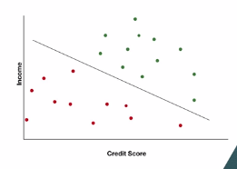

It's much farther away from any of the points, so it's not so close to making mistakes. It would take a much bigger error in the data to cause a misclassification. That's more like what we're looking for, and we'll see how to formalize this in another lesson, but first, let's see another situation.

What if it's just impossible to avoid making classification mistakes? Here's a slightly different graph of good and bad credit risks.

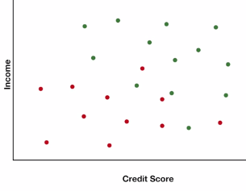

As you can see, there's no line that can perfectly separate between the green and red points. So we need what's called a soft classifier, one that gives as good a separation as possible rather than a hard classifier that separates perfectly. Here's a classifier that minimizes the number of incorrectly classified points:

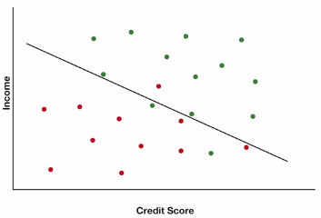

There are two green points on the red side, and one red point on the green side, but it's close to making a lot of other mistakes, like here and here. If we tilt and slide the line a little bit to here, we get a few more mistakes, but we have fewer total mistakes plus near mistakes. And we can envision trading off these two things, actual mistakes and near mistakes, depending on how important we think each one is.

Speaking of how important something is, we've been talking about minimizing errors as if both kinds of mistakes are equally bad. But what if the cost of giving a loan that won't be repaid is much higher than the cost of mistakenly turning away a good applicant? Or, if instead of classifying loan applicants, we're classifying plants into edible and poisonous? The cost of mistakenly eating a poisonous plant is obviously much worse than mistakenly not eating an edible one. How might we change the definition of the best separator then?

Here's how we can do it. The more costly one type of bad decision is, the more we want to move the line away from it. So let's say we've determined that the cost of making a bad loan is twice as high as the cost of turning away a good loan. Then we can shift the line so it's closer to the green points than it is to the red points. Now, if we have a new applicant whose status is ambiguous because it's between the green and red points, even though it's closer to the green points, our new cost-conscious classifier will still suggest that we deny this loan application.

Or if we're deciding whether it's a plant we can eat, our classifier will tell us not to take the risk. In fact, we might be thinking that if it's a question of whether or not a plant we eat is poisonous, even this new classifier might not be conservative enough. With our life at stake, even if the graph looks like we can perfectly classify data points, we still might not want to be so risky.

We might even be willing to misclassify some green points in order to push our classifier even farther from any red points. When I'm out exploring the woods with my kids, we do this all the time. If a plant looks even remotely like poison ivy, we don't touch it. And when it comes to mushrooms, our classifier is all the way off the chart. Even if it looks and smells just like a mushroom we buy in the store, we still don't eat it in the wild.

This sort of thing is also important in medical analytics. For example, the cost of missing a case of HIV is very high. The person might go out and unknowingly infect other people, so tests are often set with a high classifier. Then if someone tests positive, they can take a second test to verify whether they really do or do not have HIV.

So that's the idea of how we can consider the different costs of classification errors. We can use the same approach for soft classification, too, given that it's impossible to separate with no mistakes, we might be more willing to accept one type of mistake than another.

Finally, let's see one more type of insight we can get from this sort of picture. Suppose we thought we needed two attributes to classify applicants, and the data looks like this. Notice how the classifier is almost parallel to the vertical axis. All that really seems to matter for classification is the horizontal axis attribute, so we've discovered that only one attribute is needed for classification, not two.

### 2.3 (C): Data Definitions

In this lesson, we'll talk about many of the different types of data you might encounter in analytics. And just as importantly, we'll go through some of the terminology that analytics and data science professionals use for different types of data.

Usually people in analytics talk about data as if it's in a table. In this table, every row is called a data point, it's a single observation of information. For example, if we're looking at past loan applicants to see which future applicants might be good credit risks than each applicant would be a data point. Or if we're analyzing daily sales to predict what future sales will be, then each day would be a data point.

Each column of the table is a piece of information about every data point, for example, in the credit risk table, one column of data might contain each applicant's credit score, another column might contain each applicant's household income and a third might contain each applicant's zip code. In the sales prediction example, one column of data might contain the number of sales on that day, a second might contain the day of the week and a third might indicate whether or not the day was a holiday.

We've already seen that every row is called the data point. For columns, there are lots of different names. They're often called **attributes** or **features** and depending on how the data is being used, they might also be called **covariates** or **predictors**. There's also a special type of column known as the response or outcome, you can think of this column as being the answer for each data point. For loan applicants, it's the observation of whether they repaid the full loan or not or it could be the fraction of the loan they repaid from zero to 100%. For sales, the response could be the number of sales recorded on each day.

Now that we've laid out the mental model that most people use to refer to data, let's look at some different types of data. First, we'll see the difference between **structured** and **unstructured data**. Structured data is what most people envision when we think of data, there are some formal technical definitions of structured data but essentially, it's data that can be described and stored in a nice structured way, for example, credit score, age, number of sales, etc are all stored as numbers. A person's sex is often stored as a single letter, M or F, either M for male or F for female. And hair color can be stored as a choice of just a few words, black, brown, red, blonde or in my case, gray.

Within the category of structured data, there are some common types of data that we've all probably seen before:

* Most numeric data is **quantitative data**. The numbers have a meaning, age, number of sales, temperature, income, those are all examples of quantitative data. Higher values mean there's more of it. And lower values mean there's less of it.
* But sometimes a number doesn't have any quantitative meaning, it just shows which category something is in. Zip codes for example, don't imply anything is more or less. When I move from zip code 07470 to zip code 02139, it didn't mean that anything decreased. And when I moved from 02139 to 30318, nothing increased. The numbers just denote different categories. This sort of data is called **categorical data**.
* There's also a special case of categorical data called **binary data**. A binary attribute can take only two values, a person could be male or female, or either repaid the full loan or didn't repay the full loan. A day could be a holiday or not a holiday. A television could be on or off. As we'll see in a later lesson, binary data can sometimes be treated as quantitative even though it's categorical.

On the other hand, **unstructured data** isn't easily described and stored. The most common example of unstructured data is text. For example, I'm working with a police department trying to glean information and insight from the text of police officer's incident reports. Different officers might write their reports very differently and we have to parse through all the text to find valuable connections and trends.

There's one last thing we should cover in our basic data dictionary: sometimes data points are unrelated. Each loan applicant is a different person with no relationship to most other loan applicants.

But sometimes data *is* related in time. For example, let's go back to our daily sales data. Each data point refers to one day and we have an attribute that records each day's sales, one after the other. If we put those data points in chronological order, then reading down the column of data shows the number of sales made day by day, one after another. That's called **time series data**. Time series data is often recorded at equal intervals. For example, a company sales each day, the price of a stock every two seconds or the height of a child recorded each year on her birthday. But it's also possible to have time series data that isn't recorded at equal intervals.

### 2.4 (M): Support Vector Machines (SVM)

In this lesson, we'll see a basic mathematical model for solving Classification problems. Hopefully you remember from our previous lessons that Classification in Analytics has the same meaning as it does in everyday life: putting things into categories.

We've seen a graphical example about a bank deciding whether to give loans to applicants based on credit scores and incomes. We can plot all the information on our graph, where the horizontal axis shows the credit score, the vertical axis shows the household income, and each previous applicant is either a green data point if they repaid their entire loan, or a red data point if they defaulted.

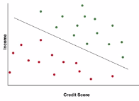

We can draw many lines that separate between the green points above and the red points below, and we discussed how some might be better than others if they're farther from making mistakes, and also how some might be better than others if they're more likely to avoid types of mistakes that are more costly -- for example, giving a loan to someone who won't repay it.

Now let's see what the math looks like. This model is called the **Support Vector Machine model**. Suppose we have a data set with n data points, and for each point we have m attributes. Let's call xij the Ith attribute of data point j. For example in our picture, x1j is the credit score of person j, and x2j is the income of person j. We'll also call yj the response for person j, either a value of 1 if it's a green point, if the person j repaid the full loan, and a value of -1 if it's a red point where the person did not repay the full loan.

In our picture, a line is defined by a set of coefficients a1 through am for each attribute, and an intercept a0. A line would be a1x1 plus a2x2 etc. up to a m x m + a0 equals zero. Or the sum over i of aixi plus a0 equals zero.

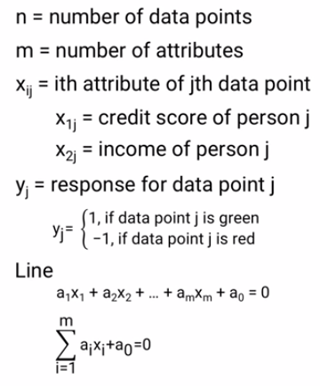

And parallel lines are just two lines with the same a1 through a m, and different intercepts a0. We can draw two parallel lines that separate the red and green points such that a0 is the intercept of the line right in the middle, and that line will be our classifier. We want to find values of a0, a1, up to a m that classify the points correctly and have the maximum gap or margin between the parallel lines.

Remember what it means to classify correctly. All the green points need to be on one side of the line, and all the red points need to be on the other side of the line. For all green points j, we need a1x1j + a2x2j + a0 to be greater than or equal to 1. We use the 1 for scaling, but it could be any number. And for red points we need a1x1j plus a2x2j + a0 less than or equal to -1. Since we defined yj to be 1 for the green points and -1 for the red points, we can combine those two expressions to get a1x1j plus a2x2j plus a0 all times yj greater than or equal to 1 for all data points j. If you were wondering before why we used yj equal to 1 or -1 instead of 1 or 0, this is why.

Now if you remember from linear algebra, the distance between the two parallel lines a1x1j plus a2x2j plus a0 greater than or equal to -1 and a1x1j plus a2x2j plus a0 less than or equal to -1, is 2 divided by the square root of the sum of the squares of ai's. So if we can minimize that sum we'll maximize the margin. Note here that we're only summing a1 through a em, a0 the intercept is not part of the sum.

So now we can write this hard separation problem as Minimize over all the a's, the sum of the squares of the a's which is the same as maximizing the margin as we saw above. Subject to, this sum on the left has to be greater than or equal to 1 for all data points. In other words, we need to find values of a0 through a em so that the margin, the distance between the lines, is the greatest. But we can only choose from among values of the coefficients a that correctly separate all the points.

But what if it's not possible to perfectly separate the red points from the green points? As we saw in a previous lesson, we can create a **soft classifier**. To do that, we need to account for errors in classification, and trade off minimizing the errors we make and maximizing the margin.

For each data point j we can calculate the error in its classification. If it's on the correct side of the line, then this sum is greater than or equal to 1, or we can rearrange so that the sum minus 1 is greater than or equal to zero. If it's on the wrong side, then the sum minus 1 is less than zero and the amount that it's than zero is the amount of error. The farther the wrongly classified point is from the line, the bigger mistake we've made.

In general the error for data point j will be whichever is larger, 0 or the amount that point j is on the wrong side of the line. So the total error that we want to minimize can be written this way:

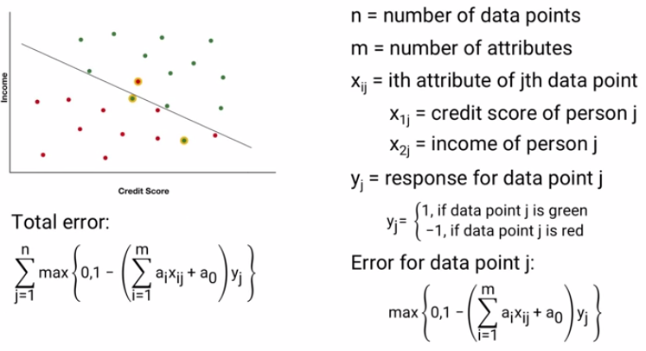

And as we've seen, the margin we want to maximize is this sum. To trade off between them, we can pick a value of lambda, and minimize a combination of error and margin. As lambda gets large, this term gets large. So the importance of a large margin outweighs avoiding mistakes and classifying known data points. And as lambda drops towards zero, this term also drops towards zero, so the importance of minimizing mistakes and classifying known data points outweighs having a large margin.

### 2.5 (M): SVM: What the Name Means

In a previous lesson we've talked about the Support Vector Machine, or SVM Model for Classification. One of the most common questions about the Support Vector Machine Model is what it's name means.

Here's a set of points. If we connect the dots around the outside of the points, like this, it's called the **convex hull** of the points.

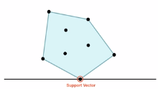

The shape looks like it's just floating here, and if there was gravity, it might just fall down. But we can use this line to hold it up. If the shape is correctly balanced on the line, then this point where they touch is supporting the shape. It's called the support vector. I suppose it could be called the support point, but each point is a vector of data, so they're called support vectors.

Support vectors don't even need the line to be below the shape. For the pure mathematical definition, a support vector could be supporting from the side, or even from the top. Depending on the line we choose, we could even have more than one support vector. In the Basic Support Vector Machine Model for Classification, remember that we're looking for these two parallel lines that are as far apart as possible while still having all the points of each color on one side of the lines. As you can see, those two points are support vectors. And because the model takes the data set and automatically determines where those two lines should be, and what the support vectors are, it's called the Support Vector Machine Model. And that's where the name comes from.

Here's one more observation about the Support Vector Machine Model. Remember that the classifier we're looking for is actually between the two parallel lines. And therefore it's in-between the support vectors, not touching either of them. So the odd thing about naming this the Support Vector Machine Approach is that the classifier returns is actually not one of the lines touching a support vector.

### 2.6 (M): Advanced SVM

In this lesson, we'll see some extensions of the basic support vector machine, or SVM model for classification:

* how to account for some classification errors being more costly than others,
* how to prepare your data before running SVM, and
* whether we can use other types of classifiers.

We'll begin by seeing a way to incorporate those differences into the SVM approach. First, let's look at **hard separation**, where we get a perfect classification of known data. The classifier we choose can depend on the value of the intercept. Generically, it's a0, but it can range from a0 -1 to a0 +1, without making any mistakes on the known data. So we can adjust it as we want.

For example, if giving a bad loan is twice as costly as withholding a good loan, we might choose an intercept of ⅓ * a0 -1 + ⅔ * a0 + 1. In a soft classification context, we might just add an extra multiplier for each type of error with a larger penalty, the less we want to accept mis-classifying that type of point.

Let's take a closer look now at the part of what we're minimizing that helps maximize the margin. We're looking to minimize the sum of the squares of the coefficient. But if our data has very different scales, we could run into a problem. For example, consider our two dimensions of credit score and household income. Credit scores range from about 300 to about 850 with some newer ones going from 150 to 950, a range of less than 1,000 between the top and bottom. Household incomes measured in dollars could have a range in the millions. That means the two coefficient values, a1 and a2, might be different by two or three orders of magnitude. So, when we're adding their squares, a small change in one could swamp a huge change in the other.

But the fix isn't too hard. Before we run SVM, we can **scale the data** so that the orders of magnitude are approximately the same. Once the data is scaled, we can also use the values of the coefficients a1 through am to eliminate attributes that aren't needed for classification.

Let's revisit a picture from a previous lesson. In this picture, we observe that the classifier is almost parallel to the vertical axis, which implies that the value of the vertical attribute is almost irrelevant for classification:

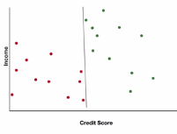

That's a nice observation if we can draw a two-dimensional graph, but what happens if our data contains a lot of attributes and we can't just draw a nice picture to see what's going on? In that case, we can check the values of the coefficients a1 through am. If there's a coefficient with a value is very close to zero, it means that the corresponding attribute is probably not relevant for classification. For example, in this two dimensional picture, if the vertical axis shows a loan applicant's income, and the coefficient for income is close to zero as it is in the picture, then we can eliminate income as an attribute and classify only using the attribute on the horizontal axis:

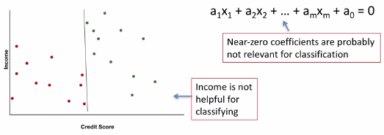

You might be wondering whether SVM works the same way in more than two dimensions, since most data sets of more than two attributes. The answer is pretty much, yes. You might also be wondering whether a classifier has to be a straight line. The answer is no. In fact, SVM can be generalized using kernel methods that allow for nonlinear classifiers.

Or you might step back and wonder whether some classification questions might also be answered as probabilities. For example, instead of directly saying, "Yes we should give this person a loan." Or, "no, we shouldn't,” we could first determine something like, there's a 37% chance that this loan applicant will default, and make our lending decision based on that probability. For some applications, this approach could be more appropriate and the lesson on **logistic regression models** covers a method for estimating those probabilities.

And finally, you might be wondering whether there are other approaches for classification, especially when there are more than two classes. The answer is yes, and we'll see that in an upcoming lesson.

### 2.7 (C): Scaling and Standardization

In this lesson we'll see two common data preparation tasks, **scaling** and **standardization**, and some situations where it's important to use one or the other. Let's start off with a situation where scaling is important.

Think back to the support vector machine, or SVM model for classification, where we were classifying loan applicants into good and bad credit risks using two predictive factors: household income, which is usually in the tens of thousands or more, and credit score which is in the hundreds. The basic SVM idea was to find the pair of parallel lines that were farthest apart while keeping all red points on one side of the lines and all green points on the other side of the lines.

The classifier would then be right in the middle of those two lines. Given a set of data xij, where xij is the jth factor value for data point i, the classifier would be defined as the line a0 plus the sum over all factors j of aj times xj. And the distance between the lines could be my maximized by minimizing the sum over all factors j of aj squared:

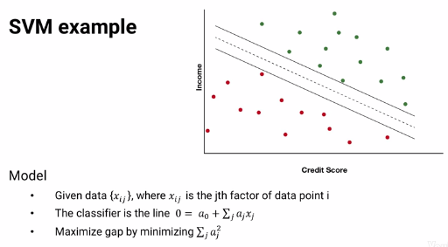

It's hard to tell because there aren't any units shown on the graph, but a reasonable set of coefficients might be something like five times income and 700 times credit score. The sum of the squared coefficients is five squared plus 700 squared or 490,025.

But what if we make a small change to the credit score coefficient. Suppose we tried the coefficients five times income plus 701 times credit score. That looks like a very small change in the credit score coefficient less than one percent difference, and it's a very small change in the slope of the line. But the sum of squared coefficients is now five squared plus 701 squared, or 491,426, a change of 1401 from before.

How much would we need to change the income coefficient to get the same level of change? If we keep the credit score coefficient at 700, the income coefficient would have to go all the way up from five to about 37.8, a change of more than 600% and a huge change in the line. Because the data are at such different scales, the coefficients are also of different scales, which means that the sum of squared coefficients is much more sensitive to changes in one coefficient than the other. And that means our SVM model isn't going to work well. We first need to adjust the data so the numbers are on the same scale.

The first way to adjust the data is to **scale it down to the same interval**. For example, suppose we want all of our data to be between zero and one. That's the most common scaling to use. For each factor j, we set xmin j and xmax j to be the smallest and largest factor values and then for each point i, its new scaled factor value, xij scaled is just (xij - xmin j) / (xmax j - xmin j). If we want to scale to some other range, say from a to b, then we just take our zero one scale value multiply by a minus b and add b.

So that's how to scale linearly. But we might also want to **scale to a normal distribution**, to measure how far from the mean each data point is. The most common way to do that is to scale to a mean of zero and a standard deviation of one, the standard normal. That's also pretty straightforward. If we let new j be the mean of factor j's values, and sigma j be the standard deviation of factor j's values, then for each data point i, xij standardized, is just xij minus mu j divided by sigma j.

So when would you want to use scaling and when would you want to use standardization? It depends. For some models it's important that your data be within a bounded range. Scaling can do that but standardization can't. Some examples where the bounded range is important are things like neural networks that often require inputs to be between zero and one, and optimization models that might require data to be bounded to ensure feasibility. It also might be that the type of data itself has to be within a certain range. For example, batting averages in baseball are between zero and one. RGB color intensities are between 0 and 255. SAT scores are between 200 and 800, etc.

On the other hand, some models seem to work better with standardization. Principal component analysis and clustering are two examples and in many cases, it's not clear whether one is better than the other. Sometimes you just have to try both and see what works best.

Either way, the important thing is that it's often necessary to scale or standardize the input data. That's true for most of the models we'll see in this course: models for classification, clustering, prediction, selection, and others. **Even though I don't bother to say first scale your data over and over again in this course, please know that it's important and you should make sure to do it.**

### 2.8 (M): K-Nearest Neighbor Classification

In this lesson, we'll talk about a simple model for solving classification problems which can easily deal with cases in which there are more than two classes. This model is called the **k-Nearest Neighbor**, or **KNN model**.

Suppose we have a data set with two predictors and a response. For example, a bank might be trying to decide whether or not to give loans to applicants based on the applicant's credit scores and incomes. We can plot all the information on a graph where the horizontal axis shows credit score, the vertical axis shows household income, and each previous applicant is either a green data point if they repaid their entire loan, or a red data point if they defaulted.

Instead of trying to draw a line or other function to separate the red points from the green points, we can use a different approach. Assume that each new applicant is similar to previous applicants that it's closest to. For example, if we look at the five closest points to this new one, four of them are green, and only one is red. So, we might assume that the new data point is more likely to be green, and recommend giving that person a new loan.

As you might expect, there's nothing magical about using the five closest points. We can pick any number of points to use. Usually the number of points we're using is denoted by *k*, which is where the name “k-Nearest Neighbor” comes from. This works easily, not just for two classes, but also for more.

In this example, each color is a different class:

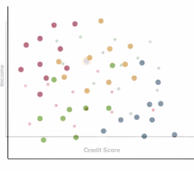

Let's say k is seven. When a new point is found, we look at the seven closest points and pick the color that appears the most. In this example, there are two orange points, one green point, and four red points. Red appears the most, so we classify this new point as red. So, that's pretty straightforward, but there are some complexities you should be aware of. Each of these is covered in other topics, so you can either look ahead to get a sneak preview, or just keep in mind that you'll learn how to deal with them as we go through this course.

First, when we're looking for the *k* closest points, there's more than one way to measure distance. The most common method is to use straight line distance, but there are others as well.

A second complexity is that some attributes might be more important than others to the classification. One way to deal with this is to weight each dimension's distance differently. The larger the weight, the greater the impact of that dimension's distance. Finding the right weights can be harder and might require techniques you'll see in other topics in this course. Regression, for example. In the extreme case, some attributes might not be very important at all for classification -- so much so that we can remove those attributes and only measure distance in the important ones. We see how to do this in the variable selection topic.

Finally, you've probably been wondering how to find the right value of *k*. How many closest points should you check when trying to classify a new point? We have to try different values of *k* and measure how well each value of *k* works. Measuring the quality of a model is called **validation**, and we'll see how to do it as part of this course.

I should point out that SVM and KNN are basic **machine learning algorithms.** So, if you've been wondering when we get to machine learning in this course, the answer is: we're already there.

# Week 2

*This week, we’ll continue with basic machine learning algorithms, this time focusing on clustering models, and move on to a model for change detection. We’ll also cover a few cross-cutting concepts, including distance norms, outliers, and the need for data preparation.*

## 3. Validation

### 3.1 (C): Introduction to Validation

In this lesson we'll talk about **validation**, checking to see how good a model is. When you present a model to a boss or a client, one of the first questions they're likely to ask is how good is it? How accurately does it classify loan applicants or how well does it predict future sales or how often does it correctly determine whether a transplanted liver will transmit infectious encephalitis?

Let's look at an example from classification. We might be tempted to look at the data points we used to create the classifier.

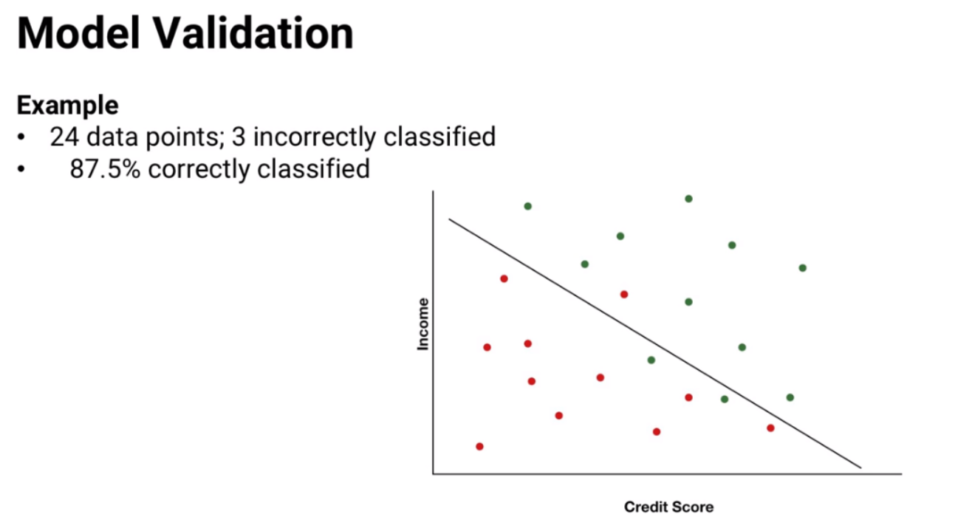

But that measure is likely to be too optimistic and here's why. Any data set, including our training set, has two types of patterns in it. Some patterns are **real effects**, real relationships between attributes and the response. And other patterns are **random effects**: just at random the data might look like it contains a pattern when it really doesn't. In this picture we have 24 data points and only three of them are on the wrong side of the classifier. So we might say that our model correctly classifies 21 out of 21 plus three or 87.5% of the data points. That's a pretty easy calculation but unfortunately ***it's the wrong thing to do***. The reason is that we fit the model to these data points, called the training data or training set, and then we measured how well it did on that same set. But that measure is likely to be too optimistic and here's why. Any data set including our training set, has two types of patterns in it. Some patterns are real effects, real relationships between attributes and the response.  
And other patterns are random effects, just at random the data might look like  
it contains a pattern when it really doesn't.

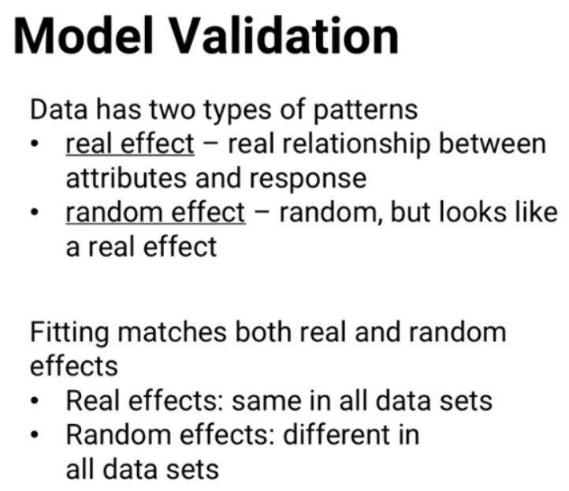

The problem is we don't know which patterns are real and which are random. So when we fit a solution to a training set, we're finding something that fits ***both*** the real effects and the random effects. But when we use our solution on different data, only the real effects are still present. The random effects will be different. That means our solution's performance won't quite be as good on different data as it is on the training set. We'll be matching only the real effects but not the random effects, so we'll have fewer correct predictions on new data than on the training data.

Let's see a quick example. The first time I taught this class I asked the 10 people sitting in the back row what day of the month they were born. If they were born on November 16th then they would say 16, if they were born on March 3rd they would say three, et cetera. Here are the responses I got.

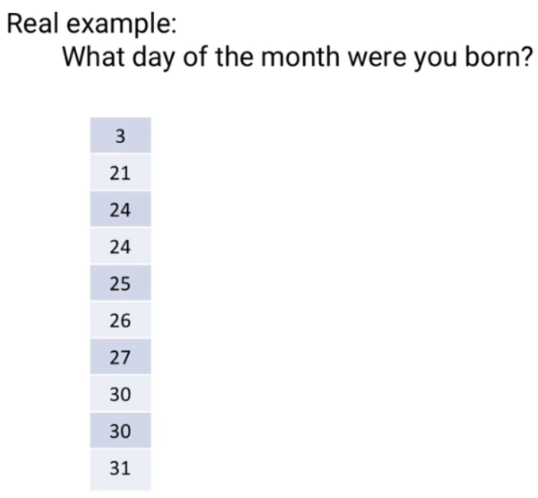

Based on this data, it seems pretty obvious that people in our Analytics degree are much more likely to be born in the last 10 days of a month. And if I wanted to build a predictive model to guess what day of the month each of you was born, my best bet might be to pick the 26th, right in the middle of where nine of the 10 data points lie.

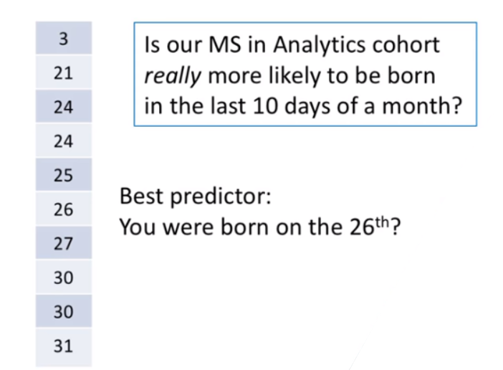

Really, of course, Analytics students are born just like everyone else, uniformly distributed through the month. This odd data is just a random effect and that's exactly why we can't measure my model's effectiveness on the training data. If we did, my model would look great! For nine of the 10 data points, I'd be quite close to the right birthday, off by five days or fewer. But on a different set of data where people are likely to be born uniformly through the month, my model would probably be off by a lot for many people.

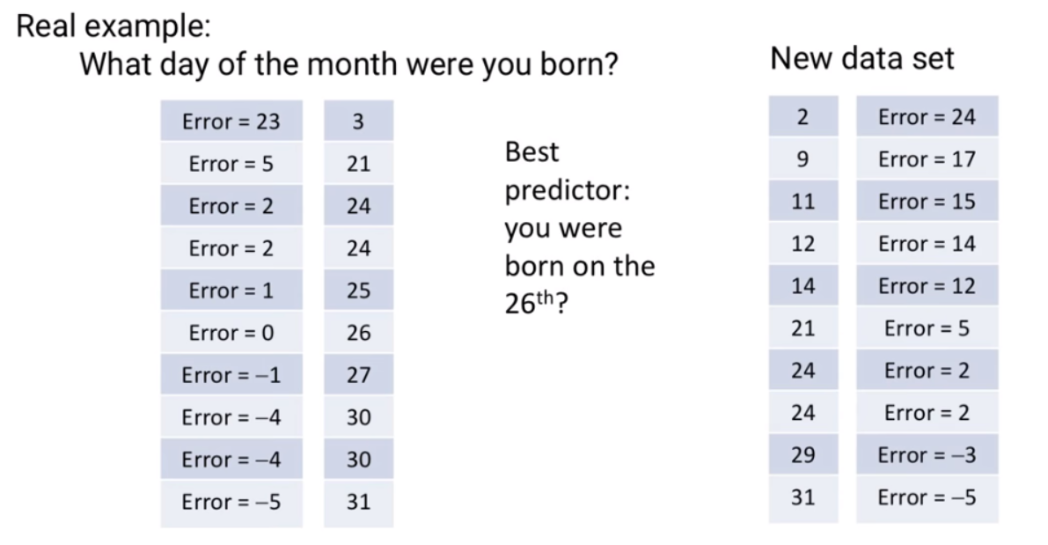

So you might be wondering whether just got lucky in my demonstration. After all, how could I know that there'd be such a weird bit of randomness where nine of 10 people were born on the 21st or later. But really I didn't get lucky.

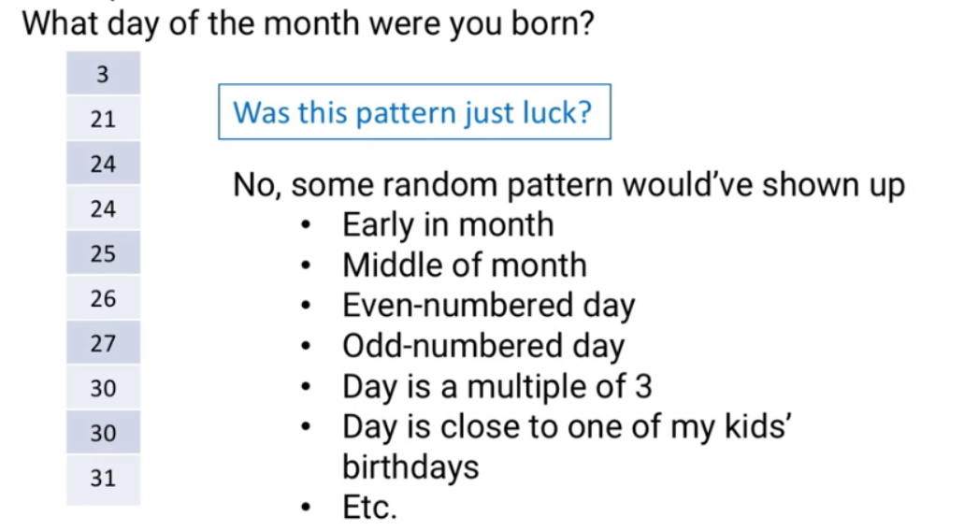

I didn't know this exact thing would happen, but I knew there would be some random pattern I could use for the lesson. Maybe a large majority would be born early in the month, or right in the middle. Or maybe lots of people would be born on an even-numbered day or an odd-numbered day or a day that's a multiple of three. Or close to one of the three days of the month that my kids were born on or who knows what?

But the point is I'd be able to find some sort of random pattern that wouldn't hold up on new data. So that shows why we can't just measure our model's effectiveness  
on the set of data it was trained on.By fitting the model to the training data, we've captured both the real effects and the random effects and only the real effects are likely to show up in other data sets. So if we can't measure our model's effectiveness on its training data, how do we measure the model's effectiveness? We'll see that in another lesson.

### 3.2 (C): Validation and Test Data Sets

In a previous lesson we talked about validation which is measuring the effectiveness of a model. We saw how a model’s performance on its training data is usually too optimistic; the model is fit to both real and random patterns in the data so it becomes overly specialized to the specific randomness in the training set that doesn't exist **in other data.** In fact we saw an extremeexample using birthdays of analytic students of how random effects can make a model’s performance look way too good if we only measure it on the training data so in this lesson we'll see the first of two ways we can better measure a model's performance.

Basically the way to measure a model’s performance is to use two different sets of data: a larger set of data to fit the model and a smaller set of data to measure the model’s effectiveness.

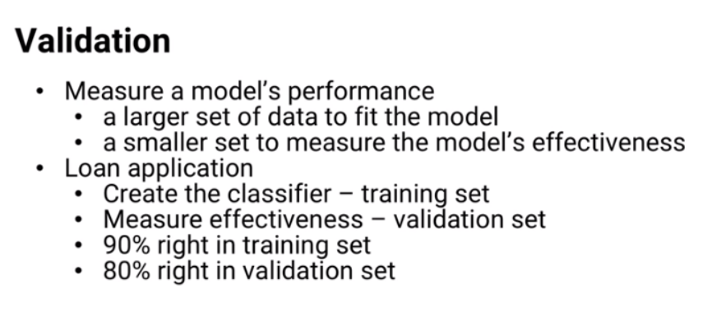

For example in our ongoing example of classifying loan applicants into those who fully repay their loans and those who don't we could use this set of data points to create this classifier and then use this set of data points to measure the classifiers effectiveness that way if the first set the training set had unique random effects that the classifier was designed for, we wouldn't be counting those benefits when we measure effectiveness on the second set called the validation set as you can see in this example this line classifies 90% of the points correctly in the training set but only 80% of the points correctly in the validation set. It's likely that 90% is too optimistic and the 80% performance on validation data is a more accurate measure of the model's effectiveness.

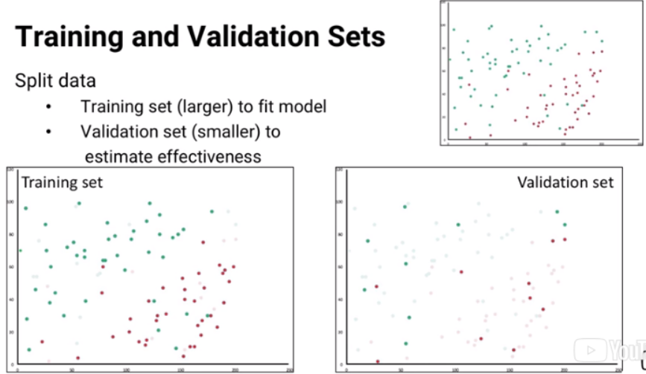

There's one more level we might have to consider. What if we're trying to compare more than one model to decide which to use? For example suppose we have both the support vector machine model and a K nearest neighbour model for classifying loan applicants and to make it even more complicated what if we had five different support vector machine models and five different K nearest neighbor models and we want to pick the best of these ten? For each one we can measure its effectiveness on the validation set and choose to use the model with the best validation set performance. Here's the performance of each model on the validation set. Each number shows what the fraction of the validation data points it correctly classifies. So we would pick support vector machine model number four because it performs best on the validation set.

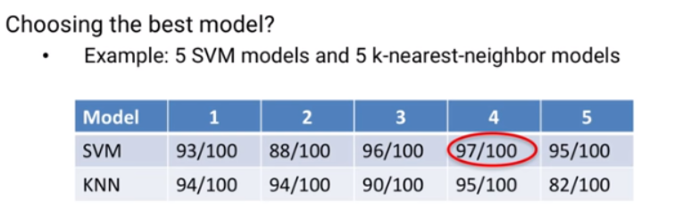

However, could we really expect that level of performance from the model we chose? Maybe not, here's the problem. Even on the validation set, every performance estimate will include some randomness. Sometimes the randomness will make the performance look worse than it really is and sometimes the randomness will make the performance look better than it really is. When we're picking the best out of these 10 models it's possible that part of what made model SVM number four look best is randomness. The fact that it's performance is highest means it's not only most likely to really be best, but it's also most likely to have gotten a good boost from above-average random effects. Let's pause here for a second because that can be a difficult piece of intuition to follow. Let me give you an extreme example. Suppose all ten models were equally good - none was better or worse than the other.

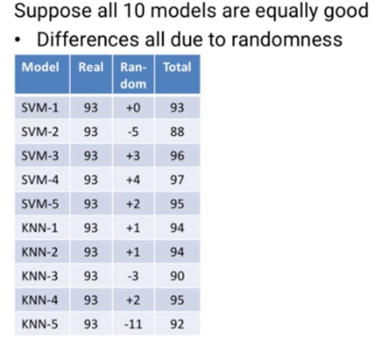

In that case the only differences in performance we see on the validation set are due to randomness. Maybe one model just happened to work a little better than the rest on this validation set, and that's why we're picking it.

That means the performance we measure on the validation set might not really be its true quality, its true quality is actually lower than what we see. That means once we've used the validation set to select the model we want, we can't necessarily use its performance on the validation set as an estimate of the models quality because that performance on the validation set has a higher than average chance of being slightly inflated by luck. So what do we do? We do the same thing all over again. Once we've selected the model we want to use, we measure its performance on a third set of data called the **test set** to estimate its true performance. If you all think this is a little confusing don't worry most people feel that way at first so here's a flowchart you can use to help. At the first step we use a training set of data to build a model. But because the model has been trained to match not only real effects but also the training sets random effects we can't use the model’s performance on the training set to measure its true quality. If this is the only model we're looking at, we can now skip step two and move right to the third step, using a test set, a different set of data with different random patterns.

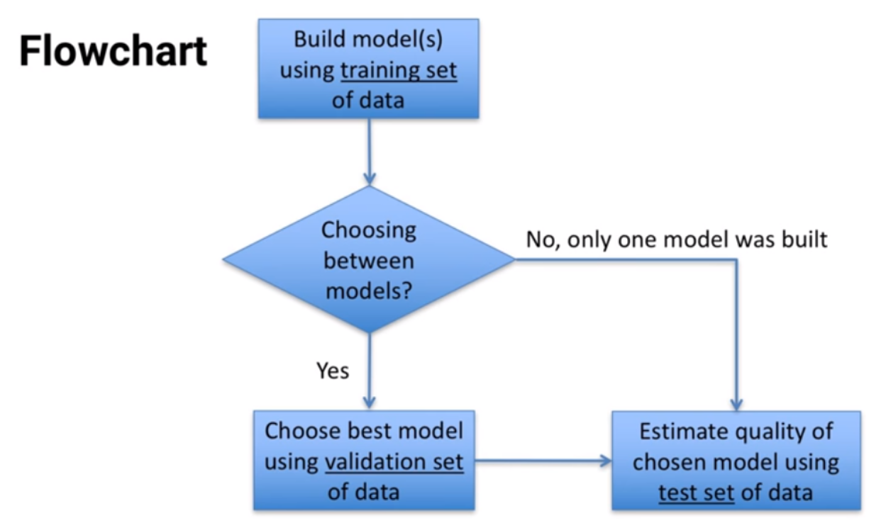

We can use the models performance on the test set as a measure of the models quality. If we created more than one model, using the training set, then we first need to pick which of the models we want to use. To do that, we test each model's performance on a validation set of data and pick the model that does best. But because the model that does best  
on the validation set is more likely to have benefited from lucky randomness, we can't use our chosen model's performance on the validation set to measure its true quality. Instead we use a test set, a third set of data and use the model's test set performance as a measure of its true quality. So, the training set for building models, the validation set for picking a model, and the test set for estimating the performance of the model we picked.  
There's one last thing to think about here. Since we don't have unlimited amounts of data,  
we have to split up our data into a training set, a validation set, and a test set. There's more than one way to do that and we'll discuss those ways in a future lesson.

### 3.3 (C): Splitting Data

In previous lessons, we talked about how to measure the effectiveness of a model.  
We saw how a model's performance on its training data is usually too optimistic, so we have to use a second data set called a ***test set*** to estimate the model's effectiveness.

We also saw that if we're choosing between multiple models, we first need to use  
a validation set to compare them. But because the model that does best on the validation set is more likely to have benefited from random luck, we can't use the chosen model's performance on the validation set to estimate its quality. Instead, we need to use a third data set, the test set, to estimate the chosen model's performance.

***In this lesson, we'll see how to split up our data into these different sets, training, validation and test.*** First, let's discuss how much data to use for each. There's not a hard and fast rule, different people prefer to use different amounts of data. When we're working with just one model, so we only need a training set and a test set, reasonable recommendations range from using 70 percent of the data for training and 30 percent for testing, to using 90 percent of the data for training and 10 percent for testing.

In general, ***we want to use more data for training, to make sure that our model has as much data as possible and can fit to as many as important data points as possible.*** But we also want to make sure that the test set has enough data that it also covers important data points. That's for two sets.

If we need three data sets, training, validation and test, then there are also different recommendations. Some prefer 50 percent for training, and 25 percent each for validation and test, others prefer 60 percent for training and 20 percent each for validation and test, and still others have suggested 70 percent for training and 15 percent each for validation and test.

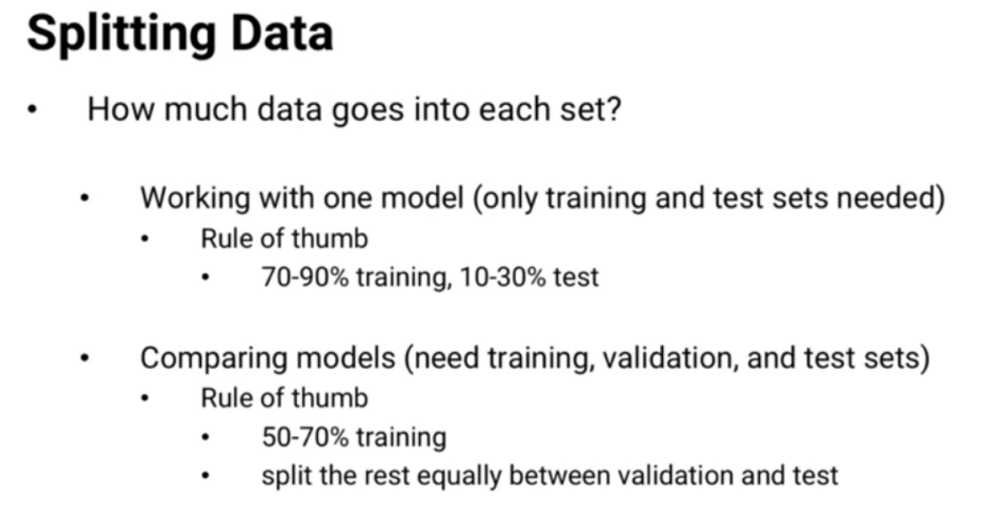

It's not clear whether any of these ratios is much better than any of these others, the ***important thing is that the training set, again, should be large and the validation and test sets should merely be large enough***.

OK, so now that we know how much data to use for each task, how can we split the data up? There are two general approaches. The first approach is simple randomness. For example, if we have 1,000 data points and we want to use 60 percent for training, and 20 percent each for validation and test, then we randomly choose 600 of the 1,000 data points and that's the training set. And then we randomly choose another 200 from the remaining data and that's the validation set, and the 200 data points that are left over will be the test set.

The second approach is rotation. In the same example where we have 1,000 data points to split into 60 percent training, 20 percent validation and 20 percent test, we can take turns.

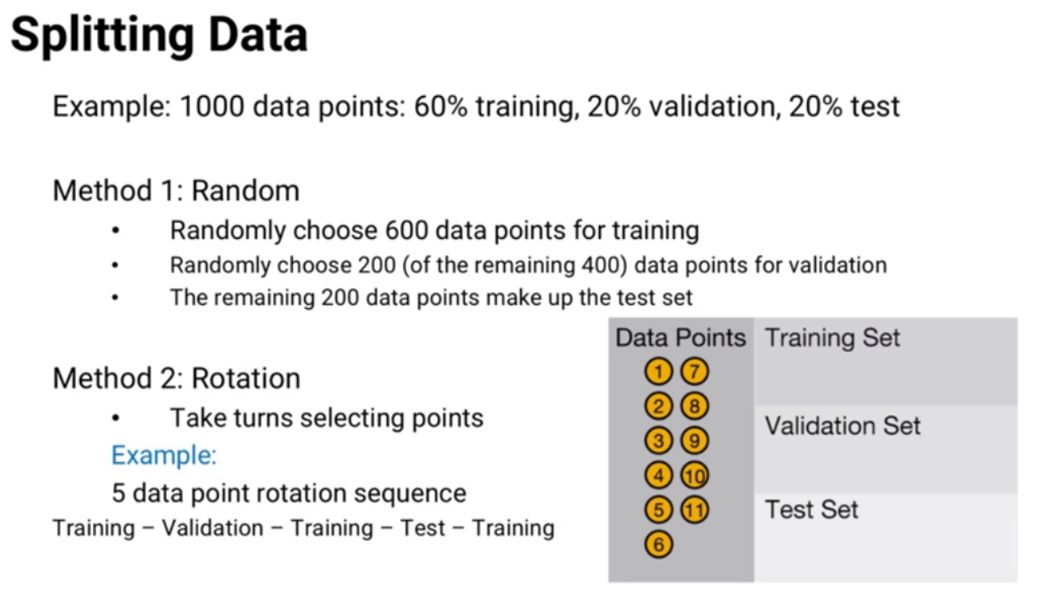

For example, we could use a five data point rotation. The first data point goes to training, the next to validation, the next to training, then test, and then training, and then we repeat. The next data point goes to training, then validation, training, test and training, over and over again we repeat.

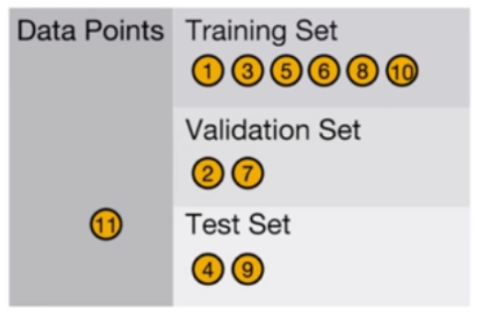

The advantage to rotation over randomness, is that we can make sure each part of the data is equally separated.  
For example, if our data spans over 10 years, the random approach might mean that the validation set gets a higher fraction of data from years one and two, and less data from years nine and 10, while the test set might randomly have the opposite. If there were differences in conditions between the first two years and the last two, then that could cause inaccuracies in our measurements. But the disadvantage to rotation is that  
we better make sure we're not creating some other type of bias when we assign data points.

For example, think back to our five data point rotation, where every first, third, and fifth data point of each group went to training, every second went to validation,  
and every fourth went to test. Suppose this was daily sales data for a retailer that's only open five days a week. Then the training set would have all of the Monday, Wednesday and Friday data, but no Tuesdays or Thursdays. And any patterns the model found in Friday data, for example, wouldn't be seen in the validation or test sets, because they only have Tuesday and Thursday data. That could be an even more significant problem than having different fractions of data in each set.

Of course we could do something in between. For example, randomly put 60 percent of the Mondays into the training set, 60 percent of the Tuesdays, 60 percent of the Wednesdays, etc, and that would solve the problem.

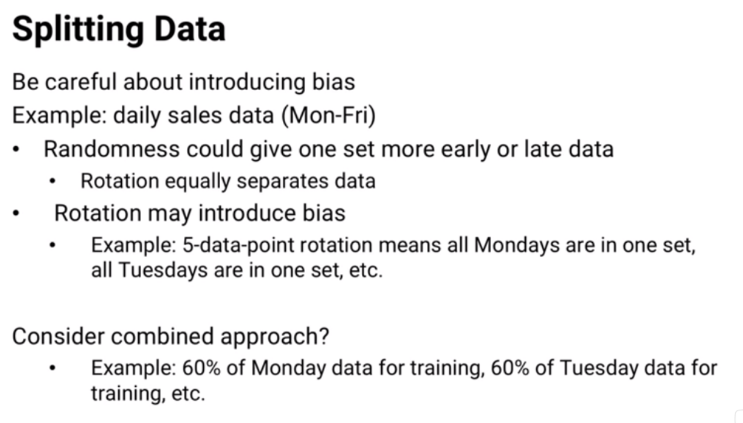

OK, so now we've seen why we need to separate data into two or three sets, and how to do it. We could stop there, but there's one more way we could use our data. It's called cross validation, and we'll see what it is in a future lesson.

### 3.4 (C): Cross-Validation

In previous lessons we talked about how to measure the effectiveness of a model. We saw why and how to separate our data into three sets, training, validation and test. In this lesson, we'll see one last way to use the data: **cross validation**.

Let's look again at our flow chart of how to use our data:

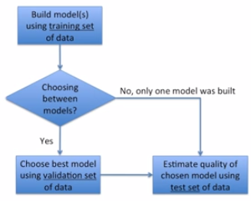

There's something in here that often gets people nervous. What if there are a couple of important data points that only show up in the validation or test sets? Then that data isn't part of the training set, so the model doesn't know about it and that means the model doesn't fit itself to these important pieces of data. Cross validation is a way to avoid that problem.

There are several types of cross validation. In this lesson we'll talk about k-fold cross validation. I guess k seems to be a popular letter to use in analytics, we have k means, k nearest neighbor, and now ***k-fold cross validation***. 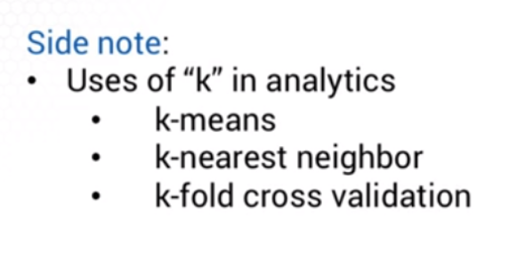

K refers to something different in each of them, but in each case it shows how many of something we have. So let's see ***k-fold cross validation***.

Let's zoom into the training and validation steps in our flow chart. Suppose we have, say, 20 percent of our data reserved for testing and the other 80 percent will be used for training and validation. And in this approach we'll be doing training and validation together. We can split this data up into k parts, here let’s say k is four.

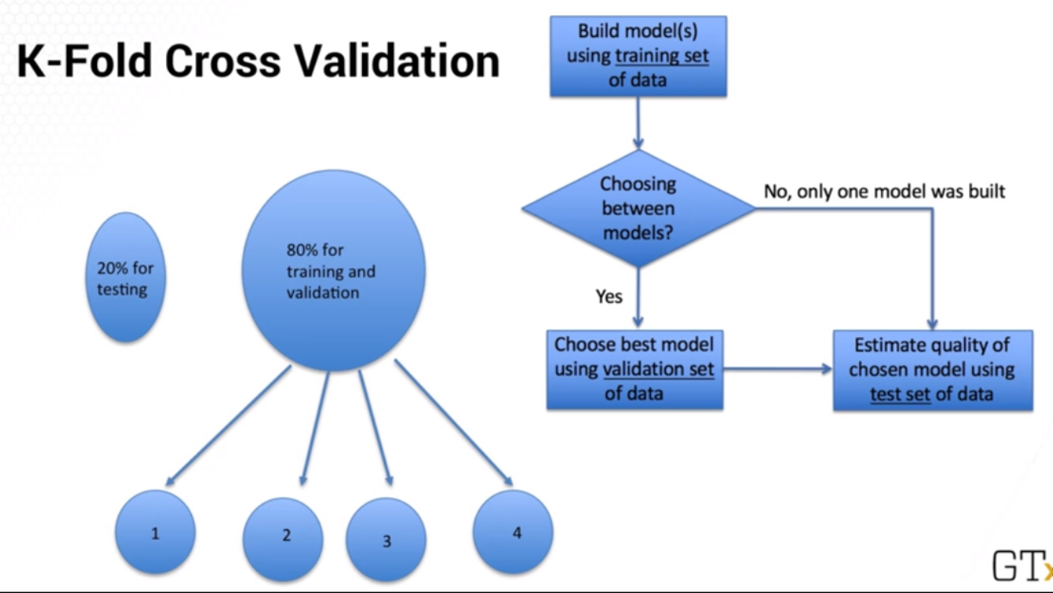

Instead of doing the training and validation once, we could do them multiple times with slightly different data sets. For each of our k = 4 parts of the data set we can train the model on three parts and validate it on the fourth. So, we:

1. train on a data set of parts 1, 2, and 3, and evaluate the model using part 4.

g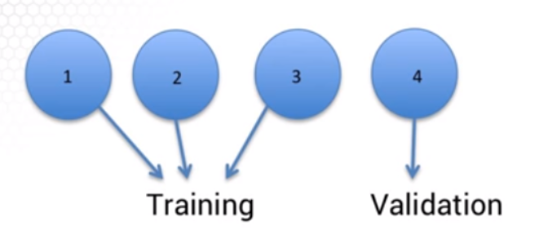

1. train on parts 1, 2, and 4, and evaluate the model using part 3.

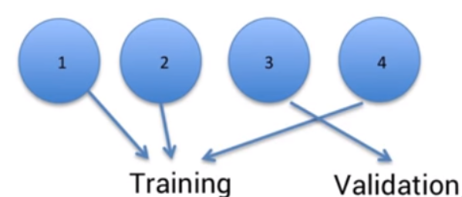

1. Then train on the combinations of parts one, three and four, evaluate using part two.

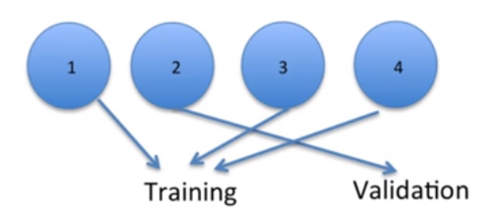

1. Then we train on the combination of parts two, three and four, and evaluate using part one.

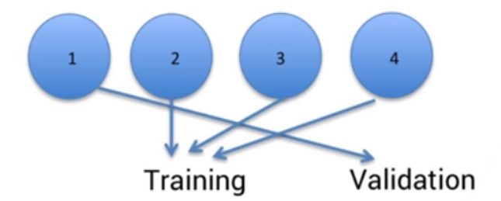

There's something in here that often gets people nervous. What if there are a couple of important data points that only show up in the validation or test sets? Then that data isn't part of the training set, so the model doesn't know about it and that means the model doesn't fit itself to these important pieces of data. Cross validation is a way to avoid that problem.

Now, every data point has been used to train three of the models, so we don't have to worry that important data was left out. And when we're comparing models to see which we should choose, we should just ***take the average of all four evaluations***.

More generally, if we're splitting the training and validation data into k parts, then for each of the k parts we train the model on all the other parts and evaluate it on the one remaining part. Then we average the k evaluations to estimate the model's quality. There's no standard number to use as k, although k equals 10 has become fairly common. 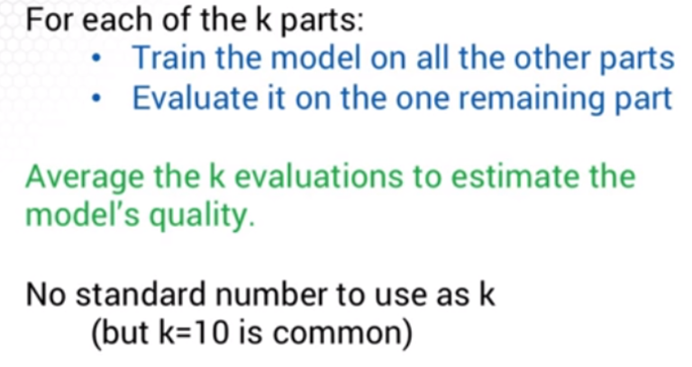

There's just one last thing we need to think about. Once we've used cross validation to choose a model, what exactly is the model we've chosen?

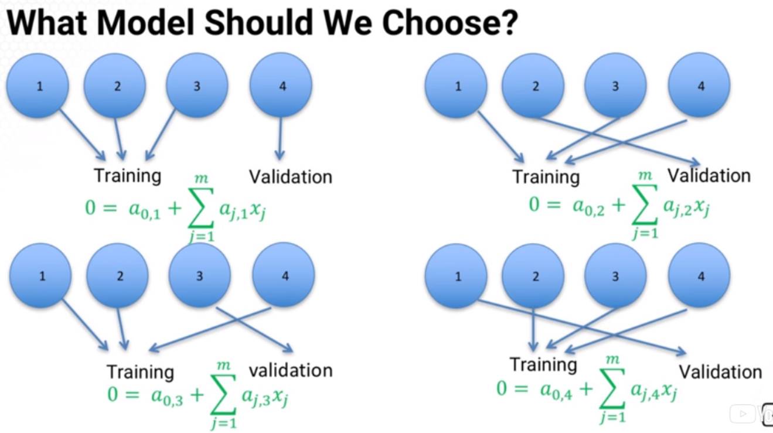

Suppose we used fourfold cross validation on a support vector machine model for classification. For each of the four ways to split the data we get a slightly different classifier. So which one do we use? ***The answer is none of them***. And we shouldn't average the coefficients across the four splits either, because there's no guarantee that will work well. ***Instead, once we have the model selected, we can train it again, using all four parts of the data together.***

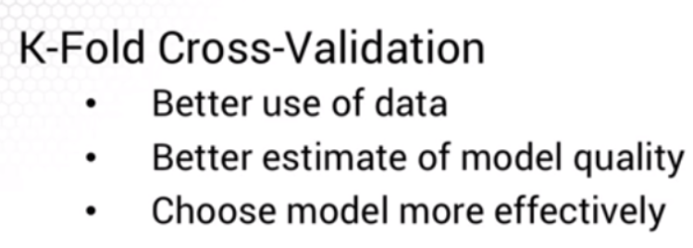

So cross validation helps you make better use of your data, and the averaging process helps give a better estimate of model quality. Combined, that helps us choose a model more effectively, so it's no surprise that it has become a commonly used approach in analytics.

## 4. Clustering

### 4.1 (M): Introduction to Clustering

In this lesson we'll talk about **clustering**, what it is, and what kind of questions it's useful for answering. Then in later lessons we'll see a simple approach for finding good clusterings. In analytics clustering means **taking a set of data points and dividing them up into groups so each group contains points that are close to each other or similar.**

Clustering is often useful in targeted marketing where we want to segment potential customers and give each group a different message. Different people might react most positively to different types of marketing messages, and we want each potential buyer to get the message that's most likely to convince them to buy. For example, if we're selling an SUV we might market it to some people with its size highlighted. To other people, we'll highlight its price. Other people might be primarily shown its versatility, and for other people we might try to convince them that they'll look cool if they're driving an SUV. 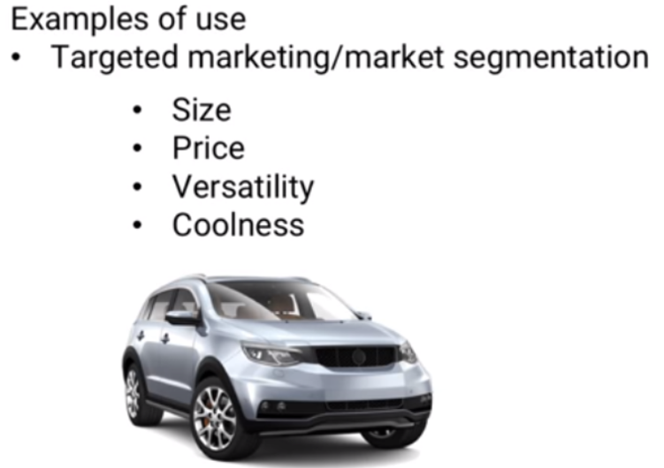

Each set of people would be a cluster, and we'd try to use the data to determine how to split up the consumers into sets, and then for each cluster the marketing experts could determine which type of marketing material they should be shown. And in fact, you might even discover from the clustering that the groups you initially expected to see aren't correct. For example, once you examine a cluster you might realize that it's made up of people who might want to hear about an SUV's gas mileage. So, clustering doesn't just help you segment into clusters you're expecting, it also can help you discover what clusters there are in your dataset.

|  |
| --- |
| Examples of Clustering Clustering might be useful in:   * Personalized medicine, clustering people who might react similarly to treatment but different clusters would have different reactions. * Physical distance, for example, when locating civic facilities like police stations, fire stations, medical clinics or libraries, gas stations, fast food restaurants etc. * Image analysis, for example, recoloring pictures or recognizing faces and other objects. |

Another use of clustering is for initial data investigation. If we can find obvious clusters of data, then we can analyze each cluster separately in case they have different properties. For example, predicting how much a customer is willing to spend on an SUV might require a different model depending on which attribute the customer cares most about, size, price, versatility or perceived coolness.

Let's go back now and see what clustering looks like graphically. Here's a simple graph of some data on potential SUV buyers:

##### 

In this graph, the horizontal axis is age and the vertical axis is number of children living in the household. Suppose we have all of these points and we want to divide them into clusters. We'll see how to divide them algorithmically in another lesson.

For now, let's just do it by eye. If we want two clusters to send two types of targeted messages, here's a reasonable way of splitting the data.

*Four ways to cluster data*

Here’s a four cluster solution:

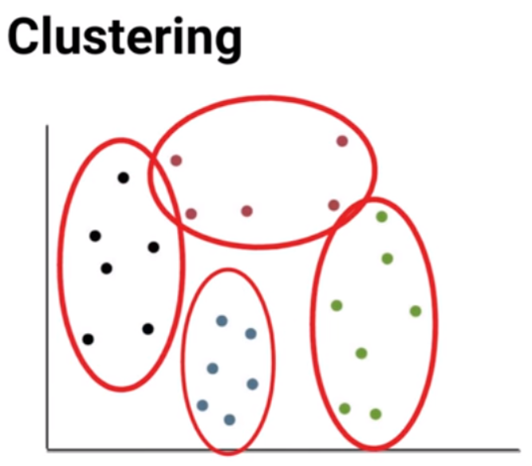

We could even have more clusters too if we want to. If you're wondering how to decide how many clusters to use, we'll discuss it in another lesson. But first we'll see in the next lesson a basic machine learning algorithm to find good clusterings.

### 4.2 (C): Distance Norms

In this short lesson we'll see the concept of a **norm** and how it relates to calculating distance. You're probably familiar with the traditional straight line or Euclidean distance measure given two points x and y with coordinates x1 x2 + y1 y2 the distance between them is the square root of (x1 - y1)2 + (x2 - y2)2 .

A second common distance metric is **rectilinear distance:**

|x1 - y1| + |x2 - y2|

This sort of distance is sometimes used when driving in a city where streets are laid out as a grid, which is why it's sometimes also called the **Manhattan distance.**

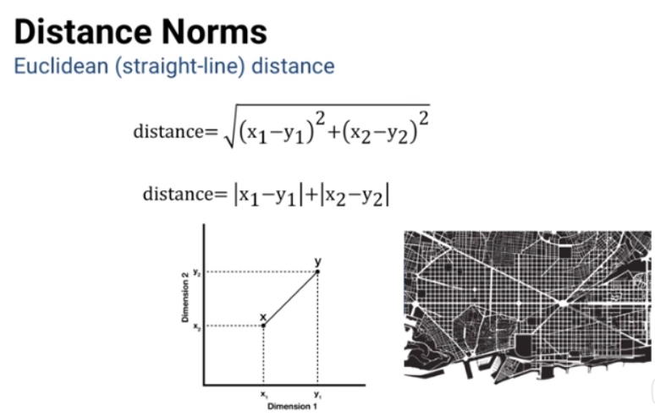

We can generalize both of these to be:

|x1 - y1|p + |x2 - y2|p, and take the pth root of that sum

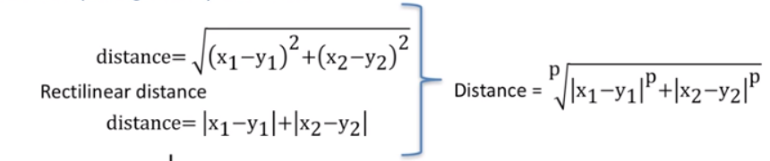

where P would be 2 for straight-line distance, and P would be one for rectilinear distance, and if we happen to be in a space with more dimensions, let's say n dimensions, we can write this as the sum over all the N dimensions of |xi - yi|p, and the pth root of all that sum.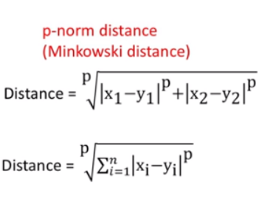

This formula is known as the p norm distance, for example, one norm distance, the two norm distance etc. It's also called the Minkowski distance of order P. In theory we could choose other values of P also: P = 3, P = 10, P = 1,000, or anything else, but surprisingly, the third most common value of P that people use is actually infinity - ***the Infinity norm distance***.

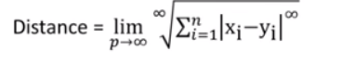

Now technically we should probably refer to it as the limit as P goes to infinity of this, but let's ignore that - and a quick warning for all of you who like formal mathematics - I'm going to be very informal with my infinities in this discussion, because it easier to get a good intuition that way.

**If we have *n* different numbers all to the infinity power,** **the largest one will dominate the rest.** For example, 8 to the Infinity swamps 7 to the infinity, and the sum of those two is so close to eight to the Infinity that 7 to the infinity is irrelevant, so this sum is just about equal to the (largest among the differences in each dimension) to the infinity power.

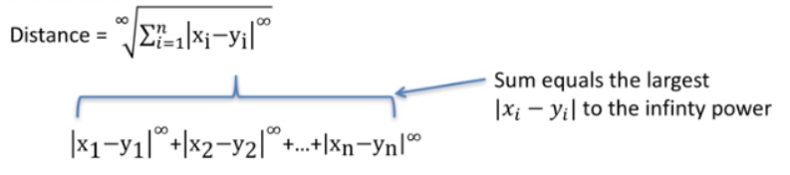

Now let's simplify: we have the infinity-eth root of the infinity of power of the largest difference - the root and the power are the same, so they cancel, and we're left with just the largest difference - and ***that's all the infinity norm is - the largest of a set of numbers; an absolute value***.

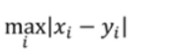

If you're thinking that the phrase infinity norm sounds like it should mean something a lot more complicated, join the club. The first time I heard it was in a casual conversation with a friend and I was really impressed with him until I sat down and worked out the math and realized he just meant the biggest.

You might be wondering two things - first what kind of person has friends who say infinity norm in casual conversation? I know I have some friends who are pretty nerdy, but this guy would say I'm pretty nerdy too, so I guess it's a good match, and a good thing we both work in analytics. Second, why would anyone ever use the Infinity norm as a distance measure?

Here's just one example: think about a warehouse that has an automated storage and retrieval system. In each aisle there's a machine that moves up and down the aisle to the right place and also stretches up and down vertically to reach the right height. Suppose we tell it to pick this item right here: it might move along the aisle to the right place and then stop and stretch up to the right height, if so, then the total time it takes before it can pick the item is the along the aisle time plus the up and down time -the exact definition of a **one norm**.

But suppose the machine was designed in a smarter way: as it's moving down the aisle it's simultaneously stretching up and down to the right height. How long does it take from when it starts moving until it's ready to pick the order? Whichever takes longer, moving or stretching. If it gets to the right place along the aisle before it finishes stretching, then the stretch time is how long it takes to be ready, and if it stretches to the right height before it gets to the right place in the aisle, then the along the aisle time is how long it takes to be ready. Either way it's the larger of the two times - and that's exactly the **infinity-norm** of the two!

So now you're part of the club - and the next time you're waiting in the slowest check-out line at the supermarket or stuck in highway traffic when all the other lanes are moving and yours isn’t don’t be afraid to complain about infinity norms.

### 4.3 (M): K-means Clustering

In a previous lesson, we talked about clustering, splitting a set of data points into groups based on their similarity and closeness to each other. Here, we'll see a basic machine learning algorithm called the **k-means algorithm** for solving clustering problems.

To see how the k-mean algorithm works, let's look at an example of clustering. Suppose we have data on SUV buyers for the past eight years, and we want to figure out what groups of buyers there might be. Here's some data:

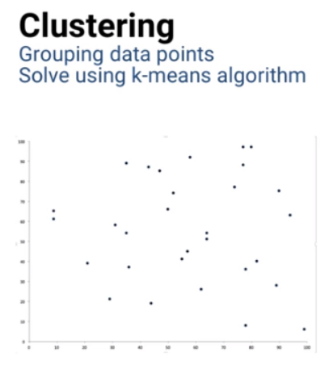

As usual, to make the algorithm more clear, I'll just use two-dimensional pictures with simplified data. But just keep in mind that this can be extended to lots of dimensions. Every data point in this graph is an SUV buyer. For each point, the horizontal coordinate shows the person's age, and the vertical coordinate shows the average daily temperature in the city the person lives in.

In the general case, suppose we have n data point and m attributes. Let's use x to denote our data, where x, i, j is the value of data point i's attribute j. Let's use y to denote cluster membership. Y,i,k is one if data point i is in cluster k, and zero if not. And let's use z, k, j to denote the j dimension coordinate of cluster center k.

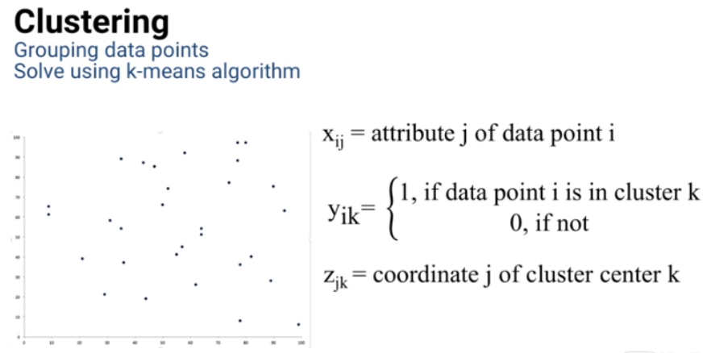

What we'd like to find is a set of k cluster centers and assignments of each data point to a cluster center to minimize the total distance from each data point to its cluster center. This piece adds up all of the distances from data points to cluster centers but only when the data point is in that cluster.

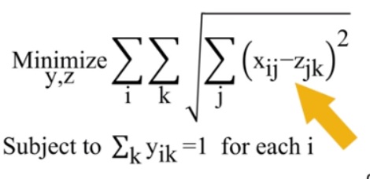

And this piece requires that every data point has to be assigned to exactly one cluster.

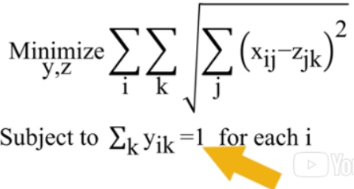

It turns out that this is a hard optimization problem to solve. We'll see more about that in the optimization topic, but for now, just trust me that it can take a very long time to find the best clustering solution. So instead we use the k-means algorithm.

Here's how the k-means algorithm works. First, we need to decide how many clusters we want the algorithm to give us. For this example, let's say it's three. We start by picking k points inside the range of our data. K is the number of clusters we want. So if we want three clusters, we pick three points. ***The points we pick are called cluster centers***. Now we temporarily assign each data point to the cluster center it's closest to. That gives us three clusters. But the points we've called cluster centers aren't really in the center of their clusters, so we need to recalculate them. For each cluster, we find the centroid of the data points in the cluster, and that's our new cluster center.

Now that we've moved the cluster centers, data points might be in the wrong place. Here's a point that's in the red cluster, but it's now closer to the green cluster center.

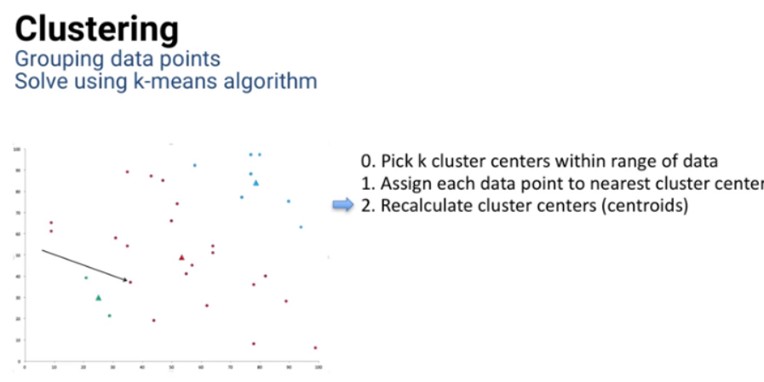

So we go back a step and reassign each data point to its closes cluster center. Then we find the new cluster centers, reassign data points to clusters, find new cluster centers, reassign data points, etc. We keep repeating until we get to a step where no data point changes clusters. Once that happens, the cluster centers won't change either, so we've found a solution. These are our final clusters. And that's it! It's a pretty straightforward algorithm.

We've already talked about how this k-means algorithm is an example of machine learning. There's another bit of jargon that also applies to this algorithm. It's a **heuristic**. *A heuristic is an algorithm that's not guaranteed to find the absolute best solution, but in many cases, including this one, it usually gets very close to the best solution.* And it gets there quickly. If we tried to find the solution that's the absolute best, it could take a long, long time. We'll talk about this more when we get to the optimization topic.

The k-means algorithm is also an example of an **expectation-maximization algorithm**. When we calculate the cluster centers, we're taking the mean of all the points in the cluster, similar to finding an expectation. And when we reassign data points to cluster centers, that's the maximization step. Really, we're minimizing finding the smallest distance to a cluster center. But we could think of it as maximizing the negative of the distance to a cluster center. So our algorithm takes turns between taking an expectation, maximizing, expectation, maximizing, over and over. So it's called an expectation-maximization or EM algorithm.

### 4.4 (M): Practical Details for K-Means

In previous lessons, we talked about clustering, splitting a set of data points into groups based on their similarity and closeness to each other and we saw a machine learning algorithm that k-means here is thick for finding good clusterings. In this lesson, we'll talk about some of the details involved with using the k-means algorithm in practice. 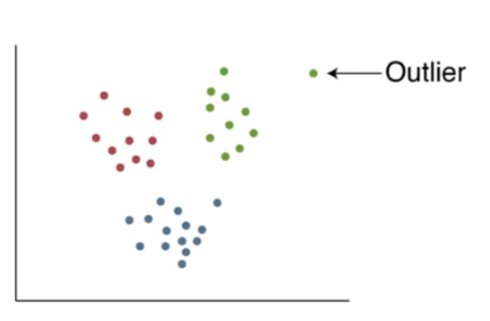

First, you might be wondering what we should do with an **outlier,** a data point that's not close to any of the cluster centers.

The k-means algorithm will simply assign the outlier to whichever cluster center is closest. But as you can see in the picture, it might not really be part of a cluster.

As a default, you might just remove this point from your data set and rerun the algorithm. That way, the point doesn't drag its cluster center artificially to one side. But I personally think that's not always the right answer. **The best way to deal with a point like this is often to find out more about it and what it means in the specific situation you're working on.** What is this outlier? What makes its attributes so different? What's the implication of putting a point like this in the nearest cluster?

Answering those questions can require time and effort, but it can really be important. It's part of what makes a difference between a topnotch analytics professional and someone who just blindly runs algorithms. And the difference in value you provide to your employer by doing extra leg work, can really be significant.

In fact, there are lots of situations in analytics where the algorithm is really just a guide. Understanding the situation can help you make decisions that are more appropriate and a lot more valuable for your organization. And as much as people refer to a lot of what we do as data science, the best professionals also practice the art of analytics, looking deeper at the combination of the data, the algorithm and the real situation to find the right answer.

Okay, let me step down from my soapbox now and move on to another issue with the k-means algorithm. Remember that the k-means algorithm is a heuristic. It's not guaranteed to find the absolute best clustering, but it has the advantages of usually finding good clusterings and of running very quickly. So we could take advantage of the speed by running it several times, each time starting with different initial cluster centers. With different starting cluster centers the algorithm might come up with different final clusterings and then we can compare them all and pick the best one. We can also use the algorithms speed to help us choose the right number of clusters to use. Instead of guessing how many clusters we might need, we can run k-means for different numbers of clusters and pick the best clustering solution.

You might be wondering though, won't more clusters always seem better than fewer? If we start with a k cluster solution and then add an extra cluster, even if it's just a single data point, then the total distance from data points to their cluster centers gets smaller. So the clustering appears better with more clusters.

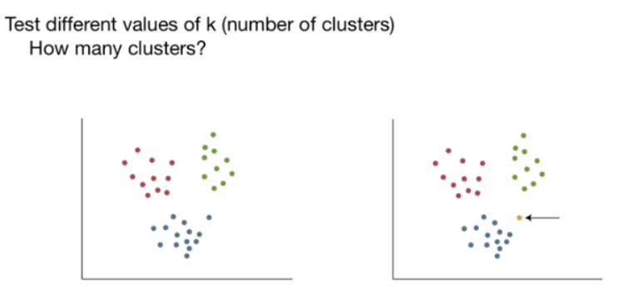

In the extreme case, the best solution might seem to be to have one cluster for each data point. Just like when we asked how to deal with outliers, there are two answers.  
I'll give the qualitative one first. Like before, the best solution is the one that best fits the situation you're analyzing. If your city only has a budget for four new fire stations, a clustering solution that gives six new areas, might not be so helpful. But there are some quantitative ways to help guide your decision-making even when seeing the clusters is impossible because your data has a lot of attributes. 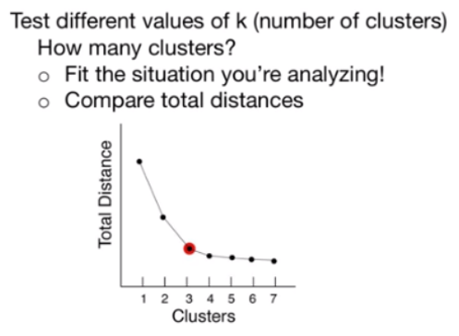

Suppose we find k-means clusterings for a bunch of different values of k and for each one we calculate the total distance of each data point to its cluster center. We can plot that in two dimensions. The horizontal axis is the number of clusters k and the vertical axis is the total distance from points to cluster centers. Now we can look to see where the kink in the curve is. Here, where the marginal benefit of adding another cluster starts to be small.

This type of graph is sometimes called an ***elbow diagram*** because the point we're looking for might look like an elbow. It can often be useful as a starting point for answering the question of how many clusters to use, but don't forget to consider the qualitative aspects as well.

### 4.5 (M): Clustering for Prediction

In previous lessons, we talked about clustering, splitting a set of data points into groups based on their similarity and closeness to each other, and we saw a machine learning algorithm, the k-means heuristic for finding good clusterings. In this lesson, we'll see how to use k-means clustering in a predictive way.

Let's take a look at a clustering solution. Here's a set of data points divided into five clusters:

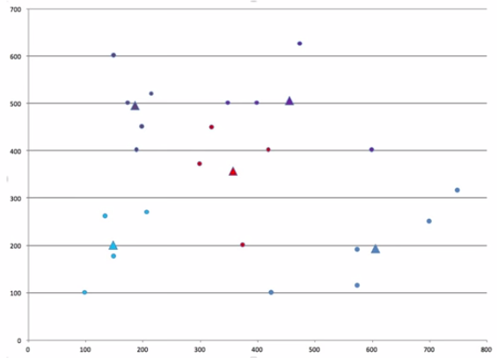

The triangles are the cluster centers. Now, suppose we have a new data point. Which cluster should we predict the point would be in? If the new point is inside a cluster like this one, the answer is easy, but if the new point isn't inside a cluster, we can just choose whichever cluster center is closest, and that's as reasonable a choice as any for predicting which cluster the new point is in.

We can also answer another type of question. What range of possible data points would we assign to each cluster? Each cluster could possibly include all the data points that are closer to its center than to any of the other centers, and we can color code the whole space to show what those regions look like. Here, the red area shows everywhere that's closer to the red cluster center than to any of the others:

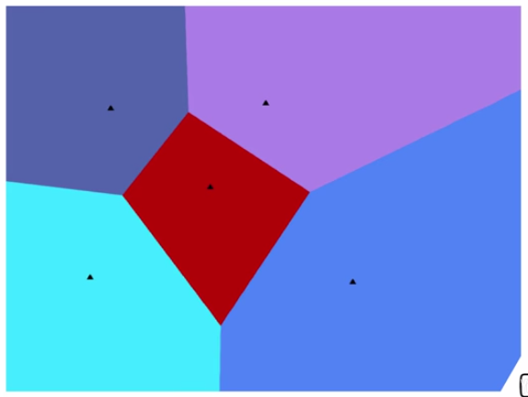

It turns out, by the way, that this sort of picture has been around for a long time. It's often called the **Voronoi diagram** after a mathematician who lived more than a 100 years ago, but a diagram like it was used more than 150 years ago to try to analyze the source of a cholera outbreak in London, and René Descartes, a mathematician who lived back in the early and mid 1600s even used something like it in his work.

### 4.6 (M): Supervised vs Unsupervised Learning

In a previous topic, we saw classification models, where we had a set of data points that we want to separate into groups. Now we've learned about clustering models, where we have a set of data points that we want to separate into groups.

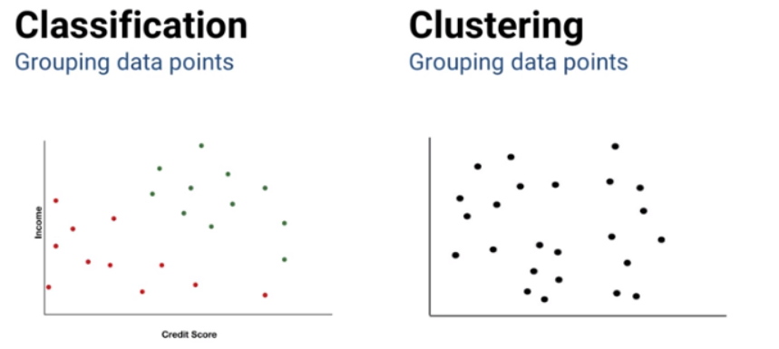

What's the difference between these two models? The difference is what we know about the data points.

In the classification model, we know each data point's attributes and we already know the right classification for the data points; we already know the response. If we're looking at loan-application data, we already know whether each data point is classified as green, meaning that they repaid their loan in full, or red, meaning that they did not repay their loan in full. That information helps us to decide how to classify new points or new applicants. The model uses both the attributes and the response of each data point.

On the other hand, in the clustering model, we don't know, upfront, the right grouping of our data points. The model has to decide how to cluster based only on the attributes of the data. That's a key difference.

* When we've observed the right answer for each data point and we're using that information in addition to attributes to figure out how to deal with new data points, like in classification, that's called **supervised learning.**
* When we haven't observed the response for each data point and we're only using attribute information to figure out how to deal with those data points, like in clustering, that's called **unsupervised learning.**

Situations that require supervised learning are probably more common in analytics and we'll spend a fair amount of this course talking about different supervised learning models. But unsupervised learning, especially clustering, is very useful, too and can be an important tool in the analytics toolbox.

## 5. Basic Data Preparation

### 5.1 (C): Introduction to Data Preparation

We often talk in this course and in real life about using specific data in our analysis -- as predictors in a regression model, factors in a classification model, etc. For example, if we focus on numeric quantitative data, we could use factors like a person's credit score, the average daily temperature in Atlanta, the number of hotdogs sold at each baseball game, the value of a stock at five second intervals, the amount of a certain chemical in drinking water, and lots of others. Usually, it sounds like we're using those factors directly, that the factor of value xij is the exact number of hotdogs sold or the exact value of the stock.

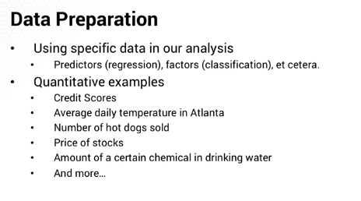

But sometimes the way we talk glosses over the need to manipulate the data first. As we'll see, the **scale** of the data is important. Using data like average household income which is often at a scale of 105 or higher along with credit score on the scale of 102 can lead our algorithms down the wrong path. There might be one or two data points whose effect on the overall solution is magnified out of proportion because of how different they are from the rest, and we'll see how to identify and deal with them. And sometimes we might suspect that our data has a lot of extraneous information in it that could complicate our model and our ability to correctly interpret the solution. In this topic we'll see how to avoid that issue too.

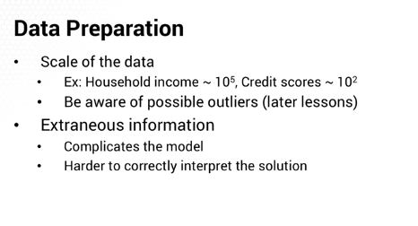

All of these potential problems with data are things that we can address before building and solving the analytics models that are covered in this course. When we talk about the data used as inputs for those models we're generally assuming that we've already done whatever data preparation steps are required, and in the rest of this topic you'll learn exactly that, how to prepare a set of data for use in analytics models.

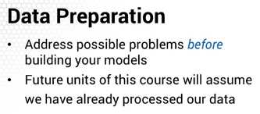

### 5.2 (C): Outlier Detection

In this lesson, we're going to talk about outliers -- *data points that are very different from the rest of a data set*. We'll see what they are, how to find them, and what to do about them. As a preview, I can tell you that the answer is, as usual, almost always “it depends,” but it's even more true for outliers because there are philosophical issues as well as statistical ones.

An outlier is a data point that's very different from the rest of a data set. The most obvious form of outlier is where the value of a data point is very different from the rest of the data like, in this picture:

##### 

O1 is very different from the rest. This is sometimes called a **point outlier** and it's what comes to most people's minds when they hear the term “outlier.” But also in this data set we might call the few points at o2 outliers because there are only a few of them and they're very different from the overwhelming majority of the data.

You might wonder whether the o2 points are really outliers. Maybe there's a good reason for them being there. And you might be right. We'll discuss that issue soon. But before that, let's see another couple of types of outliers. Here's a picture of an outlier in time series data:

##### 

We could also think this in terms of the time between beats. If we track that data, then most will be around 1,000 milliseconds except the one between 5,000 and 7,000, which will be a point outlier of about 2,000 milliseconds.

Looking at pictures and noticing outliers is the easy part. The hardest part is deciding what to do once we found an outlier. But before that let's talk about how to find outliers in a more automated way. To fiIt has just one point that's far from the rest of the curve. The temperature value at this point isn't itself an outlier, but the time at which it occurs makes it an outlier compared to the rest of the data. This type of outlier is sometimes called a **contextual outlier** because it relies on the context provided by the other points.

And here's a case of time series data where there's an **outlier by omission.** In this heartbeat data, it looks like there should be a large beat around time 6,000, but there isn't.

##### 

It's hard to tell exactly which data point should be called “wrong,” but sometime in there between time 5,000 milliseconds and 7,000 milliseconds, it seems like there's something missing. This type of outlier is sometimes called a **collective outlier** because the data points collectively seem to be an outlier. We could also think of this in terms of the time between beats. If we tracked that data, then most inter-beat times will be around 1000 milliseconds, except the one between 5000 and 7000, which will be a point outlier of about 2000 milliseconds. That was the easy part, looking at pictures and noticing outliers. The hardest part is deciding what to do once we've found an outlier.

To find point outliers in just one dimension, we could use a box-and-whisker plot. The top and bottom of the box are the 25th and 75th percentiles of the values, and the horizontal line through the middle of the box is the median, the 50th percentile. The vertical lines up and down from the box are called the “whiskers”, and they stretch up and down to what you might think is a reasonable range of values.

##### 

For example, we might pick the 10th and 90th percentiles, or the 5th and 95th. Beyond that, we plot a point for each value that's outside the reasonable range, and those points are possible outliers.

Unfortunately, there's not a good all-purpose way of detecting *multi-dimensional* outliers or other types of outliers that we could use up front, but one thing we could do is to build a model, fit the parameters, and then see which points have a lot of error. For example, suppose we fit an exponential smoothing model to this data:

##### 

It's a nice smooth function and in each time period the errors between the actual value on the models estimate will be small, except here at this point, the model’s error will be very large:

##### 

The model will expect a point that's right up on the smooth curve and the actual value is far from it. But that's only half the battle. Once you've found an outlier the next question is what should you do about it? That's a question we'll deal with in an upcoming lesson.

### 

### 

### 5.3 (C): Dealing with Outliers

In a previous lesson, we talked about what outliers are and how to find them in a data set.

In this lesson, we'll take the next step: what to do when you find outliers.

Part of the answer depends on what caused the outlier. Often, outliers are just bad data. The sensor might have malfunctioned, or wireless transmission between sensor and receiver might have failed. An experiment could have been contaminated. For example, bacteria could have accidentally been introduced to a medical test. A person might have input the wrong data or copied the wrong value, but sometimes, outliers show something real in the system and if it's something real, you need to find out what caused it and decide whether your model needs to consider it or not.

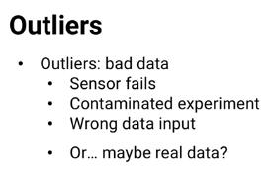

Answering those questions, whether the outlier is real or an error, and if it's real, what to do about it usually requires you to do some investigation. Looking into where the data came from, how it was compiled, what unique situations were there for outlier data points, etcetera.

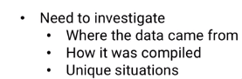

It means you'll have to look deeper than just a data set and a model, but understanding the outliers and dealing with them correctly is a great way to help ensure that your model's results are valid and valuable to your employer.

If the outlier is just bad data, we might wanna omit those data points. Or, if we need to use the data point and we need some value for the erroneous factor value, you could use the data imputation techniques we cover in another lesson in this course, but what if the outlier is real, correct data? Then you have to think more about the system. It might be that sometimes there's enough true randomness that if you have enough data, you'll almost certainly have some real outlying values.

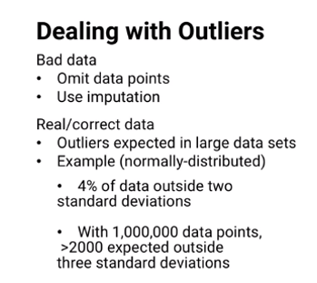

For example, if there's normally distributed randomness, then more than 4% of the data will be more than two standard deviations from what's expected, and for large data sets, it's even worse. If you have 1,000,000 data points, then about 2,000 of them will be more than three standard deviations from what's expected.

In this sort of situation, you need to consider what's going on and what you're modeling carefully. Is it important to consider these outliers as part of the model? If the magnitude of your model's error is part of the measure of its value, then maybe you should keep some of these outliers in the data set. For example, if you're modeling the time it takes to export perishable medicine from where it's manufactured in the United States to where it's needed in Africa, and occasionally weather events or political issues in Africa make it take a really long time, then considering those outlying data points is important because it's something that really occurs.

If you throw that data out entirely, then your model will be too optimistic and reality will give you some bad surprises, but you might want to deal with the outliers differently. For example, you could build one model to estimate the probability of these outliers happening under different conditions, maybe a logistic regression model, for example, and then build another model to estimate how long delivery takes under normal conditions using data with the outliers removed.

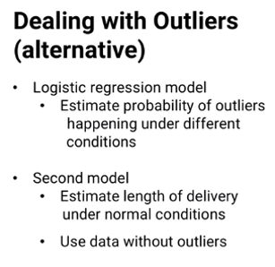

Of course, sometimes you'll find out that outliers just aren't predictable at all and might need to be removed, even if they're real data.

For example, I was working on a project for Chick-fil-A a few years ago, and we were looking at their weekly sales data. The data all looked pretty clean, except for one week where there is a huge spike upward. Sort of like this, except I can't show the real data due to confidentiality.

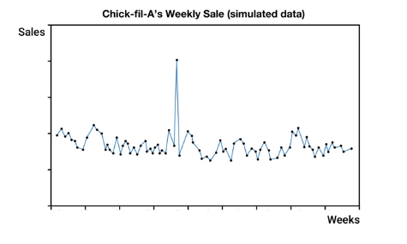

That one week was so big an outlier that we're almost sure it was just bad data and we were just about ready to toss it out, but we asked our Chick-fil-A contact just in case, and it's a good thing we did because it really was a true data point. It turns out that a Chick-fil-A executive had said something that turned out to be controversial and some people called for a boycott of Chick-fil-A as a protest, and in response, other people decided they would eat at Chick-fil-A as a counter-protest, and overall there are a lot more extra people eating at Chick-fil-A that week than there were boycotters not eating there, so there was a huge spike in the data.

In the end, it turned out that we had to remove that data point anyway. Both we and the company assumed it was a one-time event that we shouldn't try to model, but it shows that even if you think you're sure of what's going on, it's always a good idea to investigate the data just in case you're wrong.

##### 

##### 

## 6. Change Detection

### 6.1 (M): Introduction to Change Detection

As you might expect, change detection is exactly what it sounds like: determining whether something is changed. Because we're talking about changes, it makes sense that we’ll usually be using time series data, or at least data with some sort of time attribute. Here are some examples of when change detection is important:

* First, we might want to look at the data to see if we need to do something. For example, on a manufacturing process, does a machine that's displaying some variation in performance need maintenance, or is it just random variation? A hot topic these days is whether the global temperature is changed. Or a company might want to know whether sales of their product have changed. Are they decreasing due to new competition?
* A second type of question we can answer with change detection is whether an action we took had any impact. For example, did a policy change have the desired effect? If the national business tax rates got lower, did businesses hire more people? Or, in the case of an individual business, did a discount affect sales?
* And sometimes we might just want to see if there are any differences over time to help us plan or analyze for the future. For example, have there been changes in voting patterns?

#### Case Study: Semiconductor Manufacturing Traffic

As semiconductor wafers go through the several hundred steps in the manufacturing process, they need to be transported from machine to machine to machine. Because the process is so sensitive to even small dirt or dust particles, the process takes place in a giant clean room where automated vehicles run on overhead tracks, automatically picking up wafers, driving them along the overhead rails, and dropping them off at the next machine.

With so many wafers in the room simultaneously and so many steps in the process, they might need a couple hundred of these automated vehicles -- and those vehicles run into traffic. A central controller tells machines which way to go and the routes they choose are optimal in theory, but by the time the transport vehicles got to a critical intersection, there might be a huge backup of traffic. Eventually it could even deadlock the whole system.

Consider: how would you identify when traffic is starting to build up and will be a problem five minutes in the future even if it isn't a problem right now?

#### Case Study: Railroad Safety

Occasionally, rail cars axles fail and lead to derailment. So along railroad tracks, there are high-tech sensors to detect how hot an axle is. The axle temperature is then used as a predictor of failure. The railroads would like to stop the train when axle temperature rises but before it actually fails, and do some preventive maintenance to prevent a big derailment , but there's a lot of random fluctuation in the axle temperature between sensors.

Here's a figure showing the ideal scenario:

##### 

In this case, the first time we see a high temperature reading, it would be a reliable warning that a real problem exists and the railroad could remove the car from service before the failure. But what we actually see from the sensors is something like this:

##### 

As you can see here, every high reading might not be meaningful. The difficulty is that, if we wait until we're really sure the temperature is too high, it might be too late. In fact, our first approach was to use hypothesis testing, but if we waited until the hypothesis test met the standard threshold, it turns out we had to wait so long that the axle would be broken already. Instead, we needed an approach that more quickly identified potential problems, even though we had to accept some false positives. In a future lesson, we'll see a basic method to do just that to detect change more flexibly.

### 6.2 (M): CUSUM for Change Detection

In a previous lesson we saw some examples of when detecting changes could be valuable. Measuring manufacturing performance, evaluating the effective promotions on sales, determining whether national policy changes had the desired effect, et cetera. We also saw a specific example detecting railcar axles that are going to fail soon, where we needed a flexible approach that can give us an answer quickly. Quickly enough that it can detect the temperature change before the axle breaks.

In this lesson, we'll see the **CUSUM** approach to change detection. The name CUSUM is short for **cumulative sum**, and *it answers the question, has the mean of the observed distribution gone beyond a critical level?* CUSUM can detect when a process gets to a higher level than before, or to a lower level than before, or both.

In this lesson we'll look first at detecting increases and then show how to use the same method to detect decreases. Suppose we have some data, xt where xt is the observed value at time t. For example, xt might be the price of a stock on day t, the measure temperature of a rail car axle at time t, et cetera. Let's call Mu the expected value of the observations x if there is no change. So for each observation, xt - Mu is how much above expected the observation is at time t.

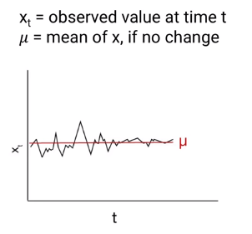

Now let's see the CUSUM metric. I'll put it up here first and then talk through what each piece means and how it works. The basic idea is to calculate a metric st and declare that we've observed a change when and if that metric goes above a threshold T. At each time period, we observe xt and see how far above the expectation it is. Then we add that amount to the previous period's metric st - 1 to give a running total st. If that running total so far is greater than zero, we keep it, but if it's less than zero, we just reset the running total to zero.

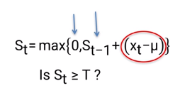

This helps CUSUM detect changes quickly -- otherwise a run of lower than expected observations might delay our discovery of an increase. Basically we're saying that if the running total would be *below zero, it's irrelevant to the question of whether we later see an increase.*

But on the other hand, we don't want to be too sensitive and say there's a change when there really isn't. We expect there to be some randomness sometimes. In fact, maybe about half the time, xt will be higher than the expectation just at random. So we include a value C to pull the running total down a little bit. *The bigger C is, the harder it is for st to get large,* *and the less sensitive the method will be.* And the smaller C gets, the more sensitive the method is because st can get larger faster.

CUSUM is a pretty mathematically simple method that you can implement quickly even in a spreadsheet. So you're probably wondering, how do you choose the right values of C and t so the model finds changes quickly, but isn't so sensitive that it often says there changed when there really isn't?

The answer is that there really isn't a simple answer. C and t are model parameters that you have to use data to find the right values for. And part of that decision depends on how costly it is if the model takes a long time to notice a change, and how costly it is if the model thinks it has found a change that isn't really there.

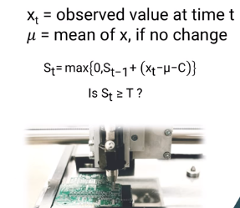

For example, in a computer chip manufacturing process, if a machine starts putting a component a little too far to the left, then each chip produced between when the chain starts and when it's detected will have to be discarded and there's a cost to that wasted material and time. On the other hand, if CUSUM *thinks* there's a change when the machine is really okay, then valuable production time might be lost while the repair crew goes in and adjusts the machine that was working fine anyway. Part of setting the right values of C and t involves trading off those costs of the two types of mistakes.

So let's see an example of how CUSUM works with different values of C and t. Here's a set of observations from a reaction time study:

##### 

The question is whether someone's reaction time slows down after a while, and to test the CUSUM method, we artificially added 100 to every observation from number t equals 11 onward and checked to see how long it takes CUSUM to notice that there is a change. Here the calculations of using a threshold t of 450 and C equal to zero:

##### 

You can see that it takes several time periods to notice the change, but it's still not too bad. And here, the same calculations using a threshold of t = 150 and C = 0 :

##### 

As you can see, it detects the change much faster, but it was also very close to falsely detecting a change early on.

It's just as easy to detect decreases using CUSUM: just use the same formula but look for negatives and decreases. And if you want to look for both sorts of changes simultaneously, just do both at once. In fact there's also a nice way to visualize this called a **control chart**. We plot st over time, and if it ever gets beyond this threshold line, it shows that CUSUM has detected a change:

##### 

There are other methods for detecting changes too, but we don't have time to go through all of them in this course. The important thing that I hope you take away from this lesson is understanding the basic idea of how changes can be detected and the trade off between early detection and false detection, as well as the straightforward CUSUM method for observing changes over time.

### 6.3 (M): Change-Detection Homework Follow-up

As you'll see throughout the course, homework solutions are typically standalone documents. But this particular homework assignment almost always leads to an important analytics ethics issue. As you probably remember, the homework on change detection involved using temperature data to see whether summers here in Atlanta are ending later than they used to. As a lot of you probably realized, it's a question that relates to climate change, and these days, climate change is not just a scientific question, it's also a very polarizing political topic. And that causes a lot of problems.

It turns out that there are several ways of using this data to answer the question of whether Atlanta summers are using later than before, and different approaches lead to different answers. Some approaches suggest that summers are ending later, and other approaches suggest that summers are not ending later. Even if everyone is using the same CUSUM methodology, your choice of values for the parameters C and T, and more importantly, the way you choose to use the data and interpret the results, can lead to different answers. You can see some of those approaches in the homework solutions.

The fact that you get different answers using different approaches isn't surprising. We'll see a pretty extreme case like this later in the course, and it's just something that happens because modeling is very much an art, rather than a science. It involves a lot of interpretation and creative thought.

But what I want to talk about today is a little bit different. In general, when I see solutions to this assignment, some answer yes, there is strong evidence of summer ending later, and others answer no, there isn't, and that's fine. But when I dig down deeper, many of them, sometimes most, of the no answers are worded in a way that say, essentially, I know climate change is happening, I know temperatures are getting hotter, so here are all the reasons I think my model is wrong. And some of the yes answers, when I dig deeper, really should be no, based on the output of the model. But again, there is a feeling that because you believe climate change is happening, there must be a problem with your model, or data, or analysis.

And even worse than the people who apologize for their models saying no, these other folks take that output that says no and try to twist it to say yes. That's a serious problem in analytics. Our job as analytics professionals is to do the best we can to interpret what the data really say to build the best models we can and report what the output of our model suggests as honestly as possible. It's not just our job, it's our responsibility to honestly report the results of our work. We're the analytics professionals, people are counting on us to give them the correct information, insights and suggestions, and we have to be honest about it. Even if it's hard, or even if it goes against what we believe to be true.

And in fact, if we only reported what we and others already believed to be true, what's the point of us doing the work? Our real value as analytics professionals is using the data and our models to come up with insights and suggestions that other people haven't, or even couldn't come up with.

So you might wondering if this dataset leads to somewhat ambiguous results, why do I assign it as homework? And the answer is exactly to illustrate this point about being faithful to our results. Any dataset could give you practice with change detection, but this one helps teach two lessons at once. You might also be wondering what's the right answer? Does this data show evidence of climate change? Specifically warming, or not, at least in Atlanta?

And the answer is, that I don't think this data is enough to give a clear answer. Because, as one of the first of my students to work with this dataset pointed out, even if we were sure from our analysis that summer was ending later in Atlanta, I haven't given you the data to see whether it's starting later, too. So, if you're looking to prove or disprove the existence of climate change, this dataset is way too limited to give an answer, even just for Atlanta. But it is very good for learning the more important point. Always be honest and true to your analysis.

## 

## 7. Time Series Models

### 7.1 (M): Introduction to Exponential Smoothing

In this lesson, we’ll see a method called **exponential smoothing** for analyzing **time series data**, data where the same response is known for many time periods. As we've seen, some examples of time series data are the highest temperature reading at the Atlanta Airport each day, the price of a stock every two seconds, daily sales of hamburgers at a restaurant, blood pressure readings over time, and things like that. We might expect the time series data will show some variation.

There might be trends over time, the price of a stock could generally be increasing as the company gains market share, or hamburger sales might generally be decreasing as the restaurant expands its menu to give customers more choices. There might also be cyclical variations, temperatures are higher in summer than in winter, or a restaurant might have more sales on weekends than weekdays. We'll see how to model these sorts of variations, but there's another source of variation we have to deal with first, *randomness*. Temperatures, stock prices, blood pressure, and hamburger sales vary simply due to random variations. On some days, people are just more in the mood for a hamburger than on other days. And the graph of daily sales might show random fluctuations.

Similarly, the graph of someone’s blood pressure over time will also show fluctuations. Because of that randomness, it might be hard to determine what someone’s expected baseline blood pressure really is. Should a doctor take action? Or is the patient’s blood pressure really about the same? And that's where a method like **exponential smoothing** comes in handy.

Let’s call st the expected baseline response for time period *t*. A person's expected blood pressure at hour t of the day, for example. And let's call xt the observed response, the actual blood pressure measured at time *t*. Imagine we're the doctor and we want to try to figure out what the patient's blood pressure has really been like over time without all the random variations. And if the blood pressure reading is today is different, what does that mean? Maybe the patient's blood pressure is different than usual.

Does that indicate an increase in the baseline or was it just random outside events? For example, if the patient took his blood pressure while watching an exciting sporting event.

There are two ways we might answer this question. We might think the observed blood pressure is a real indicator of the baseline. So S-t is equal to X-t. Or we might think there is no change to the baseline and the higher observed blood pressure today is just due to random luck.

So really, S-t equals S-t minus one. Today's baseline is the same as yesterday's baseline. The **Exponential Smoothing Method** combines these two ideas. S -t equals Alpha times the observed reading X-t plus one minus Alpha times yesterday’s baseline S-t minus one. Where Alpha is just a number between zero and one. So if we think there is a lot of randomness in the system, then fluctuations are probably mostly due to randomness and we should make Alpha closer to zero.

Yesterday's baseline is probably a good indicator of today's baseline, even if we observed something different today. And on the other hand, if there's not much randomness in the system, then we should make Alpha closer to one. If we observe a fluctuation today, it probably means today's baseline is close to the observed data.

There's just one more small detail. How do we start? As the initial condition we can choose S-1 equals X-1, and then build up from there.

This method doesn't yet deal with things like trends, where the blood pressure might be increasing or decreasing over time for example, or with cyclical variations. But in a future lesson, we'll see how to include trend and cyclical variations into exponential smoothing models.

### 7.2 (M): Trends and Cyclic Effects

In a previous lesson, we saw a method called exponential smoothing for analyzing time series data, data where the same response is known for many time periods.

If xt is the observed value at time t, for example, a person's blood pressure at time t and st-1 is our estimated baseline value at the previous time period t - 1, then we can estimate time t's baseline value st = alpha times the observed value xt+1 - alpha times the previous baseline, st-1.

##### [FORMULA SCREENCAP]

Alpha, which is between 0 and 1, helps us trade off between trusting our observation xt when alpha is large and trusting our previous estimate, st-1 , when alpha is small.

The more randomness there is in our system, the more we should trust our previous estimates and select a small alpha, so our baseline won't be excessively sensitive to our random fluctuations. And the less randomness there is in our system, the more we should trust what we see.

If we observe a fluctuation, it probably indicates a real change. As we saw in the previous lesson, there might be other reasons, besides just randomness, why baseline estimates might change over time. There could be trends, the value we're measuring might naturally be increasing or decreasing over time and there could be cyclical patterns, annual temperature cycles, weekly sales cycles or daily blood pressure cycles, for example. In this lesson, we'll see how to include trends and cycles in the exponential smoothing model.

Let's start with trends. We can easily deal with trends similarly to our baseline. Let's call Tt the trend at time period t.

So our baseline St now has alpha times our observation xt + (1 - alpha) times our previous estimate, but the previous estimate now includes a baseline term, St minus one plus a trend term, t minus one and we can estimate the new trend Tt, just like we do for the baseline.

Tt just equals another constant beta times the observed trend, which is the difference between the two baselines or St minus St minus one plus one minus beta times the previous trend estimate t of t minus one. As our initial condition, just like we started with the first baseline equal to the first observation or s one equals x one, for trend, we'll start with zero, T one equals zero.

We could also deal with cyclic patterns in the same way as trend, by making them an additive component of the formula and in some cases, that's the right thing to do, but I want to show you an alternative way, so you'll have both in your toolbox. The alternative is to deal with cyclic patterns, which are also called seasonalities in a multiplicative way. Here we need a little more notation.

Let's say L is the length of a cycle. If we have a seven-day cycle, and we're taking daily observations, then L is seven or if we take blood pressure readings every hour and there's a daily cycle, then L is 24.

We'll let Ct be the multiplicative seasonality factor for time t. The seasonality factor will help us inflate or deflate the observation, based on the part of the cycle that time period t is in. So here's what our new baseline formula will look like, including both trend and seasonality, St equals alpha times the observed value xt divided by the cyclic factor C of t minus L plus one minus alpha times the previous baseline estimate of St minus one plus Tt minus one.

Note here that when we're using a cyclic factor to inflate or deflate the observed value, we use the cyclic factor from L time periods ago. Why? Because that's the most recent cyclic factor we have from the same part of the cycle. For example, if today is Monday, we use last Monday's cyclic factor.

That's how we get the baseline estimate. Trends are updated in the same way as before and we also update the seasonal or cyclic factor in a similar way as before. Ct equals a new constant, gamma times the observation xt divided by the baseline St plus one minus gamma times the previous factor for this part of the cycle, Ct minus L. Notice that in the equations for St and Ct, we're multiplying and dividing.

So, if C is 1.1 on a certain Sunday, it means that hamburger sales were 10% higher, simply because it was a Sunday. If we sold 550 hamburgers that day, then 500 of them were the baseline value and 50 were the 10% extra demand, that we generally see on Sundays.

Just like before, we need some starting conditions, otherwise we won't know what Ct minus L is at the beginning. For trend, we use T1 equals zero as a starting condition to show no initial trend. For multiplicative seasonality, multiplying by one shows no initial cyclic effect and we need L of them, so the first L values of C are set to one and we let the data take care of everything else. And that's the exponential smoothing model.

This method is sometimes called **single, double,** or **triple exponential smoothing,** depending on how many aspects like trend and seasonality you include. Triple exponential smoothing with the base equations, plus trend and seasonality is also called Winter's Method, or Holt-Winters.

There are a couple odd details left to talk about. How to use exponential smoothing not just for descriptive analytics, but also for forecasting and as you might have been wondering all along, where the name "exponential smoothing" comes from. We'll see the answers to those questions in future lessons.

### 7.3 (M): Exponential Smoothing: What The Name Means

In previous lessons, we saw a method called exponential smoothing for analyzing time series data, data where the same response is known for many time periods. You might be wondering where the name exponential smoothing comes from, and in this lesson, we'll see the answer. Let's see the second word first, smoothing. Here's the basic exponential smoothing equation.

We'll use single exponential smoothing in this lesson, and as you'll see, the trend and seasonality components will work exactly the same way. Let's look at the exponential smoothing equation, and assume that alpha is somewhere in between zero and one. You could think of it as being a half, but the intuition is the same for any other value besides zero and one. We can see from the equation how spikes in the observed data, both high and low, are smoothed down.

If we have a really high observed value, xt, the baseline estimate, St, is not as high. The high observation is only weighted by alpha, which is less than one, and it's pulled down from that high point by the previous baseline, St minus one. And the same is true for very low observed values. The one minus alpha times St minus one term pulls it up from the low observed value. Here's a graph of what it looks like:

##### [IMAGE]

As you can see, when there are high peaks and valleys, the exponential smoothing curve does indeed smooth things out. And that's where the word smoothing comes from in the name exponential smoothing.

Now, let's look at the word exponential. Again, let's start with the basic exponential smoothing equation. Here, we have the previous time period's baseline estimate, St minus one, but that itself can be written using the same method as alpha times xt minus one, plus one minus alpha times St minus two. So let's plug that in, and here's what we get. Now, we have St minus two, and we can plug in for that two. And again, for St minus three, and again for St minus four, and we could keep going, but let's stop here. When we look at our equation for St, we can see each observation going back into the past, each weighted by one minus alpha to an increasing exponent. And that's where the name exponential comes from in exponential smoothing. As long as we have this extended form of the exponential smoothing equation up, let's see one more important thing about exponential smoothing. In the basic equation, it looks like only the previous time period's observation matters when estimating the current baseline, St. But the extended form shows the truth. **Every single past observation contributes to the current baseline estimate**, St. All the older ones are just baked into the term St minus one. So past history, all of it, is still considered when finding the current baseline estimate. But you might think that more recent observations are more important than very olds ones if you're estimating what's happening now, and the exponential smoothing formula makes that happen too. Because one minus alpha is less than one, newer observations are weighted more than old observations. So not only does the extended form of the exponential smoothing equation explain where the name exponential smoothing comes from, it also makes it clear that all past observations are accounted for, with the more recent observations being more important to the current baseline estimate.

### 7.4 (M): Forecasting

In previous lessons, we saw a method called exponential smoothing for analyzing time series data. Data where the same response is known for many time periods. And we saw how exponential smoothing really does smooth out the random peaks and valleys and observe data to give a clearer picture of the baseline behavior of whatever we're tracking.

It turns out that exponential smoothing can also be used to do simple forecasting, not just to see what happened in the past, but also to predict what will happen next. Here's how it works. Here's the basic exponential smoothing equation, our baseline estimate st for this time period t is alpha times the observed value xt plus one minus alpha times the previous periods baseline estimate S(T-1).

Now suppose we're in time period t and previous period's baseline estimate st. When we make that substitution, we get our forecasts. The forecast ft plus one equals s we want to look one period ahead to time t plus one and estimate what would happen then. Here's what that equation looks like. We don't know the observed value xt plus one and our best guess is just to use thet. In other words, our guess for the next time period is the same as our latest baseline estimate. And continuing out, the same thing happens for the next time period and all other future time periods. The estimate remains the same so the forecast remains the same. Of course because there's more uncertainty the farther into the future we go, the anticipated forecast error gets larger, too. If we include the trend term it's not much more complicated. Our best estimate of the next baseline is the most current baseline estimate and our best estimate of the trend is also the most current trend estimate.

So our forecast, ft plus one equals st plus tt, the current period's baseline estimate plus the current estimate of how the baseline is changing from one time period to the next. And that's also the same going forward. And finally suppose we also include a multiplicative seasonality, we've already seen the best forecasts of the baseline and trend and our best estimate of the next time period's seasonal factors, ct plus one, is the latest estimate we have at that same stage of the cycle, or ct plus one minus l. So our forecast for time period t plus one, ft plus one is st plus tt times ct plus one minus l, and again this remains the same going forward. If we're going to use this method for forecasting, you might be wondering how we can train the model to find the best values of alpha, beta, and gamma, to use. It turns out that we can use optimization, which itself is a whole other topic in this course.

We can measure the squared error in every forecast ft that we have as, ft minus xt squared, and minimize it over the whole training set. Whatever values of alpha, beta, and gamma minimize that sum of squared error is the model's best fit, subject of course to all three values being between zero and one. So that's the exponential smoothing method, both for smoothing data and for doing simple forecasting. Coming soon in another lesson will be a couple of other methods for analyzing time series data.

### 7.5 (M): ARIMA

In previous lessons we saw a method called exponential smoothing for analyzing time series data where the same response is known for many time periods. In this lesson we'll see the basics of a more general method of analyzing time series data called **Auto-Regressive Integrated Moving Average** or **ARIMA.**

We're just going to see what ARIMA does without going through the underlying theory. ARIMA has three key parts. The first key part is differences:

Think back to the exponential smoothing lesson we had the basic equation which we then expanded by substitution so here the equation shows that we're trying to estimate the baseline value St based on all of the previous observed data Xt, Xt-1, Xt-2 , etc. That works well if the data is stationary if the mean variance and other measures are all expected to be constant over time.

Often data isn't like that, for example, if there's trend or seasonality. But sometimes even if the data isn't stationary, differences in the data might be stationary. For example, if we look at the differences between two consecutive observations this might be a stationary process or we might need to look at the second order differences the differences of the differences or the differences of the differences of the differences called the third order differences. If you take the differences of the differences of the differences etc for D x then it's called the D-th - order differences so that's the first key part of ARIMA.

The second part is auto regression predicting the current value based on previous time periods values. We'll see more about regression in a later topic. For now just think of regression as predicting the value of something based on other factors, for example we could try to predict how tall a two-year-old boy will be at adulthood based on his mother's height his father's height and his height at age two. The auto part of auto regression means that instead of using other factors to predict we instead just use earlier values of the same thing we're trying to predict like the boy's height at age one and a half one and six months.

Obviously this only works with time series data, otherwise there won't be previous values to use. When used for forecasting, the exponential smoothing equation in its expanded form is a type of auto-regression. We're trying to predict the value based on all of the previous values this is an order infinity auto regressive model because it uses data all the way back as far as we have it. We could also just use a few previous data points if we only go back P time periods it's called an order P autoregressive model.

In ARIMA we combine auto regression and differencing. Instead of using auto regression with the actual observed data we use auto regression on the differences. We might for example use P time periods of previous observations to predict D-th order differences.

Now there's just one more part of the ARIMA model in addition to using previous observations as predictors, we also use previous errors.

This part of ARIMA is called moving average if we go back q time periods it's called an order Q moving average. When we put all of these pieces together here's what the ARIMA model looks like:

###### 

When we choose the D-th order differences P-th order regression and Q order moving average we get the **ARIMA PDQ model**. And once we've selected P, D and Q, statistical software can find the best values of these constants so the model fits the data best. As usual there's an optimization model underlying this best fit approach. There are at least three main ways of evaluating the quality of a time series model to determine what that best fit is and we'll see those in a future lesson.

The important thing to know right now is, given P D and Q the software can optimize to find the best constants for the model and it can do that pretty quickly so you can try different values of P D and Q and compare them using the same sort of validation approaches we've seen in previous lessons. The ARIMA model we've seen in this lesson is pretty general we can add seasonality to the model. We won't see that in this class but it's a pretty straightforward extension that good statistical software can do for you.

It turns out that there are specific values of P D and Q that make the ARIMA model equivalent to other things you might have heard of. ARIMA(0,0,0) is a simple model for white noise where there are no patterns ARIMA(0,1,0) is a random walk we don't won't cover them in this class but some of you might have heard them before a simple AR or just Auto regressive model is ARIMA(P,0,0) where only the auto regressive part is active and a simple MA or moving average model is just ARIMA(0,0,Q) where only the moving average part is active ARIMA(0,1,1) is the basic exponential smoothing model that we've seen in previous lessons.

There are others as well that I won't go into now. The point is that in addition to giving you a lot of flexibility with your choices of P,D and Q the ARIMA model is also powerful because it generalizes a lot of simpler models.

ARIMA can be used for short-term forecasting just like exponential smoothing. ARIMA models tend to work better than exponential smoothing when a data is more stable with fewer peaks valleys and outliers. As a rule of thumb you probably need about 40 past data points for ARIMA to work well. ARIMA models including exponential smoothing are meant to help estimate or forecast the actual value of something. But what if we want to estimate or forecast the variance of something we'll see how and why to do that in a future lesson.

##### 

### 7.6 (M): GARCH

In previous lessons we saw methods like exponential smoothing and it's generalization ARIMA for estimating or forecasting the value of something for which we have time series data. In this lesson we'll see the generalized autoregressive conditional heteroscedasticity or GARCH method. GARCH is a way to estimate or forecast the variance of something for which we have time series data. But first before seeing GARCH itself let's take a minute to see why we would want to consider estimating or forecasting variance. In general knowing the variance of something can help us estimate the amount of error there might be in our estimate for example if we're forecasting the demand for pick-up trucks to determine how many to manufacture the variance can help tell us how much our forecast might be higher or lower than the true value so we can plan accordingly. Variance estimation is especially important in investment the traditional portfolio optimization model balances the expected return of a set of investments with its amount of volatility. Some people prefer riskier portfolio with a higher expected return and others prefer less risky portfolio and are willing to accept lower expected return in exchange for less risk. In these models the variance is often used as a proxy for the amount of volatility or risk and GARCH is a common approach for estimating variance. We're not going to get into much mathematical detail of the GARCH model but here's what it looks like

###### 

You'll notice that it looks a lot like the ARIMA model that we saw in a previous lesson. There are only two differences: first, we're dealing with variances and squared errors rather than observations and linear error terms, and second we deal only with the variances - we don't use differences of variances the way we use differences of observations in ARIMA. Other than that the models have very similar structure and just like good statistical software can fit an ARIMA PDQ model for you it can also fit a GARCH PQ model. The GARCH model doesn't need a D parameter again because it doesn't use differences. So we've now seen three methods for analyzing time series data: exponential smoothing, ARIMA which is a generalization of exponential smoothing, and GARCH which is an ARIMA like model for analyzing variance. There are other approaches of course but these are the most common and the most generally useful when dealing with time series data.

##### 

##### 

## 8. Basic Regression

### 8.1 (M): Introduction to Regression

In this lesson, we'll start learning about one of the most common models in analytics, regression. There are lots of variations of regression and lots of add ins and tangential topics, and we'll cover many of them in future lessons, but for now, let's just see what sort of questions a regression can answer and what it looks like.

Regression can answer two different types of questions. First, regression can answer questions about how systems work. For example, regression can be used to determine how many runs the average home run is worth in baseball, estimate the effect of economic factors on presidential election voting, find the importance of a person's education on their future income, discover the key factors in purchasing a specific type of car, et cetera.

And second, regression can make predictions about what will happen in the future. For example, regression can be used to predict how tall a child will be when he or she grows up to be an adult, forecast the price of oil a year and a half in the future, predict the demand of housing in a city over the next six months, predict the remaining lifetime of someone applying for life insurance, et cetera. For each of these situations, or any situation where regression is used, we have a set of factors or predictors that we can use to estimate or predict their response.

Let's see the most simple version of regression, linear regression with one predictor, also called simple linear regression. Suppose we want to see the effective unemployment on new car sales. Here's a graph of some sample data:

##### [IMAGE]

The horizontal axis shows the predictor, the workforce participation rate, which measures the fraction of adults who are employed. The vertical axis shows sales of new cars. As we might expect, there seems to be a relationship between the two. When more people are working, there are more people who can afford to buy a new car, so new car sales are generally higher, but how much higher?

That's where regression comes in. Here we're going to use linear regression. That means we're looking for a linear relationship between the predictors and the response -- in this case, between workforce participation and new car sales. Here's a line that goes through the set of points:

##### [IMAGE]

If we denote Y as the response, new car sales, and X one as the predictor, workforce participation, then the equation of the line is Y equals A zero plus A one times X one. As usual, this picture is only drawn in two dimensions, X one and the response. If we had more predictors, say, M of them, then the equation of the line would be Y equals A zero, plus the sum from J equals one to M of A, J times X, J. So is this a good line or not a good line? We can measure the quality of the line's fit by the sum of squared errors. For each data point, the error can be defined to be the distance between the true number of cars sold and the model's estimate. If we denote the true number of cars sold for data point I by Y sub I and the regression's estimated number of cars sold by Y hat I, then the difference is just Y, I minus Y hat I, or Y, I minus the quantity A zero plus A one times X, I one. And the sum of all the squared errors is just this term here. If you haven't seen the lesson on estimating model quality, which covers what it means to find a model that best fits the data, now might be a good time to view it. Among other things, it'll explain why we're using the sum of squared errors to measure the quality of the line's fit. Go ahead and pause me. The great thing about online learning is that I won't even get hungry, thirsty, or tired waiting for you. Great, you're back. As I was saying, we can measure the quality of the line's fit by the sum of squared errors. As the line turns and slides, the values of the coefficients A zero and A one change. The values of A zero and A one that minimize the sum of squared errors is the best fit regression line. I won't go through the details, but here's a quick description of the underlying math. The sum of squared errors is a convex function, and we're trying to minimize it. So we can take partial derivatives of the sum of squared errors term with respect to each constant, set each partial derivative to zero, and solve those equations simultaneously to find the minimum sum of squared errors, the best fit solution. As you've probably noticed, I think seeing the pictures of how analytics methods work can really help people understand what's going on when the models get more complex. Most of you have probably heard the expression a picture is worth a thousand words. When I was putting this lesson together, I started wondering whether that expression is actually true. In the next lesson, we'll see how to use regression to test hypotheses like this. Is a picture really worth a thousand words, or is it maybe only worth, say, 916? We'll see how to answer that question and many others, more important ones, in the next lesson.

### 8.2 (C): Maximum Likelihood and Information Criteria

In quite a few lessons in this course we've seen how statistical models can be fit to a data set and unless you've waited until the very end to view this lesson you'll soon see even more models that need to be fit each time we've talked about model fitting i've glossed over an important detail how exactly do we measure the quality of a model’s fit. In this lesson we'll see a few different ways of measuring a models quality of fit. the most basic measure of model quality is likelihood basically we assume that the observed data is the correct value and that we have information about the variance. Then for any set of parameters we can measure the probability, really the probability density, that the model would generate the estimates it does whichever set of parameters gives the highest probability density called the **maximum likelihood** is the best fit set of parameters here's a small example suppose we believe that errors are normally distributed with mean 0 and variance Sigma squared and that they're independent from one data point to the next then given observed data is Z 1 through Zn and our models estimates y1 through yn here's the probability of observing Zi if the true value is y I and because the errors are all independent the joint probability of observing Z 1 through Zn if the true values are y1 through yn is just the products of each of the N terms we can simplify this into a single exponential term and because the exponential function gets larger as the exponent gets larger we can find the largest value of this whole expression by finding the largest value of the exponent we can remove all of the constants and we're left in this case with a negative sum of the squared errors so if errors are normally distributed and they're independent and identically distributed then the set of parameters that minimizes the sum of squared errors is the maximum likelihood fit here's how that this looks in the case of a basic linear regression if you haven't viewed the regression lesson yet don't worry just take my word for it now that the regression estimate why I is equal to a0 plus the sum of AJ times X IJ where X IJ is the J observed predictor value of data point I and a 0 through a a.m. are the parameters we're trying to fit so we can substitute into the sum of squared errors and minimize this function over the values of a we'll see in the optimization topic that this is a pretty easy problem for modern software to solve we can also use likelihood to compare two different models by using the likelihood ratio the ratio of their likelihoods and conducting a hypothesis test like you might remember from basic statistics regression with independent identically normally distributed errors is a simple example of maximum likelihood fitting but it can get pretty complex with different estimation formulas substituted for the linear regression formula or with different assumptions about the error and it's not always easy to compute a solution we won't talk much about computing those solutions in this course that's advanced material you might see in elective courses like computational statistics but good statistical software can handle a lot more complexity than simple regression so that's the basic maximum likelihood approach there are also some other approaches that combine maximum likelihood with model complexity the math behind these other methods is more complex and not so instructive to see at this point so let me just put these functions up one commonly used function is the Akaike information criterion or AIC in this formula L star is the maximum likelihood value and K is the number of parameters were estimating this term called the penalty term helps us balance the model's likelihood with its simplicity it's important to do that because although adding parameters can improve a model fit it can also lead to overfitting where the extra parameters push the model to fit random effects not real ones if you don't remember what I'm talking about go ahead and view or review the lessons on validation here's an example of the AIC in the case of regression we can substitute the likelihood funk and the number of parameters is just n plus 1 for a 0 through a.m. so the AIC could be calculated this way whichever model has the smallest AIC would be preferred making a I see smaller encourages fewer parameters K and higher likelihood I said I wasn't going to get into the underlying mathematics behind this formula it comes from information theory but there is one thing I do need to mention AIC has nice properties if there are infinitely many data points available to fit the model but of course we're never going to have infinitely much data and if you do good luck storing it so there's a correction term we can add to AIC to deal with a much more common situation where the data set is not infinite this adjusted formula is called the corrected AIC or AIC sub C when comparing models with different AIC or AIC sub C values it turns out that we can calculate the relative probability that one of them is better than the other specifically e to the power of 1/2 the difference in AIC values is the relative likelihood that the lower AIC model is better so for example if one model has AIC 75 and one has AIC 80 then the second model is 8.2% as likely as the first model to be the better one in this case it's much more likely that the first model is better let's see one more criterion which is similar to the AIC this one might seem to be somewhat uncreated Li named we just saw the AIC and now we have the BIC or Bayesian information criterion as you can see the formula for the BIC is pretty similar to the AIC the only difference is how it deals with the number of parameters and data points in general the BIC's penalty term is larger than the AIC's penalty term so it can encourage models with fewer parameters than the AIC does but as you can see when the number of data points n gets close to the number of parameters it breaks down so only use bi C if you have a lot more data than you have parameters when comparing two models on the same data set by their B I see there's a standard rule of thumb if the difference in B I see is 10 or more then the smaller B I see model is very likely to be better if the difference is between 6 and 10 then the smaller B I see model is likely to be better if the difference is between 2 & 6 then the smaller B I see model is somewhat likely to be better and if the difference is between 0 & 2 then the smaller B I see model is only slightly likely to really to be better and if this all sounds pretty hand wavy to you you're right it's an inexact science and similarly as with many things in analytics there's not a hard and fast rule for using AIC or bi C or just maximum likelihood for those of you with a deeper statistics background the AIC is a frequentist point of view and the B I see is a Bayesian point of view the frequentist versus Bayesian argument really gets into the philosophy of statistics and it's beyond what we're going to talk about in this course what matters to us is that all three approaches can give valuable information and looking at them together can help you decide which model among those you're testing is the best one to use.

##### 

### 8.3 (M): Using Regression

In the previous lesson we started learning about regression. We saw two different types of questions that regression can answer. Descriptive questions about how systems work and predictive questions about what will happen with other perhaps future data points. We also saw what regression looked like graphically. We're looking for a line of the form y equals a zero plus a one x one plus a two x two up through a m x m that fits through our data points as closely as possible. In this lesson we'll see how to interpret regression coefficients. Suppose we're given end data points each with a response and m different predictors. Let y i be the response of the ith data point and x i j be the value of the jth predictor for data point i. In linear regression we find coefficients a one through a m and a constant a zero so the model best fits the data. In the case of using regression to answer questions about how systems work, the key answers are the coefficients themselves.

For example, if we want to use regression to determine how many runs the average home run is worth in baseball we could compile data for each team over the course of several seasons. For each team and season the response would be how many runs the team scored that season and the predictors could be how many home runs, triples, doubles, singles, outs, double plays, stolen bases, et cetera the team had that season. After we fit our regression model we'll have coefficients for each of these baseball events. If the team hits one more home run the equation will suggest that the team should score (mumbles) home runs more runs. Taking team data from the past three major league baseball seasons, a basic linear regression gives a value of about one point four for the coefficient of home runs. In other words, every home run hit will add an average of one point four runs to the team's total.

On the other hand, if we're using regression to make forecasts then the key answers are the predicted responses. For example, if we want to use regression to predict how tall a two year old American will when he or she is an adult we could compile data for lots of Americans. For each person the response would be the person's height as an adult and the predictors could be things like the person's Father's height, Mother's height, their own height at age two and whether the person is male or female. After we fit our regression model we'll again have coefficients for those predictors. So if we're given a new data point without a response, for example, a two year old boy's height and the height of his Mother and Father, then we can use this regression equation to predict the boy's response. The predicted height as an adult. And then if our model suggests he'll be seven feet tall, we might immediately offer him a scholarship to play basketball at Georgia Tech. So we've now see two different uses for regression. One to describe what's going on and another to predict what will happen. As we saw way back in the introduction to this course, those are two of the three major steps or components of analytics. Descriptive analytics and predictive analytics. The only sort of question regression isn't directly used to answer is a prescriptive analytics question. So it's not surprising that regression is one of the most commonly used tools in analytics and we'll spend several more lessons going through a lot of the basics and extensions of regression.

### 8.4 (C): Causation vs Correlation

In this lesson we'll talk about an important concept in interpreting the output of some analytics models, the difference between causation and correlation. Just like a lot of other analytics jargon these two words mean about what they sound like. Causation means that something causes another thing, and correlation means that two things tend to happen or not happen together but neither of them might cause the other. So, what's the point? Why are these words important in analytics? Let's use regression as an example. Suppose we're studying people's recreational habits in the winter, and we have a regression model that tries to predict daily number of hours spent outdoors in the winter by people in each city. Let's call that Y. From the city's average daily temperature in the winter let's call that X1. We might find a significant relationship between the two, with regression coefficients A0 and A1, so the regression model would estimate Y as A0 plus A1 times X1, and the P value for A1 would show a strong significance. That means given a city's daily average winter temperature we can estimate the number of hours its population spends outdoors in the winter. It certainly won't be a perfect estimate, we can probably think of several reasons it wouldn't be but overall we can predict time outdoors from temperature, there's a correlation. But does that mean the model shows that warmer winter temperature causes time outdoors? Maybe. The temperature doesn't force people to go outside but in general it's not hard to imagine saying that because the winter temperature is higher in San Diego than in Chicago, people in San Diego spend more time outdoors in the winter than people in Chicago. Okay, so that's not such a big discovery, right? But now let's do the same regression in reverse. Using the same dataset let's use the number of hours outdoors in the winter as the predictor and use it to predict the city's average daily winter temperature. The regression model will estimate X1 as B0 plus B1 times Y for some coefficients B0 and B1, and the P value and the model's quality will be exactly the same. So, does this model with the exact same quality metrics as the other one now show that people spending more time outdoors in the winter causes higher winter temperatures? Probably not, right? It just doesn't make sense. We can still use the model to make predictions. For example, if I tell you there's a city where people are outdoors more in the winter than another city you can probably predict that the first city will have a higher average winter temperature but even though we can use it for empirical predictions it doesn't make sense to say that the model shows causation. Here's an even more extreme example. The first time I taught this course my kids seven, five and two years old, and there were days I walked into the classroom really tired and there were also days when my face was a lot scruffier than usual. If I had plotted a graph of my tiredness against my scruff, there would have been an obvious correlation, and a regression would do a pretty good job of predicting one from the other but neither one caused the other. More scruff didn't cause more tiredness and more tiredness didn't cause more scruff. Instead, both things were caused by a third factor, how many nights in a row at least one of my seven, five and two-year-old kids had woken up in the middle of the night. The more they had woken up in the middle of the night, the more tired I was and the more likely I was to decide to sleep for five extra minutes instead of shaving in the morning. So, just because there's a correlation, just because our regression model can make good predictions doesn't necessarily mean that the predictors caused the response. So, how can we tell when there is a causation? It turns out that's a more complicated question that it might seem. There's actually been a fair amount of philosophical thought around this question, including some where the answer is that it's theoretically impossible to prove causation. Luckily, we don't need absolute proof. Humans draw causal relations all the time using an eight rules of thumb and we're often correct. After all, we did figure out that temperature could in some sense cause outdoor activity but not the other way around. There's several different rules of thumb for trying to figure out whether a correlation shows that one thing is also causing another and most of them boil down to something like this, the cause should come before the effect, the idea of causation should make sense, and most difficult to ensure there should be no outside factors that could be causing the relationship. The reason it's so hard to ensure that there are no outside factors causing the correlation is that it means we have to think about all the possible external factors, and we're only human, we can't do that with 100% certainty. We can try to create randomized experiments, to use controls in our experiments etc., but we still might miss something. That's why so many studies of things, especially where human behavior is involved, can be controversial. It's often not hard to find a possible external factor that might or might not be part of the cause. That doesn't mean we can't still use our models to suggest causation. Coming up with insightful causal relationships is an important part of analytics but it does mean that we should be very careful and do our best to think through all the possibilities we can before we claim that our models show causation. And if you're interested in seeing what sort of meaningless correlations you can find, go to this website. You can see how per capita consumption of mozzarella cheese correlates with civil engineering doctorates awarded, how the number of letters in the winning word of the national spelling bee correlates with the number of people killed by venomous spiders, how the divorce rate in Maine tracks very closely with per capita consumption of margarine, and lots of other clearly very important correlations.

### 8.5 (M): Transformation and Interactions

In previous lessons we've seen what regression looks like graphically, and how to use the regression model's solution, the regression coefficients, to answer descriptive and predictive analytics questions. In this lesson, we'll see how to build more general regression models. First, let's look at the inputs. In the previous lessons we saw a general formula for linear regression. Each attribute appears in this formula linearly. Its value xi is multiplied by a regression coefficient ai. That works great if the data looks linear, like this. But what if the data looks more like the graph on the right? A linear approximation doesn't work well but a nonlinear fit like this one is much closer to the data. So we could transform the data to make the fit linear. If the data looks like y equals x squared then we can include a quadratic term in the regression. It basically creates a new column of data. We can use any other function of the attributes we want as well, if it fits the data. We can also transform the response. For example, we could use the regression to estimate the log of the response, or even transform both the attributes and the response. Box-Cox transformations are one type of transformations that most statistical software can automate for you. It also might be that the attributes interact in some way. For example, if we're trying to estimate a two-year-old's height at adulthood, the child's height might be related to the father's height, the mother's height, and to the product of the two heights. Perhaps if both parents are tall, for example, then the child is expected to be even taller than we might expect based on just the two parents' individual heights. So we can add an interaction term to the regression equation to capture how the two attributes interact with each other. And just as before, the interaction term can be transformed. Once it's included as a new column of data, it can be treated just like any other attribute. Once we build a regression model with interaction terms and transformations included, we can use software to find the best-fit coefficients. And you'll get a chance to do that in the upcoming homework assignment.

### 8.6 (M): Regression Output

In previous lessons, we've seen how to build and fit regression models. But building and fitting models is not the end of the process. Once we fit our model, we can look at the output to see what attributes are really important or significant and which are not. There are some helpful indicators that you'll see in the output. First there's the p-value for each coefficient. Which estimates the probability that the coefficient really might be zero. It's a type of hypothesis test. The common rule of thumb is that if the p-value of a coefficient is greater than 0.05 then we can remove its attribute from the model. Other thresholds besides 0.05 can also be used. Depending on how conservative or not conservative you want to be with including factors in your model. Higher thresholds allow more factors to be included but make it more likely that an irrelevant factor is part of the model. And lower thresholds restrict more factors from being included at the risk of leaving out a relevant factor from the model. Regardless of the threshold you choose, for most factors, the decision is not ambiguous. P-values are often very low, 0.001 or lower. Meaning that the attribute is almost certainly important. Or they're very high 0.3 or higher. I should mention two small warnings about p-values. First when there's a very large amount of data, p-values get small even when attributes are not at all related to the response. So be careful. With so much data, you need to be very careful relying on p-values. And second, even when p-values aren't meaningful, they're only probabilities which means some of them will be wrong. First example, suppose you find 100 attributes that each have a p-value of 0.02. Each of those attributes by itself look significant. But by definition, each one will have a 2% chance of not being significant. With 100 such attributes, we would expect that two of them are really irrelevant. That might not seem like a lot. But depending on what you're modeling, the outcome could be really important. For example, suppose you're using daily intake of different types of nutrients or foods as attributes. And probability of developing cancer as the response. Out of 100 foods, you determine are significant at the 2% level to increasing or decreasing cancer risk. On average, two of them are really meaningless. Which means that if your study suddenly gets a lot of publicity, people might be avoiding peanut oil for no reason. Or start taking coconut supplements for no reason. And both of those food's industries can be drastically changed. So that's p-values. The second piece of output you can use to determine the importance of coefficients is related to the p-value. Most statistical software will give you a 95% confidence interval around the coefficient. So you can see where the coefficient probably lies and how close that is to zero. Third, also related is the t-statistic. The coefficient divided by its standard error. This too is related to the p-value. It's just another way of finding the same information. Finally, you can just look at the coefficient itself. Sometimes you'll discover that the coefficient, when multiplied by the attribute value still doesn't make much difference even if it has a very low p-value. For example, suppose you're trying to estimate household income and you're using age as one of the attributes. If the regression coefficient is one, even with a very low p-value, then the attribute really isn't very important. It's unlikely to make even a $100 difference which isn't very meaningful compared to the magnitude of household incomes that are in the tens of thousands or higher. In addition to information about each coefficient, the regression output also includes information about the model as a whole. The most important information is often the coefficient of determination or R-squared value. Which is an estimate of how much variability your model accounts for. For example, if the model has an R-squared value of 0.59, then it accounts for about 59% of the variability in the data. And the remaining 41% is either randomness or is due to other factors that your model does not capture. There's also a related measure, the adjusted R-squared, which adjusts for the number of attributes used. When you're using R-squared values, please keep in mind that some things just aren't easily modeled. In textbook homework assignments, you'll often get a nicely prepared data set with great relationships. And you can sometimes get R-squared values as high as 90% or more. But in reality, that's rare. There are so many things that affect real life systems that it's often unlikely to get such a high R-squared value, even with a very good model. And that's even more true when there are humans involved. When you're doing social science analysis, including behavioral analytics where you're modeling human behavior, R-squared values of 0.4 or even 0.3 are often quite good. I guess we humans are just hard to predict.

## 9. Advanced Data Preparation

### gm9.1 (C): Box-Cox Transformation

In this lesson, we'll see why it's sometimes helpful to transform data before using it to fit a model and we'll cover one method for doing it, the Box-Cox transformation. Some of the models we see in this course make some normality assumptions about the response data we're trying to estimate and if the response data isn't close to fitting the normal distribution, the model could give biased results. Here's an example. Suppose we want to build a model to estimate someone's height. Here's a histogram of the height of American women in their 40s. As you can see, it's a pretty good fit to the normal distribution. So the variance is about the same across the whole distribution. But now suppose we also want to build a model to estimate weight. Here's a histogram of the weight of those same American women in their 40s. Now you can see that for smaller weights, there's less variance, it's a narrower area, and for larger weights, there's more variance, it's a wider area. That difference in variance is called heteroscedasticity, which just means unequal variances and if we try to build, say, a regression model for this data, we might end up with bias because the higher variance at the upper end can make those estimation errors larger and push the model to fit those points better than the others. So what can we do about it? One approach we can try is a Box-Cox transformation. A Box-Cox transformation is a logarithmic transformation that stretches out the smaller range to enlarge its variability and shrinks the larger range to reduce its variability. The idea is to find the best value of lambda. So if Y is the vector of responses and T of Y is the transform vector, then T of Y equals Y to the lambda minus one divided by lambda and it's close to normally distributed. Good statistical software can do this for you. The important thing is to remember to check whether you need to do it, for example by using a Q-Q plot like you probably remember from basic statistics and if your basic statistics course was one that didn't cover Q-Q plots, go ahead and watch the Q-Q plot lesson after this one. One last thing before we stop. A common question about the Box-Cox transformation is what does it have to do with boxes? Visually, what box is being used and can it help us see what's going on? The answer is that there isn't a box. Unlike the box in the box and whisker plot, the box of Box-Cox is actually a name. Statistician George Box was one of the inventors of the technique along with David Cox and the Box-Cox transform is named after them. If you have kids like I do, you might have read them a book called Fox in Socks. Whenever I read it to them now, I always want to say Fox in Socks and Box in Cox and when they get older I'm sure they'll be happy to have me tell them all about how it's sometimes very useful for transforming your response to eliminate heteroscedasticity.

### 9.2 (C): De-Trending

In this lesson, we'll talk about Detrending Data; what it means, when you'd want to do it, and a basic method for detrending. As you might have already seen in the lessons on time series data, the word Trend refers to data that's increasing or decreasing over time. For example, here's a graph of the price of gold at the end of the year over the last 45 years. You can see that overall the price of gold has been increasing over time but that's not the whole story. Because of inflation, the relative value of a dollar has been decreasing and that gives an upward trend to the gold price just like to the price of almost anything else. If we adjust for inflation rates over time, we get this graph. Once we've adjusted for inflation, we can see more clearly the true fluctuations in the price of gold relative to other things without the upward trend getting in the way. That's what detrending can do and the reason we want to do it is because the trend in the time series could mess up a factor-based analysis. For example, suppose we wanted to use a regression model to estimate the price of gold as a function of other factors. With trend in the price of gold, we could have the same factor values in 1974 and 2009, but we'd have a very different response value. On the other hand, after taking away the effective inflation, we can see that the baseline price of gold adjusted for inflation is about the same in those two years. And it's not just the response that we might want to detrend. It might be that some of the predictors also should be detrended. In general, you should at least consider detrending whenever you're going to use a factor-based model like regression, support vector machines, et cetera to analyze time series data. That just leaves the question of how to detrend. In the gold price example, I was able to cheat a little bit. There are plenty of websites where you can find historical inflation rates, so it was pretty easy for me to adjust each data point individually by the amount of historical inflation. But in most cases we don't know what the trend has been in the past except for the data we're trying to detrend. So one simple way of doing the detrending is to go factor-by-factor and fit a one-dimensional regression to it. Usually that's a linear fit like y equals a zero plus a one times x, but you could use a more complicated function, too. Let's see the gold prices again using a linear fit. A simple linear regression gives us the estimate that the price equals negative 45,600 plus 23.2 times the year. To detrend the data, we just subtract the trend line estimate from the real price. So the detrended price is the actual price minus negative 45,600 plus 23.2 times the year. As you can see, it's not so different from the inflation adjusted draft. It's a little different because the linear fit. The linear fit assumes a constant rate of inflation and the inflation adjusted draft accounts for different inflation rates year by year. But if you don't have inflation data, you can see that the simple detrending procedure still works pretty well. And that's all it is. Compared to a lot of other analytics models, this detrending approach is pretty simple and it usually works pretty well as a way to remove trend effects from time series data when you want to use that data in a factor-based analysis.

### 9.3 (C): Introduction to Principal Component Analysis

In this lesson, we're going to talk about feature extraction using a method called principal component analysis, or PCA, for dealing with high dimensional and correlated data. In many analytics applications, we might have lots of factors that we can use in our model and we want to know which subset of them are most important for predicting a response. For example, we might wonder whether we could use the performance of certain stocks on one day to predict overall market performance on the next day. In that case, we could have a lot of predictors. In the United States, about 3,000 securities are traded on the New York stock exchange, another approximately 3,000 are traded on the NASDAQ, plus a few hundred traded on AMEX. Of course, sometimes, external events have a strong effect on the markets; wars, terrorist attacks, election results, natural disasters, et cetera, all can have significant effects, but maybe on other days, there's a good combination of stocks we could use for prediction. There are two difficulties with this approach. First, with more than 6,000 predictors, not even including possible interaction effects or other variables, we would need lots of data to avoid having the system be over determined. Since each data point is one day, that means we'd need many years of data, so many that the underlying situation we're trying to model might have changed. For example, perhaps these days Tesla stock is a good predictor, but Tesla wasn't publicly traded until mid 2010, so we won't be able to see it's affected much of our data set. On the other hand, maybe back in 1997, Kmart stock would've been a good predictor, but it was merged with Sears in 2004 and these days, many Kmart stores have been closed. We'd like a way to reduce the number of predictors we use and we don't want to need so many years of data. There's a second potential problem. Some of the predictors might be highly correlated. For example, within the energy sector, the stock prices of ExxonMobil, Chevron, and Phillips 66 might move up and down relatively in sync with each other. The same might be true about General Motors and Ford, for example. The good news is that we can often address both problems at once using a method called principal component analysis, or PCA. PCA is a way to transform data to do two things. It changes the coordinates to remove correlation and it ranks the coordinate dimensions in order of the amount of variants in each so the most important coordinates are first. Concentrating on the first end principal components can also have the benefit of reducing the effect of randomness. If the randomness is about the same level for every factor, then the first principal component is likely to have a higher signal to noise ratio. The variation between the data points is likely to be driven by a higher ratio of actual effects to random effects. The further down the list of principal components we go, the lower the signal to noise ration is likely to be. Before we get to the map, let me show you a picture of what PCA looks like. Here's a picture of some data that has two dimensions, two factors. As you can see, there is a strong correlation between the two factors. The higher one gets, the higher the other one gets. But is we were to rotate the picture and the create a new coordinate system in this rotation, then the correlation between directions in the new coordinate system is zero. The two directions are orthogonal. If we express our data in terms of these new coordinates, there won't be any correlation, and of course, rotating the picture was just to make it look more obvious. We could rotate the picture back, and the correlation is still zero. That's pretty cool, but there's even a little more going on here. Let's call our two new dimensions D1 and D2. As you can see, the data has a much wider spread of values in the D1 direction than it does in the D2 direction. PCA will recognize that and automatically make D1 the first dimension and D2 the second dimension. If we just want to use a one dimensional factor, we'd know that D1 is a better bet than D2. That's all PCA really is, except of course, for the underlying math, and that math is what we'll see in an upcoming lesson.

### 9.4 (C): Using Principal Component Analysis

In a previous lesson, we saw the basic idea of Principal Component Analysis, or PCA for doing feature extraction. Starting with a large number of factors, and using them to generate a small number of factors that you can use to fit to a model. We also saw that PCA is useful for removing correlation between the factors you're going to use. You might remember this picture. In it, we started with a graph of two factors that are obviously correlated and changed coordinates to create two new factors denoted by the arrows that are uncorrelated. The picture also shows the relative importance of the factors. So if we only wanted to use one, we'd use D one, which has more variation in it that can help create an explanatory or predictive model. That's where we stopped in the previous lesson. In this lesson, we'll see how PCA works mathematically. We start with a matrix of data x, where x i j is the jth factor value for data point i, but after scaling. So that for each factor j, the average value of x i j over all data points is shifted to be zero. Next, we find all of the eigenvectors of the matrix x transposed times x. If you don't remember what eigenvalues and eigenvectors are, finish up this lesson, and then go ahead and watch the eigenvalue and eigenvector lesson. Let's call the matrix of all the eigenvectors capital V, sorted in order from largest eigenvalue to smallest eigenvalue. Then, the principal components are just the matrix x times the matrix v. The first principal component is x times the first column of v. The second principal component is x times the second column of v, et cetera. In other words, v is a linear transformation of the data from x to the principal components. Each new factor will be a linear combination of the original factors. Here's the formula for each t i k, The kth new factor value for the ith data point. T i k equals x i one times v one k, plus x i two times v two k, et cetera, up to x i m times v m k. If you have enough data that you're just trying to remove correlation, then you can use the whole set of principal components. On the other hand, if you're also trying to find a smaller number of variables in your model, then you can decide how many variables you want, say, n, and then use the first n principal components in the model. The math I've just shown you assumes that we're looking for a linear transformation, but it turns out that using kernels, you can use nonlinear functions also. You might remember the same idea from our lessons on support vector machine modeling, and just like in that lesson, I'm not going to go through the math. For this course, just know that it can be done, that the idea is the same, and that most good analytics software can do it for you. You might be wondering, though, suppose you use principal component analysis to find a transformed set of capital L factors, and then you use those factors in a model. How can you then go back and interpret the model in terms of the original factors? Let's use regression as an example. We have our new factor values t i k, and the regression model finds coefficients b zero, and b one through b l, to estimate the response y i is b zero plus the sum from k equals one to l of b k times t i k. But the t vectors don't have nice intuitive explanations because they themselves are linear combinations of the original factors. Luckily, it turns out to not be hard. If we plug in the transformation formula for each t vector, we can find the implied coefficient a j for each of our original factors j. A j equals the sum from k equals one to l, of b k times v j k. So, we can easily find a coefficient for each of the original factors, and that way you give an intuitive explanation for the model. So that's principal component analysis, or PCA. PCA can be a very helpful approach for both dealing with lots of factors, and dealing with correlations between them. And models based on PCA can be transformed back to the original factor space, so an intuitive explanation in terms of those variables can be given.

### 9.5 (C): Eigenvalues and Eigenvectors

In this lesson we'll see the very basics of eigenvalues and eigenvectors of a square matrix, and then we'll finish up by seeing how it applies to Principal Component Analysis. Suppose we have a square matrix "A". Then, if we can find a vector "v" and a constant "lambda" such that A times v equals lambda times v, then v is called an eigenvector of A, and lambda is the corresponding eigenvalue. Essentially, it means that if we start with some vector "v" and we use a linear transformation "A" on it, we end up with a vector that goes in the exact same direction. It might be longer or shorter, scaled by lambda, but its direction is the same. I won't go through a mathematical proof, but it turns out that every value of lambda for which the determinant of A minus lambda times the identity matrix equals zero, every one of those values of lambda is an eigenvalue of "A" and once we have an eigenvalue, we can plug it into the equation A times v equals lambda times v and solve for the corresponding eigenvector v. There's plenty of software that'll find eigenvectors and eigenvalues for you so don't worry. What's more important is to know how they're important for Principal Component Analysis, or PCA. If you haven't yet viewed the lesson on PCA, go do that now and then come back to this lesson. Okay, so let's go on ahead, there's not much more. Remember from the PCA lesson that we start with a matrix of data "X" where "Xij" is the jth factor for data point "i" after scaling. The first step of PCA is to find all the eigenvectors of the matrix "X transpose times X". Then we multiply X by each eigenvector to find each of the principal components. I'm not going to go through any of the mathematical theory behind what's going on, but it basically uses the properties of eigenvectors and eigenvalues to get not just transformed set of coordinate directions but also for the directions to all be orthogonal to each other.

## 10. Advanced Regression

### 10.1 (M): Introduction to CART

In previous lessons, we've seen how to build, fit, evaluate, and use regression models.

In this lesson, we'll see how to use trees to divide the data set, and specify different models for each subset of the data. Although we're seeing it in the regression topic, tree-based methods can be used in a lot of different contexts. In fact, one standard name for this sort of approach is CART, which stands for **Classification and Regression Trees**. So you can see that it's also applicable to classification.

Trees can also be used for decision making. There it's called a decision tree. Here's how it works in regression. Normally, we just fit a single regression model using all of our training data. For example, suppose we're trying to estimate the impact that an online retailer sending a marketing email has on the amount of money a recipient spends on their website. We might build a regression model with a bunch of factors. Demographic factors like age, male or female, number of children in the household and annual income. Purchasing factors such as average amount spent per month on the website, and of course a binary factor for whether or not each person received a marketing email. But what if some of those factors behave differently in different combinations? For example, maybe the coefficient for receiving a marketing email should really differ by age. It might be more effective with some age groups compared to others. We can split our model, for example, into two branches. Say, one for age 25 and younger, and one for age 26 and older. For each branch, we then create a separate regression model using only the data points that fit the branch. This allows the regression to choose different coefficients for the two sets of data points. In fact, it might even be that some factors are significant in one branch but not in the other branch. And we don't need to stop here, we can do the same thing again. Maybe in the 26 and older branch, we should really split it into a 26 to 50 age group and a 51 and older age group. And perhaps in the middle aged group, households with no children and households with at least one child might be different enough to split them up too. Now we have four branch endings referred to as leaves. For each of them, we'll run a separate regression to find each leaf's individual set of coefficients. This will help us both descriptively, we can use each leaf's specific coefficients to explain people's behavior within just that leaf, and predictively. We can build more targeted predictions. For example, if someone is 37 years old with 2 children, we would follow the correct branches. Older than 26, between 26 and 50, and at least one child, and we use this regression to predict the effect of a marketing email on this person's website purchases. The tree approach can also help us figure out what we need to do better. For example, we might have regressions with good r squared values for the three green leaves, but a low r squared value for the red leaf regression. If so, we've now learned that we might need to investigate further what other factors might be predictive for people aged 51 and older, because the ones that are modeled don't seem to be doing a good job. So that's the tree approach to regression. As I mentioned before, the regression tree approach can also be useful for other analytics models. For example, we could build the same sort of tree of classification models, or we could build a decision tree. For example, each leaf could be a decision, whether or not to send a marketing email, and going down the tree branches shows us which decision to make. At this point, you might have some questions. How do we choose what branches to put in the tree? When do we stop branching? Why is this method called a regression tree? We'll see the answers to the first two questions in another lesson, but before we get there, let me answer the third question. The term tree comes from computer science. If we rotate the picture 180 degrees, it looks a lot more like a tree. Here's the root, or root node, going down into the ground. Here are the branches, and at the end of the branches are leaves, or leaf nodes. For some reason, computer scientists started drawing their tree pictures like this and both the name tree and the upside down orientation stuck. Luckily, we have people all over the world taking this course, so wherever you are in the world, just imagine the tree growing on the opposite side of the world from you and it'll look exactly right.

### 10.2: (M): Branching

- In a previous lesson, we saw how tree-based analysis such as a regression tree works. But we ran out of time before we could talk about how to specify a tree's branches or when we should stop branching. In this lesson, we'll see the answers to those questions. First, let's look at how to branch. There are really two questions involved in branching. Which factor or factors should be part of the branching decision and how should they be split? In theory, we could branch on any combination of factors. For example, if we're trying to predict how much computation time a processor will require to optimize the assignment of courses to classrooms on campus, then we could create branches based on the combination of two factors. One branch where the number of courses times the number of available classrooms is at least 1,000. And one branch where the number of courses times the number of available classrooms is less than 1,000. In practice though, there isn't a good algorithm for determining good combinations to use. Instead, common practice is to branch on one factor at a time. There are a bunch of different approaches to branching and we'll see just one of those ways to give you an idea of how tree methods work and what you need to consider. Here's how it works.

**How it’s Done**

We start with half of the data and build a regression model on it. Then, whenever there's a leaf we can branch from, we can calculate the variance of the response among all data points in the leaf. **We test splitting on each factor to determine how much lower the total variance of the two branches would be compared to the least variance, and choose the factor with the lowest total variance**. If the decrease in variance is more than some threshold delta, and there would be enough data points in each branch, we make the split. Otherwise, we assume there's not enough benefit to branching and the leaf remains as is. When we're done branching, we can then go backwards using the other half of the data to prune the tree. **For every pair of leaves created by the same branch, we use the other half of the data to see whether the estimation error is actually improved by the branching. If the branching does improve error, the branches stay. But if the branching actually makes the error get larger or not change, then we remove the branches**. Once we've finished branching and pruning, we have our final tree. As I mentioned, there are plenty of other branching methods, both for regression trees and classification trees, but the main ideas are the same. Using a metric that's related to the model's quality, first find the best factor to branch on at a leaf and the best value of the factor to branch at. Then make sure it really improves the model or else prune the branch back. When branching, we need to have some sort of threshold for accepting a branch. If the branching doesn't improve the model enough or if one or both of the branches would have too few data points in it, we should reject the branch. The reason is that we don't want to overfit the model. In theory, we could just branch and branch and branch until every leaf has just one data point in it, which would not only be ridiculous, it would also be a very poor predictor. Each leaf would be so specialized for its own data point or small number of data points that it wouldn't be good for predicting what happens with future data points. **A common rule of thumb is that each leaf should have at least 5% of the data points in it.**

So, that's how regression trees are grown and pruned. But that's not quite the end of regression tree methods for us. In an upcoming lesson, we'll see how to use not just one regression tree, but many of them.

### 10.3: (M): Random Forests

- In a previous lesson, we saw how tree-based analysis, such as a Regression Tree, works. In this lesson, we're going to see how to use more trees. And what's it called when a lot of trees grow close to each other? A forest. The method we're going to see in this lesson, is called the Random Forest Method. We saw in our lesson on tree-based methods that we can split our data set into leaves, by branching on factors that help separate the data into sets that are similar. And then for each of those sets of data, for each leaf, we build a different model. In the Random Forest example, we introduce randomness to allow us to generate different trees that might have different strengths and weaknesses. The idea is that overall, the average of all these trees is better than a single tree with a specific strengths and weaknesses. So let's see how we introduce randomness. First, we give each tree a slightly different set of data. If we have end data points, we randomly pick end data points for each of our trees, but for each tree we might pick some of our points for that tree more than once, and never pick other points for it. Second, whenever we're branching, we don't just pick the one of our end factors that looks best to branch on. Instead, we randomly pick a smaller number of factors and choose the factor in that subset, that looks best for branching. A common number of factors to use is one plus login. And a third aspect of Random Forest, although this part isn't random, is that we don't need to prune the tree. Because we're randomly choosing factors at each step, and each tree has slightly different data, if we do the same procedure over and over and over again, we'll end up with lots of different trees. This set of lots of different trees, all found by randomly choosing factors out of each branching step, is called the Random Forest. We might have hundreds of trees in the forest. All different from one another. Each giving a different classification or prediction, or explanatory model. So that's fine. We come up with lots of trees, each of which gives a different model, usually there might be 500 or 1,000 or even more different trees. But now we've got a lot of models. How do we know which one to use? The answer is we don't use a single one. Instead, if it's a Regression Tree, we use the average predicted response over all of the trees in our forest. And if it's a Classification Tree, we use the mode, the most common predicted response over all the trees in our forest. The Random Forest approach has a lot of benefits. It often tends to give better estimates overall, because while each tree might be over-fitting in one place or another, they don't necessarily over-fit the same way. So the average overall trees tends to flatten out those overreactions to random effects. On the other hand, it's much harder to explain the output of a Random Forest model. Random Forest software does calculate a relative importance of each variable, based on how much branching on each variable helps the model, over all trees in the forest. But that doesn't help explain how the variables interact, or how a certain sequence of branches is helpful or meaningful like we could find in a single tree. Because all the trees are different. So the best we can do is some sort of aggregate measure rather than giving specific insights. And whereas a single tree can give us a specific regression or classification model for a set of data points, the Random Forest can't.

Because Random Forests can be run without much preparation or thought, I've heard them referred to as a default model: if there's no strong reason to try something else, or if you want to try to find a good black box sort of predictive model quickly, go ahead and try it. But if you're looking for a model that will help give detailed insight into what's going on, it might be harder to get that from a Random Forest.

### 10.4: (M): Logistic Regression

In previous lessons, we've seen various sorts of regression models and how to choose a good set of variables and interpret them in a regression model. Soon we'll also see how to use trees to refine models. In all of these lessons and examples, we're implicitly assuming that the response, what we were trying to explain or predict, has a wide range. For example, we might be trying to predict a child's height at adulthood, or the number of sales of a popular product each week, or the number of people who will see a particular tweet and it's retweets. Or, estimate the value of a home run in baseball, or the impact of a kidney transplant on a potential recipient's longevity. But what if we're trying to estimate a probability? For example, what's the probability that a loan recipient will repay the entire loan on time? Or, from my own research, the probability that one college basketball team will beat another, or the probability that a particular liver donor has an infectious form of encephalitis that could spread to a transplant recipient. Then, a linear regression model probably isn't the right choice. It can generate responses outside the range of probabilities between zero and one, even though the data we observe will generally have responses that are either zero or one. For example, past loan recipients have either paid back their loan on time, or haven't. College basketball teams have either won or lost, and transplants recipients have either been infected, or haven't. In all of those cases, we can designate one of the two responses as one, and the other as zero. For example, a transplant recipient who was infected would have a response of one, and a recipient who wasn't infected would have a response of zero. For this sort of question, we can use a different type of regression model called the logistic regression model. Here's the standard linear regression model. The logistic regression model just takes that linear function and puts it into an exponential. Now, that function's range can take any value from negative infinity to positive infinity. If it's negative infinity, then the response will be zero, and if it's positive infinity, then the response will be one. You don't need to remember that. Just plug negative and positive infinity into the formula. Here's what the logistic regression curve looks like in general. The values of the coefficients can change how steep the middle part of the curve is, and where the steep part is. Notice in these pictures that all of the data points are at the top or bottom of the graph, at the value zero or one. That can make visualization a little more complicated. Suppose, for example, we have several data points with the same predictor value and the same response. All those points would show up right on top of each other, and we need to enhance our visualization to show it. Perhaps, for example, the size of each dot would show how many observations there are. If we have a dataset where there are both zero and one responses for almost every predictor value, then we can also plot the data this way. Where each bar shows the fraction of responses that are one for each predictor value. We still need to consider how many observations there are for each predictor value, but now we can see more clearly how the logistic regression curve fits nicely through the data. Most of the things we can do with linear regression, we can do with logistic regression in a similar way. We can use transformations of input data and consider interaction terms. We can use variable selection methods for logistic regression, and we can build logistic regression trees and random logistic regression forests, as we'll see in upcoming lessons. Logistic regressions can take longer to calculate, because they don't have a closed-form solution, but they're still pretty fast to compute. However, there are small, but important differences between linear and logistic regression when it comes to understanding the quality of a model. Linear regression has an R-squared value that estimates the fraction of variance and the response that is explained by the model. For logistic regression, there isn't a nice alternative with similar mathematical properties. But of course, people want one. So several researchers have come up with what are called pseudo R-squared formulas. Different software packages use different ones, and they're all usually pretty reasonable for comparing different models. Just be aware that none of them is really measuring the fraction of response variance explained by the model, like it does in linear regression. One other thing about logistic regression. Sometimes it can be used for classification. We find coefficients as if we're trying to estimate a probability, but in the end we want to use the model to give a yes or no answer. Usually that's done by specifying a threshold probability. For example, if the model estimates a probability of 0.7 or higher, we'll give this applicant a loan, otherwise we won't give the loan. A common way of looking at this is to use a receiver operating characteristic curve, or ROC. In this graph, we plot the sensitivity, and one minus the specificity of the model for each threshold. The area under that curve creatively called, AUC, shows the probability that if we choose a random person from the yes group, and one from the no group, the yes person has a higher estimate in the model. So, for example, if we choose one random person, call him Joe, who repaid the loan, and one random person, Moe, who didn't, then the AUC would be probability that the model gives Joe's data point a higher response value than Moe's. For reference, an AUC, also called concordance index, of 0.5, means that we're just really guessing. As we talked about in previous lessons, this sort of measure isn't necessarily the one you should use. It doesn't differentiate between the cost of false negative and false positive results, among other things, but it can give you a quick and dirty estimate of model quality. But if you really want to determine which model might give you the highest value solutions, go back to the principles we talked about in the lesson on valuation of confusion matrix data. You can apply those same principles here in logistic regression.

### 10.5: (C): Confusion Matrices

In this lesson we'll talk about how to measure how well a classification-type model works. Whether you're using pure classification model like a support vector machine or k-nearest-neighbor approach that categorizes data points directly or a probability driven approach like logistic regression, here's the bottom line. Of all the things in the category, how many does your approach correctly classify into that category and how many are not? And of all the things that are not in the category, how many does your approach correctly say are not in the category? And how many does it incorrectly classify as part of the category? This sort of table is called a confusion matrix.

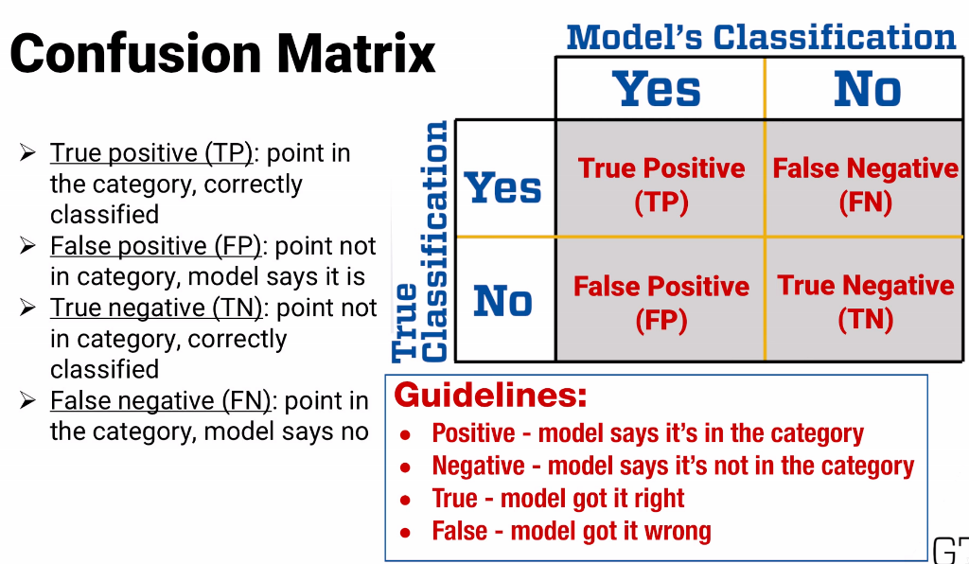

The word confusion here shows how much the model is confusing the two categories. Each of the cells in the table has a name too. If the model correctly indicates that a data point is in the category it's called a true positive or TP. If the model makes a mistake, it takes a data point that's not in the category and says it is, that's called a false positive or FP. If the model correctly indicates that a data point is not in the category it's called a true negative or TN. And if the model takes a data point that is in the category and says it's not that's called a false negative or FN. Here's a quick guideline to remembering these names. Positive means the model says it's in the category and negative means the model say it's not. And true means the model got it right, false means the model got it wrong. Here's an example. Suppose we have a support vector machine model to filter out spam from our email. After testing it on 1000 emails, 500 of which are valid and 500 of which are spam, here are the results. Of the 500 valid emails, 490 are correctly classified as real and 10 are incorrectly labeled spam. Of the 500 spam emails, 400 are correctly classified as spam and 100 are incorrectly labeled as real. Note here that because we have two classes, we can put all the results into one confusion matrix. Here it's the confusion matrix for real email. So positive means it's real, negative means it's spam. The confusion matrix lets you quickly find the answers to some important questions. For example, supposing that the user believes half of their incoming email really is spam and wants to know what fraction of email in their inbox they should expect to be spam, if this model is used as a filter, how could they do it? Take a minute, think about the answer, and then unpause your video. The total number of emails in their inbox is TP plus FP. And FP is the number that are actually spam. So, this would be 100 false positives divided by 490 true positives, plus 100 false positives or about 17%. Similarly, suppose they want to know what fraction of real email would get lost in the filter. That's just 10 false negatives divided by 490 true positives plus 10 false negatives and that's 2%. So the confusion matrix can be really helpful for presenting data to make these sorts of calculations in a straightforward way. Hopefully that wasn't confusing. But now let's see how people have really put the confusion back into confusion matrices. There are a couple of common measures that people might assume you'll know. Sensitivity, the number of true positives divided by true positives plus false negatives. That's just the fraction of category members that are correctly identified. And specificity, true negatives divided by true negatives plus false positives. That's the fraction of non-category members that are correctly identified. Those are good ones to remember.

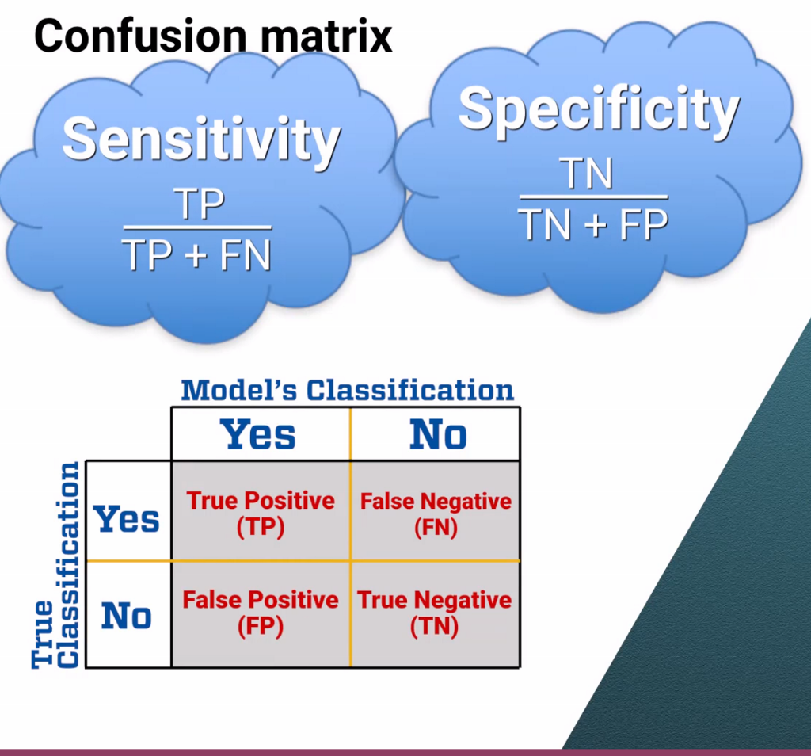

But there are also lots of others, with each come with their own name, sometimes more than one name for the same thing, like: accuracy, diagnostic odds ratio, fallout, false negative rate, false omission rate, false positive rate, hit rate, miss rate, negative likelihood ratio, negative predictive value, positive likelihood ratio, positive predictive value, precision, recall, true negative rate, true positive rate. (*overwhelmed scream*) You can go ahead and memorize all these if you want, but I don't recommend it. You can always look up a definition for something if you need it and we have the definitions posted for you in the glossary. The most important thing to do is to not get bogged down in memorizing definitions, but instead to understand the basic confusion matrix and be able to think through like we did above, how to use the contents of the confusion matrix to calculate whatever metrics are important in your analytics application. You can also use the contents of a confusion matrix to calculate the expected value or cost of a model's suggestions. We'll see that in another lesson.

### 10.6: (C): Situationally-Driven Comparison

- In this lesson, we'll see how to use measures of a model's quality to evaluate and compare different possibilities and choose the best one. I'll illustrate the method using a confusion matrix, so if you're not familiar with the concept, please watch the confusion matrix lesson first. I see you're still here, so I'll assume that you're not confused about confusion matrices. Let's use the same example we had there. We've built a support vector machine model to filter out spam from our email. After testing it on 1,000 emails, 500 of which are valid, and 500 of which are spam, we found that 490 of the 500 real emails are correctly classified, and only 100 of the 500 spam messages make it through to the inbox. Here's how we can use the confusion matrix to evaluate a model. We just need one additional piece of information: the cost of lost productivity. There's zero productivity costs to correctly classifying real messages and to correctly filtering out spam. But what if someone wastes time reading spam? I've seen more than one estimate of the cost, let's use one estimate I've seen, about $0.04 per message read. Estimating the cost of missing a real message, because it was classified as spam is harder. Let's say that's $1 per missed message. Assuming half of email is really spam, as in our example, the total expected cost of 1,000 messages is 490 times $0, plus 10 times $1, plus 100 times $0.04, plus 400 times $0, or $14. Here's the cost of the true positives, or correctly identified real messages, the cost of false negatives, real messages that are filtered out incorrectly, the cost of false positives, spam that's not filtered out, and the cost of true negatives, correctly filtered spam. Overall that's about 1.4 cents per incoming email. What if our initial assumption is wrong though? Maybe only 40% of email is spam and 60% is real? Then we just need to scale each of our entries in the table. Real email gets scaled up from 50% to 60%, and spam gets scaled down from 50% to 40%. Now it's about 1.52 cents per incoming email. This is very helpful information by itself, but it can also help us compare different models. Let's look at our original model's confusion matrix. Looking at the ratio of false positives to all positives, or all email that gets through, we know that about 17%, or 1 out of 6 of the messages in the inbox will be spam. 1 out of 6 might sound like a lot. So suppose we develop another stricter model that filters out more spam, but as a result, more real email gets accidentally filtered out too. Using this new model, our inbox would have about 1 out of 10 messages be spam. As a person who has to wade through a lot of spam some mornings, this sounds like a nice improvement. But is it really? Let's look at the cost of the new model. Now that's 5.2 cents per incoming email, a lot worse than the first model. So even though the second model classifies more email correctly, and reduces the amount of spam in my inbox, it's actually worse than the first model because it makes me miss more real messages, some of which might really be pretty important.

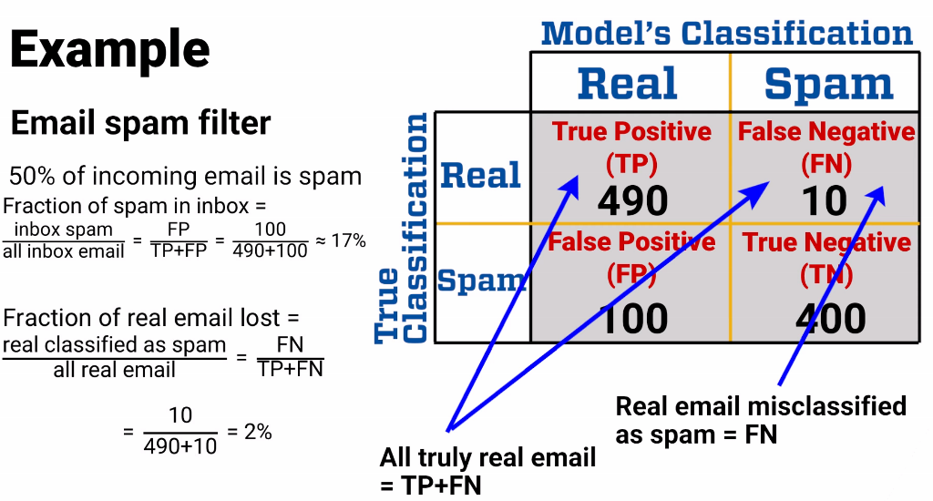

### 10.7: (M): Advanced Topics in Regression

In this lesson I want to make you aware of some advanced methods related to regression. We're not going to cover any of them in any detail, they're things you can learn in our elective courses. Instead, I want to give you a brief description of each one, so you have some idea of what they are. Some of these methods are parametric methods, like much of what we've seen before. We choose the form of the predictor, like in basic linear regression, where the response is estimated as a zero plus the sum of aj times xij. And other methods are non-parametric. We don't force any specific form onto the predictor. For example, in the k-Nearest-Neighbor and spline regression models we'll see in just a minute. The first method I'd want to show you in this lesson is Poisson regression. **Poisson regression** is used when we think the response follows a Poisson distribution. For example, when we're trying to count the number of arrivals at an airport security line. But instead of having a single parameter lambda to estimate, in Poisson regression, we assume that the parameter is a function of other attributes. For example, the base rate of arrivals to the airport security line can be a function of time of day, day of the week, whether it's a holiday, etc. And we could use Poisson regression essentially to estimate that function, lambda of x, and then, given lambda of x, we can make predictions about the expected arrival rates. A second advanced regression method is called regression splines. A **spline** is a function made up of polynomials that connect to each other. In this graph, there are four pieces to the spline. Where the pieces connect is called the knot, and the polynomials connecting them have to be mostly smooth at the knots. The regression spline allows us to fit different functions to different parts of the data set, with smooth connections between the parts to ensure that we don't have drastically different answers for very nearby points. An order-k regression spline means that the polynomials are all order k. There's one other term that might be helpful to know, a specific implementation of regression splines is called **multi-adaptive regression splines**, or MARS, but since MARS is actually a trademark in many libraries, including one for Python, you can find it under the name Earth instead, really. It's not always the best way to do regression splines, but it often works very well. The next advanced regression method I'd want you to be aware of is called **Bayesian regression**. In Bayesian regression we don't just start with data, we also start with some estimate of how we think the regression coefficients and the random error is distributed. For example, suppose we're trying to predict how tall a child will eventually be as an adult, based on the heights of the child's mother and father. An expert on height genetics might give us a starting distribution, for example, that the coefficients of mother's and father's height are each uniformly distributed between 0.8 and 1.2. We can then use Bayes' theorem to give an updated estimate of the coefficient's distributions, based on the data we have. Bayesian regression is often most helpful when we don't have much data to start with. In the absence of a lot of data, we can essentially combine expert opinion with the small amount of data we do have, and use the data to temper the expert opinions and vice versa. Or if we don't have an expert opinion, we could choose a broad prior distribution, say uniform over a very large interval, and use it as seed data that can be adjusted significantly by the data we have. The last regression I'd want you to see in this lesson, might be the simplest. It's called **k-Nearest-Neighbor regression**, and it's very similar to the k-Nearest-Neighbor method that's in the classification topic. In k-Nearest-Neighbor Regression, we don't try to guess what function of the attributes might be a good predictor of the response. Instead we just plot all the data we have, and then when we get a new data point that we need to predict a response for, we find the k closest data points to the new one, and take the average of their responses. That's our predicted response for the new point. Just like in the k-Nearest-Neighbor classification method, we could do fancier things, like weighting each dimension of distance, or removing dimensions that aren't very predictive, but at it's core, this is a very quick and easy method to implement. That's the end of this lesson, but it's not the end of all the advanced regression methods that people continue to come up with and refine. As you might imagine, because the purpose of these models is to answer some of the most common and most important questions in analytics, researchers are hard at work coming up with better and better versions all the time. So in addition to learning about the specifics of regression itself, I hope you've also learned in this topic the overarching sorts of ideas that these models are based on. So whenever a new hot model is developed, you'll have the ability to understand and use it.

# 

## 11. Variable Selection

[*Module 11 Knowledge Check*](https://docs.google.com/document/d/1yuw3-UDAshOEO7obCBcrQhyoLQaJSfegLRhkrjMU-PE/edit#heading=h.5i3ow9ltiy89)

### 11.1: (C): Introduction to Variable Selection

As we'll see in this lesson, there are two important reasons why we might not want to keep so many factors in our model. Instead, we'll use methods of **variable selection** to choose which factors to include. As we go through the lesson, I'll use regression to explain the ideas, but please keep in mind that they can apply to any other factor-based model, as well. And whenever I show a variable selection method that's specific to regression, also keep in mind that the same idea can be applied to other factor-based models.

Let's start by seeing the two main reasons why we might not want to many factors in our model. First, when the number of factors is close to the number of data points, or even more when we have more factors than data points, there's a danger of **overfitting**. Remember back to the lessons on validation, when we talked about how when we fit models to data, we're fitting to real effects and to random effects. That's why we have to measure effectiveness on a data set that's different from what it was trained on. The effectiveness on real effects will be about the same, but the different data set will have different random effects, so we won't be overestimating the model's effectiveness.

The problem with having too many factors in a model is similar. If we have too many factors, then the model might fit too closely to random effects. Here's a simple example. Suppose we want to fit a regression model to predict how tall a girl will be as an adult based on the total height of her father and mother. Here are a bunch of data points. And here is a regression line through those points. This looks fine. And if we want to estimate the adult height of a girl whose parents add up to 11' tall, our model estimates about 5'3".

To show overfitting, we need the number of factors to be the same order of magnitude as the number of points. If we were to add 10 more factors to this model we'd have a good example. But then we'd need a 12-dimensional picture, and you wouldn't be able to see what's going on. So instead of just adding more factors, let's suppose we had just the same one factor, but fewer data points.

Here's a set of just three points with its regression line and equation. Here's another set, and another. As you can see, in one case, we happen to get a couple of taller-than-expected data points, and in another case we happen to get a couple of shorter-than-expected data points, and the regressions fit not only to the real effect, but also to the random effect of getting taller or shorter data points. And now, when we try to use the models to estimate the height of a girl whose parents add up to 11' tall, we get three very different estimates.

The reason is that our estimates are strongly influenced by the random effects. We have enough factors to get a good fit not only to real effects, but also to those random effects.

Let's see an even sillier case. Suppose we wanted to estimate the adult height of a girl based on how many degrees above or below the daily average temperature it was 37 days after she was born. We probably wouldn't expect there to be any correlation between adult height and relative temperature 37 days after birth, so the data might look like this. As you can see by the slope of the line and the regression equation, there's no effect. But, if the number of factors is the same order of magnitude as the number of data points, then again we get regression lines that fit random effects, which leads to the false conclusions we see in the regression equations. And that's why overfitting is a problem we need to avoid.

In addition to overfitting, there's a second reason we might not want too many factors in our regression equation. **Simplicity**. Simple models are usually better than complex ones. With fewer factors, less data collection is required. As you can probably imagine, collecting all sorts of exotic data and many, many data points can be both difficult and expensive, and sometimes even impossible.

Using fewer factors also means there's less chance for including a factor that isn't really significant. As we saw in the lesson on interpreting regression output, if you have a factor with a p-value of .05, there's still a 5% chance it's really meaningless. And if you have 20 of them, assuming independence, there's a 64% chance you've included a factor that isn't really meaningful.

Finally, explaining a model with lots of factors can be very difficult. That's really important, because in most uses of analytics, if you want your model to be adopted, you have to explain to managers and executives who might not have analytics training, what your model means. Most people, whether they have quantitative training or not, won't just take an R-squared value as sufficient evidence. Instead, we all want to know why a model works. What is it really saying qualitatively about the relationships between factors? If you go in with a model that includes 100 or 1,000 factors, it's often very hard to explain how that model works. If you have a model that products almost as well using a much smaller number of factors, the explanation is much easier.

I almost can't stress this enough. No matter how good the pure data science is, if you can't clearly communicate what your model is doing, in many cases, it just won't be trusted, and it won't be used.

In fact, there are even some industries where your very complex model would be illegal to use. For example, in the United States, there are some factors such as race, sex, religion, and marital status, that cannot legally be used to make credit decisions. No problem. You just take those columns out of your data set when running the regression, right? Well, not quite. You also need to make sure your model is not using other information that correlates highly with one of those factors.

For example, there are a lot of zip codes that are very predictive of a resident's race. The factor "does this applicant live in Utah" correlates very well with the probability that an applicant is of the Mormon religion. And there are combinations of innocuous-sounding factors that can be predictive of sex, marital status, or other forbidden factors. The difficulty with an overly-complex model is that it can be very hard to demonstrate that your model is not indirectly using any of the forbidden factors in making its credit recommendations, and that means a regulator might not allow your model to be used, no matter how good a job it does at predicting who's a good credit risk.

### 11.2: (C): Models for Variable Selection

In a previous lesson, we saw why it's often better to create models with fewer factors, but we haven't yet seen how to go about doing the variable selection, choosing that smaller number of factors. In this lesson we'll see some **variable selection approaches.** As with the previous lesson, I'll discuss and illustrate those approaches in the context of regression, but please keep in mind that the same ideas are applicable to lots of different types of models.

In this lesson, we'll talk about two general types of variable selection methods, each of which can be done in different ways. The first type of variable selection approach is more classical to go step by step, either building up or narrowing down a model. The **forward selection** approach is to start with a model that has no factors. At each step we find the best new factor to add to the model and put it in as long as it's a good enough improvement. When there's no factor that's good enough to add, or if we've added as many factors as we want to have, we stop. At the end, we can optionally go back and remove any factors that turn out not to be good enough.

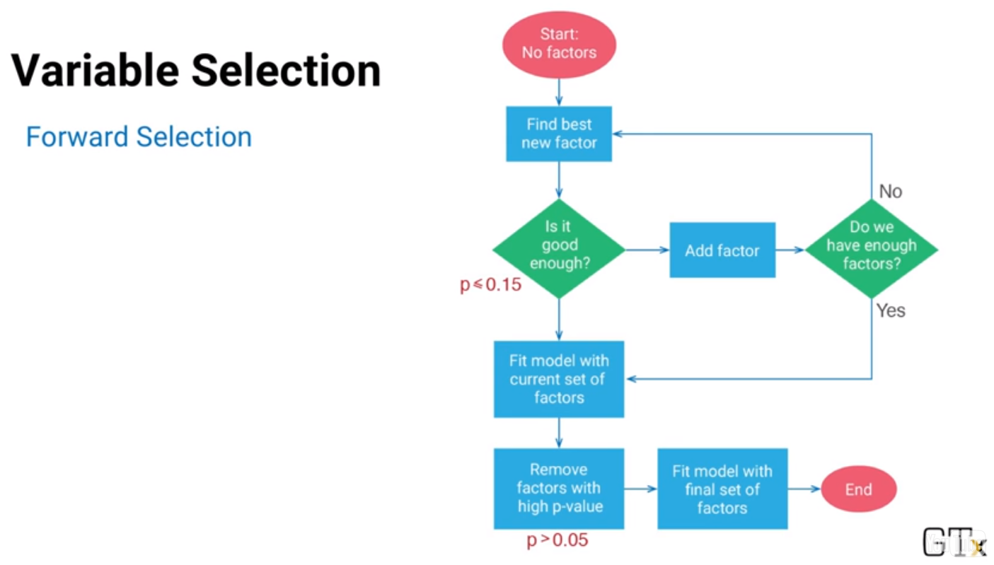

The definitions of good and good enough are parameters that you can set. It's common, for example, to allow new factors to enter the model if their p-value is below .1 or .15 just for exploration, but at the end when removing factors, we might remove anything with a p-value above .05.

**Backward elimination** is the opposite of forward selection. We start with a model that includes all factors and at each step, we find the worst factor and remove it from the model. We continue until there's no factor bad enough to remove, and the model doesn't have any more factors than we want. Again, the definition of bad enough is something you can set.

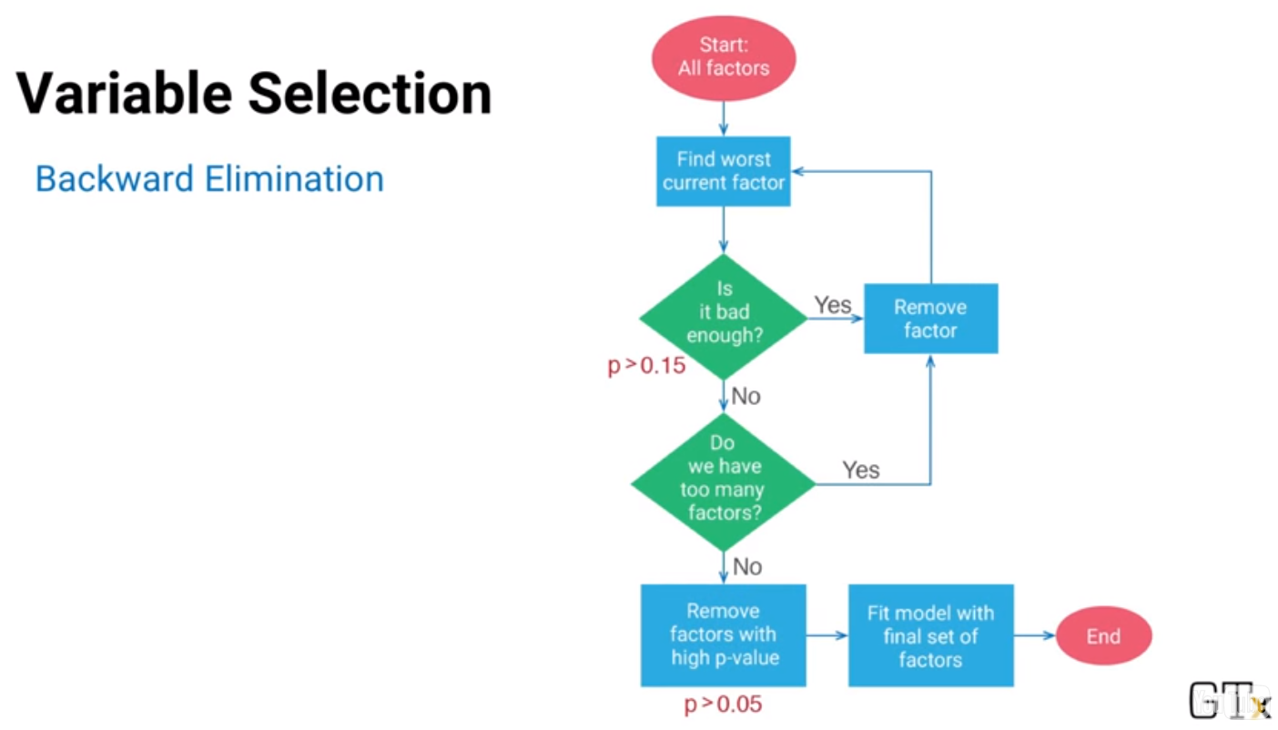

Another common approach is a combination of forward selection and backward elimination called **stepwise regression.** There's more than one variant of stepwise regression, so I'll just show one. We start either with all factors or no factors and at each step, we remove or add a factor. In the flow chart, you'll see that we're using a forward approach, building up from nothing. As we go through the procedure, after adding each new factor and at the end we eliminate right away any factors that no longer appear to be good. That allows the model to adjust if a factor we earlier thought we needed no longer seems necessary thanks to new factors added to the model.

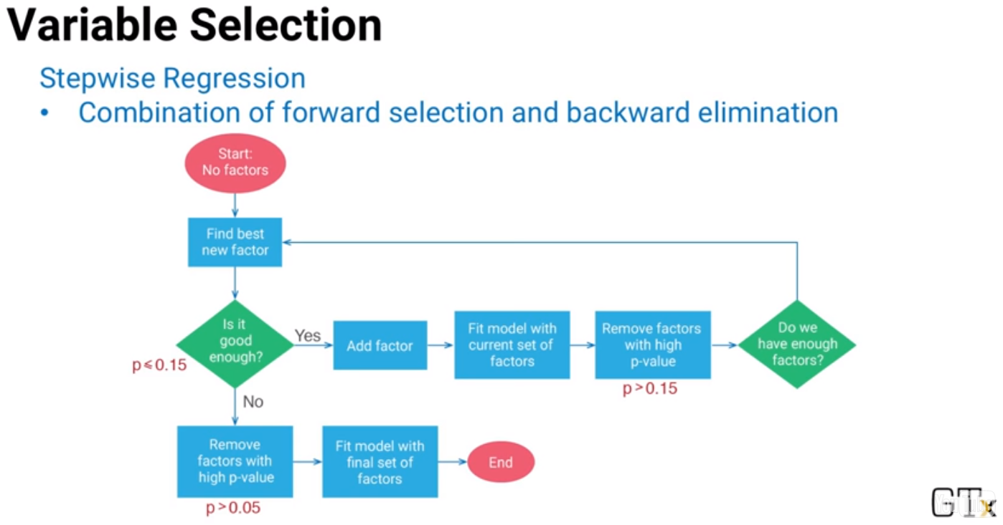In all of these examples I've talked about, using p-values to determine whether to add or remove a factor from the model is what we've been doing, but there are other metrics you might use instead. We've talked in a previous lesson about a model's r squared value and about the Akaike information criterion and the Bayesian information criterion. All of them can be used to pick the factor to add or remove in a forward selection, backward elimination, or stepwise regression procedure. So that's one type of variable selection method where decisions are made step by step. That sort of method is called a **Greedy Algorithm.** At each step, it does the one thing that looks best without taking future options into consideration. Those models are all more classical.

There are other newer methods based on optimization models that make decisions more globally, looking at all options at the same time. The first of these methods I want to show you is the **LASSO** approach. In the LASSO approach, we add a constraint to the standard regression equation. As before, we want to choose coefficients to minimize the sum of squared errors *but add in the restriction that the sum of the coefficients can't be too large:*

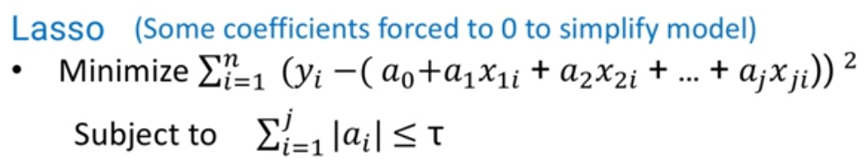

Essentially, *we're giving the regression a budget to use on coefficients.* It'll use that budget on the most important coefficients which means all the rest of the factors will have zero coefficient and so those factors won't be part of the model. As we've seen in past lessons, for example in the support vector machine approach to classification, whenever we're constraining the sum of coefficients, we first need to scale the data; otherwise, the units we use to measure the data will artificially affect how big the coefficients need to be. For example, measuring age in years will require a much larger coefficient than measuring age in days. So if you haven't yet seen the lesson on scaling data, please go back and view it.

One last note about the LASSO approach. You might wonder how to pick the right value of t. That depends on two things: the number of variables you want and the quality of the model as you allow more variables. The best idea is often to use the LASSO approach with different values of t and see which gives you the best trade off. A second approach is called the **Elastic Net**. It's almost the same as the LASSO method, but we constrain a combination of the absolute value of the coefficients and their squares:

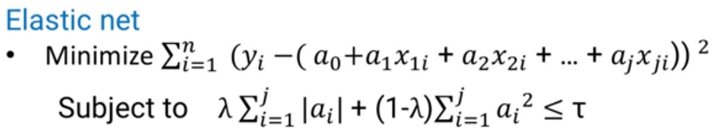

The same issues, needing to first scale the data and picking the right value of t, apply for the elastic net just like for LASSO.

Incidentally, if we were to take out the absolute value term from the elastic net, we'd get a model called **Ridge Regression**. We'll see Ridge Regression in a different lesson. It doesn't do variable selection, but it does sometimes lead to better predictive models.

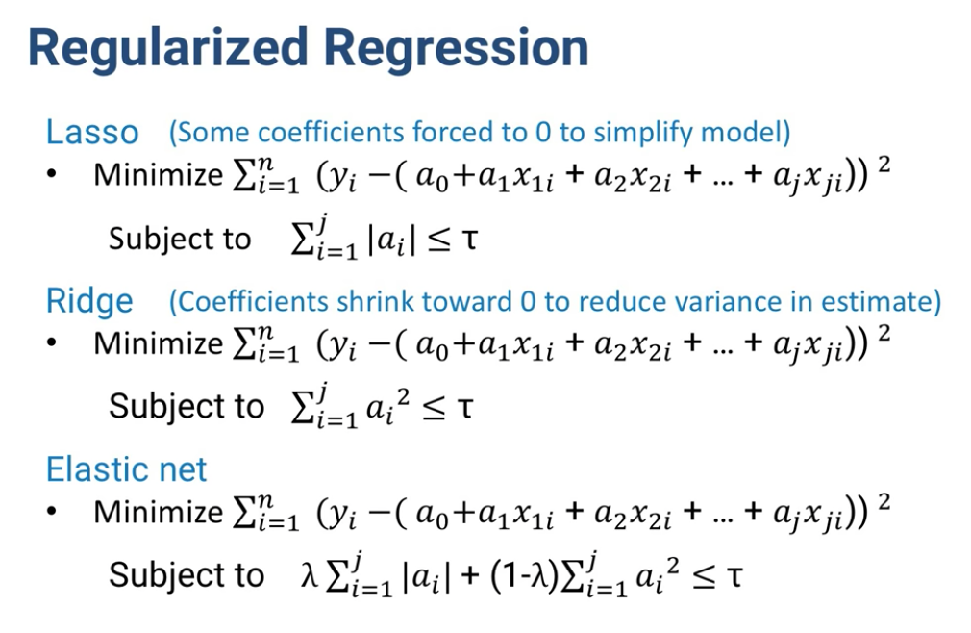

### 11.3: (C): Choosing a Variable Selection Model

Quick methods like the forward, backward and stepwise approaches are often good for data analysis. They'll point out some variables that might be important to investigate further and they'll do it quickly. Within the three methods, Stepwise is probably the most common, as a generalization of the other two. On the other hand, they can end up giving you a set of variables that fit more to random effects than you would like and that consequently, appears to have a better fit such as a higher R squared value than the model really has. When you test these models on different data, they often don't perform as well.

On the other hand, methods like LASSO and Elastic net are usually slower to compute but they tend to give better predictive models. In general, I would recommend these more advanced, slower models unless you're just doing introductory data exploration, in which case, you can use the greedy methods first and then build a more refined model later with LASSO or Elastic net. You might still be wondering though, what's the difference between the two?

And what's the difference of this sum of squared coefficients? To answer that, we'll have to see one more form of regression, called **ridge regression**:

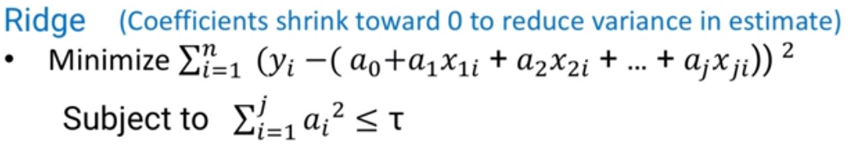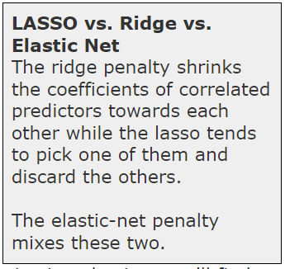

As you can see, Elastic net looks like LASSO regression plus ridge regression. We start with the basic regression model. LASSO adds the absolute value term in the constraint. And ridge adds the quadratic term. We've seen in a previous lesson how the absolute value term in LASSO helps to decrease the number of factors with non zero coefficients.

There's more math behind this than we have time to cover in this class but let me explain briefly what goes on. The quadratic term in ridge regression tends to shrink the coefficient values. Whatever the basic regression model coefficients would be, the quadratic constraint pushes them toward zero or regularizes them. Because it's a quadratic term rather than a linear one like LASSO, it turns out that it doesn't make lots of coefficients equal zero. For anyone who knows optimization theory, it's the difference between an extreme point and an interior point of a polytope. And if you don't know what those words mean, don't worry. If you take the optimization elective, you'll find out.

In any case, shrinking the coefficient values add some bias but it helps to reduce the variance in our estimates of the coefficient values.

And because prediction error is a function of both bias and variance, it turns out that trading off bias for variance can lead to better predictive models:

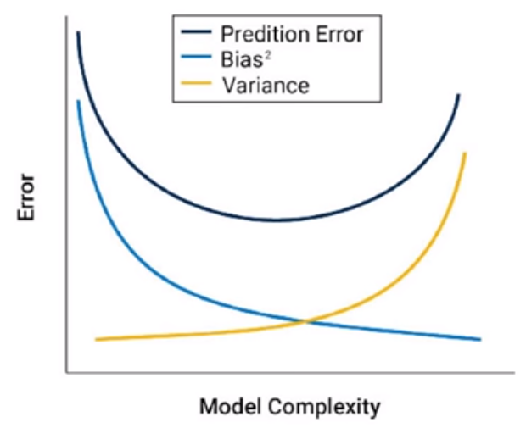

Coming back to the Elastic net approach, its benefit is that it can combine the variable selection benefits of LASSO with the predictive benefits of Ridge regression.

On the other hand, it also combines some of the drawbacks of each. Suppose the data set has two factors that are highly correlated. LASSO will usually pick just one of them to have a non zero coefficient. The other one is left out of the model. Ridge regression will include both and because both coefficients shrink, they get closer to each other. It's not always clear that the one of the two factors LASSO uses is the best one.

For example, among relevant patients in your data set, two medical tests might give highly correlated results and either one would lead to a good predictive model. But one test could be very inexpensive while the other is very costly. Obviously, you'd prefer for your model to use the inexpensive test but LASSO might include the expensive one instead. So, you might need to check the correlations yourself and manually remove the expensive test and rerun the model. Or you might never know and possibly be stuck with an expensive recommendation. On the other hand, Ridge regression includes more factors and because larger coefficients contribute much more to the constraint term, it tends to shrink the coefficients toward each other. That means if you have some really good predictors, their coefficients might be underestimated by this method.

Overall, there really isn't a good rule of thumb for when to try one approach or another. If you have time to try one of them, you probably have time to try more than one and compare the differences between the models they suggest. As you've probably heard me say several times already in this course, despite all the mathematical foundations, there's a lot of art to analytics. And this is yet another example where the models can help provide insight and direction but in building a final model, our human input is almost always beneficial.

# Week 9

## 12. Design of Experiments

[*Module 12 Knowledge Check*](https://docs.google.com/document/d/1yuw3-UDAshOEO7obCBcrQhyoLQaJSfegLRhkrjMU-PE/edit#heading=h.njl93bogzjen)

### 12.1 (M): Introduction to Design of Experiments

Sometimes, we don't have the data we need and getting the full set of data either isn't possible or would take too long. So we have to design a way to try to collect the best subset of data we can get, quickly and efficiently.

And when collecting that data, we have to make sure that the data we get will be sufficient for us to answer the questions we need to. That design process is called **design of experiments** or **DOE**. Here are some examples of when we might need to use this sort of method.

Suppose we want to advertise Georgia Tech's Master of Science in Analytics degree on web pages using a banner ad. And our marketing department has designed two ads that both look good. How can we determine which one will get the most people to click on it? Or, think about an online retailer. When you search for something on the retailer's site, you might not like the results of the search, or maybe they don't have what you want, or the price is too high, or it's the wrong color, or it isn't available for immediate delivery. The retailer still wants you to purchase something from them, so they'll often put up pictures of similar or related products you could buy instead. How can that retailer determine which other products or what mix of products to show you?

And we could extend the question in a different way. Suppose you do want to buy the product. What complementary product should the retailer show you to get you to make a larger purchase than you intended?

Another example is a survey or political poll. Surveying everyone is too expensive, they have to just survey a small subset of the population, but how do they know they're getting a representative sample?

And even if the sample is representative in simple ways, maybe it isn't in more complex ways. For example, in the political poll, they might want to make the poll demographically representative. Representative samples of men and women, young, middle age, and older people, and several other factors. How can they still have a representative sample of each combination of factors, while only surveying 600 people? And in the end, how do they determine which of the several factors are most important to predicting someone's answers? There are lots of other examples when this type of question is important too. Comparing combinations of medical treatments, maximizing agricultural productivity. Determining factors that lead to a startup company's success, etc.

Before we go deeper into DOE, I want to mention two important concepts. The first is **comparison and control**. If we're trying to determine whether red used cars sell for higher prices than blue used cars, then we need to compare red car prices to blue car prices. That's pretty obvious.

What's a little less obvious is that we have to control for other factors. When we separate our cars into red and blue, we need to make sure that the red and blue car data points collectively are about the same in all other important features. If we compare data from sales of two-year old red Porsches and ten-year old blue family cars, it's more likely that the red cars will have sold for more money than the blue ones, but is that because of the color? Or because, one set of cars is much newer than the other, or because of the difference between Porsches and family cars. We need to make sure, that we're controlling for the effects of color, and car type. And to do that, we either need to make sure the two data sets have the same mix, or we need to break down the data into smaller sets, that test all of the factors, not just color.

A second important concept is **blocking**. A blocking factor is something that could create variation. Let's go back to the red and blue car example, again. The type of car, sports car or family car, is a blocking factor that could account for some of the difference between red cars and blue cars because sports cars are more likely to be red. If we account for that difference, we can reduce the variability in our estimates. We can analyze red sports cars by themselves and red family cars by themselves. In each set, we'll have lower variance than if we just analyzed all red cars together.

### 12.2 (M): A/B Testing

In this lesson, we're going to talk about how to use analytics to pick the best out of several alternatives. We'll start with a simple case and then move on to something more complex.

I'm sure you've all seen banner ads on websites. And you've probably even seen two different banner ads for the same thing. In fact, I'm sure you've seen two different banner ads for the same thing. You just might not have noticed the differences because sometimes they are very subtle. Have you ever wondered how they decide which ad to show you? That's what we'll start talking about today.

|  |
| --- |
| Case Study: Banner Ad Test Suppose we have two designs for this Georgia Tech Master of Science and Analytics banner ad. And we want to decide which one to put out there. We could get all of our marketing and leadership teams in a room and have everyone argue it out. But the answer still might be wrong because none of us are perfect. And the way group dynamics work in this sort of discussion, it's not clear we'd come to the right answer.  But we don't need to do that, instead, we can go collect some data. Suppose we use both ads for the first, say, 2,000 times the ad is shown. Each time, we'll randomly pick either the first ad or the second ad. And we'll track how often each ad is clicked. At the end, we'll have essentially binomial data for each ad. Maybe Ad A was clicked 46 times out of the 1003 times it was displayed. And Ad B was clicked 97 times out of 997.  As you probably remember from basic statistics, we can use a simple hypothesis test to show that, in this case, it's very likely that Ad B is more effective. If Ad B was clicked only 47 times out of 997, then the test would show there's not much evidence for either ad being better than the other.  Either way we'll have our answer. Either we'll know how to use Ad B going forward. Or we'll know that it probably doesn't matter which ad we use. Note here that we don't even need to decide in advance to test 2,000 times. Instead, we could run our hypothesis test after every observation, or every ten observations, or something. And we could stop whenever the results get extreme enough that we're sufficiently sure which alternative is better. In analytics, this sort of procedure is called **A/B testing.** And we can use it whenever we want to choose between two alternatives as long as the following 3 things are true:   1. We need to be able to collect a lot of data quickly enough to get an answer in time to use it. 2. The data we collect has to be from a representative sample of the whole population we want to use the answer on. Otherwise, the answer might not apply. 3. The amount of data we collect has to be small compared to the total population we want to use the answer on. Otherwise, for example, if we only expect 2,500 views of our ad, and we spend the first 2,000 of them collecting data, then there won't be enough people left for us to get much benefit from our results. |

So that's how we can test to see which of two alternative are better. A/B testing is a common approach in marketing, especially online, as well as in other applications.

But what happens if we have several alternatives? And what if we're concerned with not just figuring out which is better, but we also don't want to waste too many trials on bad alternatives? We want to make sure that we also take advantage of what we're learning along the way? Or what if we have several factors we want to test to see which combination works best? Those questions are more complicated. And we'll see how to deal with them in upcoming lessons.

### 12.3 (M): Factorial Designs

In a previous lesson, we saw A/B testing, a simple way to compare two different alternatives. For example, to see which of two different banner ads generates more clicks. You can see that they have different fonts, different wording and a different background color.





Suppose we know that the ad on the left generates 50% more clicks, but why? How important are each of the differences?

To answer that question, we can do a **full factorial design.** We can test the effectiveness of every combination. Two fonts times two wordings times two background colors gives eight different combinations. And once we've tested them all, basic ANOVA analysis of variants can determine how much each of the factors contributes to the differences in each combination.

That might be fine if we only have eight combinations to test. But what if we have, say, seven different things we can change and each one has three possible choices. Then we would to test three to the seventh power different combinations, a total of 2187. That's often too many to test. So instead we might just choose a subset of combinations to test called a **fractional factorial design.**

The basic idea is to test fewer combinations while still testing a good range of values for each factor. For example, let's look at the banner ads again. Here's a table of the eight combinations we need for a full factorial design…  
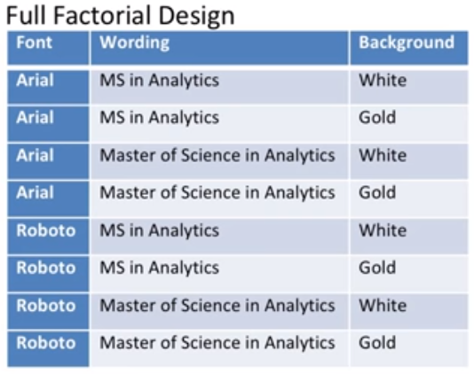

… and a table of a partial factorial design, which needs only needs four combinations:

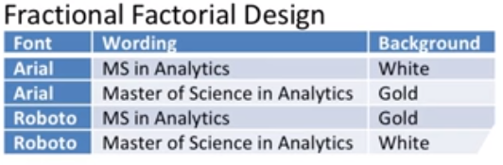

The second table has some nice properties. Each choice appears the same number of times (twice), and each pair of choices appears the same number of times (once). For example, the combination of Arial and white appears once, as does Roboto with MS in Analytics, etc. That's called a **balanced design.** For more complicated experiments with more factors and more choices, it's still possible to create good designs, good sets of combinations to test.

There's another possible approach if we believe that the factors we can change are independent. In that case, we can again test a subset of combinations and then use regression to estimate the effect of each choice. Each factor would get its own categorical variable.

For example, we might have a variable for background color, which could be gold, blue, or white, and a variable for font size, which could be 10, 12, or 14 point. Based on each of the factors that makes up every combination, we could use regression to estimate the number of clicks as the response. If there aren't significant interactions between the factors, then this could work well.

Of course, depending on the factors, we might need to include a few **interaction terms.**For example, font color and background color probably are not independent. A white background might do very well on tests and a white font might do very well on tests, but a white font against a white background would not be very effective. There are other more advanced approaches which I won't talk about in any detail.

For example, the response surface methodology is similar to a factorial design, but it allows for squared terms as well as linear terms when running the tests. The important takeaway is that all of these approaches can be very helpful when they're used before modeling and even before collecting data. If you're in the position to decide what data to collect and what comparisons to try, factorial design can be a powerful tool.

### 12.4 (M): Multi-Armed Bandits

Let's say there were ten different alternatives, and we tested each one a thousand times. And number one turned out to be the best. So the thousand times we tested alternative number one, we were showing the best ad.

But the other 9,000 times, we were showing an ad that wasn't the best. So we probably lost value. Had we shown them number one, we would have gotten more people clicking on our ad. And what if we hadn't stopped at a thousand tests each, but had done 10,000 tests each? We could be more sure that number one really is the best ad, but we would have lost even more value from showing ads that weren't our best. So there's a tradeoff.

Every time we're presented with an opportunity to show an ad, we have to balance the benefits of getting more information, and getting immediate value. In analytics jargon, those two types of benefits are called **exploration** and **exploitation**. Exploration means that we're focusing on getting more information, in this case to determine with more certainty which ad is really the best. And exploitation means that we're focused on getting immediate value. In this example, to show the ad that seems to be doing best so far, because it seems to be most likely to be clicked.

The question of exploration versus exploitation is somewhat common, especially in machine learning algorithms. In our context, there's even a name for this sort of problem, **the Multi-Armed Bandit problem**. The name comes from gambling, specifically slot machines. In a slot machine, you put money into a slot and pull a lever. And depending on what pictures show up in the machine's window, you either win money or get nothing back. A slot machine is sometimes called a one armed bandit. One armed because a little lever that sticks out like an arm. And bandit because the probabilities of winning and the amount you can win are carefully calibrated to give the player a negative expected value. On average, you'll lose money playing them. So that's a one armed bandit.

But suppose there were several slot machines next to each other, each with a different expected payout that we don't know. A slot machine player would want to play the one with the highest expected payout. But the only way to find out which has the highest payout is to test them all.

Here's how the multi-armed bandit approach works. Suppose we're testing K alternatives, we start without any information. So each alternative seems to have equal probability of being best. So for the first test we have an equal probability of selecting each alternative. After performing some tests, we've gotten more information, so we can update the probabilities of each one being best and start assigning new tests according to those probabilities. We keep testing multiple alternatives, so we're still doing exploration. But we make it more likely to pick the best ones, so we're also doing exploitation. We keep repeating this process, collect data, update probabilities, and continue, until we're sufficiently sure which one of them is best. And along the way, we're getting more value out of the process by making it more likely to pick the options with higher estimated value. As usual, there are several parameters we can vary in this sort of algorithm. We can change the number of tests between re-calculating probabilities. We can change the way we update the probabilities.

For example, we can use basing updates, or estimate from the observed distributions. And, we can change how we assign new tests. For example, just looking at probabilities of each alternative being best, or taking into account the expected value of each. And also, as usual there's no simple rule for what choices will work best.

But in any case, it usually works much better than running a fixed, large number of tests for every alternative. And it's worthwhile. Multi-armed bandit models both help you learn faster on the fly, and also create more value along the way.

## 13. Probability-Based Models

### Summary: Probability Distributions

|  |  |  |  |  |
| --- | --- | --- | --- | --- |
| Distribution | PMF | Memoryless? | Notes | Example |
| Bernoulli | $$p^{k}q^{(1-k)}$$ |  | Special case of binomial distribution |  |
| Binomial | $$\frac{n}{k}p^{k}q^{(n-k)}$$ |  | A bernoulli distribution with the same value of p and are independent | Number of successes in a sample drawn with replacement |
| Geometric |  | Yes (The only Discrete memoryless) | Discrete Analogue to Exponential | Number of phone calls by a telemarketer until one is answered |
| Poisson |  |  |  | Number of arrivals of busses in a given time span |
| Exponential | $$λe^{-λw}$$ | Yes (The only *continuous* memoryless) | Inter-arrival time between Poisson Events  Continuous Analogue to Geometric | Time waiting for a bus until one arrives |
| Weibull | $$\frac{k}{λ}(\frac{x}{λ})^{k-1}e^{-(\frac{x}{λ})^{k}}$$ |  |  | Time until first failure of a machine (assuming failure rate is proportional to a power of time) |

### 13.1 (M): Introduction to Advanced Probability Distributions

In this lesson, we'll start to cover **probability distributions** and what they can tell us. Much of the buzz in analytics these days is how we can take huge amounts of lots of different types of data and combine them with appropriate models to discover some important insights. But sometimes before spending a lot of time and effort working through all that information to try to find something insightful, it's helpful to first try a simple approach.

|  |
| --- |
| Case Study: Baseball Ticket Upgrades An Atlanta baseball team wanted to allow fans sitting higher up, further from the action, to pay an upgrade fee to sit in a better seat that wasn't going to be used anyway. But when could they feel confident selling the seat upgrade? They wouldn't want to sell the seat too soon. If the ticket holder then showed up, that would cause a problem.  The team could wait a long time before selling the upgrade. If the fan hadn't shown up halfway through the game, then they probably aren't coming. But that also reduces the value of selling the upgrade. So, they wanted to determine how early they could sell each upgrade.  What factors might you want to take into account when trying to predict say, ten minutes before game time whether or not a season ticket holder will be at the game?  If you're like most people, you might have come up with a variety of factors:   * Factors about the ticket holder: age, marital status, number and age of children, even type of job and past data on how frequently the ticket holder comes to games and what time he's arrived in the past. * Factors about the team: how well they are playing? Where they are in the standings? And what star players are on the team? * Factors about the game: how good is the opponent? What star players are on the opposing team? How popular is the opposing team and does the game have any special significance? * Factors about the day. Day of the week, whether it's a holiday. What season of the year it is? What the weather is like that day? How the traffic is today on roads leading to the stadium or arena? Are there any special milestones or giveaways?   That's a lot of data to try to collect, let alone to analyze -- and it turned out we didn't need it.  We discovered most individuals come to a game about the same amount of time before the game relative to everyone else. So a person who usually arrives after about 60% of the crowd is there will do so whether it's a game when people tend to arrive earlier, perhaps a game with big playoff implications or whether it's a game when people tend to arrive later. Perhaps a week night game with a day with bad weather and lots of traffic, and the amount that they deviate is modeled pretty well with a normal probability distribution.  Just by tracking how the stadium is filling up, it turns out the company can use a simple probability distribution to get a pretty good idea of when they can safely sell and upgrade into a season ticket holder's seat and none of that extra data or analysis was necessary. |

It turns out that there are some standard probability distributions that are often good models for specific types of real phenomena: arrivals to security lines at an airport, broken equipment in a manufacturing facility, website viewers who buy products they've clicked on and more. In a future lesson, we'll see some of these useful probability distributions and how and when they come in handy.

### 13.2 (M): Bernoulli, Binomial and Geometric Distributions

In a previous lesson, we saw an example of how sometimes simply matching data to a probability distribution can give valuable insight based on how the probability distribution is derived. That's especially true when the only information we have about a data point is the response, or when it would be hard to collect and analyze additional information. In this lesson, we'll see some specific probability distributions, the binomial and geometric distributions. We won't spend much time on things you might remember from basic probability, each distribution's probability mass or density function, expectation, variance, etc. If you don't remember them, you can easily look them up.

Instead, we'll have a different focus, what some probability distributions are good at modeling and how to use them. As a basis for this lesson, let's start with a simple **Bernoulli Distribution.** The Bernoulli distribution is basically like flipping a coin just once to see whether we get heads or tails, except that instead of a coin that comes up heads half the time and tails half the time, the Bernoulli Distribution has more flexibility. We can specify a probability p that the coin comes up heads and probability 1-p that the coin comes up tails.

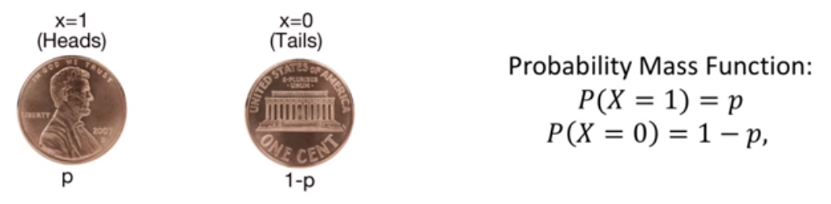

You can imagine the Bernoulli Distribution modeling a single event. Will it rain today or not? Will I get this job offer or not? Etc. But by itself, it's not so useful because it's only talking about one data point.

Where the Bernoulli Distribution gets useful, is when we put many of them together. Here is an example. Suppose a charity wants to keep it's month to month cash intake consistent. So each month, they send out mailings to one-twelfth of their list asking for donations. That way they hope to get about the same number of donations each month.

For this example, we'll assume that each donation is the same amount. If that's not true, it just adds one more layer of complexity, but doesn't change the basic idea. Essentially what the charity is doing is assuming each donation request is a Bernoulli random variable with probability p. Each recipient will send in a donation with probability p independent of the others. And each month they have the same number of these **Bernoulli trials**. The charity's key assumption is that every month, the probability p is the same. Otherwise if p differs from month to month, then the charity won't have the consistent cash flow they're looking for.

To test the assumption, the charity can observe how many successful trials -- how many donations they get each month -- and then use the binomial distribution to find the probability of getting at least that observed number of donations. If that probability is very low, it's likely that p is different for that month.

This question, the probability of getting x yes answers out of n independent Bernoulli trials, each with probability p is called the **binomial distribution.** Here's what the probability mass function is:

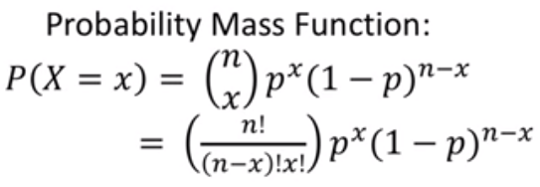

... and here's what the graph looks like:

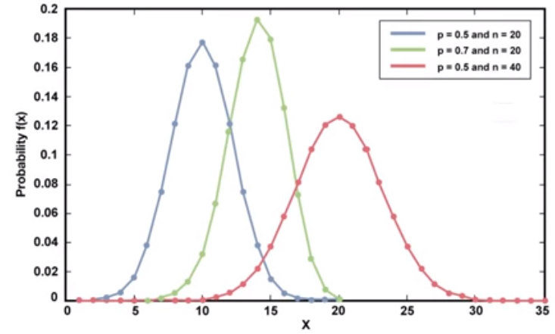

This approach might look familiar to you from a basic statistics course. It's a common approach in hypothesis testing and it's really just a good use of the binomial distribution.

One last note about the binomial distribution: as n gets very large, the binomial distribution converges to the normal distribution. The normal distribution is handy as an estimate for the binomial when n is large. Computing 157,496 factorial can get messy. And also, the normal distribution is very useful for modelling errors as we'll see in lessons on predictive models.

Another type of Bernoulli-related question that comes often is, how many trials are needed before we get an answer of a certain type? For example:

* How many interviews do you need to go on before getting your first job offer?
* How many of our Masters in Analytics students does a company need to make an offer to before one of you accepts that offer over the others you've gotten?
* How many hits does a baseball bat last through until it breaks?
* How many times does a manufacturing process create working units before a defective one is made?

This type of distribution is called the **geometric distribution.** Here's the probability mass function, and what the graph looks like:

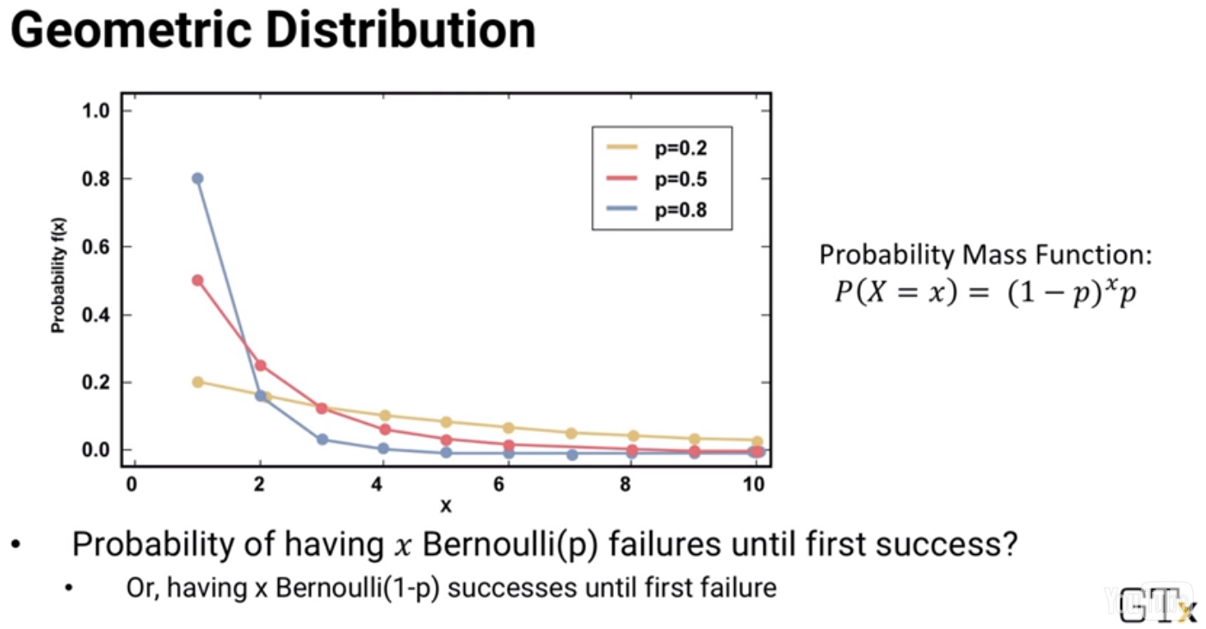

Note that in this formula, p is the probability of getting the answer you're looking for at the end -- the job offer, the broken bat, or the defective unit. Sometimes that means p is the probability of a good outcome like the job offer, and one minus p is the probability of the corresponding bad outcome, like not getting the job. And other times p is the probability of something bad, like a defective unit being produced, and 1-p is the probability of something good, the production of a working unit. So be careful how you define p and 1-p. As with most things in analytics, the best approach is to understand the meaning behind the formula and think through yourself which is p and which is 1-p.

In addition to answering the how many sorts of questions, we can use the geometric distribution to answer a more fundamental question about a process. For example, are hits of a baseball bat and ball really independent Bernoulli trials with the same probability of breaking? We can check. If the distribution of hits before the bat breaks fits the geometric distribution, then the answer might be yes, they are **independent, and identically distributed**, which means we don't need to collect and analyze data about weather conditions, specific batters and pitchers, types of pitches thrown, etc.

On the other hand, if the distribution of the data does not fit the geometric distribution, then we know we have to look deeper. Here's another example, an airport security check where the screeners are instructed to take aside anyone who seems suspicious and let all others go through. Consider the number of people who pass through the security check at the airport before someone is taken aside to be searched. We might wonder, are the screeners really evaluating everyone on their own merits?

Or maybe the screeners are doing something that's really very human to do. If nobody has been taken aside lately, a screener might be more likely to pull someone aside for screening, even if they don't meet the regular threshold of suspicion. And if several people have been taken aside lately, the screener might be more likely to let someone go through, even if they're slightly above the regular threshold. That's a very human thing to do. Our brain seem to be hardwired for that sort of behavior, but how can we check?

We could look at the data. The distribution of the number of people who are passed through before someone is taken aside, and check whether it's a good match for the geometric distribution. If it looks similar then the screeners are probably doing a good job of treating each person independently. On the other hand, if it looks more like this second picture, then it's more likely that the screeners are letting recent screening history affect their decisions. So we've now seen two useful probability distributions that are based on the Bernoulli. In a future lesson, we'll get to see even more useful probability distributions.

### 13.3 (M): Poisson, Exponential and Weibull Distributions

In a previous lesson we saw an example of how sometimes simply matching data to a probability distribution can give valuable insight based on how the probability distributed is derived. That's especially true when the only information we have a better data point is the response, or when it would be hard to collect and analyze additional information.

In this lesson, we'll see some specific probability distributions, the **Poisson, Exponential** and **Weibull.** We won't spend much time on things you might remember from basic probability, each distribution's probability, mass or density function, expectation, variance, etc. If you don't remember them, you can easily look them up. Instead, we'll have a different focus, what some probability distributions are good at modeling, and how do you use them.

We'll start with a **Poisson distribution:**

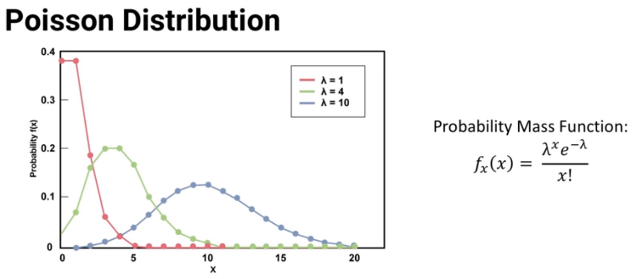

That probability mass function looks pretty esoteric, but it turns out that the Poisson distribution is really good at modeling random arrivals of people to lines or queues of calls to call centers, etc. In this formula, lambda is the average number of arrivals in a time period. The function gives *the probability that x people arrive given the average arrival rate lambda.* The Poisson model assumes that the arrivals are independent of each other and have the same distribution. You probably remember the short hand for this from probability, independent and identically distributed or i.i.d..

You might remember from probability that there is a complementary distribution to the Poisson called the **Exponential distribution.** Here's how these two are related. If arrivals are Poisson, with arrival rate lambda, then the time between arrivals, known as the inter-arrival time, follows the Exponential distribution, with one over lambda as the average inter-arrival time:

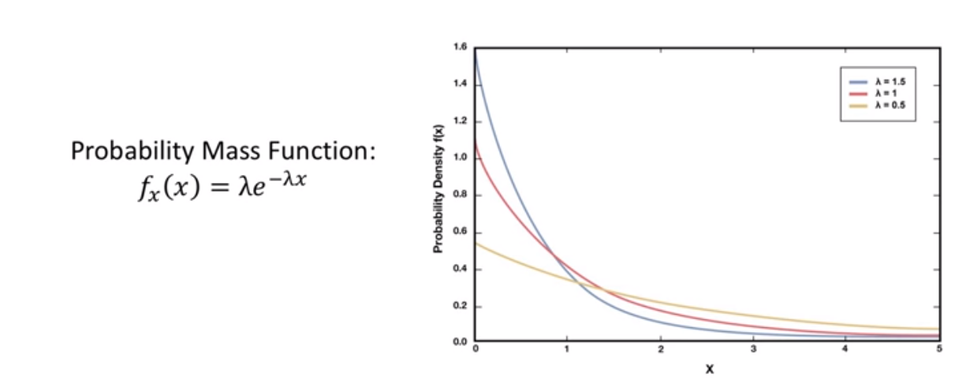

And it goes the other way too. If times between arrivals are exponentially distributed with average inter-arrival time one over lambda, then the arrivals follow the Poisson distribution with an average of lambda arrivals per unit time.

|  |
| --- |
| Case Study: Atlanta Airport Arrivals Right after the terrorist attacks of September 11th, 2001, much stricter airport security rules were put in. Atlanta's airport prides itself on being the busiest in the world, but security line delays were suddenly an hour or longer – sometimes much longer. So they asked me and three of my Georgia Tech colleagues to recommend ways that they could speed up the process.  The first step was to collect data. We hired students to keep track of when passengers showed up to the security line. Instead of counting passenger arrivals in a time period,they clicked their stopwatch every time a new passenger showed up, and subtract from the previous passenger's time to determine how long it was between their arrivals.  The security line inter-arrival data collected by the students fit very nicely to an Exponential distribution, which meant that the arrival process was Poisson. And that knowledge was very helpful when we built the simulation model that most of our analysis was based on. |

We'll see simulation models in another lesson. But for now let's see one more useful probability distribution: the Weibull. The **Weibull distribution** is very useful for modeling the amount of time it takes something to fail, specifically the time between failures. It's similar to the geometric distribution we saw in a previous lesson, except that the geometric counts how many trials there are between failures, while the Weibull tracks how much time there is between failures.

For example, if you're wondering how many times you can flip your light switch on and off before the switch breaks, that's geometric. But if you want to keep the light on all the time, and you're wondering how long the bulb will last before it blows, that's Weibull. Here's what the Weibull distribution looks like:

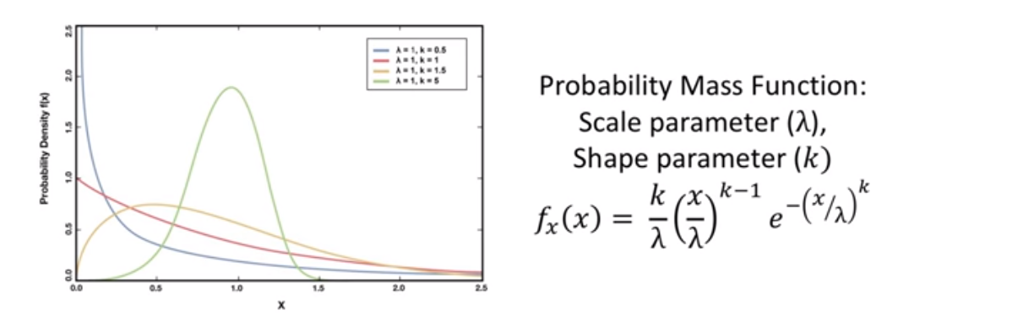

Notice that there's an additional parameter, **k**.

When **k < 1**, the Weibull is good at modeling situations where the failure rate *decreases* over time. The worst things fail first. That might be a reasonable model for some mechanical parts. If there's a slight defect, it'll fail more quickly. But as the worse parts fail sooner, the parts that are left are the better ones, and take longer and longer to fail.

On the other hand, when **k > 1**, the Weibull is good at modeling situations where the failure rate *increases* over time. This is often a reasonable model for things that wear out, like the tires on a car for example. The more worn they get, the more likely it is that they'll fail soon, so we'll observe fewer failures at first, and more later on.

And, as you might now guess, when **k = 1**, the Weibull distribution is good at modeling situations where the failure rate is *constant* over time.

By the way, take a close look at the Weibull probability density function. Notice that when **k = 1**, it reduces to the Exponential distribution. Well, not quite exactly. You have to substitute lambda for 1/lambda, I guess because Misters Weibull and Poisson lived in different countries, 150 years apart, so they didn't coordinate their notation for us. But it's essentially the same expression. Whether it's a failure rate that's constant over time, or an enter arrival rate that's constant over time, the two distributions give the same results.

Now that we've seen several probability distributions, you might be wondering how to tell if your data fits one of them. There's a lot of good software that can take a set of data and determine its fit to a probability distribution, and it'll also tell you what the best fit parameters are, for example what the most appropriate value of lambda is to use in a Poisson distribution. In fact, there is also a good software that can fit your data to many different distributions at the same time and let you know which ones it fits well. You'll get the chance to use some software in the homework assignment for this topic.

Distribution fitting software can be really convenient, but it also can be a little dangerous. There are so many probability distributions it can match to that it's easy for the software to lead you down an unnecessarily confusing path.

For example, suppose you want to know whether arrivals to a process follow the Poisson distribution based on inter-arrival data. And the software tells you that the distribution that fits your inter-arrival data best is the Weibull with k = 1.002. As we just saw, when k = 1, the Weibull reduces to the Exponential distribution, but the ability to fit that one extra k parameter to a value minutely different from 1 lets the software report a slightly better result, which could very easily just be due to a little randomness in what's really exponentially distributed data. So the bottom line is, use the software, but as always in analytics, think about what the output means.

### 13.4 (C): Q-Q Plots

In this lesson, we'll go over a basic method for visualizing whether two distributions of data are about the same or whether one data set is distributed similarly to a probability distribution.

As you probably remember from basic statistics, there are various statistical test to answer those questions, but sometimes a statistical test which returns a single value can hide something important that a visualization can show. And that's why it's sometimes helpful to see with your own eyes.

The idea of a **Q-Q plot** is that whatever variations in the data there might be, and even if the number of data points in two sets is very different, two similar distributions should have about the same value at each quantile. For example, in each of the two datasets, the value that's at the tenth percentile which means it's larger than 10% of the data and smaller than the other 90% should be about the same in both sets of data. And that should be true for any percentile, not just the tenth.

If I take two large cohorts of analytics students, it's likely that a person who's at the 60th percentile in height in the first cohort, and a person who's at the 60th percentile in height in the second cohort should both be about the same height. The Q-Q-plot just shows that graphically. The axes of the plot show the range of values in the data.

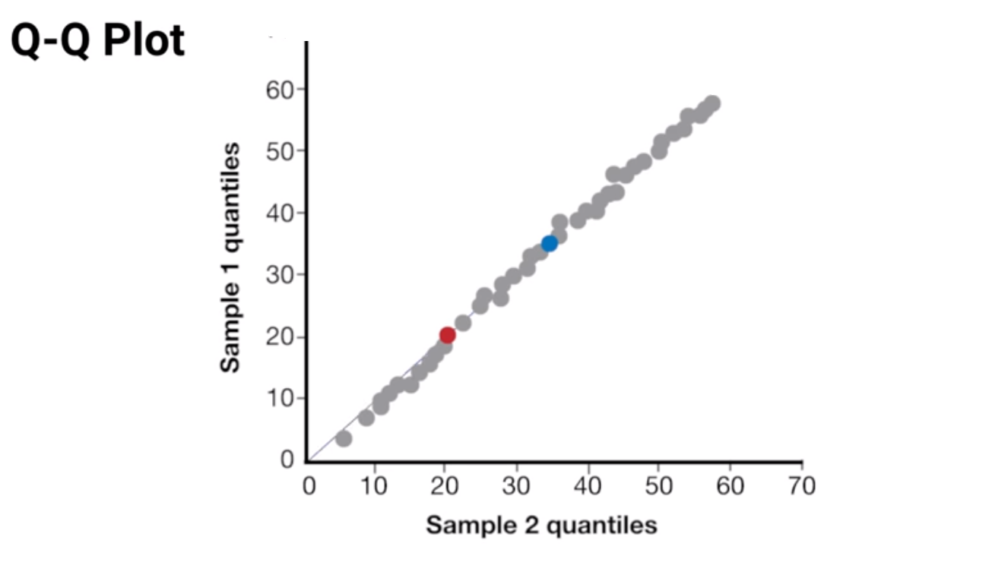

We can plot the median or 50th percentile value of one dataset against the median value of the other. The first dataset's 50th percentile value is a horizontal coordinate and the second dataset's 50th percentile value is the vertical coordinate. And we can do the same for example with a 25th percentile value. The first dataset's 25th percentile value is a horizontal coordinate and the second dataset's 25th percentile value is a vertical coordinate. (And we can plot lots of other percentiles too.)

So are these data sets a good match? If they are, we'd expect that *the points should fall on or near the 45 degree line where the horizontal and vertical coordinates are the same.* And in the case above, they do.

But here, we can see an example of where they're not a good match:

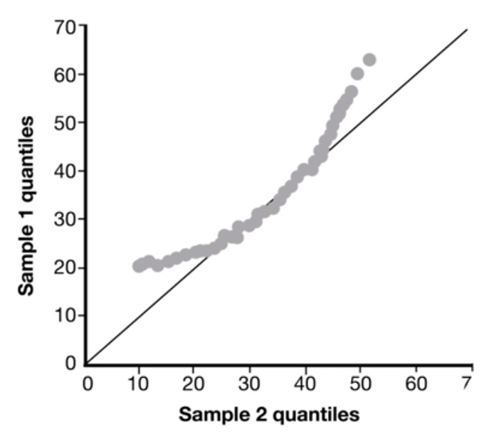

At the low end of the data range, the second dataset has higher values. And at the high end of the data range, the second data set also has higher values.

Of course, a statistical test would give the same results as what our eyes told us. So what's the point of Q-Q plot? First, looking at the plot lets us qualitatively understand what's going on. In the second example the statistical test would tell us they are not a good match, but it wouldn't have given us the extra information that at the lower and higher ends, called the **lower and upper tails**, that the second data set has higher values. And second, sometimes the raw statistical test will lead us in the wrong direction.

For example, look at this new plot. There are so many good matches everywhere except the very ends of the upper and lower tails that a statistical test might tell us it's a good match. And in a lot of cases, that's probably a correct result. But what if we're specifically trying to study what happens with extremely high and low values? In that case the Q-Q plot gives is the right information. We can easily see from it that even they're almost all the points are close to that middle line, at the very ends of the tails, the values are not the same. And if the point of our project is to study those extreme values, then they're not a good match.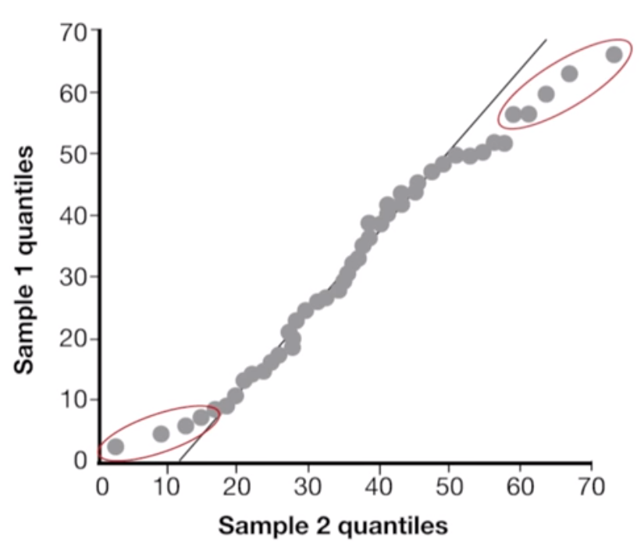

The examples we've seen have all been comparing two datasets. We can also easily use Q-Q plots to test whether a single dataset is a good fit to a probability distribution. We can use the dataset for the horizontal axis and for the vertical axis, we calculate or simulate the theoretical values of what the quantile should be in a perfect distribution and compare it to the dataset.

One more thing about Q-Q plots. In some statistics courses, maybe even one you've been in, it's expected that you'll memorize what different Q-Q plots look like. For example, a plot like this shows that for lower quantiles the dataset 2 has larger values and for higher quantiles it has smaller values. In other words, the data in the second set is more squashed toward the middle.

You can go ahead and memorize that sort of thing if you want to, but I think the more important takeaway is just that you understand how to read the plots yourself. And you can figure out what they're saying even if you don't have some shapes memorized.

## 13. Probability-Based Models, Continued

### 13.5 (M): Queuing

In previous lessons, we saw some probability distributions that are often good models for things in real life. In this lesson, we'll go one step farther. If we know something fits a probability distribution, what more can we do to model its behavior?

Here's one example, suppose we were running a telemarketing business. We have an autodialer that automatically calls phone numbers out of a huge database. Most calls go unanswered, people use their Caller ID, but sometimes a person will answer the phone. If the phone is answered, the call gets put into a waiting line of calls, known as a queue, for one of our employees to pick up and talk. We want to know how many employees we should have, based on how many people answer the autodialer, and how long a call takes once our employee is on the phone.

We can analyze this as a queueing system. Calls are answered and added to the queue. Based on some probability distribution that describes how often someone answers the phone. We have some number, C, of employees answering calls. Calls leave this system after they're finished, based on another probability distribution. That describes how long a call takes, once one of our employees is on the phone. In the simplest case, suppose the call arrival distribution is Poisson, with parameter lambda. And the call length is exponential, with parameter mu.

And suppose we have just one employee. Then we can calculate things like the expected fraction of time our employee is busy. The expected wait time of a person before talking to the employee, the expected number of calls in the queue, etc. We can do that by considering the rate at which the number of waiting calls goes up or down. However many calls there are, new ones come in with rate lambda, and the current call being taken is finished with rate mu. We can write transition equations, and solve them all simultaneously.

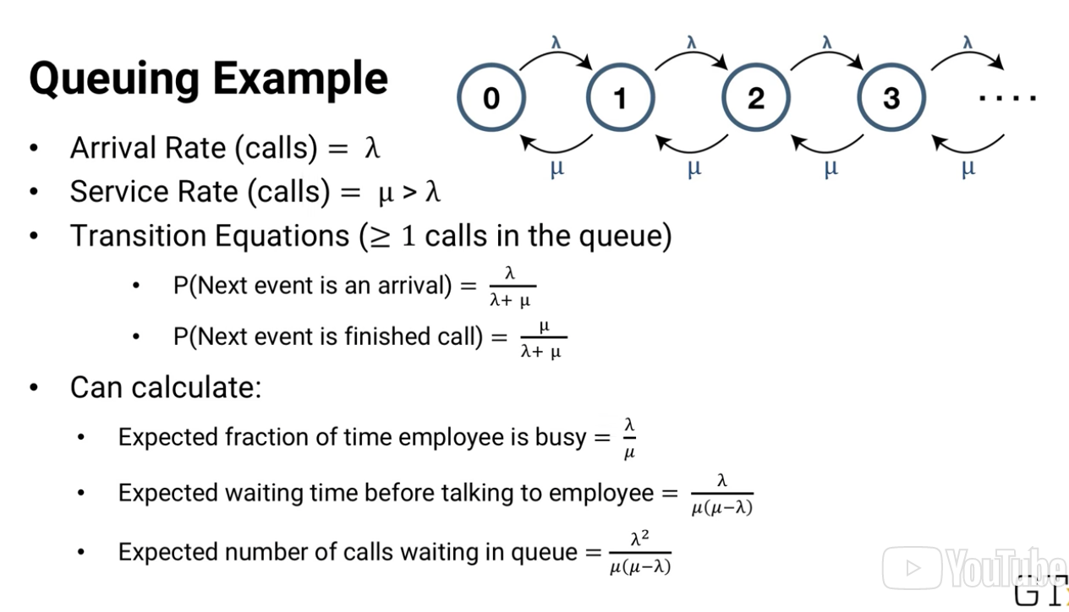

I won't go through the math, but we end up with expressions for the system attributes we're looking for. The math gets harder, but not too much harder, as we add more complexity. Suppose we add an extra employee. So when there are two or more calls, two people are on the phone at a time, so the next call-to-finish happens faster.

And suppose we only have capacity to have four calls in the system at once. In all of those cases, we can still come up with closed-form answers, because of something called the memoryless property of the Poisson and exponential probability distributions. The memoryless probability means that it doesn't matter what's happened in the past, all that matters is where we are now. In the exponential distribution, it doesn't matter how long an employee has been on the phone. The distribution of the remaining call time is exactly the same. That's purely a property of the exponential distribution. It's not something we need to know beforehand about phone calls. It's something we can discover, by finding the call time distribution. If the distribution of phone call times fits the exponential distribution, then it means we've discovered something about phone call time, it's memoryless.

The Poisson distribution is also **memoryless**, because it's related to the exponential distribution, as we saw in a previous lesson. So if we find that the arrivals of calls to the queue fit a Poisson distribution, we know they're memoryless. And it works the other way, too. If we're wondering whether something might fit the exponential distribution, and we know that it's not memory-less, then we know it won't be exponential.

For example, suppose we're working for a law firm that's involved in a lawsuit about automobile tires. Should the tire manufacturer pay damages for an accident that happened, when a tire with 10,000 miles on it failed? We might want to approach that question by first determining how likely it is for a tire to fail at 10,000 miles, in general. Was the tire defective, or is it normal-enough tire behavior? We can try to answer that question by modeling tire failure. Tires are more likely to fail, the more worn out they are, so the expected mileage that a tire fails at is not memoryless. It depends on how much it has been driven so far. That means we can't use the exponential distribution to model tire failure. As we saw in a previous lesson, maybe a Weibull distribution with k > 1 would be better.

So let's go back to our phone call example, there are lots of complexities we could add to generalize it. The arrival distribution of calls and the service distribution, the rate at which calls are answered, could change. So could the number of servers, the number of people answering calls, and the size of the queue. We could also specify the population size, the number of people who can be called, and the queuing discipline. For example, whether the first call to arrive is the first one answered, or whether there's a different strategy.

There's a standard notation for this, called **Kendall notation**. And I'm not going to go through all the possibilities, just know that it exists. There are other extensions that Kendall notation doesn't include. For example, some people might hang up the phone, if they've been waiting too long for one of our employees to talk with them. Or, if you imagine a queue where people see how many others are in line ahead of them, like if you're at a grocery store. A person might think there are too many people, she'll have to wait too long, and she'll leave without buying anything. That's called balking, and it can also be incorporated. The problem is that, once we start moving away from an easy-to-analyze probability distribution. And we start adding more and more complexities, the math gets very difficult. In these sorts of cases, we can use a tool called simulation instead, and we'll see it soon, in a future lesson.

### 13.6 (M): Simulation Basics

In this lesson, we're going to talk about simulation. In simulation, we build a model of something to study and analyze its behavior.

For example, we could express the steps of the manufacturing process mathematically, code it in a programming language, and then run the code and observe how the process works. Or we could do the same with an airport security process, nationwide freight train dispatching, or almost anything else.

There are several types of simulation. **Deterministic simulations** never vary, given the same inputs, the outputs will always be the same. There's no randomness in the system. In **stochastic simulations**, we might get different output each time we run a model, because the system includes some randomness that we've modeled.

In this lesson, we're going to focus on stochastic simulations, because they're generally more useful in analytics. Some simulations are **continuous-time simulations.** They model changes that are happening continuously, for example chemical processes. Propagation of diseases through a population are also sometimes modeled this way. These models are usually based on differential equations.

Other simulations are **discrete event simulations.** In discrete event simulations the system only changes at discrete time points when something happens. For example, in a call center, changes might happen when someone calls or when a worker finishes talking to someone and starts talking to someone else.

In this lesson, we're going to focus on discrete event simulations. Discrete event stochastic simulations are very valuable in prescriptive analytics for analyzing systems that have a lot of randomness or variability. In these sorts of systems, just using average values, like we might in an optimization model, isn't good enough.

Here's a very small example. Suppose we're modeling a machine at one step of a semiconductor manufacturing process. On average, wafers arrive at the machine every 20 seconds and on average they take 19 seconds to process. So if everything goes according to the average numbers, each new wafer arrives exactly one second after the last one is finished, and the process never has any delay. But if there's some random variability in the arrival and service processes, then things look a lot different. Here's what it looks like when arrivals are Poisson, still with an average of 1 every 20 seconds, and manufacturing time is exponential, still with an average of 1 every 19 seconds. As you can see, there's sometimes a very large queue building up. On average, there will be about 19 wafers waiting to be processed.

The simulations you just saw were created in the Arena software package. Arena, or any similar software, gives a nice framework for building not just a small simulation like this, but very complex and intricate simulations of lots of different processes. Here's an example of an airport baggage simulation. You can see two concourses with about 30 numbered gates each, some airplanes waiting at the gates, and some red baggage tugs, some are working and some are waiting for flights to arrive. The purpose of this simulation was to help decide how many baggage tugs were needed and where they should be located to ensure that arriving bags were moved quickly, both from planes to baggage claim for passengers coming into the city, and from one plane to another for passengers making connections.

This second example is an example of a cancer treatment clinic. In this simulation, you can see the building layout and a variety of clinic workers at various stations, doctors, nurses, receptionists, lab workers, etc. You can also see waiting areas.

One purpose of this simulation was to determine the right mix of workers, so that patients wouldn't have to wait a long time. And it could also be used to help determine the right amount of physical resources. For example, is the number of examination rooms too low, too high, or about right?

Here's a third example of a simulation which models an airline's global flight network, and one purpose of this model is to help the airline react to disruptions. If there's a bad storm that causes a major airport to shut down for a few hours, what's the best way for the airline to reschedule its flights to cause minimum disruption to its passengers, crew, and overall operations? You can also see on the left of this pictures, some of the elements that are under the hood of a simulation model that are built into the software.

Simulation software generally allows you to build models using several types of elements. Entities, which are things that move through a simulation, for example, bags moving through an airport baggage system. Modules that represent parts of a process, like queues, storage, and stations. Actions to take, resources like workers, decision points, and ways of tracking statistics about the simulation and its entities. You just create and connect elements to represent each piece of the system, and when appropriate, specify the associated probability distribution or decision role associated with each.

You'll get a chance to do it yourself in an upcoming homework assignment. Under the hood, the software has a lot of code to generate random numbers from the probability distributions. There's actually a lot of important theory about this, because computers don't really generate random numbers, they just generate numbers that might appear random, called pseudo random. And they shouldn't use numbers whose non random properties, especially lack of independence, lead to incorrect outcomes. If you ever need to code a simulation yourself without using software, that's something you should look into.

Another key issue in simulation is replication. You can't just run a stochastic simulation one time. You'll just get one random outcome, which might or might not be representative. Instead, you'll need to run it a lot of times and then look at the distribution of the outcomes. For example, if you're using simulation to determine the average daily throughput of the semiconductor manufacturing process, each simulated day you run might give a different answer. You can plot the distribution, find the average throughput, find the variance in the throughput, etc., and use that information in your overall analysis. Once you've built a simulation, it's important to validate it as much as possible against real data.

For example, if your simulation shows an average daily throughput of 250 wafers, but the real production facility has an average daily throughput of just 100, then your model probably is not a good reflection of reality. Or if your simulation shows a throughput distribution like this and the real facility has a throughput distribution like this, then your model still is not a good reflection of reality even though they have about to same average. So don't just look at the average, make sure the variability is about the same too. So that's the basics of simulation in a nutshell. In an upcoming lesson, we'll see how to use a validated simulation to answer prescriptive analytics questions.

### 13.7 (M): Prescriptive Simulation

In a previous lesson, we saw the basics of simulation. Now we're going to talk about how to use the simulation for analysis, especially for **prescriptive analytics**.

Once you've validated your simulation, you can go ahead and use it. Simulation can be very useful for asking, what if sorts of questions about systems. For example:

* how are the overall process throughput change if the company invested a $100,000 on a faster machine for one step of the process?
* how valuable would hiring an extra call center worker be?
* what's the right distribution of baggage tugs to have at the airport – one for each gate, one for every two gates, or a floating pool at each half side of the concourse?

We can run the simulation with different options and compare the results to see what the best course of action is.

Some simulation software even has the ability to do some heuristic optimization of a set of parameters. For example, on a huge manufacturing facility with hundreds of steps, what's the best buffer size to have at each step of the process? Automatic optimization is helpful in some cases, but let's go back to the case where we want to make the comparisons by hand.

We can run a baggage system simulation with one setup per baggage tugs, for example, one tug at each gate, and we can run the same simulation with a different set up, say one tug for every two gates. And then we can compare the simulated system performance between the two. For example, we could measure the fraction of bags that get to baggage claim in 20 minutes or less from when the plane lands.

But we need to be careful when making comparisons. Essentially each replication of a simulation is one draw from the entire distribution. And if we run, say 1,000 replications of each simulation, we have 1,000 data points for each. 1,000 fractions of bags that get to baggage claim 20 minutes or less from when the plane lands. Then we're faced with the question whether one set of a 1,000 points is better than another, and that requires its own statistical analysis.

We could do a basic test to see whether the means are different for example, but we might be able to do even more. Suppose when we run the first replication of each simulation, we use the same random numbers whenever possible. And when we run the second replication of each, the two simulations use the same random numbers as each other. And so on. The Ith application of each simulation uses the same random numbers as each other. Then it’s like having a thousand different scenarios, and for each scenario we can see which method is better and see how often one is better than the other.

This sort of **nonparametric test** can give you valuable information. You'll see more about nonparametric tests, if you haven't already, in our lessons on nonparametric models.

Remember, though: simulation is only as good as the quality of the input. If there's missing information or an incorrect assumption, the simulation might give the wrong answers. For example, in a call center simulation we might assume every worker answers calls equally quickly. But I've worked with a company on their call center, and we discovered that there's a lot of variability between workers. Enough that simulating them all as the same leads to costly sub-optimal decisions. In fact, the differences were big enough that the company focused their project on addressing the variability itself. That said, simulation is a great prescriptive analytics tool.

### 13.8 (M): Markov Chains

In this lesson, we'll see a probability based analytics model that can be used for making comparison. It's called the **Markov Chain Model.** A Markov Chain Model is based on states of a system. A classical example that's used in teaching is states of the weather, say either sunny, cloudy, or rainy. As we'll see soon, this is not a very realistic example, but let's use it anyway for now. For each state i in the Markov chain model, we know the probability that at the next step the system will be in state j. That probability pij is called the transition probability.

For example P sunny-rainy is the probability that if it's sunny today, it'll be rainy tomorrow. And for visualization we can put all of the transition probabilities pij into a transition matrix P. Once we have the transition matrix, we can answer a variety of questions about the system. For example, what's the long-run probability that it's rainy?

Suppose we start out with a vector pi that shows the probability that the system is in each state. So pi rainy is the probability that it's rainy today. If we multiply pi times p, it gives us the vector of probabilities of being in each state tomorrow. Multiply again by P and we get the probabilities of it being in each state the day after tomorrow. And we could keep multiplying by P day after day. All of those answers depend on the initial probability vector pi. If we want to find out what happens in the long run, we can think of multiplying pi by P to the infinity power. But that's hard to do in practice. Instead, we can just imagine a time called steady state, where the states have gotten so mixed that the initial conditions no longer matter. In steady state, the probability of being in state i is the same every day. So if we apply the transition matrix by multiplying pi by P, we'll get our vector pi back again. The probabilities are the same.

If we solve the system of equations pi times P = pi, and the sum of all the pi i equals 1, since they're probabilities, then we can find the steady state probability vector pi*. Note that there isn't always a steady state. We need to make sure that it's possible to get from every state to every other state and that the transitions aren't set up in a way that the system cycles between states. But for most real applications, that isn't a problem.

A key assumption of Markov chains is that they're memoryless. It doesn't matter what the previous states were. The only thing that matters is what state we're in now. For example, in this weather example it doesn't matter what the weather was yesterday or the day before, if it's sunny today, then p sunny rainy is the probability of rain tomorrow.

Of course, in reality this memoryless assumption is almost never true. It's not a good model for the weather and it's not a good model for most real systems either. So why am I bothering to teach you about Markov Chains?

Because it turns out they're useful in other ways, especially when we're trying to connect smaller amounts of information to find larger ones. For example, suppose we want to know which web page is the best one to learn about Markov Chains. We can list all of the Markov Chain webpages we can find and call them states. For each page, i, if it links to page j, we make that transition probability equal to some value p. Otherwise, we make the transition probability equal to 0. Most pages won't link to each other. So we'll have lots of 0's in the transition matrix.

But now, we can use the transition matrix to see what happens if we start at a Markov chain page and iteratively jump from one page to another using the available links. Choosing a link at random and following it, choosing a link from that page and following it, etc., only among Markov chain webpages.

By finding the steady state probabilities, we'll discover which Markov web page we would be at, most often, second most often, etc, if we keep jumping around forever, and we could use that order as a ranking on the webpages. In fact, that's the basic idea of how Google ranks webpages for searches. It's called the Page Rank System.

In my own research, I also used Markov chains to rank college basketball teams as part of the RMC ranking method, and others have used Markov chains for ranking as well. Markov chains have also been used to model things like urban sprawl, population dynamics, and disease propagation, applications where the memoryless property is important in the short run but not so important in the long run.

Overall, Markov Chains are not the most commonly used analytics methodology, mostly because of the limitations of the assumption that the system is memory-less. But they're used enough that I think you should know about them, especially because there aren't many good substitutes for Markov Chains in the instances where they really do work well.

## 14. Missing Data

### 14.1 (C): Introduction to Missing Data

All through this course, we talk about analytics models that are based on data, often, lots of data. For example, in regression we assume we have data xij the value of the j factor in data point i. And we often might have datasets where the number of data points i is in the millions or higher and the number of factors might be in a thousands or more. So we can easily have billions of pieces of data. And that's not even yet at the size people often refer to as big data.

When we learn about models and analytics, it's nice to pretend that all those billions of data values are right there at our fingertips just waiting to be used. And in other courses you learned about how to store, retrieve and handle all that data. But for now let me ask you a different question: out of all those billions of data values you need to collect, how many do you think might not be available?

#### Examples of How/Why Data Can Be Missing

**National Temperature Study: 1,000 Locations**

* Gauges can break down

**Biometric Study with a Device**

* Transmission of data may break, and packets may drop

Human involvement can be a source of error.

* Fills form incorrectly
* Skipped questions
* Can’t remember (Medical history)
* Data Collection company may not make some data available to you

#### Data Problems

* Missing Data
* Wrong Data
  + Drastically different responses can be considered an outlier (not in scope of this lesson)
* Often patterns in missing or wrong data
  + Some are more likely to be missing
    - Ex: Liver Transplant patients: It’s hard to know if a liver recipient had headaches the week before the transplant. It’s just not a standard part of a medical record.
    - Income: For some reason, higher income people aren’t likely to report income, than middle income people
    - Radar Gun: Radar guns may treat slow moving cars as an anomaly and simply not show a speed
    - Income + Radar Gun are classic examples of how reported data can be biased.

### 14.2 (C): Methods That Do Not Require Imputation

In a previous lesson, we saw how data sets are often incomplete. There can be missing values. In this lesson, we'll see some of the ways of dealing with missing data.

In general, when a data point has some missing data, there are three things we can do:

1. Throw the data point away entirely
   1. PROS:
      1. Not potentially introducing errors
      2. Easy to Implement
   2. CONS
      1. If too much data is missing, we don’t want to throw away so much data
      2. Have to take into consideration that there’s a potential for censored or biased missing data
         * Ex: Heart transplant data with “Date of Death” as a column. If we threw out all people who had this field missing, the data would be way too pessimistic
2. use categorical variables to indicate categorical missing data
   1. With quantitative variables, it’s hard, because it can pull coefficient estimates into the wrong direction.
   2. We solve that quantitative problem by introducing **interaction variables** between a categorical variable and another variable
      1. This essentially creates two models
      2. Ex: # Kids when Height is missing + # Kids when Height is NOT missing
      3. This is essentially a tree model with a single branch
3. estimate the value of the missing data and use that estimate in place of the true value (imputation)

### 14.3 (C): Imputation Methods

In this lesson, we’ll see how to estimate missing values, a process called **imputation**. There are many ways of imputing values for missing data. We'll see three that trade off, simplicity, and realism, but there are even more complex methods out there that we won't cover in this course.

#### Imputation Methods

1. **Midrange Value (Mean, Median- if numeric, or Mode- if categorical)**
   1. Advantages:
      1. It’s like we’re hedging against being too wrong with our imputation.
      2. Easy to compute
   2. Disadvantages:
      1. Imputation can be biased
         1. People with high income are less likely to respond to income questions on survey. Thus, the mean/median will underestimate the missing value
2. **Use a Predictive Model (Regression)**
   1. Predicting the value of missing data based on the other variables
   2. Reduce or eliminate the problem of bias
   3. Disadvantages:
      1. Complex: Build, fit, validate, test to estimate the missing value. Then, need to Build, fit, validate, test another model to address the question we’re trying to answer.
      2. Overfitting: Does not capture all the variability
         1. This arises because we have to use the data twice- once for imputation, and a second time to fit the model.
         2. Ex: Doctors who have 3 cars: Their imputed incomes can be way off because this method doesn’t account for the fact that doctors income can range a whole lot.
3. **Perturbation**
   1. Because imputation does not capture all variability, we can artificially introduce variability by adding perturbation to each imputed value
      1. +/- random amount from a normally-distributed variation
      2. On average, we’d be better off simply using just the predictive model’s estimate. Perturbed variation makes our estimate less accurate, but it will give a better estimate of the *overall spread of values*

It’s important to know that it’s necessary to limit the amount of imputing.

* **A standard rule of thumb is that no more than 5% of data should be imputed**, and that's generally true for each factor. Beyond that point, you're better off using an alternative method like indicator variables, categorical variables for missing data values.

Question: Does imputation introduce additional errors?

* Imputation Error + Perturbation Error (if applicable) + Model Error
  + It’s very hard to determine each error component, and how they add up.
  + We can use a test data set to evaluate the overall model’s performance.
  + That’s the most ideal solution, despite the fact that the test data is missing some data
* So, yes, errors do get added.
* That doesn’t mean imputation is inferior to using regular data.
  + Regular data can be just as worrisome
    - It’s almost impossible to have a dataset where each value is actually correct.

Think of a digital thermometer, for example, that gives different readings for the same person, ten seconds apart. Pretty much any method you have for getting a true data value into your data set, whatever process you can come up with, someone else taking this course can think of a reasonable way for that process to occasionally give the wrong value. And feel free to think of that as a challenge for the discussion forum.

So, rather than worrying too much about whether a test date is set, that itself might have missing values could lead to misjudgment of a model's error, keep in mind that even data sets that appear prefect also contain errors, and those errors are implicitly incorporated in your models overall reported error and that's something we just have to deal with in analytics.

## 15. Optimization

### 15.1 (M): Introduction to Optimization

**Optimization** is undertaken by many statistical models (clustering, regression, variable selection, timeseries...etc.) to get their answers.

We will focus on specifically, **Mathematical Programming Models.**

* Structured with Variables, Constraints, and an Objective Function

Optimization is also a very important topic in analytics in its own right, especially for **prescriptive analytics**, the type of analytics that asks, given what I know and what I predict, what's the best course of action to take?

**Optimization** can answer questions like:

* Which airplane mechanic should be scheduled for each shift over the next week to meet the expected maintenance requirements at O'Hare Airport at lowest cost, making sure we don't violate any federal regulations or union contract requirements and accounting for unexpected breakdowns?
* How much crude oil should be sent by tanker and by pipeline from each oil field to each refinery to meet demand and avoid oversupply while keeping costs low?
* What web pages should be optimized in a server farm, and how many copies of each should be stored to maximize the profit made by responding quickly to hits?
* How should a large machine shop sequence its production to get maximum throughput while meeting all clients' deadlines, taking into account the reality that some output will fail inspection and need to be remained?
* What's the shortest route from my house to the airport, given current and predicted traffic?

In my own research and consulting, I've used optimization models to suggest how Army recruiters could most efficiently use their resources, create a method for Major League Baseball teams to determine their draft priority, plan worldwide delivery schedules and routes for giant oil tankers, and schedule electricity generation that accounts for specific effects of current and upcoming weather patterns on the atmospheric effects of pollution.

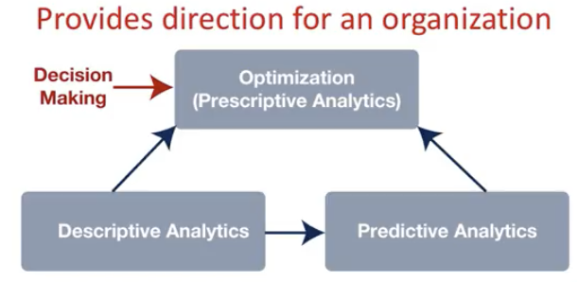

While optimization is a step/component in descriptive and predictive analytical models, it can also sit above descriptive and predictive analytics, and be a goal in it’s own right. Optimization allows you to not only use analytics to report on things but also to direct your organization at strategic, operational and tactical levels.

But optimization is also a more difficult tool to use than many of the models we've seen before.

* Models have software that can build and solve the models
* Optimization software only automates solving the problem.
  + Model building for optimization is entirely up to the user.

Before we go on and start learning about optimization models, I want to highlight a 2013 study by Gartner.

* Only 3% reported the use of prescriptive analytics.
  + Prescriptive Analytics: Referred to as the "final frontier of analytic capabilities," prescriptive analytics entails the application of [mathematical](https://en.wikipedia.org/wiki/Mathematical_sciences) and [computational sciences](https://en.wikipedia.org/wiki/Computational_science) and suggests decision options to take advantage of the results of descriptive and predictive analytics.
  + Prescriptive analytics doesn’t just tell you the state currently (descriptive), not does it just tell you what it can be (predictive). It tells you *why* it will happen
  + Low usage because: In addition to needing good data and descriptive and predictive analytics as a foundation, they need people with specialized training to build optimization models, and to a lesser extent, simulation models.
* Gartner was predicting growth to 35% by 2020, from 3% to 35% in just seven years. So my perspective is that it's not just worth learning about, it's necessary to learn about prescriptive analytics models because either the organization you join will already using them or because they'll want to be using them. And your knowledge can give you an important edge.

### 15.2 (M): Elements of Optimization Models

Building optimization models requires a lot of human insights and expertise. So the next few lessons will help you learn the basics of optimization modeling. In this lesson specifically, we're going to see three key pieces of optimization models.

Optimization models have three main components:

1. **Variables**
   1. Decisions that the optimization solver will pick the best value for.
2. **Constraints** 
   1. Restrictions on variable values
   2. Ex: The sum of X must be less than 30
   3. It’s important to realize that software does the explicit math, but does not understand reality. Hence, the importance of making constraints explicitly stated in mathematical form
      1. A political candidate must visit state i y times. The sum of all visits to the state i must equal y.
3. **Objective function**
   1. A measure of quality of the solution
      1. The quality of the set of values for the variables, which we are trying to maximize or minimize
      2. Given the variables, we can rank/assess these variables by inputting them into a objective function. The value obtained after inputting into an objective function can be used as a yardstick to see how well these combinations of variables/solutions fare amongst other possible variables/solutions.
   2. The primary reason why we can say Optimization sits on top of the other analytical methods. In order to find alpha and beta of an objective function, we need to use analytical models to determine these parameters

**“Solution”**

* This word has been used very loosely throughout. But in optimization, it’s a value to be used for a variable.
* A value (solution) for a variable is said to be *feasible* if the value satisfies all of the model’s constraints
  + A feasible solution that provides the best objective function is called the optimal solution

For example, if we're optimizing a political candidate's travels around the country, then we might have variables like these. xi might be the total amount of time the candidate spends in state i, yi might be the number of visits the candidate makes to state i. And zi might be 1 if the candidates ever visit state i and 0 otherwise.

We might also want to make more specific decisions, like which days the candidate visits each state. So we might have a variable like wid, the time the candidate spends in state i on day d specifically. And vid might be 1 if the candidate visits state i on day d, and 0 if not.

These are all decisions that we're trying to make, and if we build our model correctly, the optimization software will then find the best solution, the best combination of values for the variables.

The **constraints** in a model are restrictions on those decisions that we make, restrictions on values of the variables. For example, we might have restrictions like these. There are only 30 days left in the campaigns so the total time the candidates spends on all states can't be more than 30 total days. In other words, the sum over all states i of xi, the time the candidate spends in state i, must be less than or equal to 30.

We might also want to make sure, for example, that the candidate visits Florida at least 3 times in the last week, days 24 through 30. In other words, the sum over days d equals 24 through 30 of v Florida d must be greater than or equal to 3.

And we need to link our variables together correctly. vid is the number of visits to state i on day d, and yi is the total number of visits to state i. So we need to make sure that when we sum up vid over all days d, the total equals yi. That's an important constraint. We might expect it to be true, because of how we've defined the variables in English, but optimization solvers only look at the math. They don't look at the words of what we want the variables to mean. So if we don't use constraints to explicitly tell the solver how variables should be related, the solver will go happily ahead and find a mathematical solution, telling our candidate to visit state i 12 times, but that each vid should be 0.

The last piece of an optimization model is called the **objective function.** It's a measure of the quality of a solution, the quality of a set of values for the variables, which we're trying to maximize or minimize. In our campaign example, the objective function might measure how many additional votes we could expect the candidate to get based on the campaign schedule. Perhaps, alpha times the population of state i times the square root of time spent in state i plus a third times however long is spent in neighboring states. Plus beta times the number of times each state is visited each day, times the factor for the day, maybe visiting too early or too late dilutes the effect.

You might wonder, of course, how we know the value of alpha and beta and the square root relationship to the amount of time spent in a state and its neighbors. That's one of the ways that optimization can sit on top of other analytics models. **In order to use the optimization model, we first need to use statistical methods, like regression**, to find the right values of alpha and beta, to determine the relationship between time and votes, etc. In fact, it's pretty common for optimization models to require input that's found as the output from other models. And we'll see some examples when we get to the part of the course when we start putting a variety of models together to create a comprehensive solution to a question or problem.

I've been using the word solution pretty loosely, but in optimization a solution is a value for each variable. For example, the amount of time spent in each state. A solution that satisfies all of the models constraints is called the feasible solution. And the feasible solution that has the best objective function value is called the optimal solution. That language is just like in everyday life, feasible means it's possible to do and optimal means best.

### 15.3 (M): Modeling is an Art: Two Examples

In previous lessons, we saw the basics of optimization. The sort of analytics questions it can answer, and the three main parts of an optimization model, the variables, the constraints, and the objective function. In this lesson, we'll see a couple of examples of simple optimization models to give you an idea of some of the difficulties in building them.

|  |
| --- |
| Case Study: The Army Diet Problem Back in the late 1930s and 1940s, the United States Army wanted to know what to feed its soldiers in order to satisfy everyone's nutritional requirements at minimum cost.  For each of n foods, they knew how much of each of m nutrients the foods contained. aij is the amount of nutrient of j per unit of food i. Based on nutritional guidelines of the time, they knew the minimum and maximum amounts of each nutrient that a soldier should have each day. Let's call them $m_{j}$ for the minimum and upper case $M_{j}$ for the maximum. And based on current prices, they knew the cost $c_{i}$ per unit of food $i$. Now let's think about the structure of an optimization model. We need to start by defining variables. The decisions that the model will suggest we make. What do you think the variables or decisions should be?  The army came up with one variable $x_{i}$ for each food $i$, where $x_{i}$ is the amount of food i in each soldier's daily diet. For example, x broccoli would be the amount of broccoli in the daily diet. Given those variables $x_{i}$, now we can write constraints for the nutritional requirements: ${\sum_{i=1}^{n}{}}_{}a_{ij}x_{i} ≥m_{j}$  * : The sum over all i of $a_{ij}$ times $x_{i}$ has to be greater than or equal to $m_{j}$. ${\sum_{i=1}^{n}{}}_{}a_{ij}x_{i} ≤M_{j}:$* The sum over i of aijxi has to be less than or equal to upper case Mj. * They require that the daily intake of nutrient j is between the lower and upper limit. * For each food i, $a_{ij}x_{i}$ is the amount of nutrient j per unit of food i times the number of units of food i eaten, so it's just the amount of nutrient j the soldier gets from food i each day. Add that up over all the foods, and you get the total daily intake of nutrient j. * And there's another constraint that's so obvious, it's often overlooked. All the xi must be greater than or equal to 0. It's impossible to eat negative amounts of food.   Remember that the army wants to minimize the cost of the daily diet. Here's the objective function: ${minimize \sum_{i=1}^{n}{}}_{}c_{i}x_{i}$  * : the sum over i of cixi. For each food i, we multiply the per unit costs ci by the units of the food eaten or xi to find the money spent on that food each day. Adding up over all foods gives the total cost of the diet. And that, the variable definitions plus the constraints plus the object function, is the optimization model they used.   Of course there are lots of other complexities we could add, we could add constraints to enforce variety in diets rather than making soldiers eat the same few foods over and over. We might need to change the cost ci seasonally. Farms are more abandoned and therefore less expensive in summer than in winter, for example. And we might want to consider the taste of food including combinations, for example, peanut butter with jelly. These are all things we could add to the model, but as the first try the basic model we have here is the same basic model the army began with decades ago. The diet model we've just seen is pretty straightforward, as optimization models go. |

People's intuition often leads them to the model we've just built. Now let's see an example where intuition often leads people the wrong way.

|  |
| --- |
| Case Study: The Call Center Problem Call Center scheduling   * Meet forecasted demand $d_{i}$ for each day of the week   + ex : $d_{Tuesday}= 247$* Union contract requires that workers each work 5 days in a row and then get 2 days off. And, to keep costs down, the company would like to know how many workers should be working each day so the total number of worker-days is minimized. How do you get the variables for the objective function, and the constraints?   + It would be obvious to establish the objective function as: $minimize \sum_{i=1}^{n}{}x_{i}$ where $x_{i}$ is the number of people working on day i, but you run into problems later on when you need to include the 5-day constraint. This is computationally very difficult, so we need to think outside the box   + Instead, Define ${x_{}}_{i}$ to be: *The number of people who start their 5 working days in a row on day i.*     - *Ex: x=Sunday:* the number of people whowork Sunday, Monday, Tuesday, Wednesday, and Thursday, and then get Friday and Saturday off.     - **Objective Function: $minimize 5\sum_{i=1}^{7}{}x_{i}$**        * 7 Days in a week that a worker can start their 5 day stint multiplied by 5 the working days.     - **Constraint:** Meet Demand: $\sum_{ji=1}^{n}{}x_{j}≥d_{i}$      * Ex: $x_{Fri}+x_{Sat}+x_{Sun}+x_{Mon}+x_{Tues}≥d_{Tues}$      * The number of people who start their 5-day stints on Friday through Tuesday will be working on Tuesday.       * So, we need the total number of people working on Tuesday to be greater than the demand.       * (And the obvious constraints: can’t have negative workers, and can’t have fraction workers)       * **Because the union contract restriction is already part of the variable definition, we don’t need to write a special constraint for this restriction.** |

It turns out to be hard, and the reason is that we chose the wrong set of variables. Instead, we should've chosen variables like these. xi is the number of people who start their 5 working days in a row on day I. For example, x Sunday is the number of people who work Sunday, Monday, Tuesday, Wednesday, and Thursday, and then get Friday and Saturday off. With these variables, the objective function is still easy to write. Each variable now accounts for 5 worker-days, so the total worker days is 5 times the sum of the seven xis.

### 15.4 (M): Modeling With Binary Variables

In previous lessons we've seen how optimization can be used to answer prescriptive analytics questions, and we've seen the basics of optimization modeling, variables, constraints, and objective functions. In this lesson we are going to see how to create more complex structures in optimization models by introducing **binary variables** to the new model.

Let's start off by looking at a model of stock market investment.

|  |
| --- |
| Example: Stock Market Investment Invest to Balance return and risk (Markowitz Theoretical Model)  **Given: $$B = Investment Budget$$ $$n = number of stocks available$$ $$r_{i }= Expected return of stock i relative to market$$ $$Q_{ij}= Covariance of returns of stocks i and j$$**  **Define Variables $$x_{i }= Amount invested in stock i$$**  **Establish Constraints $$\sum_{i = 1}^{n}{}x_{i}≤B$$ $$x_{i}≥0 for all stocks i$$**  **Objective Function $$maximize \sum_{i =1}^{n}{}r_{i}x_{i} - θ\sum_{i}^{n}{}\sum_{j}^{k}{}Q_{ij}x_{i}x_{j}$$**   * Maximizing the Expected Return $\sum_{i =1}^{n}{}r_{i}x_{i}$ less/minus the risk $θ\sum_{i}^{n}{}\sum_{j}^{k}{}Q_{ij}x_{i}x_{j}$* We multiply the risk term by   + By varying this parameter, we can find different solutions, different investments that balance return and risk differently.   Thus far, we presented a very theoretical model. It doesn’t take into account certain things that would apply to us in every day life.  Invest to Balance return and risk (Real Life Model)   * Adding Transaction Fees * Adding Minimum Investment in Each stock   **Given: $$B = Investment Budget$$ $$n = number of stocks available$$ $$r_{i }= Expected return of stock i relative to market$$ $$Q_{ij}= Covariance of returns of stocks i and j$$ $$t_{i}= Fixed transaction fee to trade stock i$$ $$y_{i}=Binary variable (1 if stock is in portfolio, 0 otherwise)$$**  **Adjusted Objective Function $$maximize \sum_{i =1}^{n}{}r_{i}x_{i} - θ\sum_{i}^{n}{}\sum_{j}^{k}{}Q_{ij}x_{i}x_{j} - \sum_{i=1}^{n}{}t_{i}y_{i}$$**  ….But we need to adjust our constraints now  **Adjusted Constraints**   * + Also means we invested $0 in stock i   + We can invest up to our whole budget B into stock i * Personal investment preferences can be established through constraints   + - “Invest in at least one”     - “Invest in one or the other”     - If investing in energy, must invest in 5 energy stocks   + Alternative way of denoting the same thing as above:     - ( so     - “ |

Integer Variables in Optimization

These are just some of the ways that integer variables can be used to write special sorts of features in an optimization model. Like:

* fixed charges in objective functions
* constraints that choose among options
* constraints that require either the same decision or opposite decisions
* and if then constraints.

There's really an art to building models with integer variables and we don't have time to cover all of the possibilities, or get lots of practice with them in this course.

### 15.5 (M): Optimization for Statistical Models

In some previous lessons, we've seen how optimization models can answer a wide range of prescriptive analytics questions. And we've also seen how to build optimization models, including three key pieces. Variables, constraints and an objective function. In this lesson, we'll see another way that optimization is very important in analytics.

**Linear Regression Model**

Statistics vs. Optimization POV

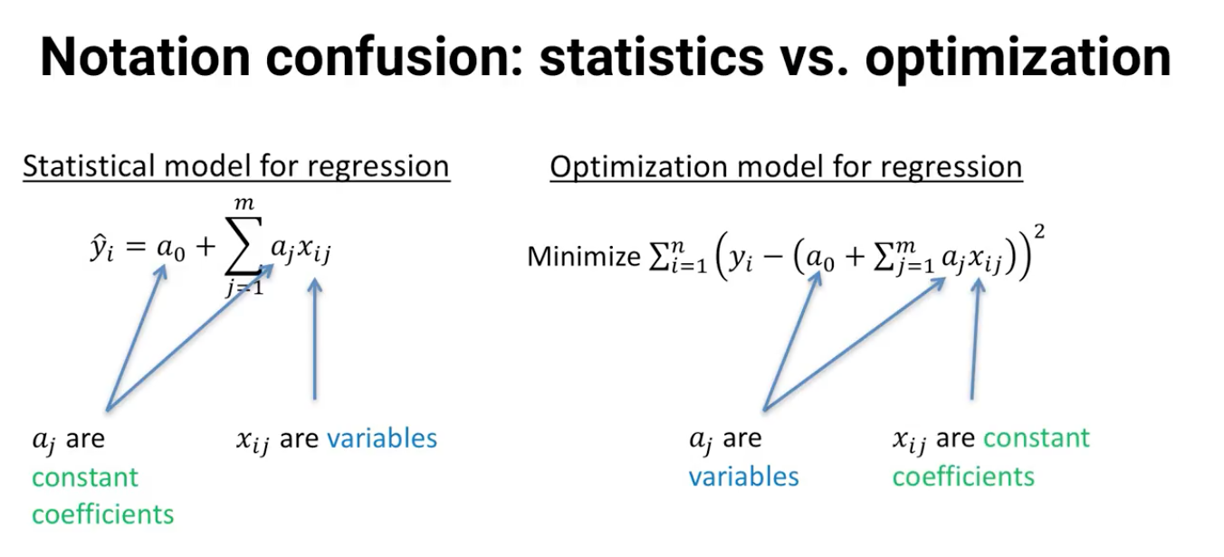

**Lasso + Ridge + Elastic Net**

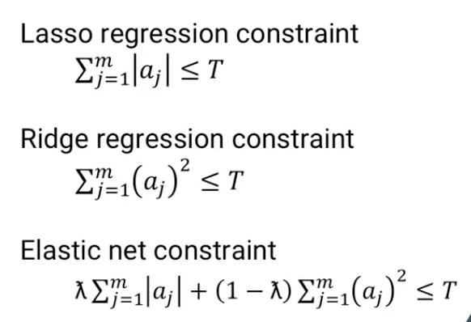

* The Lasso regression method is just standard regression with one constraint added to restrict the sum of the variables (remember, variables = coefficients in the optimization POV).
* Ridge regression is similar, but the restriction is on the sum of squares of the variables
* Elastic net just combines the two terms into one constraint.

**Logistic Regression**

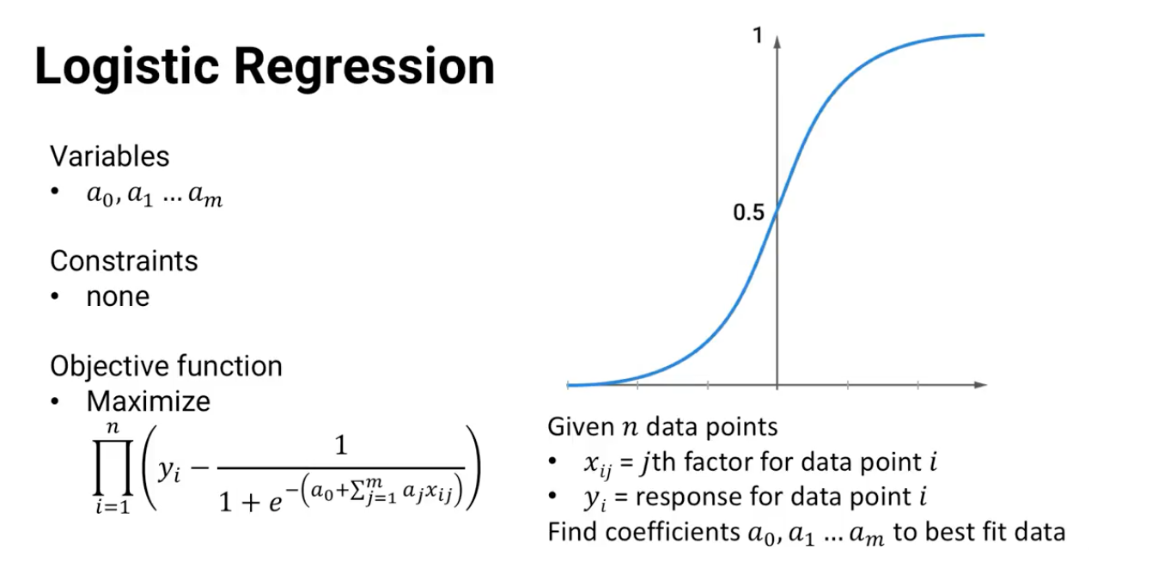

Logistic regression is based on optimization too. Just like in linear regression, the optimization variables are the regression coefficients, and there are no constraints. The objective function is to minimize prediction error.

**Support Vector Machine Models**

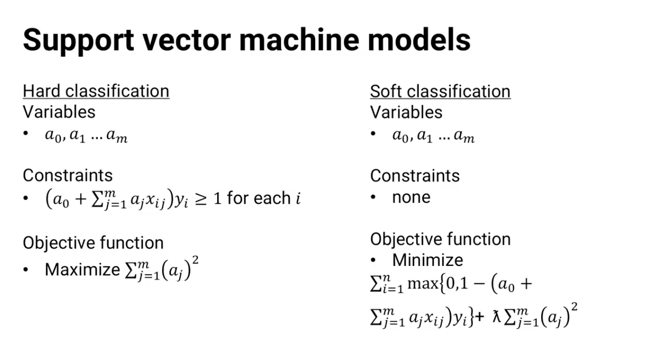

* For hard classification, the variables are the coefficients a0 and a1 through am and the constraints are that each data point has to be correctly classified. The objective function is to minimize the distance or margin between the support vectors.
* For soft classification, we have the same variables and there are no constraints, but the objective function is a little different, it absorbs the margin and the classification errors.

**Time Series Models**

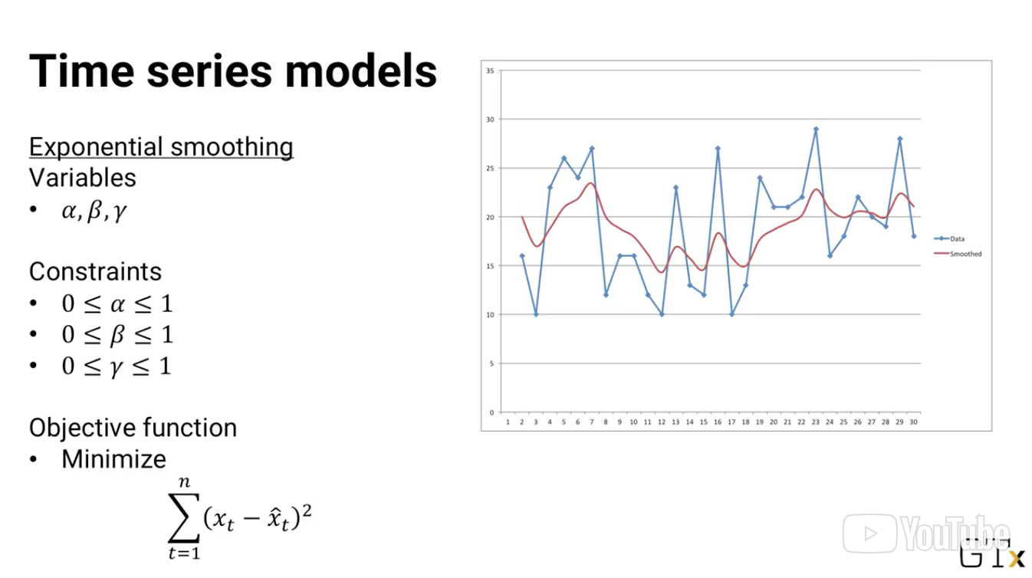

* Constraints are the alpha, beta, and gamma need to be between 0 & 1
* Objective Function is to minimize the prediction error

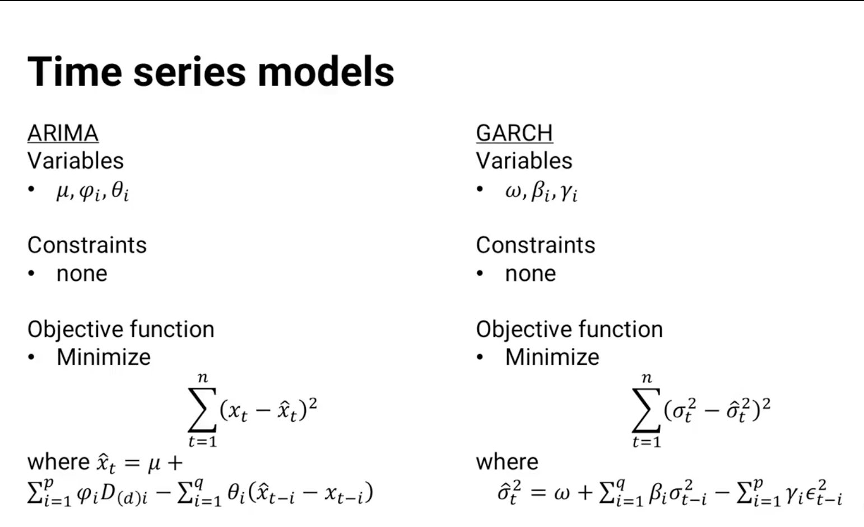

The GARCH model is similar, and it's similar in terms of optimization also.

Clustering can also be viewed as an optimization problem. Here's how we define the clustering problem earlier in the course,and here is the optimization model:

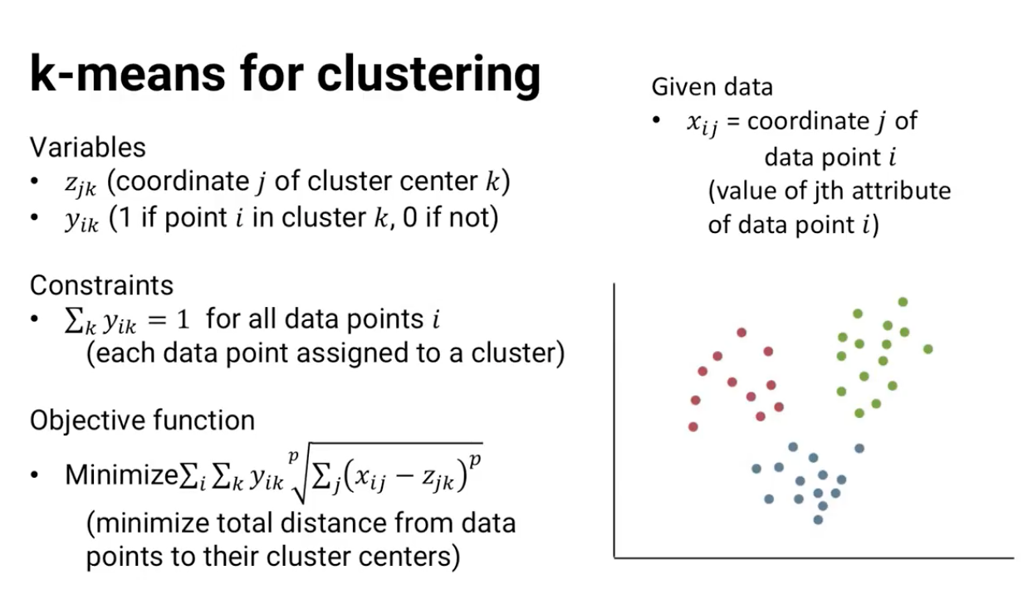

The **variables** are the coordinates for the cluster centers ($z_{jk}$), and **binary variables** for whether each data point is part of each cluster ($y_{ik}$).

The constraints require each data point to be assigned to exactly one cluster. And the objective function is to minimize the sum of distances from each data point to its cluster center. And these are just some of the optimization models that underlie analytics techniques.

Even basic statistical methods like maximum likelihood estimation have optimization underneath them. Now that we've seen all these optimization models, I need to admit that there's one thing that I've glossed over in this lesson. Based on their mathematical structure, some of these optimization models are easier and faster to solve than others -- sometimes *much* faster and *much* easier. I

### 15.6 (M): Classification of Optimization Models

In previous lessons, we've seen a variety of optimization models. Some that answer prescriptive analytics questions, and some that underlie standard models in descriptive and predictive analytics. Depending on their mathematical structure, some of these models can be solved quickly, and others can take a long time to find solutions. In this lesson, we'll see how to classify optimization models and see how easy or hard they are to solve.

In general, optimization models can be written like this: let x be the vector of variables. Then the optimization model is to minimize or maximize an objective function f of x, subject to the constraint that the variables x have to belong to a set capital X. That's pretty general and usually not such a helpful format for applied analytics. But let's see what some specialized versions of this model look like.

|  |  |  |  |  |
| --- | --- | --- | --- | --- |
| **Objective Function** | **Constraint** | **Program Type** | **Difficulty to Solve** | **Time to Solve** |
| Linear | Linear | Linear | Easy | Fast |
| Quadratic | Linear | Convex Quadratic | Easy | Fast, but slower than Linear Objective Function |
| Quadratic | Quadratic | Convex | Easy | Can Take Long |
| Linear/Quadratic | Linear, but some variables are Binary | Integer Program (subset of liner) | Hard | Slow |
| Linear/Quadratic | Linear, but some variables are Integers | Integer Program (subset of liner) | Harder | Slower |
|  |  | General Non Convex | Hardest | Slowest |

Suppose f(x) is a linear function, the sum of ci times xi plus a constant. And suppose the constraint set X is defined by linear equations and inequalities, the sum of aij times xi is less than or equal to bj equal to bj or greater than or equal to bj for each constraint j. This case is called the **linear program**, and it's easy and fast to solve even large instances. State of the art software can solve instances with more than a million variables and constraints.

If f(x) is a convex quadratic function and the constraints are again linear, then it is a **convex quadratic program**. Convex quadratic programs are also quickly solvable, though not as quickly as linear programs. More generally, suppose the object function f(x) is concave and a maximization problem or convex in a minimization problem and the constraints said x is a convex set. That's called the convex optimization problem and it's still mathematically an easy problem to solve, though it can a lot take longer to find optimal solution sometimes.

On the other hand, suppose we have a linear program but some or all of the variables are restricted to take only integer values. This is called an **integer program**.There are some very good software packages to solve integer programs. But despite a lot of research in this area there is still even some pretty small integer programs that state of the art software can't find optimal solutions to, even given days and days of computing time. And if the variables are binary variables, variables that have to be either 0 or1, that's still true even though they're a more restricted type of integer variables.

And most generally, if there is an optimization problem that's not a convex optimization problem then, even very small problems can be very hard to find optimal solutions to. These are called **General Non-Convex Problems**. In general, we can rank optimization problems from quickest and easiest to slowest and hardest in this order:

1. Linear Programs
2. Convex Quadratic Programs
3. Convex Programs
4. Integer Programs
5. General Non-Convex Programs

* So what do we do if a problem is too hard to find the optimal solution to?
  + As we saw back in the clustering topic, we can use a **heuristic**, a rule-of-thumb process that usually gives good solution seven if it's not guaranteed to find the optimal solution.

There's one other type of optimization model that I should mention because it can be solved very quickly, even more quickly than linear programs. It's called a **network optimization problem**. Suppose we have a linear program that we can draw this way.

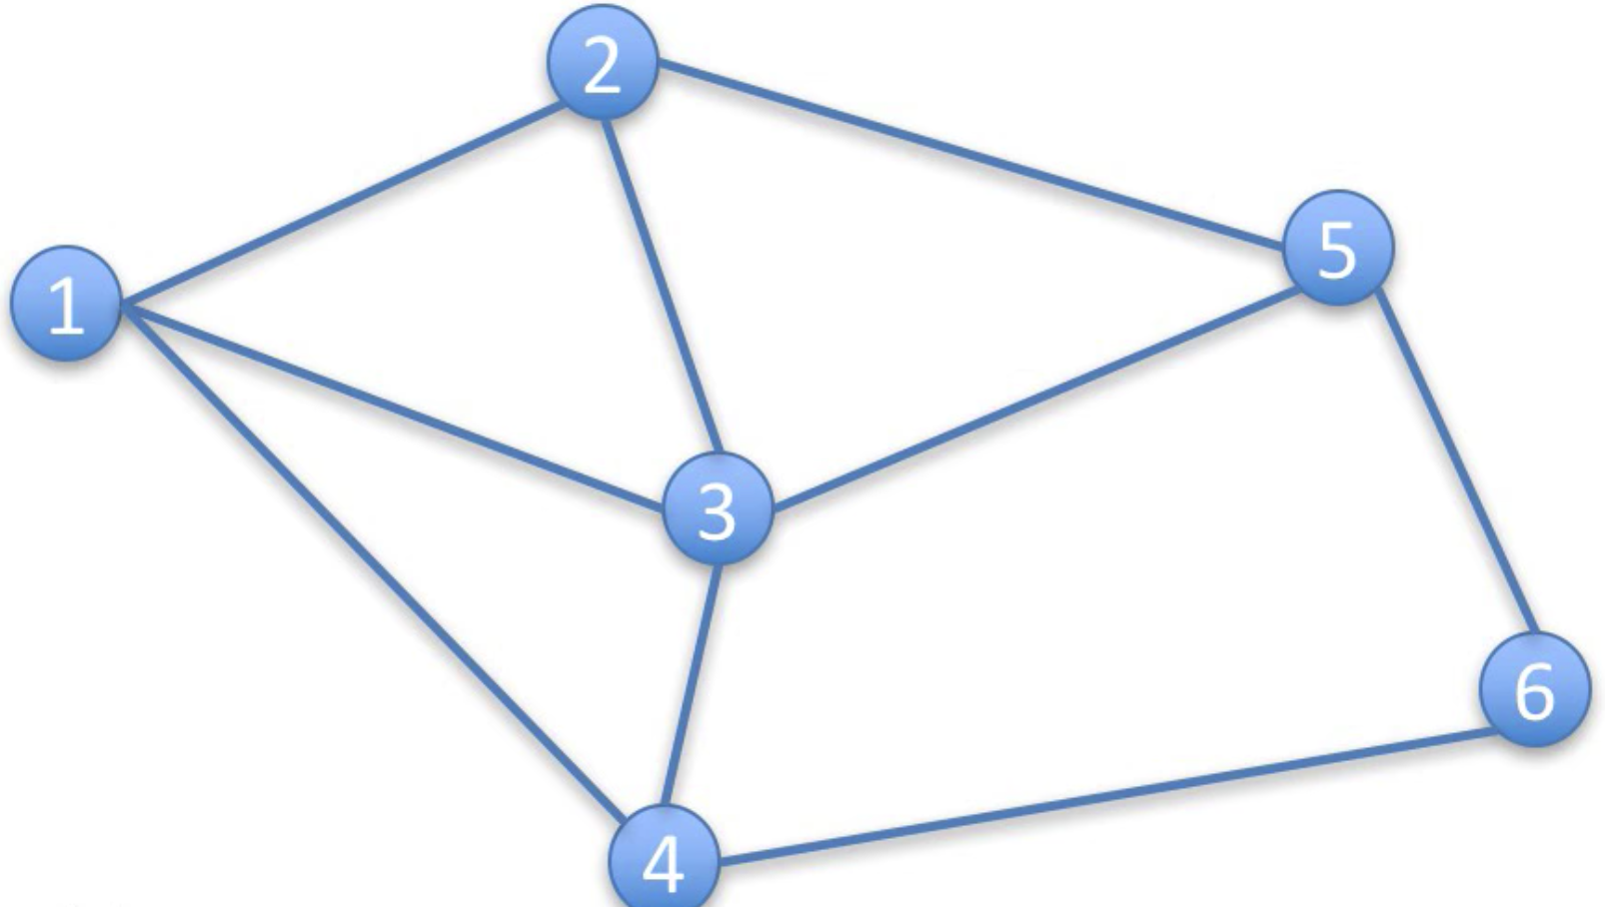

We have a set of locations called nodes or vertices and a set of connections between them called arcs or edges. For each arc, from one node to another, say from i to j we have the variable of xij. We could think of the variable as showing how much flows from node i to node j.

* For each node i, we have a constraint saying that however much flows into j has to equal the amount that comes out of i. That includes the possibility that some flow enters or leaves the network as node i. For each arc we can have constraints on the minimum and maximum flow, and finally the objective function is a linear function of variables.

If that's all we have in our model then it's a network model and we can solve it very **quickly using specialized algorithms**. And if the data is all integers, then there will be an **optimal solution** where all the variables have integer values even without us enforcing that property by writing constraints.

You might be wondering why I'm bothering to bring this up. On the surface, it might seem unlikely that we would have a situation that fits into a network model. But it turns out that there are some common questions that can be solved with network models.

#### Network Model Types

* Shortest Path Problem
  + GPS
* Assignment Problem
  + Which worker gets what job?
* Maximum Flow Model
  + How much oil can we get through a complex pipeline each hour?

There's one more important issue for us to see in optimization.What happens if we're not sure of our input data? There might be some uncertainty in our estimates, and certainly in our forecasts, or we might not know exactly how the system will behave in certain cases.We'll see how to deal with those difficulties in a future lesson.

### 15.7 (M): Stochastic Optimization

What if data or parameters aren’t known exactly?

What if forecast values are known exactly?

In previous lessons, we've seen a lot of different types of optimization models. In all of them, we implicitly assumed that we knew all of the input data. Whenever there is a parameter, like the number of additional number of votes a candidate would get for every extra visit to a state, we treated that as a known value. And whenever there is a forecast like the return on investment for stock, we assumed we knew the expected value exactly with no uncertainty and we use that expectation in place of the range of possible outcomes.

Often, the decision suggested by an optimization model would be good ones even if we treat uncertain and random things as if we know them exactly but other times it's important to model the uncertainty and randomness in an optimization framework, because considering a single outcome won't give good suggested decisions for many of the possible range of outcomes.

#### Approaches to Optimization with uncertainty and Randomness

One simple approach is just to be **conservative in modeling**. Suppose we're scheduling call center workers:

$x_{Fri}+x_{Sat}+x_{Sun}+x_{Mon}+x_{Tues}≥d_{Tues}$

and we have to make sure that enough of them are working each day. Instead of writing a constraint to say that the total number of workers has to be at least enough to meet expected demand, we could instead change the right hand side of the constraint to be expected demand, plus some additional amount theta.

$x_{Fri}+x_{Sat}+x_{Sun}+x_{Mon}+x_{Tues}≥d_{Tues}+θ$

The solution is likely to have a few extra workers now on most days, but it's less likely to have too few workers on days when demand happens to be higher than the expectation.

Alternatively, if we have a good estimate of the probability distribution for demand, we can even write a **chance constraint** the probability of having enough workers to meet demand must be at least some value p. In either case we'd have to pick the value of theta or p that makes the most sense for the problem we're modeling.

A second approach is to use the **scenario modeling**, define many scenarios and optimize over all of them. For example, in this case there might be different demand scenarios defined by the number of bugs discovered in the rollout of the new product or service. The rollout might go smoothly, there might be a couple of small, recurring bugs, one major bug that appears three days into the launch two major bugs that appear immediately, a catastrophic error after the first 10,000 customer sign-up, et cetera. For each of these scenarios s there would be different expected call-center demand each day. We can denote that by dis the demand on day i in scenario s.

Once we have all of the scenarios, we could choose to force the model to pick a solution that satisfies every scenarios constraint. That is sometimes called the **robust solution**.

* + - * Expected demand on Tuesday, under 4 different scenarios

Of course, satisfying every possible scenarios demand might be expensive. In most scenarios the call center might have lots of people sitting by the phone with nothing to do. Alternatively, we could try to optimize the expected cost over all scenarios.

* In addition to the cost of paying workers we could also estimate a cost of having too few workers to meet demand and put that into the objective function.
* But, since we have lots of scenarios we then need to estimate the probability of each scenario occurring and weigh the missed demand costs by each scenario's probability in the objective function.

Either way we deal with scenarios, the difficulty is that there might be lots of them. And for each scenario we have a separate set of constraints. That means the optimization model could get very large very quickly. And it could get hard enough to solve that we need to use heuristics to find a solution that's hopefully a good one, even if it's not the absolute optimal solution. So all of these approaches, for that matter all of the optimization models we've seen so far, are **mathematical programming models**. They have the structure of variables, constraints and an objective function. But there are other optimization models that have different structure.

We won't have time to cover the details of any of them in this course but this is a good time to introduce the name of one, **dynamic programming**.

#### Dynamic Programming Models

Relies on states (the exact situations, and their values), and decisions (choices of next state).

* Without getting into any of the mathematical detail, in dynamic programming, systems are divided into states, and **assumes there is no uncertainty**. The state specifies exactly what's going on in the system.
* For example, a state might be one week into the roll out one major bug was detected and fixed on the first day.
  + At each state, the decision maker gets to make a decision. For example, how many people to tell that tomorrow we want them to start working their five consecutive days.
  + And based on that decision, the system moves to the next state.
  + Using **Bellman's equation**, we can determine the optimal decision to make at every state. We won't go into any details of Bellman's equation or how to optimize but just know it's possible. The dynamic programming model assumes there's no uncertainty. Given in a state and a decision we know exactly what the next state will be.

But as we've talked about in this lesson, sometimes there's uncertainty involved. We make a decision without knowing exactly what the next state will be. As long as we know the probabilities of going from one state to another, we can modify the dynamic programming model with the probabilities incorporated.

It's called a **Stochastic dynamic program**.

* Introduces uncertainty
* Modified dynamic programming model with probabilities of entering a state incorporated
* If we have a discrete set of states and decisions, and the probabilities only depend on the current state and decision, then it has an even more specialized name, a **Markov decision process**.

There are other variants too. For example, approximate dynamic programming allows you to truncate the calculation that we won't get into either in this class. The main point is that there are lots of ways to deal with uncertainty and optimization problems -- some based on mathematical programming models, and some based on other models like dynamic programming. Either way, they provide approaches for optimizing under uncertainty to make good prescriptive analytics recommendations even when it makes a difference that our data and our forecasted values are not exactly known.

### 15.8 (M): Basic Optimization Algorithms

We've seen in previous lessons how to build optimization models, but we haven't talked about how those optimization models are solved. Different types of optimization models are solved using different algorithms, and we won't get into the details of any of them in this course. But I do want to show you how most optimization algorithms work at a high level.

Most optimization algorithms have two main steps.

1. The first step is **initialization**,
   1. create a first solution to pick values for all of the variables. It could be a very simple, possibly very bad solution. And in some cases,the values of the variables might not satisfy all of the constraints. But one way or another, a starting solution is found.
2. Repeat a simple two-stage process.
   1. Starting with the current solution, find a vector of relative changes to make to each variable. That vector is often called an **improving direction**.
   2. And then make changes in that improving direction some amount, and that amount is called the **step size ($Θ$)**.

In this equation, the vector t is the relative change in each variable, and theta is the amount that we change. The new solution is just the old solution, plus the improving direction times the step size. And then we iterate, we keep repeating this process of finding an improving direction, finding a step size, and getting a new solution until either the solution doesn't change much or we run out of time.

You're probably familiar with this sort of algorithm even from calculus. Remember, Newton's method for finding the roots of a function, f(x),it's exactly this sort of approach. At each step n, we have a current solution xn, we find an improving direction,-f(xn) divided by f prime xn where f prime is the derivative of f. And then we move one unit in that direction. So out new solution xn + 1 is xn plus 1 times the improving direction.

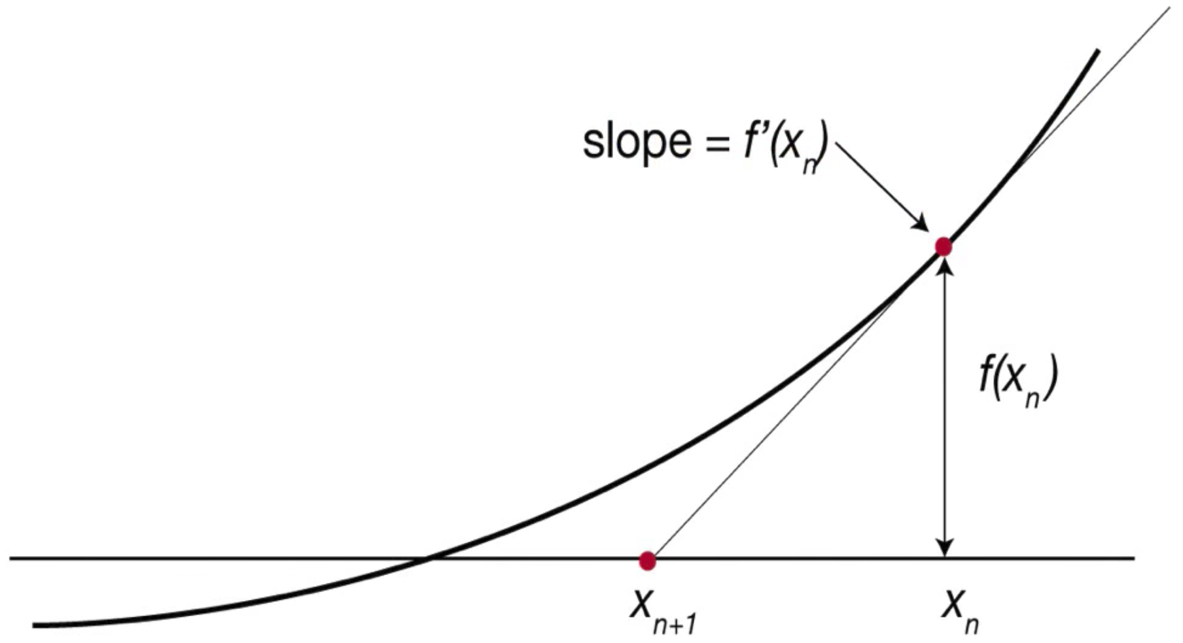

Depending on the attributes of our optimization problem,this approach might be guaranteed to converge to the optimal solution. For example, if it's a convex optimization problem, or it might not be guaranteed to give an optimal solution, especially if it's not a convex optimization problem.

|  |  |
| --- | --- |
| **Convex Optimization Problem** | **Non-Convex Optimization Problem** |
| Guaranteed to find optimal solution | NOT Guaranteed to find optimal solution |
|  | May Converge to infeasible Solution |
|  | May find only a local optimum |

If it is not a convex problem, the method might converge to a point that's not in the set of feasible solutions like in this picture. Or it might converge to a local but not global optimal solution. A solution that's better than all the others close to it, like in this picture, so there is no clear improving direction, but it isn't as good as something farther away.

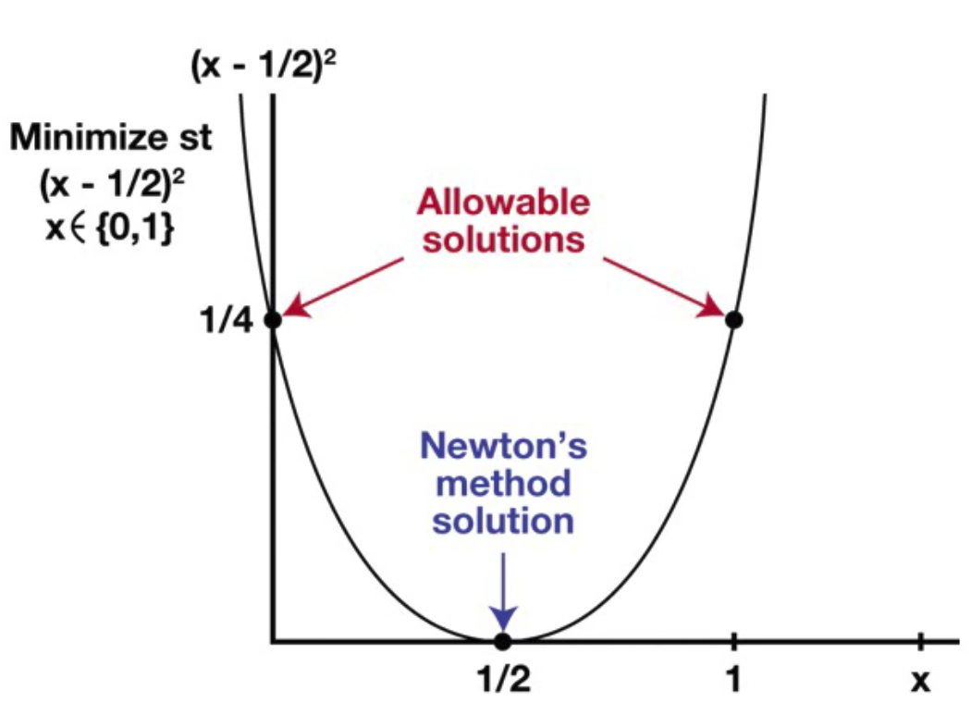 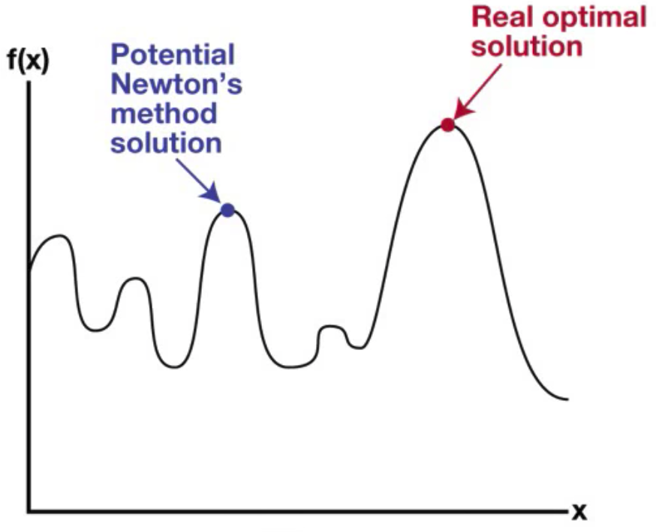

Even if it's guaranteed to find an optimal solution, in some cases, an improving direction and step size method might quickly converge to an optimal solution. And in other cases it might take a long time. For example, lots of network algorithms and algorithms for solving linear programming problems converge quickly, but algorithms for solving integer programs, which are often tree based but rely on direction and step size methods and subproblems, can take a lot longer.

## 16. Advanced Models

### 16.1 (M): Non-Parametric Methods

In this lesson, we'll see some statistical tests that aren't really in the category of advanced analytics methods. But they're often not taught in the basic statistics prerequisites that we require for this course. So, I want to make sure you get to see them now. 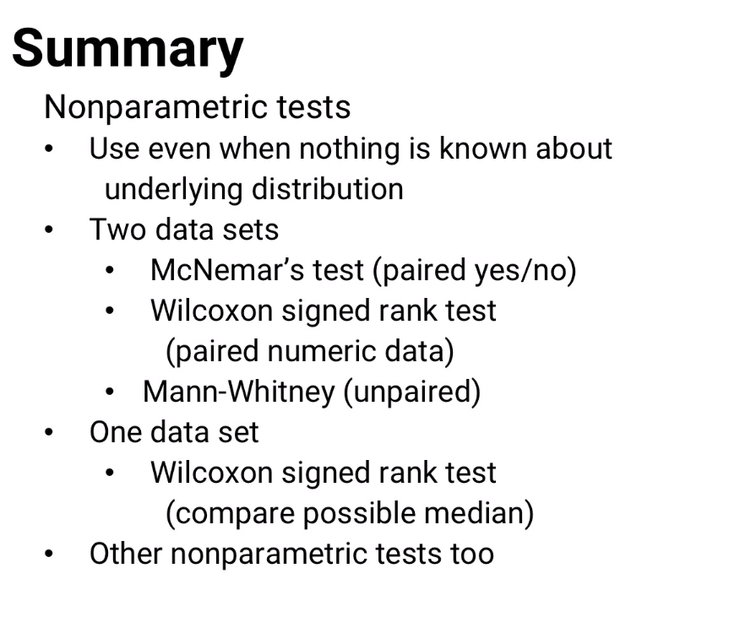

Usually, hypothesis tests taught in basic statistics courses **assume that we know the underlying distribution that we're testing against (which is the definition applied to this section)**. But sometimes that's not the case: All we have is responses and we don't have a good model for the distribution.

Nonparametric tests:

* Make it less important whether a small data set includes the right distribution and range of results
  + Just need *enough* data to figure out where the middle value is

Numeric Data: Use **Wilcoxon**

Yes/No Data: Use **McNemar**

|  |  |  |  |
| --- | --- | --- | --- |
| **Non Parametric Test** | **How It’s Done** | **Other Notable Attributes of Test** | **Uses** |
| McNemar’s Test  Assumptions  None needed. This method doesn’t care about the underlying distribution. | 1. Throws out all the cases where the results are the same. 2. Tests **the responses (NOT the underlying distribution)** using the **binomial distribution** to see whether we’d expect results this extreme or more extreme just by luck | We don’t need to know anything about the distribution. It’s just a comparison of the results | Used for comparing results on pairs of responses, data points where two different approaches were used on the same thing. |
| Wilcoxon Signed Rank Test for Medians  Assumptions  Distribution is continuous and symmetric | **Median difference Test**  Given responses :   1. Rank from smallest to largest 2. only for values where 3. Get p-value test for $W$  **Sample Median Equivalence Test (paired test)**  Given pairs ${(y}_{1},z_{1}),....,(y_{n},z_{n})$ from observations y & z, use for rank test | Calculating p-values here are harder than McNemar’s Test  The Wilcoxon test is like a normal distribution test | Answers the questions:   1. “Is the median of the distribution different from ? 2. Do two sets of paired samples have the same median? |
| Mann-Whitney Test  Assumptions  Samples are independent from each other | Given independent observations and :   1. Rank all observations **together:** , 2. U = smaller of two adjusted rank sums: $U = min\{U_{y},U_{z}\}$  where: $$U_{y}= \sum_{i=1}^{n}{}rank(y_{i})-\frac{n(n+1)}{2}$$ $$U_{z}= \sum_{j=1}^{m}{}rank(z_{j})-\frac{m(m+1)}{2}$$  3. Find significance of U (need software or table) |  | Used for Two Data set analysis, but not paired samples |

#### **McNemar's Test**

McNemar’s Test does the following:

1. Throws out all the cases where the results are the same
2. Tests using the **binomial distribution** to see whether we’d expect results this extreme or more extreme just by luck

Used for comparing results on pairs of responses, data points where two different approaches were used on the same thing.

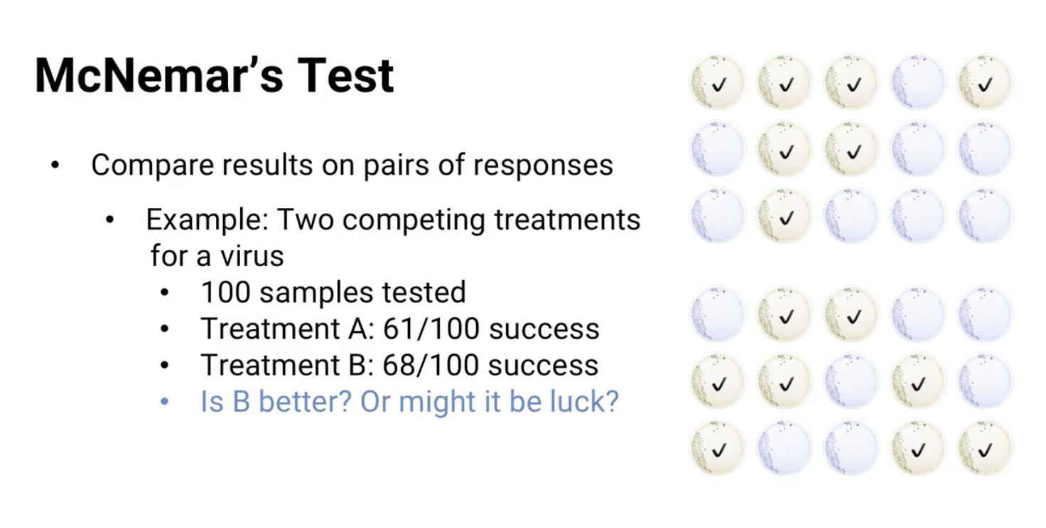

Here's an example: suppose we have two competing treatments for a virus and both were tested. Viruses were extracted from a hundred varied patients who had the disease. And because the virus is constantly mutate, the 100 virus samples were all a little different. Both treatments were tested on virus samples from all 100 patients. Now, we want to see whether one treatment is better than the other. Suppose treatment A killed the virus and samples from 61 of the patients. And treatment B killed the virus from 68 of the patients. Is B better or might it just be luck?

That probably depends. Here are two different scenarios:

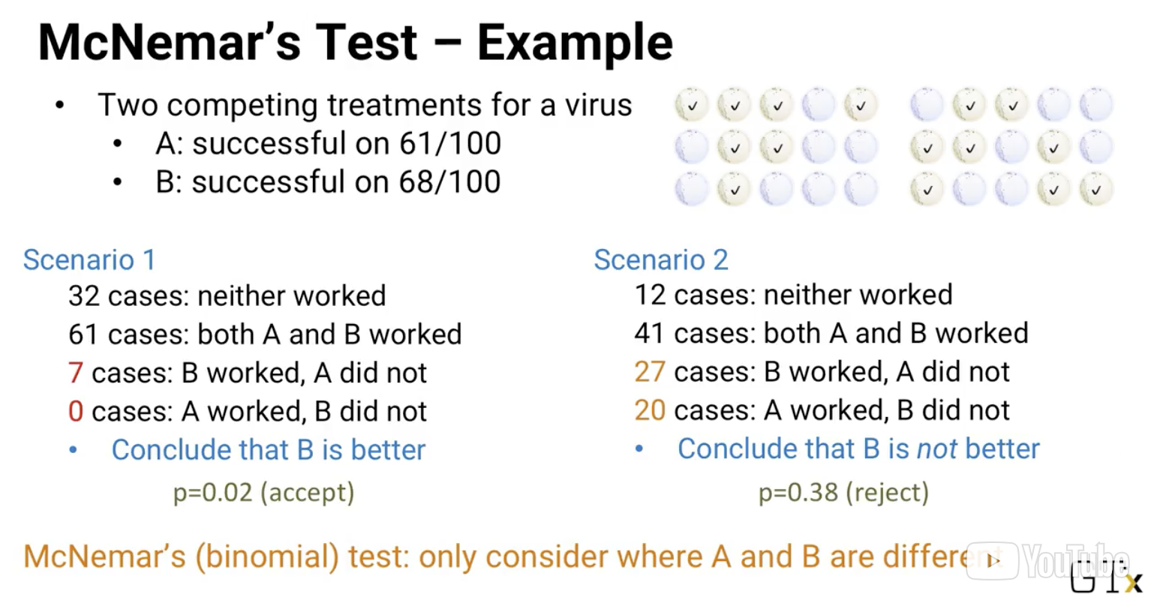

* Scenario 1:

 $(B∩A^{c}) + (A ∩B^{c}) =7$

 $(B^{c}∩A^{c}) = 32$

$(B^{}∩A^{}) = 61$

+ We might conclude that B is better than A. B works on all the same people as A plus some more.
* Scenario 2:

 $(B∩A^{c}) =27$

 $(B^{c}∩A) = 20$

$(B^{c}∩A^{c}) = 12$

$(B^{}∩A^{}) = 41$

+ Actually, this would be a great result (in the real world). We might recommend that patients be given **both** treatments (since usually some combination of the two will work). But in a statistical sense, it's hard to tell which one is better.
    - They were different in 47 cases: 20 times A was better and 27 times B was better.
* Scenario 1 is actually the more statistically sound and shows a statistically significant difference (p=0.02). Scenario 2 could have happened just by luck
  + That’s the essence of **McNemar’s Test.**
    - *We don’t need to know anything about the distribution of how much is cured. It’s just a comparison of a pair of results*

#### 

#### **Wilcoxon Signed Rank Test** **for Medians**

Again, we don't make assumptions about what the response function is mathematically. The only assumptions we make are that it's continuous and symmetric. The question it answers is whether the median of the distribution is different from a specific value, m. Given a set of responses, y1 through yn, we find the absolute value of each yi-m. And we rank the absolute values from smallest to largest. Then we add up the ranks, only of the ones where yi is greater than m. Let's call that sum W. The test is a standard p-value approach. If the probability p of getting a sum of ranks at least as extreme as W is small, then we can say that the median is probably different from m. Otherwise, we don't.

Calculating p-values here is harder than in the McNemar test. In McNemar's test we use the binomial distribution, but the Wilcoxon signed rank test is like a normal distribution test. In the old days we needed to look up the p-values in a table. These days there's software that can calculate it for us.

There's also a version of the **Wilcoxon Signed Rank Test for paired samples**, similar to McNamara's test. For each of the end samples, we have two observations, say yi and zi. The test is exactly like the previous Wilcoxon test, but instead of the absolute value of each yi-m, we use the absolute value of each yi - zi. And the question we're answering is whether the ranks indicate that the two sets of observations are likely to be different. It's used on different data sets than the McNemar test. The Wilcoxon test is designed for when the observations yi and zi are numeric data. And McNemar's test is designed for when the observations are just yes or no.

There's one more nonparametric test for comparing two samples that I want to show you. And this one is for samples where the outcomes are not paired. Before we were assuming that both yi and zi were observed for the same data point. For example the same virus. Now we're just assuming that all the observations are independent of each other. This test is called the **Mann-Whitney test**.

In the Mann-Whitney test we rank all of the yi and zi together. And then, add up the ranks of all the samples that come from the first set. All the ranks of the yi and the ranks of the samples in the second set, all the ranks of the zi. Whichever sum is smaller is compared again against the table that gives the significance of the difference. There are definitely other nonparametric tests, but these are a good set to know for most analytics applications.

The basic idea is that even when we don't know anything about the underlying processes that create the observations, we can still use the relative ranks or outcomes of two competing approaches to see whether the difference between them is significant.

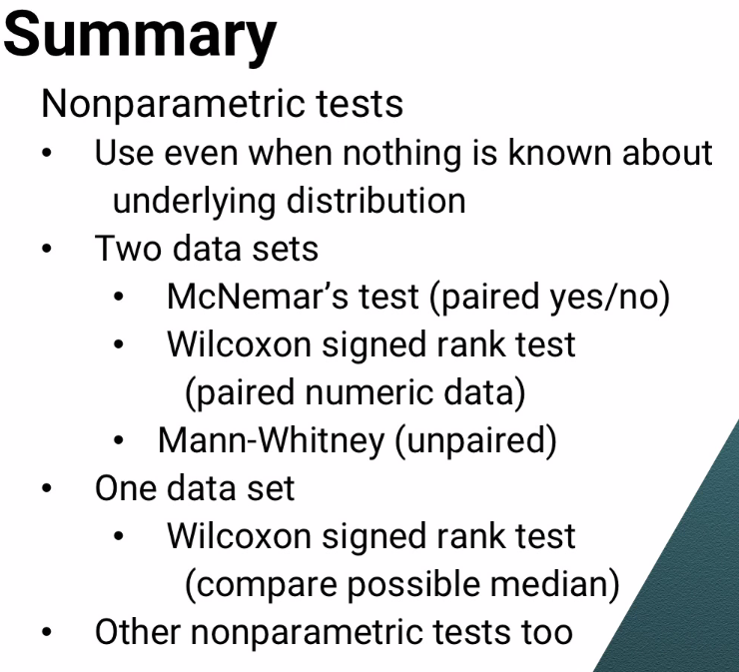

### 16.2 (M): Bayesian Modeling

In this lesson, we'll see the basics of **Bayesian models** and how they're sometimes used in analytics. Because Bayesian results are sometimes counterintuitive, I'm going to go through a couple of examples not because this topic is harder than the other models we've seen in this course, but to show you how the counterintuitive results arise and how to explain them to someone. Because with these sorts of models, being able to explain them to decision makers who never learned the math can be critical to getting the results accepted.

Bayesian models are based on a basic rule of conditional probability called Bayes's rule or Bayes's theorem:

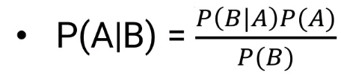

*The probability of A given B is the probability of B given A,   
times the probability of A, divided by the probability of B.*

For example, suppose we have a medical test for a disease. When a person has the disease, the test finds it 98% of the time. The test gives a false positive result for 8% of the people who don't have the disease and only 1% of the population really has the disease, which means 8.9% of the people test positive. So if someone tests positive, what are the chances they really have the disease?

Here's how we can use Bayes theorem to get the answer. We're looking for the probability someone has the disease, which we call A. Given that he tested positive, which we can call B. That's equal to the probability of testing positive or B, given that he has the disease or A times the probability of having the disease divided the probability of testing positive.

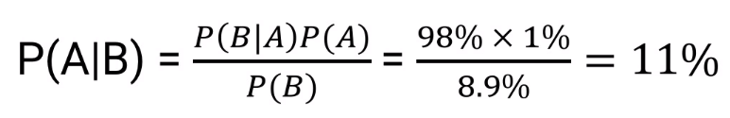

So, that's 98% times 1% divided by 0.89% or only about 11%. Even after testing positive, a person only has an 11% chance of having the disease. Because there are so many people who don't have it that the number of false positives is about eight times higher than the number of true positives. That's a little counterintuitive. Almost 90% of positive tests don't have the disease, but it's not so hard to explain.

But that's just a simple application of Bayes's theorem, the sort of thing you might remember from basic probability.

#### Empirical Bayes Modeling

Useful when an overall distribution of something is known or estimated, but there’s only a little data available for a specific case.

|  |
| --- |
| Example: NCAA Tournament Outcome Prediction **The Math**  Based on the outcome of regular season games, we want to try to estimate how much better one team is than another. From past NCAA point spread data, we can estimate that the difference in points scored by the home team and road team is approximately normally distributed with variant sigma squared:   * + h= home court advantage   + m= true difference in teams’ strength (unknown)   + = variance   We can estimate m to get an estimate: ${m ∼N(0, τ^{2})}_{}$ Look at observed data and gather the following: $x$  * : Observed point difference in a specific matchup that happened before $m$* : real difference between the two teams, m ^= x, where x is the observed point difference   We could say that the real difference is exactly x, but that’s just one data point and it doesn’t account for all of the randomness involved in the system. We can model just how likely our estimated real difference (m) might be, given what we just observed (x)   * Apply Bayes Rule: * Without showing all the steps, it turns out that the true difference m is distributed like this:   + are all obtained from past data   We can extend the specific matchup framework, and extend out to make a generalization about how good a specific team is to all teams by integrating the distribution from 0 to infinity:  **Explanation**  Example: Home team won by 20 points   * h: 4 points   + Estimated home-court advantage $τ$* : 6 points   + SD in team strength difference $σ$* : 11 points   + SE from random variation   Of the 20 point Victory:   * 4 points due to home court * 12.5 points due to random variation * 3.5 points due to the difference between teams * It’s a bit counterintuitive:   + 3.5 Points due to difference between teams doesn’t outweigh the home court advantage (4 points)...   + ...The 20 point victor is likely to lose on the other team’s court * In actuality   + The variance between team strength is only 36   + The variance due to randomness is about 120   + A 20 pt. Win is more likely to happen, because of randomness than it is to happen because of the *team strength* |

Here's an example from my own research in predicting outcomes in the NCAA basketball tournament. And mean equal to the home court advantage h plus m, the true difference in the team strength.

Of course, we don't know m. If we did, that would tell us exactly how much better one team is than the other. But thanks to Bayes rule, we can figure it out.

First, we can model the differences between college basketball teams' strength. The difference in how good the teams are as normally distributed with mean zero and variance tau squared. Next, we look at our observe data, the outcome of actual games. For example, suppose Georgia Tech beat North Carolina at home by x points. We want to figure out m, the real difference between the two teams from our observation of x. We could say that the real difference is exactly equal to x, but that's just one data point and it doesn't account for all of the randomness involved in the system.

Instead, here's how we use Bayes rule. We look for the probability of having true difference m given the observation x. By Bayes rule, the probability of m given x is the probability of observing a point difference of x given a true margin m times the probability that the true margin is m divided by the probability that the observed margin is x.

I won't go through all the steps, but it turns out that the true difference m is also normally distributed with mean and variance shown here:

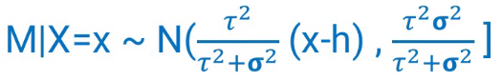

So after we calculate sigma tau and h from past NCAA data, if Georgia Tech beat North Carolina by x points, we could find not just the distribution of how much better or worse one team is than the other. We could also integrate that distribution from zero to infinity to show the probability that Georgia Tech is the better team.

So that's the math, but let’s see what it's actually saying. Suppose the home team won a game by 20 points. Based on old NCAA data, we estimate that home court advantage is close to 4 points that the standard deviation in team strength difference is about 6 points and that the standard error from random variation is about 11 points.

So based on our empirical based model, the most likely thing is that of the 20 point victory about 4 points is due to home court and about 12.5 points are due to random variation which leaves only in about 3.5 points that are due to difference between the teams. At first glance, that's pretty counterintuitive. A 20 point win shows just a 3.5 point difference. That's less than the effective home court, so the empirical Bayes model seems to predict that the 20-point winner is slightly more likely to lose if the two teams played again on the other home court. That's not intuitive at all. What's this empirical Bayes model doing?

Here's how it gets there. The variance of the difference between team strengths is about 36. The variance due to randomness is about 120. So, there is a lot more variance due to randomness. A 20 point win is more likely to happen, because of randomness than it is to happen, because of the difference in team strengths and the empirical Bayes model recognizes and shrinks the extreme result down to a more reasonable estimate.

And if you're wondering, the data shows that empirical Bayesian model is right. When two teams place each other twice at a season and one beats another by 20 points at home, they're actually slightly less than 50% likely to beat the same team on the road just like the empirical Bayes model predicts.

So, that's an example of a Bayesian approach where we can take a single observation. Combined with a broader set of observations that are relevant in general, but not specifically and make a deduction or a prediction. There are other more complicated forms of Bayesian models that I won't go into in this course. The main takeaway is that, especially in the absence of lots of data, Bayesian models can be very helpful. But you have to understand how the intuition really works.

### 16.3 (M): Communities in Graphs

In this lesson, we'll see a model that will help us answer important questions in the analysis of large, interconnected populations. There are important impacts in the analysis of how:

* marketing messages propagate through social media networks
* disease outbreaks spread through populations
* computer viruses spread through a network
* words have spread from language to language over time
* terrorist networks communicate
* and more.

Specifically, we'll focus on automated ways of finding highly-interconnected subpopulations. Within those subpopulations things can spread much more quickly.

For example, here's a picture where each person is denoted by a circle and a line between two circles means those two people are in the same room together at least once a day:

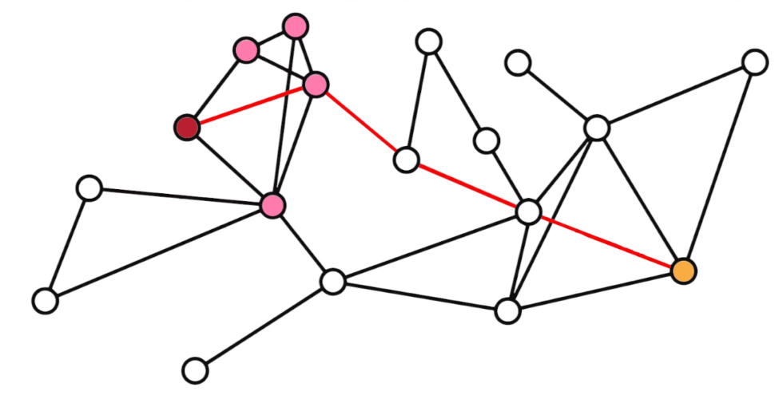

If the red person gets the flu, it might take a long time to spread all the way to the orange person: the shortest way requires four connections.

On the other hand, look at all of pink the people. These people are much more likely to get the flu quickly -- most of them are connected to the infected person, and even the ones who aren't have a lot of connections to people who are directly connected to the infected person. The same idea would be true if we were talking about getting a marketing message through a social network. If we send the message to the red circle person, It's much more likely to quickly spread to the pink circle people than it is to the yellow circle person. In this lesson we'll see a model for quickly and automatically finding communities like the one with the red and pink people within a population.

First, let's start off with some standard terminology:

* **Community:** A set of circles that’s highly connected within itself (below)

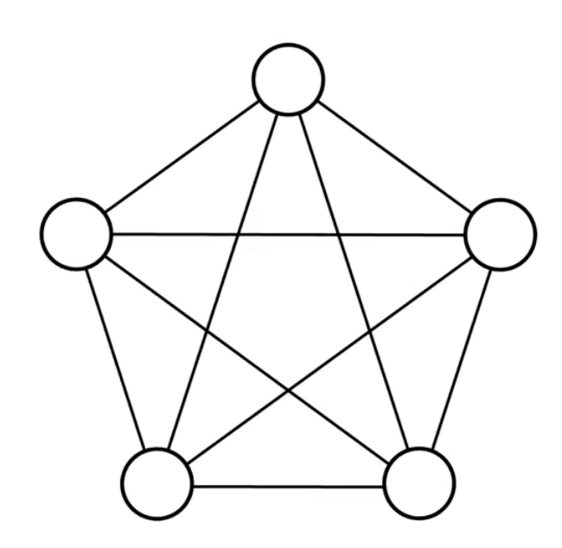

* **Graph**



* + **Nodes/Vertices:** The circles
  + **Arcs/Edges:** The Lines
  + **Cliq****ue:** (This) A set of nodes that **all** have edges between each other is called a **clique**. The meaning is similar to the word clique, that refers to a small group of people who stick together and exclude others.

The question of finding cliques in graphs has been around for a long time. People have proved that it's part of a class of mathematically hard problems to solve but our question is a little different. We don't necessarily need full cliques, communities that have lots of edges between the nodes are also valuable to find even if there are edges missing from what would be a clique.

The method we're going to see for decomposing a graph into communities is called the **Louv****ain Algorithm** (**Heuristic** to Decompose a graph into communities)**.** The Louvain Algorithm tries to maximize a measure called the *modularity* of a graph and we'll need a little little notation to talk about it.

* + If no arc, then = 0
$w_{i}: total weight of arcs connected to node i$

$W: total weight of ALL arcs$

* Modularity = $\frac{1}{2W}\sum_{i,j in same community}^{n}{}(a_{ij}- \frac{w_{i}w_{j}}{2W})$
  + Is a measure of how well the graph is separated into communities or modules that are connected a lot internally, but not connected much between each other
  + Measure of “cliqueness” of the overall graph

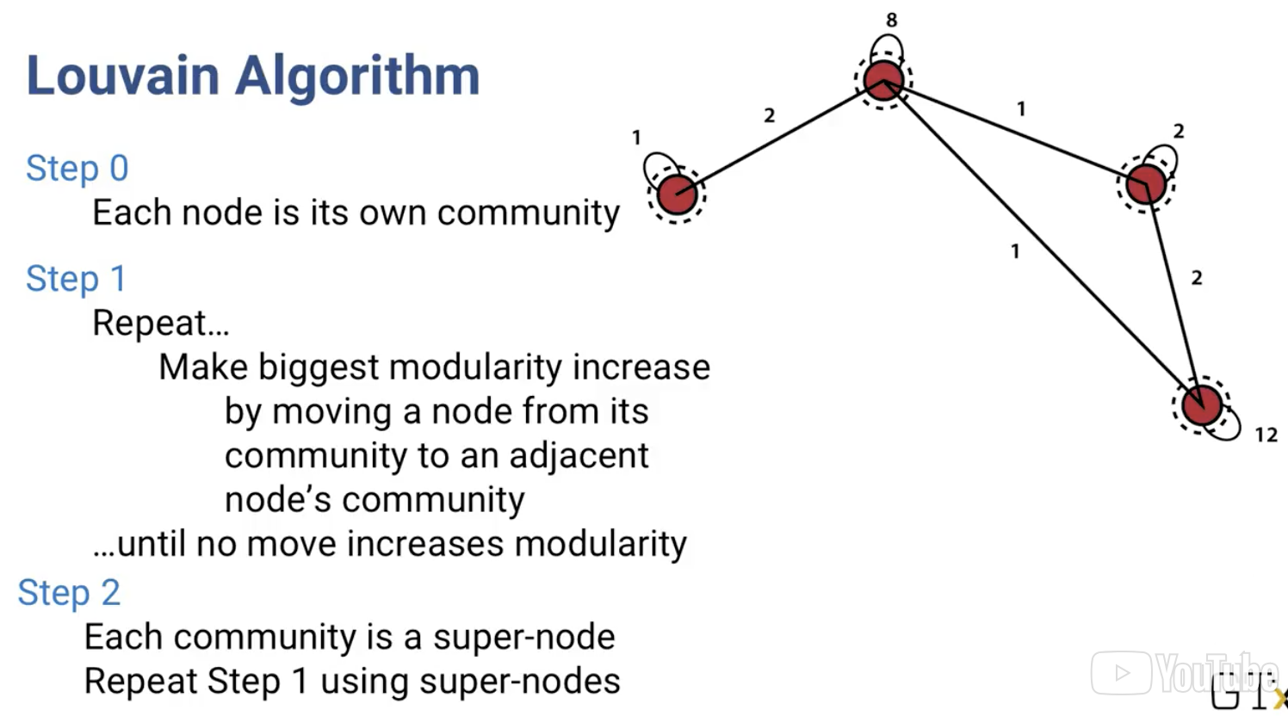

Step 2 is a repeated process of a new graph generated from communities formed from Step 1.

* Each new community becomes a super node by itself, with total weight of all the nodes inside it
* Super Arcs are created between the super-nodes with weights equal to all the arcs between the super nodes
* There is also a super-arc for each super-node to itself (inside the red dot), with weights equal to all the arcs inside the super-node

For each arc say between nodes i and j, aij is the weight of that arc, basically how important it is. In some cases all the arc weights will be the same, but sometimes one arc is more important than another in the specific application we're dealing with. If there's no arc between i and j then aij is 0.

For each node i, wi is the weight of each node, equal to the total weight of all the arcs connected to node i, again how important it is. To make it easier to write the modularity formula Let's call capital W the total weight of all the arcs in the graph.

Then modularity is just 1 / 2W times the sum over all pairs i and j of nodes in the same community of (aij minus wi times wj over 2W.

I won't go into exactly what modularity represents, but it's a measure of how well the graph is separated into communities or modules that are connected a lot internally, but not connected much between each other.

The Louvain algorithm has just a few mostly repeated steps. It starts with each node being its own community. Then for each node, i, it looks to see if it moves i into another community how much does the modularity go up? Whichever move creates the biggest modularity increase, that's where node i goes. Or if nothing increases modularity, node i just stays where it is. It does that for every node and then starts again with the first node and goes through them all again and again until there's no way to improve modularity by moving a node.

But it doesn't stop there. Now it starts over with a new graph where each community now becomes a super-node by itself, with total weight of all the nodes inside it. Super-arcs are created between super-nodes, with weights equal to all the arcs between the super super-nodes.

There is also a super-arc for each super-node to itself with weight equal to the weight of all arcs inside the super-node. The algorithm then starts again at the beginning using the super-nodes and super-arcs.

It's not too hard to implement yourself but usually you don't have to. Arc, Python and others already have the Louvain algorithm implemented for you. Although the Louvain algorithm is a heuristic, which means it's not guaranteed to find the absolute best partition of a graph into communities, it often gives very good solutions very quickly. And it's used somewhat often when we want to find communities inside a large network, especially social media networks, and networks of people, computers, etc.

### 16.4 (M): Neural Networks and Deep Learning

These models are often used when we need to react to patterns that we don't even understand.

For example, think about the CAPTCHA type of questions on web forms. We might be asked to say what some handwritten numbers and letters are to prove that we're human and not a machine. It's usually easy for our brains to figure out what each number and letter is. But we usually can't write out a set of rules that a computer could use to answer that same question. There are so many exceptions and oddly formed numbers and letters that we can't specify rules or algorithms.

The idea of neural networks in deep learning is to train a system to react to whatever patterns our human brain is reacting to without knowing what it's reacting to. They've been especially successful in things like recognizing speech and writing, natural language processing, and image recognition.

Neural networks have a catchy name -- they're modeled after the way neurons work in brains. In an artificial neural network they are **three levels** of simulated neurons: 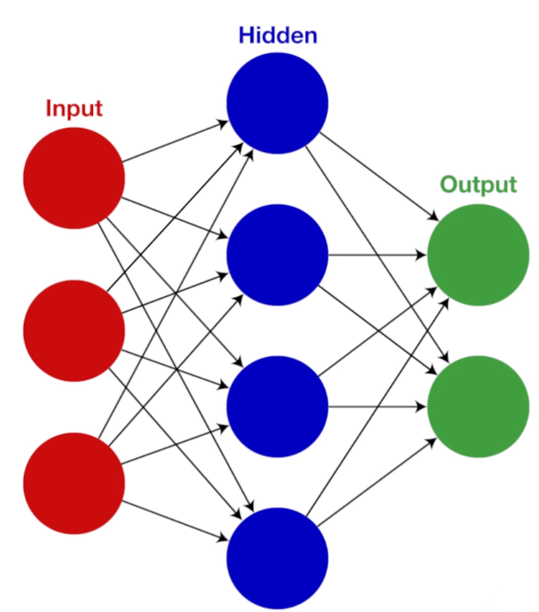

1. **input level**
   1. External inputs come into each input neuron. Each input neuron accepts a single piece of information. For example, if we're trying to solve the CAPTCHA problem We might divide the picture of a digit into pixels and every pixel's status between fully white and fully black goes to its own input neuron.
2. **Hidden Level**
   1. As the inputs come in, they're passed to the first level of hidden neurons. Each simulated neuron calculates a weighted value of those inputs and sends the result to neurons at the next level. Those next level neurons do the same thing; in fact there might be several layers of hidden neurons one after another.
3. **output level**
   1. Eventually the output layer neurons get their inputs and each one uses those inputs to find their results. For example a common approach to captcha is to have one output neuron for each possible number of letters and each output neurons result is like a level of certainty that the input in edges that number or letter. In the end, the model’s predicted output is whichever output neuron has the highest result.

Then comes the important step: depending on how wrong each output neuron was, the weights of the different inputs are changed within all the simulated neurons. There are lots of ways to do this. A simple one is basic gradient descent using the slope of a function like you might remember from Calculus.

If the network learns well, with enough data eventually all of the weights will be adjusted so that the network generates correct outputs from the input. At least that's the theory. In practice, neural networks often don't give the best results.

* Cons of Neural Nets
  1. They require lots of data to train
  2. It's often hard to choose & tune the learning algorithm so the weights don't change too slowly but also don't change so quickly that they jump all over the place.

**Deep Learning**

But the idea of neural networks has been more recently extended to a related and often much more successful model called **deep learning.** It's actually an old idea at its core but the ability to make it work well is a more recent development. Deep learning is very similar to neural networks in it's leveled structure, but as the name deep implies, it might have a lot of layers. There are lots of variations of deep learning, but the basic idea of all of them is about the same, and not much different from neural networks, and in practice it seems like it might usually be a better approach. Deep learning has a pretty good success in analytics in the areas of natural language processing, speech recognition and image recognition.

### 16.5 (M): Competitive Models/ Competitive Decision-Making

Almost all of the models we've seen in this course have been sort of an us-against-the-data models.

* In descriptive models, we assume that there's a bunch of data and hidden in the data is an understanding of reality that we're using analytics to tease out.
* In predictive models, it's almost the same. We're using the data to find hidden relationships that will help us predict what's going to happen in the future.
* In prescriptive models, we're using the data to figure out the best thing for us to do assuming that the process we're optimising isn't going to change.
  + But what if it does change and even more, what if it's changing intelligently and we have to determine the best thing for us to do given that the system will act or react in its best way.

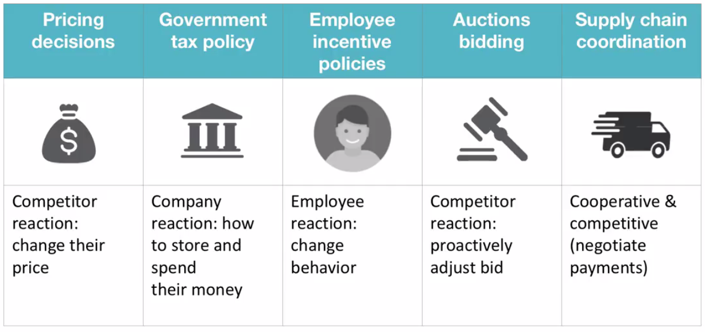

In that case we need to use analytics models to consider all sides of the system. For example, a company might be using past purchasing data to set the price for a new product that's launching, based on competitors' price for a similar products. But once they set their price, competitors might adjust their own prices so the company's sales can be different from what their first model anticipated. Governments set corporate tax policies and companies react by choosing various ways to store and spend their money. To figure out how much tax revenue the government gets, we need to consider both sides of the decision. Companies set incentive policies for their employees and employees then act in the best way for themselves. I once supervised a project where the human behavioral aspects of this situation were the key to the recommendations we made. In the United States, the government sometimes auctions off bandwidth for communications. Companies bidding in that auction want to pay as little as possible for what they want but they need to beat out everyone else. Each one of the companies is simultaneously thinking the same way and to find their best bid price, they need to consider not just their own situation but what everyone else will do too. And sometimes the situation is both competitive and cooperative. Like a supply chain where multiple companies are all working to achieve the same final goal, while still negotiating prices and payments throughout the supply chain. For example, Intel makes computer chips to go in Lenovo laptops. And the product isn't a success unless both Intel and Lenovo do good work in a coordinated way. How should the payments be structured between them so both companies have the right incentives to work well together? In these sorts of situations, we have to use competitive decision-making. It's often called **Game Theory**. And in a situation involving competition and cooperation, it's called **cooperative game theory**.

Sometimes, everyone has to make decisions simultaneously, and can't change once they're made. So you have to think about what strategy you competitors might use and come up with your best counter-strategy.

Of course, they're thinking about what counter-strategy you might use and coming up with their counter-counter strategy. So you need to consider that and devise your counter-counter-counter strategy and so on. If you do that infinitely many times you'll reach your best solution and that's essentially what game theory is all about. The same general idea is also true even if decisions are made sequentially. Sometimes you can see the other side's strategy before making your decision or vice versa. That's called a **sequential game**. In the gas station example, the best strategy was just to do one thing. It's called a **pure strategy**. But sometimes, the best strategy is a randomized strategy, also called a **mixed strategy**.

Most of you have probably played the game rock-paper-scissors. There are two players and each one simultaneously puts out their hand in the shape of a rock, paper, or scissors. If they pick the same thing, nobody wins. Otherwise, someone with a rock beats someone with scissors. The rock crushes the scissors. Someone with scissors beats someone with paper. Scissors cut paper. And someone with paper beats someone with a rock. Paper covers rock. In this sort of situation, using a pure strategy over and over again will lose. If your opponent knows you're always picking rock, she'll pick paper and beat you every time. Instead, a randomized, or mixed strategy, where you randomly pick each one with probability one third is your best bet. There are many other classifications of games and strategies, and I just want to mention two more. In some situations, everyone has what's called perfect information. You know all about everyone else's situation and vice versa, sort of like you're playing chess. In other cases, everyone has imperfect information. In the gas station case, for example, neither one really knows the other's profit margins exactly. And in still other situations, some people have more information than others, so it's not symmetric. And the last classification I want to mention is zero sum or non-zero-sum games. In a zero-sum game whatever one side gets, the other side loses, and vice versa. For example, if you and your friend bet a dollar on the outcome of rock-paper-scissors, that's zero-sum. The overall outcome is zero. One of you gets a dollar, and the other loses one. On the other hand, in a non-zero-sum game, it's possible for the total benefit for everyone to be higher or lower depending on the decisions made. Economics is often like this. It's possible for everyone in an economy to effectively become richer or poorer, rather than just having a fixed amount of richness. One last thing you might be wondering about is how to find the best decisions to make in these competitive situations. It turns out that in most cases different optimization models can be used, and that's not such a surprise since we're thinking in terms of finding the best, or optimal strategy.

#### 16.5a (M): Competitive Models Demo

In this lesson, we're going to talk about competitive decision-making. Almost all of the models we've seen in this course have been sort of an us-against-the-data models. In descriptive models, we assume that there's a bunch of data and hidden in the data is an understanding of reality that we're using analytics to tease out.

In predictive models, it's almost the same. We're using the data to find hidden relationships that will help us predict what's going to happen in the future. And in prescriptive models, we're using the data to figure out the best thing for us to do assuming that the process we're optimising isn't going to change.

But what if it does change and even more, what if it's changing intelligently and we have to determine the best thing for us to do given that the system will act or react in its best way? In that case we need to use analytics models to consider all sides of the system.

For example, a company might be using past purchasing data to set the price for a new product that's launching, based on competitors' price for a similar products. But once they set their price, competitors might adjust their own prices so the company's sales can be different from what their first model anticipated.

Governments set corporate tax policies and companies react by choosing various ways to store and spend their money. To figure out how much tax revenue the government gets, we need to consider both sides of the decision. Companies set incentive policies for their employees and employees then act in the best way for themselves.

I once supervised a project where the human behavioral aspects of this situation were the key to the recommendations we made. In the United States, the government sometimes auctions off bandwidth for communications. Companies bidding in that auction want to pay as little as possible for what they want but they need to beat out everyone else. Each one of the companies is simultaneously thinking the same way and to find their best bid price, they need to consider not just their own situation but what everyone else will do too.

And sometimes the situation is both competitive and cooperative, like a supply chain where multiple companies are all working to achieve the same final goal, while still negotiating prices and payments throughout the supply chain. For example, Intel makes computer chips to go in Lenovo laptops. And the product isn't a success unless both Intel and Lenovo do good work in a coordinated way. How should be the payments be structured between them so both companies have the right incentives to work well together?

In these sorts of situations, we have to use competitive decision-making. It's often called **Game Theory**. And in a situation involving competition and cooperation, it's called **cooperative game theory**.

Sometimes, everyone has to make decisions simultaneously, and can't change once they're made. So you have to think about what strategy you competitors might use and come up with your best counter-strategy. Of course, they're thinking about what counter-strategy you might use and coming up with their counter-counter strategy. So you need to consider that and devise your counter-counter-counter strategy and so on. If you do that infinitely many times, you'll reach your best solution. That's essentially what game theory is all about.

The same general idea is also true even if decisions are made sequentially. Sometimes you can see the other side's strategy before making your decision or vice versa. That's called a sequential game. In the gas station example below, the best strategy was just to do one thing. It's called a pure strategy.

But sometimes, the best strategy is a randomized strategy, also called a mixed strategy. Most of you have probably played the game rock-paper-scissors. There are two players and each one simultaneously puts out their hand in the shape of a rock, paper, or scissors. If they pick the same thing, nobody wins. Otherwise, someone with a rock beats someone with scissors. The rock crushes the scissors. Someone with scissors beats someone with paper. Scissors cut paper. And someone with paper beats someone with a rock. Paper covers rock.

In this sort of situation, using a pure strategy over and over again will lose. If your opponent knows you're always picking rock, she'll pick paper and beat you every time. Instead, a randomized, or mixed strategy, where you randomly pick each one with probability one third is your best bet.

There are many other classifications of games and strategies, and I just want to mention two more. In some situations, everyone has what's called **perfect information**. You know all about everyone else's situation and vice versa, sort of like you're playing chess. In other cases, everyone has imperfect information. In the gas station case, for example, neither one really knows the other's profit margins exactly. And in still other situations, some people have more information than others, so it's not symmetric. And the last classification I want to mention is **zero sum** or **non-zero-sum games**. In a zero-sum game whatever one side gets, the other side In this short demonstration, I'm going to show you a very basic example of game theory. So, you can see how it works and what sort of an analysis it involves.

Here's a simplified example. Suppose there are two gas stations at the same street corner. Say one is BP and the other is Shell. Most people will buy gas from either one, and if one costs less than the other, they'll go to that one. Each day the two gas stations have to set their price, and to simplify things. Let's say their choosing between two alternatives, $2.50, or $2.00. If they both set the same price, then they'll split the demand half and half. But if BP chooses the lower price and Shell chooses the higher price, then almost all the demand will go to BP. What prices do you think they should choose?

You might think that their best strategy is to talk to each other and agree to both set the higher price. Then they'll both get about half the total demand d at $2.50 each. If they're costs there say a dollar per gallon, then they both get d/2 * $1.5/gallon profit, or $0.75d. But if BP charges a higher price and Shell charges the lower price, then Shell will get all d demand at a profit of $1 per gallon for a total profit of $1.00d, a better outcome.

So if BP chooses as higher price, Shell will choose a lower price. On the other hand if the BP station chooses lower price then Shell has two choices. At the higher price they'll get no demand and no revenue. And at the lower price they will get half of the demand or d over 2 at $1 profit per gallon. For a total profit of $0.50d, clearly a better decision. So whatever BP does, Shell should choose the lower price.

And since we're assuming everything about the two stations is the same, whatever Shell does BP should also choose the lower price. So that's what the model predicts that we'll see. Both stations at the lower price.

It's called a **Stable Equilibrium**. Neither station has an incentive to change. You might also notice that each one's outcome in the stable equilibrium is worse than if they had agreed to both charge the higher price. That's not always true in game theory, but in this case it is. It's an example of something called the prisoner's dilemma. Basically, even if they agree on the higher price, both sides have an incentive to cheat and switch to the lower one. So the theory assumes they'll both end up there.

In reality, it's not always true. Many people in companies are trustworthy, but the math sort of assumes otherwise. Or at least the math assumes they wouldn't make that agreement.

But sometimes no agreement is necessary to get the higher price. Let's redo this example with a smaller profit margin. Suppose costs are $1.75 per gallon instead of $1 per gallon. Now, if both charge the higher price, they each get d over 2 times 75 cents per gallon profit, or $0.375d. If BP charges a higher price and Shell charges the lower price, then Shell's profit is $0.25d. And if both charge the lower price, then each one's profit is $0.125d. So, in this case, both are better off charging the higher price. One last extension of this example. Really, they're not just choosing between two price points. They can really choose any price they want.

Here's how that analysis would work. Suppose BP chooses a price P sub BP. If Shell chooses a higher price, then in the model, they sell nothing. Everyone goes to BP. If Shell chooses a lower price than BP, then Shell's profit is d times P Shell minus cost. And if Shell chooses the same price as BP, then they split the demand and the profit is d over 2 times P Shell minus cost. So Shell has incentive to choose a slightly lower price than BP, just lower enough that they attract all the demand. But then BP has the same incentive to choose a slightly lower price than Shell. Which gives Shell incentive to lower its price. Which gives BP incentive to lower its price, etcetera.

In this simple model, they'll both keep lowering prices until the price is just about equal to the cost. And although this example model is obviously very simplified, this is part of the reason that competition tends to drive down prices for consumers. Or to incent companies to differentiate their products to give consumers more choices about quality or features. loses, and vice versa. For example, if you and your friend bet a dollar on the outcome of rock-paper-scissors, that's zero-sum. The overall outcome is zero. One of you gets a dollar, and the other loses one. On the other hand, in a non-zero-sum game, it's possible for the total benefit for everyone to be higher or lower depending on the decisions made.

Economics is often like this. It's possible for everyone in an economy to effectively become richer or poorer, rather than just having a fixed amount of richness. One last thing you might be wondering about is how to find the best decisions to make in these competitive situations. It turns out that in most cases different optimization models can be used, and that's not such a surprise since we're thinking in terms of finding the best, or optimal strategy.

### 17.1 A Format For Discussion

In this part of the course I'm going to to give you some case studies to work on. In each one, your job will be to think carefully through how you'd approach them using analytics. What models might be good ones to answer the key questions, and what data you might need for your models to work well. I'm going to ask you to make extensive use of two tools. The discussion forums and your brain.

For each case, you should do 3 things. First, think carefully about the answers yourself, then discuss with a group of your fellow learners, your homework group for example, and maybe iterate those 2 steps. Think, discuss, think discuss until you all feel like you have a reasonable approach. Then, discuss again using a broader form. The full class discussion word. I suspect you won't all agree and that's fine. You shouldn't all agree.

At the end, you'll get to write up your own solutions and see solutions that your fellow learners have come up with, too. Whenever I assign this sort of thing, there are two different pieces that can take a lot of your time. What the answers are and how to present your answers. I really don't want you to get bogged down in the how question. I want you to spend your time thinking about the analytics questions not on formatting. So before I move on to the first piece, I want to give you a framework for formatting your answers.

The way I want you to present your answers is to use a simple structure that, hopefully, will also help guide your analytics thinking along the way. For each piece of your solution I want you to use this sort of language. Given this data, use this model to get this result. For example, given a child's age, sex, current height and parents' heights, use linear regression to predict the child's height at adulthood. Here's another example. Given the amount of crude oil available each day at supply ports, the daily demand at each refinery, the availability, speed, and cost of the company's fleet of oil tankers. The port capacity at supply ports and refineries, and the range of weather effects on travel time, you use an optimization model to determine the best pickup, delivery and routing schedule for all of the tankers.

And here's one more example to show you can integrate models with each other. Given minute by minute traffic data on 12 popular websites. Use ARIMA and GARCH models to predict the mean and variance of the traffic on each site five minutes into the future. And then given those predictions from the ARIMA and GARCH models. Pass data on the fraction of visitors to each website who click on your company's banner ad at each time of day. And the fraction of banner ad clickers who purchase your product use a simulation model to suggest the break even price for advertising on each of the websites for over the next five minutes. Using this given, use and to format will help guide your thinking and it will also help make it easier for you to describe your ideas to each other.

So now that we have a standard format for this sort of thing. Let's go ahead and start looking at cases.

### 

### 

### 18.1 Introduction to Power Company Case

In this lesson I'm going to introduce the first case that you'll be thinking about in this part of the course. The case actually comes from a student project that I supervised a while back. We were working with a city's power company. I can't say which city or which power company but it was a pretty good sized city and they had a problem. The power company's problem was that some of their customers don't pay their bills, and I'm not talking about well meaning people who just aren't able to pay. For those customers, the power company has a fund that people can donate to to pay power bills for the people who can't afford to pay. We have something like that in Atlanta. My family and I pay extra on power bill every month and so do a lot of other people and that extra money goes to pay the power bills for people who are not able to pay. So that's not what the power company was concerned with. They were concerned with other people who could pay but don't. The power company wanted to turn those people's power off, but there were two problems. First, they only wanted to turn off the power from people who are not ever going to pay. But some of the people who didn't pay might have just forgotten. Or some customers get behind on payments but are able to pay it all back after a while. For those customers, the power company wanted to keep their power on. They'll pay for it eventually. They only wanted to cut off the power from people who would never pay for it. And second, the company needed to prioritize and be efficient. There were more people each month whose power should be shut off than the company had capacity to handle. The shut offs had to be done manually by workers who had to go to each location, and the time required to travel all around the city and turn off the power at all of those locations was more work than the company had the capacity to do. So that's the issue to think about. How can you use analytics models to make good recommendations for the power company? Since this is your first case, let me give you a little bit of structure. Here are some questions to consider. The bottom line question is, which shutoffs should be done each month, given the capacity constraints? One consideration is that some of the capacity, the worker's time, is taken up by travel, so maybe the shutoffs could be scheduled in a way that increases the number of them that can be done. But not every shutoff is equal. Some shutoffs shouldn't be done at all, because if the power is left on, those people are likely to pay the bill eventually. How can you identify which shutoffs should or shouldn't be done? And among the ones to shut off, how should they be prioritized? As you're going through these questions don't forget to think about what data you would want or need to base your answers on. And what analytics models or methods you you'd need to use. And keep in mind that it's often useful to have the output of one model be an input to another. Of course, this isn't the sort of question that has a single right answer. There are potentially lots of different approaches and there's no way to know whether an approach works well unless you've tested it with real data. And that's not what I want you to spend your time on. Rather than most of your time being used up on basic preparatory data formatting and analysis, I want you to spend your time thinking about the analytics modeling component of a solution. So go ahead and try it. Think about the problem and your approach, then talk about it with other learners and share and combine your ideas and then put your approaches up on the discussion forum and give feedback and suggestions to each other. You can use the give and use two format to guide the discussions and have fun. This is my favorite part of analytics, taking a real problem and thinking through the modeling and data process to build a good solution framework. It's something I really like to do. That's why I'm in this field and that's why I spend so much of my research and consulting time working with all sorts of companies and organizations to help them with their analytics. So I'm really going to enjoy this part of the course, and I hope you do too.

### 

### 

### 18.2 Models for Customer Identification

In a previous lesson we saw the power company case. Since then you've been working at ways of using analytic models that could provide a solution for them. As we talked about in the previous lesson, there are lots of different approaches you can take, and it's hard to tell whether a specific approach might be good without trying it out on real data. And I don't want you to spend all the time that that would require. So we're just going to talk about some possible approaches and their pros and cons. In this lesson we're going to start that discussion, let's start by looking at customers who can pay, but aren't going to. That's easy to say, but how do we know who those customers are? Just identifying them is probably going to require some analytics. First, let's think about what data might be useful for answering this sort of question. Information about the customer might be helpful, we might have access to their credit score, income, past history of defaults on payments to any company. And past power bill payment history, including amounts due, number of days late and defaults. We might also have information about the customer's location and demographics. Things like zip code or even neighborhood, value of their home, whether they rent or own the apartment or house they live in, how long they've lived there. Where and how long they live before living at this address, whether or not they're married? How many people live in the household, basic demographic information like age, sex and race etc. And we might also have some similar information about people who live near them. But we have to be careful, I know we have people all over the world watching these videos, and the laws are very different in different places. Here in the United States it's illegal to make these sorts of decisions based on race, sex, age and other demographic factors. And it turns out that we can often make a pretty good guess about some of those factors using other things that would seem okay. For example, many neighborhoods have a large majority of one race or another. So using zip code or street address as a predictor could give almost the same information as using race. For that reason, it would also not be legal to use those factors in many decisions. Basically, if you could get the same race-based result using a different factor, it can be considered the same as using race, which is illegal. And the same is true for the other protected factors as well, so we had to be more careful in our modeling. We couldn't use a lot of this location and demographic data as predictors, instead we had to rely more on payment history, credit score, and other similar factors. So given that data, what sort of models should we use to identify customers who can pay but won't? One good approach might be classification, trying to separate customers into those who will pay, those who can pay but won't and possibly customers who are unable to pay. The company's assumption was that anyone in this last category would contact the power company and let them know, but in reality that might not be true. We could use a pure classification model like SVM, or k-nearest neighbors, or we could try to cluster data points to see if we can identify the two or three clusters we're looking for. Or we could use a probability based approach, like logistic regression that would return a probability of each data point being in a classification. For each of these methods, we could use a single model approach, or we could use tree based approaches, either a single tree or a multiple tree approach like random forests. And there are hybrid approaches, for example we could cluster the data without specifically trying to identify non-payers, just create whatever natural clusters there are in the data. And then build a separate classification, or a logistic regression model for each cluster. There's some pros and cons of each of these approaches. The unsupervised approach of clustering might be the quickest to try, but by itself, it's less likely to identify the exact clusters you want, compared to a supervised method like classification or regression. A classification or clustering approach would give us a clear decision. Do we consider this non-paying customer to be one that should have power shut off or not? A logistic regression approach would require us to have a second step. Once the model estimates the probability that a customer should have the power shut off, we then need to find a threshold or some other method for taking those probabilities, and converting them to yes or no decisions. On the other hand, the probabilistic approach of logistic regression would let us consider the expected value of turning a customer's power off, while a classification or a clustering method might not. To work with expected values of course, we need more than just the probability, we also need to know how costly a decision would be, and we'll see some models for that in an upcoming lesson. But first I want to point out one more thing, in this lesson we talked about a bunch of different modeling approaches that could work. And you've heard me say several time before that modeling is an art and there isn't a clear right answer, different people might come up with different models that all work well. But just because there isn't a single right answer doesn't mean that there aren't clearly wrong answers. There's certainly are wrong answers and in fact there are lots of wrong answers. For example, if someone proposed using a GARCH model to estimate the probability of customer won't pay based on demographic factors that's clearly wrong. GARCH estimates variance, not probability, and it's designed for time series data. Or someone who proposed a queueing model to classify customers is also pretty likely to be wrong. And there are lots of wrong answers, you could probably come up with a lot more wrong answers than right ones. That doesn't mean I've covered all of the potentially right answers in this lesson, I certainly have not. But it's a lot easier to be wrong than it is to be right, and that's why the world needs analytics professionals who have good modelling skills, to sift out one of the good answers from the many wrong ones.

### 

### 

### 18.3 (X): Models for Cost Estimation

In previous lessons we saw the power company case and talked about how to identify which customers were unlikely to pay their power bills in this lesson we'll talk about models for a second important issue in that case how much cost there might be to leaving power on or turning it off for a specific customer waiting an extra month before turning power off can be expensive if the account has a high level of power usage but waiting on a low usage account is less risky at first it could seem like the cost of turning power off might be more constant from account to account depending only on labor cost but there's a companion cost that's important the cost of turning the power back on if the people react to the shut off by paying their bill or by showing the company that they're unable to pay we'll discuss those a little in a future lesson there are also more subtle indirect costs the personnel and legal costs of dealing with customers whose power has been shut off the societal cost of shutting off power the affect on the long-term reputation of the power company and others I'm not going to talk about modeling legal societal or reputation costs in this course and the turn on and shut off costs are probably close enough to each other to treat as constant but the risk how much power might be used and not paid for in the next month if a non-paying customer's power is left on that's something that can vary enough that it's probably worth modeling there are a couple of approaches we could use for some customers who have a long enough history of power usage we could use a time series model exponential smoothing is one possibility including factors like the trend over time and seasonal effect to the weather an arena is another if we're going to consider how much variability there is in the customers power usage then a GARCH model might be helpful as well on the other hand we might also use a basic regression model to estimate power usage based on customer related factors and historical power usage it could be a simple linear regression model or it could be a tree based approach or even something like a clustering model to separate the data points into groups and then a separate regression model for each group like in the lesson about modeling which customers powers should be shut off there are some pros and cons to different models if the customer has enough past monthly usage data then a time series model could be a very good approach it takes into account seasonal effects of power usage which are significant in most areas and also can account for trend although it's often not effective for longer-term forecasts in this case we're only looking to forecast one time period ahead one month on the other hand if there's not much past usage data for a customer then our forecast might have to be factor based and that means using one of the regression type models if there's a little bit of past usage data for a customer then we could use that information as one of the factors to account for seasonal effects that past usage could be normalized the customers usage relative to the overall average for that season could be used as part of the model I should also mention the possibility of a hybrid approach instead of separately modeling the question of who won't pay and the question of how much power someone will use we might choose to try modeling them together essentially modeling the amount of money someone will owe at the end of the next month but because most people pay their bill there will be a lot of zero values people who won't owe anything and then there are ange in this sort of situation where there are lots of data points with one value and then a range of others with many fewer data points each it's usually more effective to first try to identify which data points will have the one popular value and then analyze them separately from the rest so now we've talked about two different pieces of a solution using analytics to estimate which customers power should be shut off and using analytics to estimate the cost of not shutting off power if the customer doesn't pay which is the cost of the customers next month power usage but that still doesn't answer the full question we need to go one or two steps further given a set of customers who might not pay and the cost of leaving their power on which customers power should be shut off remember that it's not just a question of expected value shut offs are constrained by the time it takes to shut off power and the time it takes to drive from one shutoff location to another and although the company didn't ask we could even go one more step since there aren't enough person hours to do all the shut offs does the savings the company could get from doing more shut offs make it worthwhile to hire more workers long term will see some approaches for answering those questions in a future lesson.

### 18.4 (X): Models for Shutoff Selection

In previous lessons we saw the Power Company Case and talked about how to identify which customers were unlikely to pay their power bills and how much power they might use the next month if their power isn't shut off. So based on that information, we can envision having a priority list of shut offs based on the difference between the expected cost of leaving power on, and turning it off. But that's not necessarily enough. Suppose these are the locations of everyone who hasn't paid their power bill. It might be that the four highest priority locations are these red points. Which means it'll take a long time to drive to each of them. But suppose the next eight points in the priority order are these blue ones. Since these points are clustered workers might be able to shut off the power at all eight in the same amount of time that they would need to just shut off the four red points. And even though the red points individually have more value, the total value of the eight blue points might be higher than the total value of the four red points. That's an extreme example, but it shows the sorta thing we need to think about in order to create a complete solution for the Power company. The difficulty is modeling how long it takes to travel between each pair of points and how long it takes to travel around a larger set of points. There's actually a model for this sort of problem called the Vehicle Routing Model. It's an advanced topic in optimization and logistics that we haven't covered in this course But just using what you know from this course, it's still possible to put together some reasonable models. First, let's talk about data. We'll need past data on the drive times or speeds, which could even vary by time of day. When UPS created its multi million dollar Orion system through out its delivery tracks, they took into account all kinds of minute issues in driving, which with the result being an expected annual savings over $100 million But collecting all that data took years and lots of money. The power company can't get that detail but they could still use generic drive time estimates. We'll also need data on the time it takes to shut off power at location and the result of the models from previous lesson that identified customers whose power should be shut off and estimated the amount of power that they might use next month In general, we're trying to optimize. What's the highest value set of customers we can choose for power shutoffs? So an optimization model with a binary variable to denote yes or no for each customer would make sense. And the objective function could be the sum over all customers of the expected difference between shutting off power or not times the binary variable. the hard part is writing constraints to make sure the workers can do all the shut offs the model suggests, and that's beyond what we cover in this course, but the basic idea of using an optimization model to answer this question is a good one. A second potentially valuable model to use is clustering. To avoid long driving times we might cluster the physical locations and then modify the optimization model to allow more customer shut-offs the fewer clusters the worker has to visit each day. And a third potentially valuable model to use is simulation. The optimization and clustering models generally just use expected values. But there might be a lot of variability in drive times, and in shut off times, and in power usage. So after modeling those processes, possibly by distribution fitting, we could use simulation to evaluate how good the expected value model solutions really are. And make adjustments as necessary. Whichever method we use, we could then see what the value would be of adding new workers. How much would the power company benefit? We could just change in our model the number of workers and then rerun our model. Whenever the benefit to the company outweighed the additional cost of workers, our model would recommend that the company create new jobs. Overall that's a lot of different analytics models we might piece together to deal with all the pieces of this problem. The student team I supervised did it this way. They used a logistic regression model to estimate the probability of each customer not eventually paying their bill. A linear regression model using Box-Cox transformation to predict the amount of power used next month by each customer, and an extension of the special vehicle routing optimization model to maximize the total value of shut offs and to determine how many more jobs the company should create. I hope they would have time to also build the simulation to evaluate the models based on the variability in the system, but their team was only half the size of what it needed to be so they ran out of time. Even so, they did a very nice job. But that's just one possibility. There are lots of other combinations of models they could have used, as we've seen in the last few lessons. And that's part of what makes analytics modeling so interesting.

# 

# 

### 19.1 (X): Introduction to Retailer Case

In this lesson I'm going to describe the next case for you to think about from a modelling perspective. Like the other cases, it comes from applied analytics work that I've either done myself or supervised others doing. This case deals with a large big box retailer that wants to optimize its shelf spacing. The underlying idea they came to us with had three parts. First, that the more shelf space they give to a type of product, the more of it they'll sell. Second, the more of a product type they sell, the more they'll sell complementary products. And third, if two complementary product types are next to each other on the shelves, then the complementary effects will be even greater. You can think about this idea in the context of a grocery store. If there's more shelf space for cereal, the store might sell more cereal and sell more milk. And if the cereal and milk are next to each other, then the increase in milk sales will be even larger, or at least that's the company's hypothesis.

So the company asked us to optimize their shelf space. How much shelf space should the company have to maximize their sales or profit? Of course there is some restrictions. For each product type, the retailer imposed a minimum amount of shelf space required, and a maximum amount that can be devoted. And, of course, the physical size of each store means there's a total amount of shelf space that has to be used.

But the key is the division of that shelf space among the product types. For the purposes of this case, I want you to ignore our other factors. For example, don't worry about promotions for certain products, and don't consider the fact that some companies pay the stores to get more shelf space. Just think about the basic question asked by the retailer and how you could use analytics to address it.

As part of your answer, I'd like you to think about how to measure the effects. Before you can answer the company's question, you probably need to know how much extra sales the company might get with different amounts of shelf space. How will you estimate that?

And for that matter, how will you determine whether the effect really exists at all? Maybe the retailer’s hypothesis are not all true. Can you use analytics to check? One of the key issues in this case will be data. In the power company case the data needs were more basic. In this case thinking about the data might be harder than thinking about the models. So go give it a try. See what you can come up with that might be helpful for this retailer.

### 

### 

### 19.2 (X): Testing the Hypothesis

In a previous lesson, we saw the retailer shelf space case. They wanted us to suggest how to arrange types of products on their shelves to maximize their sales or profit, and they were basing the project on three assumptions:

1. The more shelf space at product type has, the more of it they'll sell.
2. The more of a product type they sell, the more complementary types of products they'll sell (like cereal and milk, or paint and paintbrushes, or pants and shirts).
3. If two complementary product types are next to each other, then the complementary effects will be even bigger.

In this lesson, we'll talk about the first step we needed to take -- in this case, determining whether these hypotheses were correct or not. For this specific retailer, doing a hypothesis test is usually pretty straightforward. You should be familiar with basic hypothesis testing from your statistics prerequisite for this course. The difficulty is in collecting the data to do it.

Luckily, the retailer had a good data set to test the second and third hypotheses: for several years they've been collecting detailed point-of-sales data including exactly which products were purchased when each customer checked out so it was easy to check hypothesis #2 once the retailer identified for us which pairs of product types they believed were complementary. The hypothesis tests were able to do did demonstrate that, given the purchase of one, a purchase of the other was more likely for most of the pairs. In fact, we tested all the pairs and discovered a couple of other complementary pairs that the retailer hadn't suspected -- and, in addition to just testing the hypothesis, a simple regression model was able to estimate the magnitude of the complementary effects.

Data for the third hypothesis was a little less available. Although we had the point of sales data, they hadn't tracked specific product locations, so in many cases we didn't know when product types were near each other or weren't. But there was enough data to show statistical significance in most cases, and in some cases to estimate the magnitude of the effect, though with higher error.

But now let's look at the first hypothesis: the more shelf space the product has, the more they'll sell. Of course, at the extreme, the answer is probably obvious: if there's no shelf space for a product type, then none of it will be sold. But the retailer was interested in something more relevant: if they made *small* changes to the shelf space distribution, what would happen?

One possibility is to go store by store for every store in the retailer’s chain that we want to test. We could vary the amount of shelf space given to product types and record the sales on each of those days. In its simplest form it would be like an A/B test from our design of experiments topic. Then we could use the two sets of data for a simple hypothesis test or we could make a change check the impact on sales and use a change detection model to see if there is a difference the problem is that there are other factors too for example there's often seasonality for a product like candy sales are likely to be higher in the month before Halloween for a product like paint for the outside of a house sales are likely to be lower in the winter etc there also might be trends for example clothing sales depend on fashion so sales might be going up or down based on popularity but we could try to deter the data first but there could even be other external factors involved you might think we could avoid these issues by randomizing day by day or by rotating between two or more shelf space amounts day by day but moving products around on the shelves every day is too costly and time-consuming so that wasn't an option if we had several years of data then we could try a two-stage approach first use exponential smoothing to remove the seasonal and trend effects and then run the hypothesis test on the baseline values we could also use regression to show the effect especially if there are many different amounts of shelf space used over the time data was collected but of course the retailer didn't want to wait that long collecting data instead the retailer proposed a different experiment rather than looking at differences within a store they suggested looking at differences between stores different stores in the chain had different amounts of shelf space for each product type so we could use a factor based model something regression based for example to determine the impact on sales of shelf space there might be differences in sales due to the demographics of the surrounding population the part of the country each store was in etc and the factor based model might make sense as a way to tease out the effects of those factors as well as shelf space but there was a problem as we've seen in this course the model could show correlation but proving causation was harder the model did show that in some cases stores with more shelf space for a product type did sell more of that product type but why did the larger shelf space cause the higher sales by enticing customers to buy or did the store managers know that sales were higher for whatever reason and therefore devote more shelf space to the product we couldn't tell which was true at the store level the store managers believed they were setting shelf space based on demand and at the corporate level the belief was that shelf space was causing demand so we reported these results to the retailer who asked us to continue working on the rest of the project because in the meantime they were bringing online a whole new data source that could approach the shelf space versus sales question in an entirely new way and we'll talk about those two things models using the new data source and the second phase of the project coming up in future lessons.

### 19.3 (X): Using a New Data Source

In previous lessons, we saw the retailer shelf-space case. And we talked about some approaches in determining whether changing the amount of shelf-space for a product type had a significant effect on sales. We discussed several approaches based on standard types of data. But some were unable to determine whether the correlation also showed causation, and others required a long data collection period. But it turned out that the retailer had a new type of data coming online at a small number of stores which we thought we could use to answer the question faster and more definitively. The new set of data was individual tracking using cameras throughout the store. Cameras would track each customer through the store and all the way to checkout. The system would match the customer tracking with purchases, so we could tell, for example, how much was purchased by customers who walked past a product type. And how much was purchased by customers who stopped at a product type. That would help eliminate the effects of seasonality, region, etc, by adjusting the denominator the number of potential sales. So we could use a hypothesis test even if the sample sizes were very different to compare the fraction of people in the aisle who purchased that product type. And the average amount of product type purchased by people in the aisle. At least that was the theory. When I tried to implement it, it turned out that the tracking and matching was harder than it seemed. When a group of people moved from one camera's area to another's, the system wasn't so good it figuring out who in the group was who. We can certainly imagine a model for doing that. For example, given visual information about color of clothing, size and other factors, even how a person walks, a model like logistic regression can determine the probability that a person in one camera's shot is the same as a person in another's. And an optimization model could compile those probabilities to find the overall maximum probability way of matching people from one camera to another. But it turned out that the visual recognition system wasn't so good, and or the models in it weren't so good. So the data matching a customer's walk through the store with the same customer sales wasn't available after all. Lets pause here for a minute and think about what this all means. If the system had worked correctly, not only would the camera track people around the store, it would also match that tracking with the customer's purchase. Which means, since most people pay with credit cards now, that the store tracking would be matched with each customer's name. Now you might find that a little scary, and I agree. The analytics guy in me thinks it's great to have all this sort of data, on every customer. Just think about all the cool, valuable stuff we could do with it.

But on the other hand, the regular person in me, doesn't really want every retailer or anyone else to know exactly where I'm going and what I'm doing. I'd like some privacy. The combination of our technology and the analytics models that exist to work with that technology sometimes have really serious privacy implications. Matching my customer track in a store with my name probably isn't that big a deal in the big picture, but analytics can do a lot more. You've probably heard of the claim that from just a dozen pieces of data compiled from a few different data sources, analytics models can make very accurate predictions of things like your political preferences, your marital status, age of your kids, if any, where you live and even whether you happen to be at your home right now, or whether you home is currently empty. It was even demonstrated that the combination of data and models could have a reasonable chance of figuring out your social security number. So the government had to change the way it assigned the numbers.

And I bet most of you have heard the story of how data and analytics models together helped a large retailer figure out that a teenage girl was pregnant. They started sending her ads and coupons for products she'd need for her baby. And that's how her father found out she was pregnant.

So as you're going through your career in analytics working with more and more personalized data and creating better and better models to analyze it, just keep in mind that it's important to think about the ethical issues that could come up. I'm certainly not saying analytics is bad, in general. There's lots of great stuff happening because of analytics and some of it is extremely personal. For example, personalized medicine has enormous potential benefit to humanity. But, just be careful and understand that sometimes more analytics isn't necessarily better.

### 

### 

### 19.4 (X): Making Recommendations

In some previous lessons, we've seen the retailer's shelf-space case, determining the best amount of shelf-space to allocate for each product type, and which product types should be near each other to maximize sales or profit. We talked a lot about a variety of models for determining whether the underlying assumptions of the case were true. And in the end, we weren't able to verify the assumption. But let's go ahead, assuming the assumption is correct and talk about how we can use analytics models to optimize the use of shelf space.

One approach might be to start with clustering. We might define the distance between a pair of products to be inversely related to the fraction of times pairs of products were purchased together. So the more often they're purchased together, the smaller the distance between them. Then using a clustering model, we could find groups of products that should be near each other on the shelves. Instead of a clustering model, we could also use a community-finding model, like the Louvain algorithm. Or we could use an optimization model. Really, the Louvain algorithm can be thought of as a partial clustering model, and both are really types of optimization models. So there's not so much difference in how we describe them. Once the clusters are defined, we could use optimization to assign an amount of shelf space to each product type, to maximize the total sales or profit.

The first time I taught this case in a classroom, a group of students came up with a clever addition to this approach. After assigning shelf space to each product type, they suggested a third level of model. Given the product type clusters and the amount of space assigned to each, and the store layout, this model would use optimization to locate the clusters around the store. This model would actually try to maximize the sales value of the product types that customers had to walk past in order to find what they had come into the store for. Grocery stores do this a lot. For example you'll find a lot of candy right by the check out aisles where everyone has to go. Maybe a lot of people buy candy if they see it, but many fewer will have it on their shopping list when they come to the store.

This model could be especially effective when used with a camera tracking data, which could be used to determine whether customers seem to be walking purposefully towards a product type or whether they stopped on a whim to look at that section.

Overall, it turned out in this case the best analytics modeling approaches were still a little bit ahead of the data-collection technology (although this project was several years ago, so that might have changed). Despite the limitations of the data, the basic models were probably still useful to the retailer, but this is a good example of why it’s important to consider not just the modeling aspect of analytics, but also how it meshes with the data aspect of analytics. It's easy to be seduced by sophisticated modeling approaches, especially if you're like me and you think they're really cool, but without the necessary data, they might not be so useful.

# 

# 

### 20.1 (X): Introduction to Monetization Case

In this lesson, I'm going to introduce another analytics case for you to think about. This case will be a little bit different from the others. In the other two cases, there are specific questions for you to answer. But in this case you'll need to consider for yourself what analytics can be used to do in addition to how to do it. When I first talked with the company in this case, they had just purchase access to a lot of new data sets. And their question was, how could they use this data set in ways that would generate more revenue than the high cost of purchasing the data?

Their main idea was that the market price of each data set was probably about break even, so using a single data set by itself wouldn't yield so much profit. What they wanted to do was find ways to use the combined information in all of the data sets to generate much more value than the cost of the individual data sets themselves. For example, suppose one data set that they bought from a publisher of college alumni magazines contains survey information they collected from magazine recipients, including information about net financial worth and personal interests.

A second data set, purchased from a consortium of nonprofit organizations listed all of the consortium's charities that people contributed to in the past five years. And a third data set, purchased from a credit bureau, listed people's history of defaults. If the company could find the same person in more than one data set they might be able to compile composite profiles that they could sell to other companies that compile targeted marketing lists.

For example, a person with a high net financial worth and an interest in travel who donates money to archaeological museums might be a prime target for marketing high priced archaeological trips to Israel. And even better they might be able to find predictive relationships that they could both sell to others or exploit themselves. For example they might discover that people who are listed as chase players are the first data set. And who donate money to religious organizations are less likely to default on their loans. That would be very valuable information for many different types of lenders.

So that's the sort of thing I'd like you to think about. Here are three data sets. I won't give you the full data, just a list of some of the fields for which they have information. The first data set is the alumni magazine data that the company purchased. Its fields include each person's first name, last name, the college or university they attended, year of graduation, major or majors, marital status, number of children, where they live, each person's email domain, financial net worth, and a set of binary variables. One for each interests in their long list. Various sports activities, hobbies, games, etc., showing whether each one was or wasn't listed by each person.

The second data set is the default data from a credit bureau. It's field includes each persons first name, middle name, last name, marital status, sex, year of birth, where they live, whether they ever owned real estate, email domain and a list of monthly payment status over the last five years, for credit cards, mortgages, rent, utility bills, etc. For each month and each payment, what type of payment it was? For credit cards it would say Visa, American Express etc not just credit card. How much was owed? How much was paid? And whether the person was considered to be in default. The third data set is one that the company collected by itself. By inserting tracking code on the web pages where it advertised products the company obtained information from everybody who logged into its website, it's customers. Its fields include each person's title, first name, middle initial, last name, credit card type, credit card number, list of products purchased in the past with date of purchase and shipped to address. And thanks to the companies tracking code, which webpages the person looked at. How long the person spent on each page? What the person clicked on each page? And for customers where the software was able to take over the device's camera, an estimate of how long the user's eyes spent on each page viewed. What I want you to think about for this case, is how the company could use these data sets to generate value. And what analytics models they might need to do it. I've been intentionally vague about who the company is, to keep it confidential. But in this case, go ahead and assume they're a large, diverse retailer, like Amazon or Walmart.com, or something similar. The real one was a different sort of company but this is a good one to use for this sort of case. So go ahead, there are lots of good answers, and I want you to think about two types. At least one of your answers should be based on just one data set, the one they've collected internally on customer browsing patterns on the web site. And at least one of your other answers should be based on combining more than one of the data sets.

### 

### 

### 20.2 (X): Sample Models

in a previous lesson, we saw the case of a company that had recently acquired or collected three different data sets and asked how all this new data could be monetized. How could the company use the data to make money?

As you all probably discovered as you thought and discussed, there are lots of possible answers, which is exactly why the company spent the money to get all this data in the first place. Here are just a few:

Let's start with just the browsing pattern data. One thing the company could do is to use a **design of experiments approach** in real time. When a person first signs into the computer's web page, it could start out by showing pictures of a variety of different products. As it collected data about which ones the user was looking at more, the model could use a multi-armed bandit approach to recommend which products should cycle through the space for images. The model would trade off exploration, showing images of new products, and exploitation, showing images of products that are similar to ones the user looks at longer.

In the background, a second model could be using the look time data to determine what similar means for this user. For example, if the user looks at a gold dress, is she looking because she likes gold dresses and similar images to show would be other styles of gold dresses? Or is she looking because she likes the style of the dress and similar images to show would be other colors of the same dress style. That sort of question might be answered by a learning model or a clustering model, for example.

A second way to use the browsing pattern data might be to look at repeated shipment patterns. For example, a user who orders diapers every two weeks shipped to his home address, probably has a baby. And based on the size of the diapers and other purchases, a model could estimate the baby's age and start showing products that might be useful for parents with a baby of that age. As the baby got older and wasn't a baby anymore, the model would still have a good estimate of the child's age and could suggest age appropriate products.

Or someone who bought something or had it shipped to a different address once a year at the same time of year is probably buying a present, maybe a birthday present, or an anniversary present. If the model can identify that buying behavior, it could even give helpful reminders, like, is it time to buy a present for someone who lives at 765 Ferst Drive? We have some great suggestions!

Those are two possible ways of using the company's own data set, one using the advanced tracking and one using the more standard information. Now let's go ahead and think about creating value by combining data sets. A pretty standard way of combining data sets is for credit offers. College alumni associations often partner with credit cards to make offers. Matching a person in the alumni magazine data set with a person in the credit bureau data set is a straightforward way of finding data to use for an analytics model to determine what level of credit should be offered. We could use classification, regression, or one of several other model types. The results could be sold to credit providers.

Another possible way to create value might be to combine information from all three data sets. For users of the company's website, a list of the user's hobbies and interests taken from the alumni magazine data could suggest what types of products should be shown to the user. The credit bureau data and past purchasing data could be used to determine what price level a product should be. A user with better credit, higher monthly credit card expenses and more expensive purchases can be shown more expensive items. A user with worse credit, small expenses, and a less expensive purchasing record, might be shown less expensive items. Based on how the user reacts, whether the user looks at the products, clicks on them, or buys them, or doesn't, the company's model for making recommendations could be updated.

Those are just a few of the many, many possibilities. And besides the question of whether something is feasible from an analytics point of view, the business viability of a suggestion is just as critical. Often we won't know whether a suggestion will be profitable or not until we've tried it.

But we're still missing one key piece. In this lesson, we've been assuming that matching people in different data sets is easy, or at least doable. But it turns out that matching itself is a hard analytics problem, and that's something we'll talk about in an upcoming lesson.

### 

### 

### 20.3 (X): Matching Across Data Sets

In a previous lesson, we saw a case where a company wanted to compile information from multiple data sets. Including some in had purchased from other companies and monetize it, find a way to generate value. To do that most effectively, A company in that situation usually needs to find matches. A person in one data set who's the same as a person in another data set. Of course, matching people across data sets might not be so easy. Here's a sample of some personal data you might get from the three sources that could be used for matching. Because they're taken from different sources, some fields are only available in one data set or the other while other fields overlap. By the way, since you're not on the Georgia Tech campus, you might not know this little bit of Georgia Tech trivia. The name George P Burdell is famous around here. He's not even a real person. It's a made up name that somehow became a campus tradition. Here and there all around campus we'll see the name George P Burdell popping up now and then. On a seminar sign in sheet, on a list of scholarship winners, in a handbook for incoming departmental research assistants, and more. So what do you think? Is this a match? Are they the same people? It's pretty clear that these two people are different. One is me, and the other isn't. Other than their email domain, not much matches between the two. So let's take me out, how about these two? Now it's more ambiguous, they look similar, but there are a couple of contradictions. Is the difference in marital status and real estate loan showing that they're different people? Or maybe they're the same person and George Burdell got married and bought a house between when data set two and data set three were compiled. Now how about this trio of Joel Sokol's, are these three Joe Sokol's the same people? This looks like an even better match than the two George Burdells. There is nothing in here that contradicts each other, except maybe the email addresses. But it's pretty normal for people to have more than one address. So what do you think? It turns out that the first and third ones are me, but the second Dr. Joel Sokol is a dentist in Brooklyn, New York. If you don't believe me, just go google him or just look at his email domain. You'll see him, he has a mustache and I shaved my off years ago. So how can we use analytics to see who is or isn't a good match? If you've thought about this question already go ahead and keep watching. If this wasn't you thought about before, that's okay. Go ahead and take some time to think about it now and then come back to this video and pick up here. It turns out that this can be a difficult question for analytics manuals to get a good handle on. In general, the approaches are factor based using two types of factors. The first factor measures how good a match is for each field. Sometimes it's just a binary factor. For example, one if it's an exact match, and zero if not. So Smith in one data set and Smith in another data set would have factor value 1. While Smith and Jones would have factor value 0. But more sensitive models might look at how close a match something is, they might range from 0 to 1. Smith and Jones might still have just about 0 match value, but Smith and Smuth might be somewhere between 0 and 1. They could be different names, or they could just be a typo. Someone typed the wrong letter. The difficult part is trying to calibrate these values. How much should the Smith-Smuth match get on a 0 to 1 scale? What about Smith and Smyth with a Y? And how do we account for all the different kinds of typing errors that might happen like Smiht, with the T and H reversed? And that's just an example of matching last name with last name. There are other more subtle match types. For example, the first data set in this case had a year of college or university graduation as a field. And the second data set had a year of birth. It's not an exactly matching field, but the information could still be checked for potential matches. A university graduation year 21 to 23 years after the birth year might be more likely to be a match. While the university graduation year just 10 years after the birth year is very unlikely to be a match. And a university graduation year 28 years after the birth year is in-between. Those types of matches are just the first types of factors used. There's another type of factor we can use, based on the field's value itself. In the United States, Smith is the most common family name. Less than 1% of the population, but still there are more than 2 million Smiths. On the other hand there are fewer than 6,000 Sokols in the United States, less than one Sokol for every 300 Smiths. So a match of Sokol with Sokol should be worth more than a match of Smith with Smith. And if you think Sokol is rare, my wife's maiden name has fewer than a hundred in the United States -- so few, that they don't even make the huge lists I got this data from. And now that she's married to me, and become a Sokol, there's even one fewer.

So what kind of models can we use, to take factor based data. Analyze the closeness and commonness of matches, and combine those factors to return the result about whether two records are the same person. That's a good question. The best approaches I've seen combine a variety of supervised learning models. Some of them quite advanced. For example, to analyse near matches especially when text or language is involved a deep learning approach might be best. Other approaches like Bayesian learning could also do well. Some sort of learning approach, deep learning, neural networks, Bayesian learning etc., might also be a good approach for the second phase of the problem. Given the quality of matches, and the rarity of the data that was matched, are these two records the same person? Here too, we might have more than one type of model. Something classification based, like a nonlinear kernel based SVM approach that returns either a zero or a one, could be successful. Or we could use a model that returns a probability that the two records are the same person. Like a logistic regression model, or a Bayesian learning model. And a neural network or a deep learning model could return either type of answer. And we might even use a combined model, something like a neural network that implicitly finds the values of different types of matches on its way to answering the overall matching question. Overall, this is a difficult question for analytics models to answer. And it usually requires the use of advanced modelling techniques but it's also a very valuable question to answer and one that's worth thinking about.

### 

### 

### 21.1 (C): Many Analysts, One Dataset

In this course, we've talked about lots of different analytics models. And then you've worked through three different types of case studies, thinking about what models you might use to answer the questions each company posed. It always turns out that learners come up with lots of different approaches to these cases, and believe it or not, that's normal. It's rare for two different people to build the same model, and come up with the same answer.

In this lesson, I want to introduce you to a research study, a study of people like us, analytics folks. The people who ran the study compiled a set of professional soccer data, with more than a dozen attributes. And ask a question whether a soccer players were more likely to be given a red card based on one particular attribute. Or whether the other attributes explain the variability without needing that one particular attribute. They gave the same data and asked the same question to 29 teams of analysts, a total of 61 analytics professionals, including 62% who had a PhD. Nearly half had taught at least one course in statistics, and almost 40% had published at least on article on statistical methodology.

It turns out that these 29 teams all built different models, and came up with different answers, all 29 of them. About two-thirds of the teams answered yes, and about one-third answered no. The quantitative answers ranged from yes, players with that particular attribute were 193% more likely to get red cards, all the way to no, they might even be 11% less likely to get red cards, but there really just seems to be no difference.

And just look at all the different modeling techniques that were used:

##### [IMAGE]

And it turns out that even the data used by the different models was different too. Of the 15 other attributes that were available and were used by the most analyst teams, one attribute was used by every team, and one attribute was used by about 60% of the teams. Every other attribute was used by fewer than half the teams, and no set of attributes was used by more than 3 of the 29 teams.

So what's going on here? Why are the models so different, and the results unclear? I think there are two things going on, first, like we've seen throughout this course, modeling is an art. That means different people will have different approaches and might end up with different results. And in the research study, each team got to review other teams approaches. And there is no significant difference between the reviews given to teams whose models answer yes, and the reviews given to the teams whose model answered no. So it's not like the yes models were worse than the no models, or vice versa -- they were both rated about equal. Differences in expertise between teams also didn't explain the difference in model results. Modelling is just an art and the individual artistry is both important and hard to measure.

Second, everyone in analytics comes into a situation with their own biases. In this case, the particular factor being tested was the lightness or darkness of the player's skin. So there were some strong opinions coming in mostly in the yes direction. It's hard to tell how much that affected the eventual outcomes because of the way the study it was designed. But in general people's biases can easily affect their modeling choices, even when we're trying to avoid being biased.

The authors of the study suggest that maybe crowdsourcing analytics results could help: give the question to a bunch of different analytics professionals and take some sort of average or consensus of the results. But that's not necessarily a good idea. There are plenty of studies showing that this sort of thing can sometimes lead to very wrong results, whether the different people are allowed to communicate or not. Shared biases still exist too, and as the authors themselves point out, an excellent answer could be swamped by a bunch of mediocre ones. This approach might help avoid the worst results, but it also usually won't give the best results of the bunch either.

So here's what I think this all means, and what I suggest. First, modeling really is an art. In this course and more generally in Georgia Tech's master of science and analytics degree, we teach you a lot of different techniques, but they're not cookie cutter, it's up to you how you use them. Second, we all need to be careful about our own biases. A good idea might be to think about what our gut feeling is about an answer, and then in addition to building the model we think is right, also try to build a test model that we give the best chance of proving our gut feeling wrong. And third, we need to keep an open mind to other approaches. Since lots of us might come up with different models or use different attributes, it's hard to argue that our own way is clearly the right one. Don't dismiss someone else's approach out of hand, but also don't let yourself be marginalized by someone with a different opinion, their model isn't necessarily better either. To do good analytics, you need the type of training you've gotten in this course. And getting even deeper into analytics, like you can by completing Georgia Tech's whole master of science in analytics degree, can really give you great interdisciplinary preparation. But although the training is necessary for success, that's not all you need, you're own individual intuition,and insight and artistry is going to play a key role in your analytics career, so go ahead and embrace it. Now that you have the training, as you do analytics more and more you'll find yourself also developing that intuition and artistry to help you be even more successful as an analytics professional. If modeling is an art like drawing or painting, then this course is giving you the skills you need to make sure you don't draw like me. I told you back in the first couple of lessons that I'm not a good artist. Instead you can combine the skills you've learned in this course with your own personal intuition and talent to be an analytics Michelangelo, or an analytics DaVinci, or an analytics Rembrandt, all different styles but all clearly masters of their trade. Maybe you will be too.

### 

### 

### 21.2 (C): Course Summary

Over the course of our time together you've seen a lot of different analytics models:

* Basic machine learning, including classification models like SVM and k-nearest neighbors.
* Clustering models, like k-means.
* Models for analyzing time-series data, including CUSUM for change detection, Exponential Smoothing, ARIMA, and GARCH.
* Regression models, including linear regression, logistic regression, and an overview of several advanced topics in regression.
* Tree-based methods like CART and Random Forests.
* Models for design of experiments, including A/B testing, factorial design and multi-armed bandit models.
* Probability-based models, like distribution fitting, queuing, Markov chains, and simulation.
* Optimization models, both modeling for prescriptive analytics purposes and for use in statistical modeling.
* And some advanced topics, including non-parametric models, graph analysis, competitive models, and deep learning.

You've also seen a lot of important analytics topics that cut across many models, like:

* preparing data, including detecting and dealing with outliers, Box-Cox transformations, de-trending, scaling and standardization, and principal component analysis.
* Dealing with missing data, including imputation.
* Variable selection, evaluating the quality of a model.
* Validation, including using training validation and test datasets, and cross-validation, etc.

And finally, we went through three different case studies to give you an idea of how to put analytics models together. The first case about a power company was the simplest. Most solution involved linking several analytics models together, but they were all pretty straightforward. The second case dealt with a retailer's shelf space allocation. It also involved several different types of analytics models. But, in addition, it required you to think carefully about the data. In this case, data turned out to be more of a problem. And the third case dealt with trying to monetize new data sets. Here too several analytics models were required. But the toughest part of this case was trying to match records from different data sets, which often requires some advance analytics models.

Looking back, that's a lot of stuff to learn in one semester. I know that it probably wasn't easy, especially when some of the homework questions required you to learn on your own instead of following exact instructions. But I think that's the best way to learn. And if you've made it to this point in the course, then you've probably succeeded. When you go ahead and apply your new analytics modeling knowledge in your work, you'll be in a good position to use it successfully and create lots of value. As you know, there are lots of details about all of the analytics models and concepts we covered in this course. And in a course that covers so many things, we don't have the time to go deep into any of them. But with Georgia Tech's Master of Science and Analytics coursework online, you can take elective courses to get a lot more depth in any of those areas of analytics modeling. If I was looking at the course list, I'd feel like a proverbial kid in a candy store. I'd want to take almost every course we offer. I hope you feel the same way and enjoy whatever other coursework you take in our degree.

It's been a pleasure helping you learn a broad range of analytics models this semester. And I hope you enjoyed the course too. Now you can go out there and use it. And remember, analytics modeling is very much an art. And the intuition you bring to the table is just as important as the models you've learned. Each of you could come up with different insights using a different approach to the same data set. And I'm really looking forward to hearing about all the successes you have. Good luck, have fun, and happy modeling.

## Appendix I: Analytics Software and Functions

### R

|  |  |
| --- | --- |
| Function | Description |
| kernlab::ksvm() | Week 1. Used to run Support Vector Machine (SVM) analysis. |
| knn::knn() | Week 1. K Nearest Neighbors classification. |
| stats::scale() | Week 1. Scales data. |
| outliers::grubbs.test() | Week 2. Detects outliers. |
| stats::kmeans() | Week 2. Clusters data points. |
| qcc::cusum | Week 2. Time series change detection. |
| smooth:es() | Week 3. Performs exponential smoothing. |
| stats::HoltWinters() | Week 3. Performs exponential smoothing. |
| stats::lm() | Week 3. Performs regression. |
| stats::glm() | Week 3. Performs regression. |
| DAAG::cv.lm() | Week 3. Cross Validation |
| stats::prcomp() | Week 4. Performs Principal Component Analysis. |
| randomForest::randomForest() | Week 4. Performs random forest. |
| rpart::rpart() | Week 4. Creates decision tree. |
| glmnet::glmnet() | Week 5. Performs elastic net, LASSO, ridge regressions. |
| stats::step() | Week 5. Stepwise algorithm |
| FrF2::FrF2() | Week 5. Constructs factorial design models. |
| stats::qqplot() | Week 5. Creates QQplot |
|  |  |
|  |  |
|  |  |
|  |  |
|  |  |
|  |  |
|  |  |

### Arena

### Python

|  |  |
| --- | --- |
| Function | Description |
| PuLP | Week 7. Optimization |
| simpy | Week 6. Simulation https://simpy.readthedocs.io/en/latest/ |

## Appendix 2: Formulas

### Module 13: Probability Distributions

|  |  |  |  |  |
| --- | --- | --- | --- | --- |
| Distribution | PMF | Memoryless? | Notes | Example |
| Bernoulli | P(x=1) = p  P(x=0) = 1-p | No | P is assumed to remain constant | Flipping a coin.  Expected # of donations |
| Binomial | $$\frac{n}{x}p^{x}(1-p)^{n-x}$$ | No | Approaches normal distr. | Expected Probability of Getting x heads |
| Geometric | $$(1-p)^{x}p$$ | Yes | Discrete Analogue to Exponential  P doesn’t have to be good nor bad | Number of phone calls by a telemarketer until one is answered  Number of successes until first failure |
| Poisson | $$f(x)=\frac{λe^{-λ}}{x!}$$ | Yes | Good at modeling random arrivals | Probability of # of arrivals/successes |
| Exponential | $$λe^{-λw}$$ | Yes (The only *continuous* memoryless) | Inter-arrival time between Poisson Events  Continuous Analogue to Geometric | Time waiting for a bus until one arrives |
| Weibull | $$\frac{k}{λ}(\frac{x}{λ})^{k-1}e^{-(\frac{x}{λ})^{k}}$$ |  | Time between failures  The amount of time it takes for something to fail | How much time before a lightbulb fails? |

1. As is the [**student-run Slack!**](https://join.slack.com/t/isye6501x/shared_invite/MTg3MDIyMzI3ODQyLTE0OTU1NzA4MzItZDFiMDk2MTM1OA)